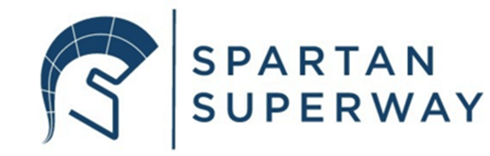
Superway- A Solar Powered Automated Transportation Network
11m Full Scale Track

San Jose State University
Mechanical Engineering Department
ME 195A Final Report
14 December 2019

Advisor:
Ron Swenson
Authors:
Ninebra Babazadehsaralan “Nina”
Jonathan Lagasca
Neeraj Lal



Abstract
Spartan Superway is a student research project striving to create an automated transport network in the bay area. This project is not just for engineers, it is for humanity, because the current climate crisis is everyone's problem. The climate epidemic is of utmost importance in the bay area because the bay has arguably some of the worst traffic congestion in the country. Some put hope in the hydrogen powered/electric vehicle however, the timeline for widespread implementation of such technologies are long. With the Spartan Superway project, this solution to climate change can come as soon as a couple years. The Full-Scale Spartan Superway team is here to address the final hurdle in the engineering design process, and this report will include all necessary information about the project.
As with any research-based project, the first step in the entire process is of course research, however, with this year’s Full-Scale Team, the research that the team needed to do was considerably less than most. This is because over summer an intern by the name of Jacque worked on the track design, however he had to leave back to France to return to school. Having Jacque around gave the team a massive head starts as we were not starting at 0, but rather the team had some previous information to draw upon. In addition, the team worked hand in hand with Jacque for a couple weeks before he had to leave, as a result, the project had a solid foundation for the current Full-Scale team to build upon.
After the project was handed off to the Full-Scale Team, a considerable amount of time was spent truly understanding the previous design. Upon finalization, the actual track layout remained largely the same, some holes were moved around, but the two-piece modular design was kept. However, for the uprights, a different approach was taken to suit the needs of the project further. The final modular track pieces were precisely cut through a high precision water jet located on campus. The material choice for the track was particle board, and the uprights were designed with 2x4’s. All necessary analysis work has been completed and one entire turn of the track has been completed. This upcoming semester the team expects to finish construction of the track and uprights before spring break to allow for ample testing time on the 11m track.
Acknowledgements
In a project of this magnitude, the help of extraordinary individuals is quintessential to the success of such a project. In the case of the Full-Scale Team, this is no different. First, the team would like to thank Professor Furman for working so closely with the team to find a fulfilling project for to complete. All the Full-Scale team members joined late, so from the start the team was at a severe disadvantage. Despite this, Professor Furman helped the team out tremendously to get the team started. Next, the team would like to thank Eric History for really helping the entire team stay organized. Despite Eric not being able to be present physically, he does an amazing job in staying in constant communication with the team through email. Lastly, the team would like to send a special thanks to Ron Swenson, Bill James, and Jacque …., for being the primary advisors on this project. Bill is helping the team out with a bogie, and it was his intern Jacque that really started the project out and thought of the modular track design. Ron is sponsoring all the materials for this project, and the team cannot thank him enough for his constant support and sincere advice. In addition, Ron and his family have so graciously donated an amazing space for the enter Spartan Superway crew to research, design, and build their creations.

Table of Contents
Abstract 1
Acknowledgements 2
Table of Contents 3
I. Executive Summary
II. Introduction and Project Description 6
III. Objectives 16
IV. Structure of Project 19
V. Literature Review 19
VI. Design Solution 22
VII. Conclusions and Next Steps 37
VIII. References 37
IX. Appendices 38

- Executive Summary
The goal for this report is to meticulously document the work that has been completed regarding the 11m Full Scale Spartan Superway Team. Spartan Superway is an ongoing project that continues year to year, and the primary goal for the project is to help abate the climate crisis that is ongoing. Spartan Superway focuses on making transport autonomous and renewable by utilizing electric solar power. Traffic is a major problem within the bay area, and the transportation system in the bay has seen little change in the last decade. Spartan Superway is here to help solve these problems one team at a time.
In addition, an important goal for the Full-Scale Team is to make sure that this track layout can be utilized from year to year. In other words, Full Scale Team wants the track created to be used for testing, so a future team that might need to test out a bogie design, has a functional track to go ahead and test their bogie design on. As a result of teams being able to utilize existing tracks, progress on project can be expedited. Perhaps, one of the most pressing issues of Spartan Superway is the fact that teams are never able to make it to the testing phase of their project, and this year’s Full-Scale Team will help abate that problem for future teams.
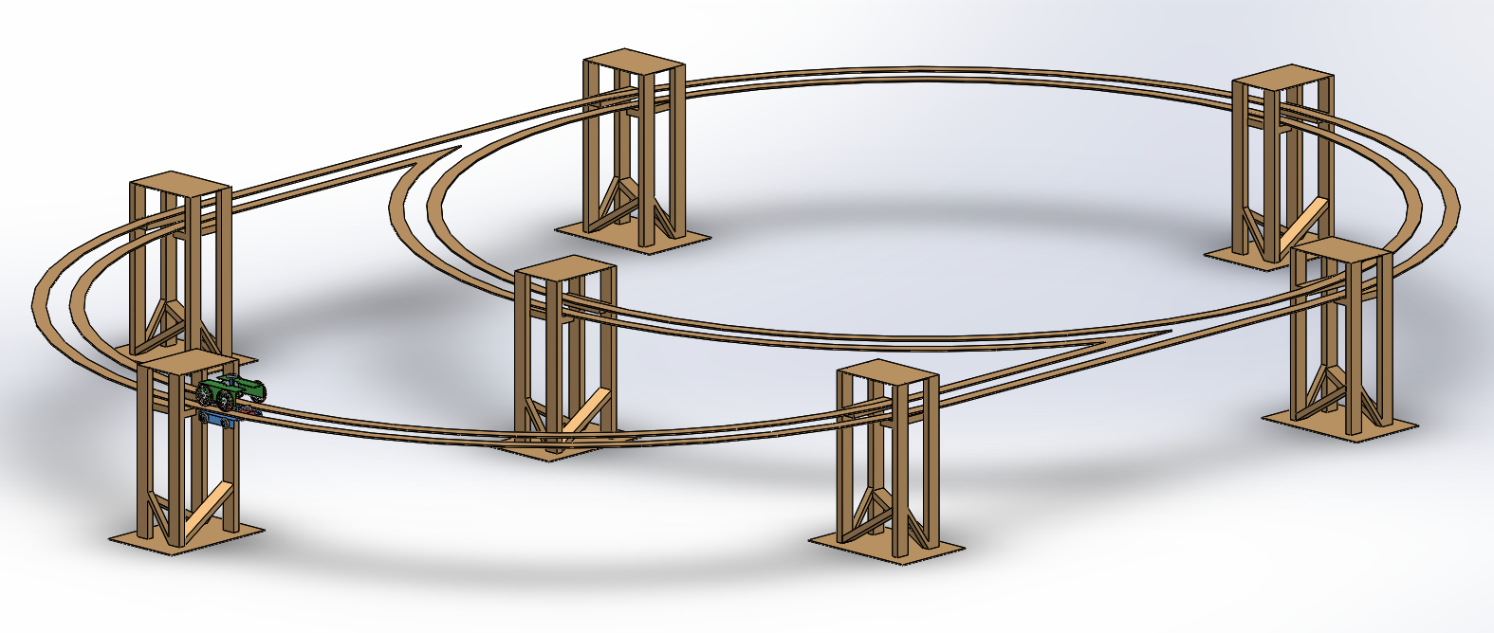Bogie
Figure 1: 11m Track with Uprights integrated

Full Scale Team has a unique modular design for the track and uprights which allows for less complexity in manufacturing. This modular track design utilizes two different pieces for the turn section, and one piece for the straight section of the track. The uprights use the same dimensions for the entire track, this is the result of having adjustable ridges for the track to sit upon. In addition, the uprights have adjustable bases and ridges which allow for proper track leveling. As a result of the interchangeable design of the track and upright, this track system is simple to manufacture and easy to maintain.
Throughout the semester, the emphasis was on the upright design as the uprights see many dynamic loads, so designing proper uprights was an arduous task. The track on the other hand was rather simple, and throughout the semester the pieces were being water jetted whenever possible. At this point, it is safe to say about 55% of the track pieces have been water jetted, and about 30% of the track has been assembled. The track currently is resting on tables and chairs and should soon be on the designed uprights before spring break of next semester. The uprights in question went through 2 different iterations before a final design was selected. The final model has been completely analyzed, and the team’s analysis work shows where uprights will be needed, and what kind of load the uprights will be withstanding.

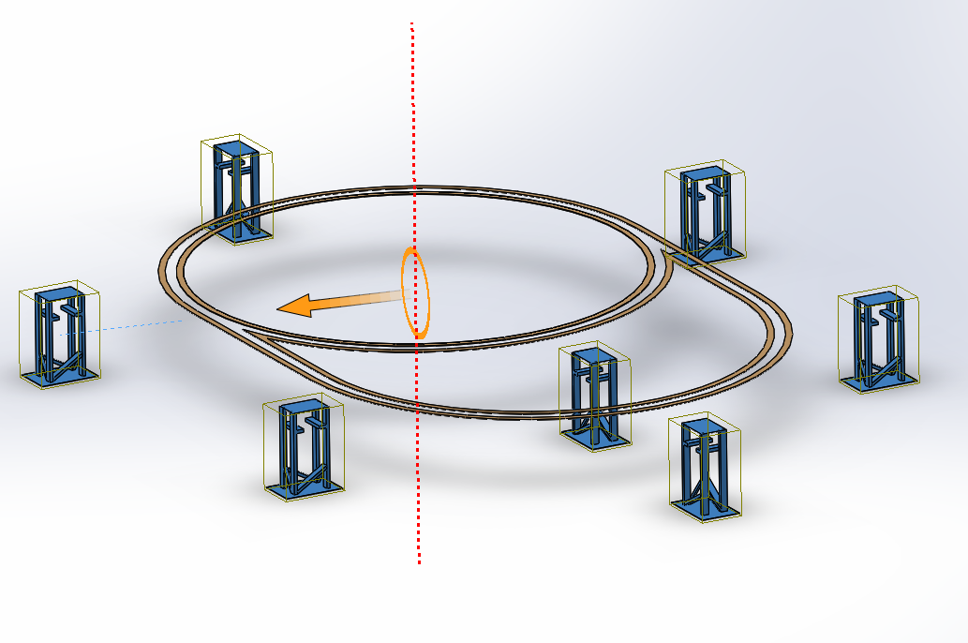
Figure 2: An exploded assembly view showing the track and upright integration

- Introduction and Project Description
Traffic Congestion is a major problem here in the United States because too many people need to be somewhere at the same time each day. This condition makes road to have slower speed and longer trip times, which caused Americans living in urban areas to travel an extra 6.9 billion hours and consequently consume an extra 3.1 billion of gallons of fuel. This is the problem that has grown since the 1950s, and it keeps getting worse.

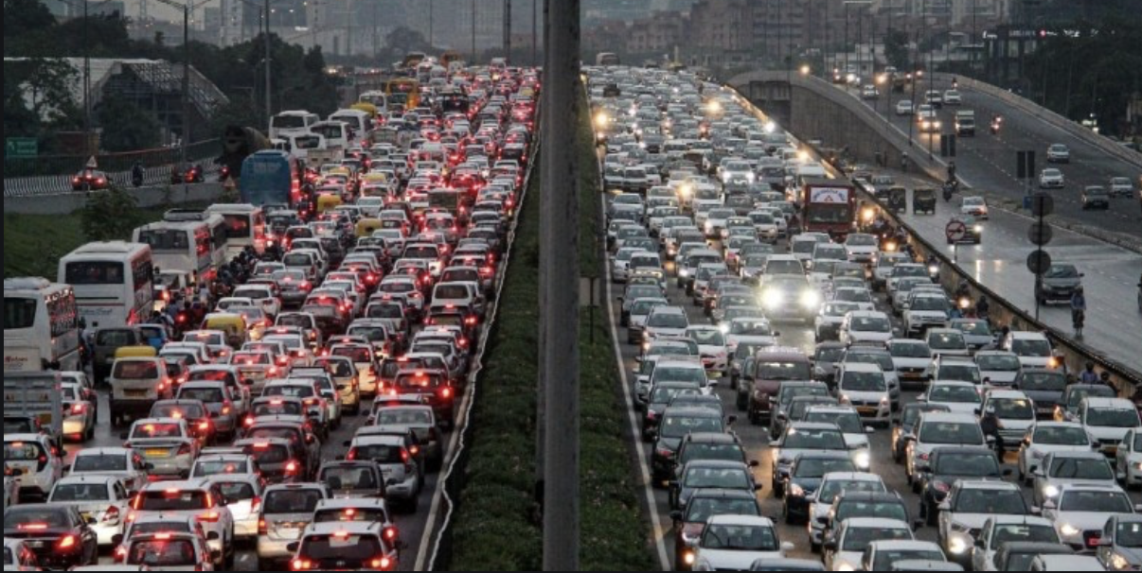
Figure 3: Traffic Congestion is a major problem here in the United State
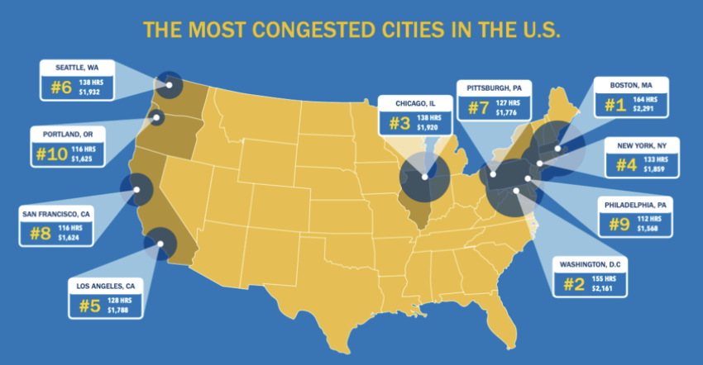
Figure 4: United States cities with the most traffic congestion

By having traffic congestion, and roads being filled with cars then the loss of productivity become the second major problem here in the United State. People need to use roads to travel and go on with their daily routine, but not being able to manage their time due to the traffic congestion then they lose productivity and time. This loss of hours simply cost the United State economy $87 billion in 2018 which is due to road traffic and have no alternative to skip this traffic congestion.

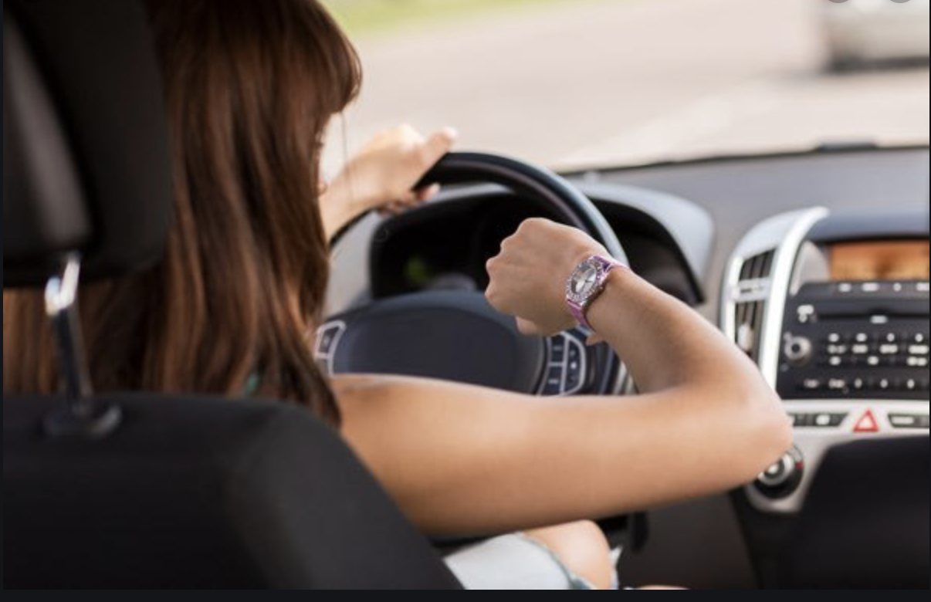
Figure 5: loss of productivity due to traffic congestion is the current problem in the United States

Safety is the number one priority in everyone’s life, but how can a person be 100% safe if he/she must spend hours and hours of the day going through the block roads? The number of new drivers taking the road is way larger than new road being built, this means that there are more drivers sharing less space which this led to traffic congestion, loss of productivity and car accident. In the United States, deaths resulting from traffic accident outweigh the toll taken by two most deadly diseases such as cancer and heart disease. Based on this report, it is obvious that the traffic congestion which leads to car accidents and then death is becoming another major problem for the United State, and it needs to be resolved in order to save people's lives.

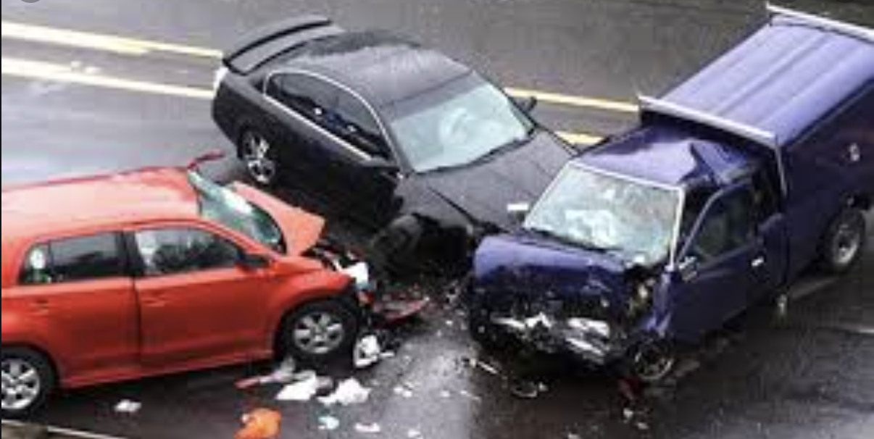
Figure 6: car accidents - the number of death and injuries increases every day due to traffic congestion

After all, the climate crisis driven by greenhouse gases is the reason that our earth is in danger. Human activities are the reason for increasing greenhouse gases into the atmosphere for the past 150 years. Burning fossil is the main greenhouse gas emissions, and there are many sources that emit greenhouse gases into the atmosphere daily, but transportation sector generates the largest share of greenhouse gas emissions. Based on the report from EPA on greenhouse gas emissions in the United States, there is 28.9% of 2017 greenhouse gas emissions are from transportation. This large number comes from burning fossil fuel for cars, trucks, ships, trains, and planes.

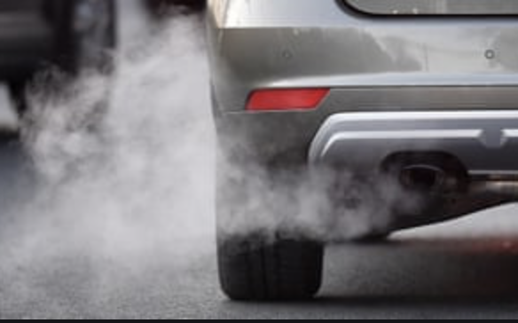
Figure 7: greenhouse gas emission is a threat to climate change
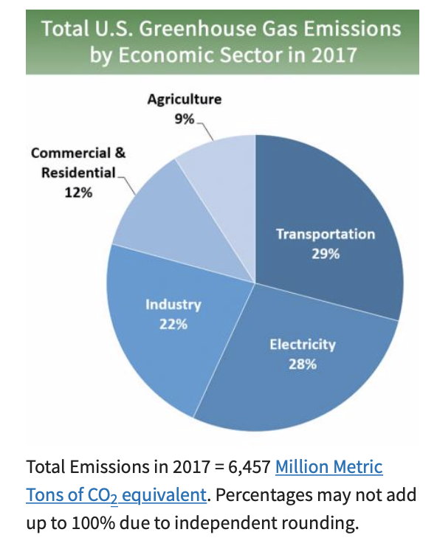
Figure 8: Total United State greenhouse gas emissions by economic sector in 2017
Once again, the traffic congestion is the reason that our environment has a large amount of greenhouse gas emissions daily. Traffic congestion leads to block roads, unsafe roads, and non-clean energy use roads. Therefore, the societal needs for and impacts of improvements in urban transportation.
When someone thinks of traffic congestion problem, she/he immediately comes up with an idea of adding more roads. As mentioned earlier, the number of new drivers taking the road increase every day, therefore; adding new roads cannot be the best solution. Also, adding roads might help to reduce the current traffic problem that leads to block roads, but it will increase the danger to climate change. If the number of roads increases, then the use of fuel burning transportation will also increase, which is a death to our world. by adding more greenhouse gases into our atmosphere, then we increase the danger of climate change which simply means the end of the world. The solution that will help thi9s major problem of our society has to fix all current problems, such as: traffic congestion, road’s safety, climate change.
Spartan Superway understand the major problem of our society and gathered a team that can help to put a stop on harming our society, environment, and basically our world. The Spartan Superway system solves the major problem of traffic congestion by design a solution that helps with traffic on the road, block roads and unsafe roads due to traffic, and more importantly the climate change.
The safe roads begin with Spartan Superway. Here at Spartan Superway all teams work together to complete the design that can benefit the consumer and society itself. This is the solution that help people with getting their daily routine done, while it has zero danger to our environment. By using this new way of transportation, the society and its population will live longer, heater, and happier.

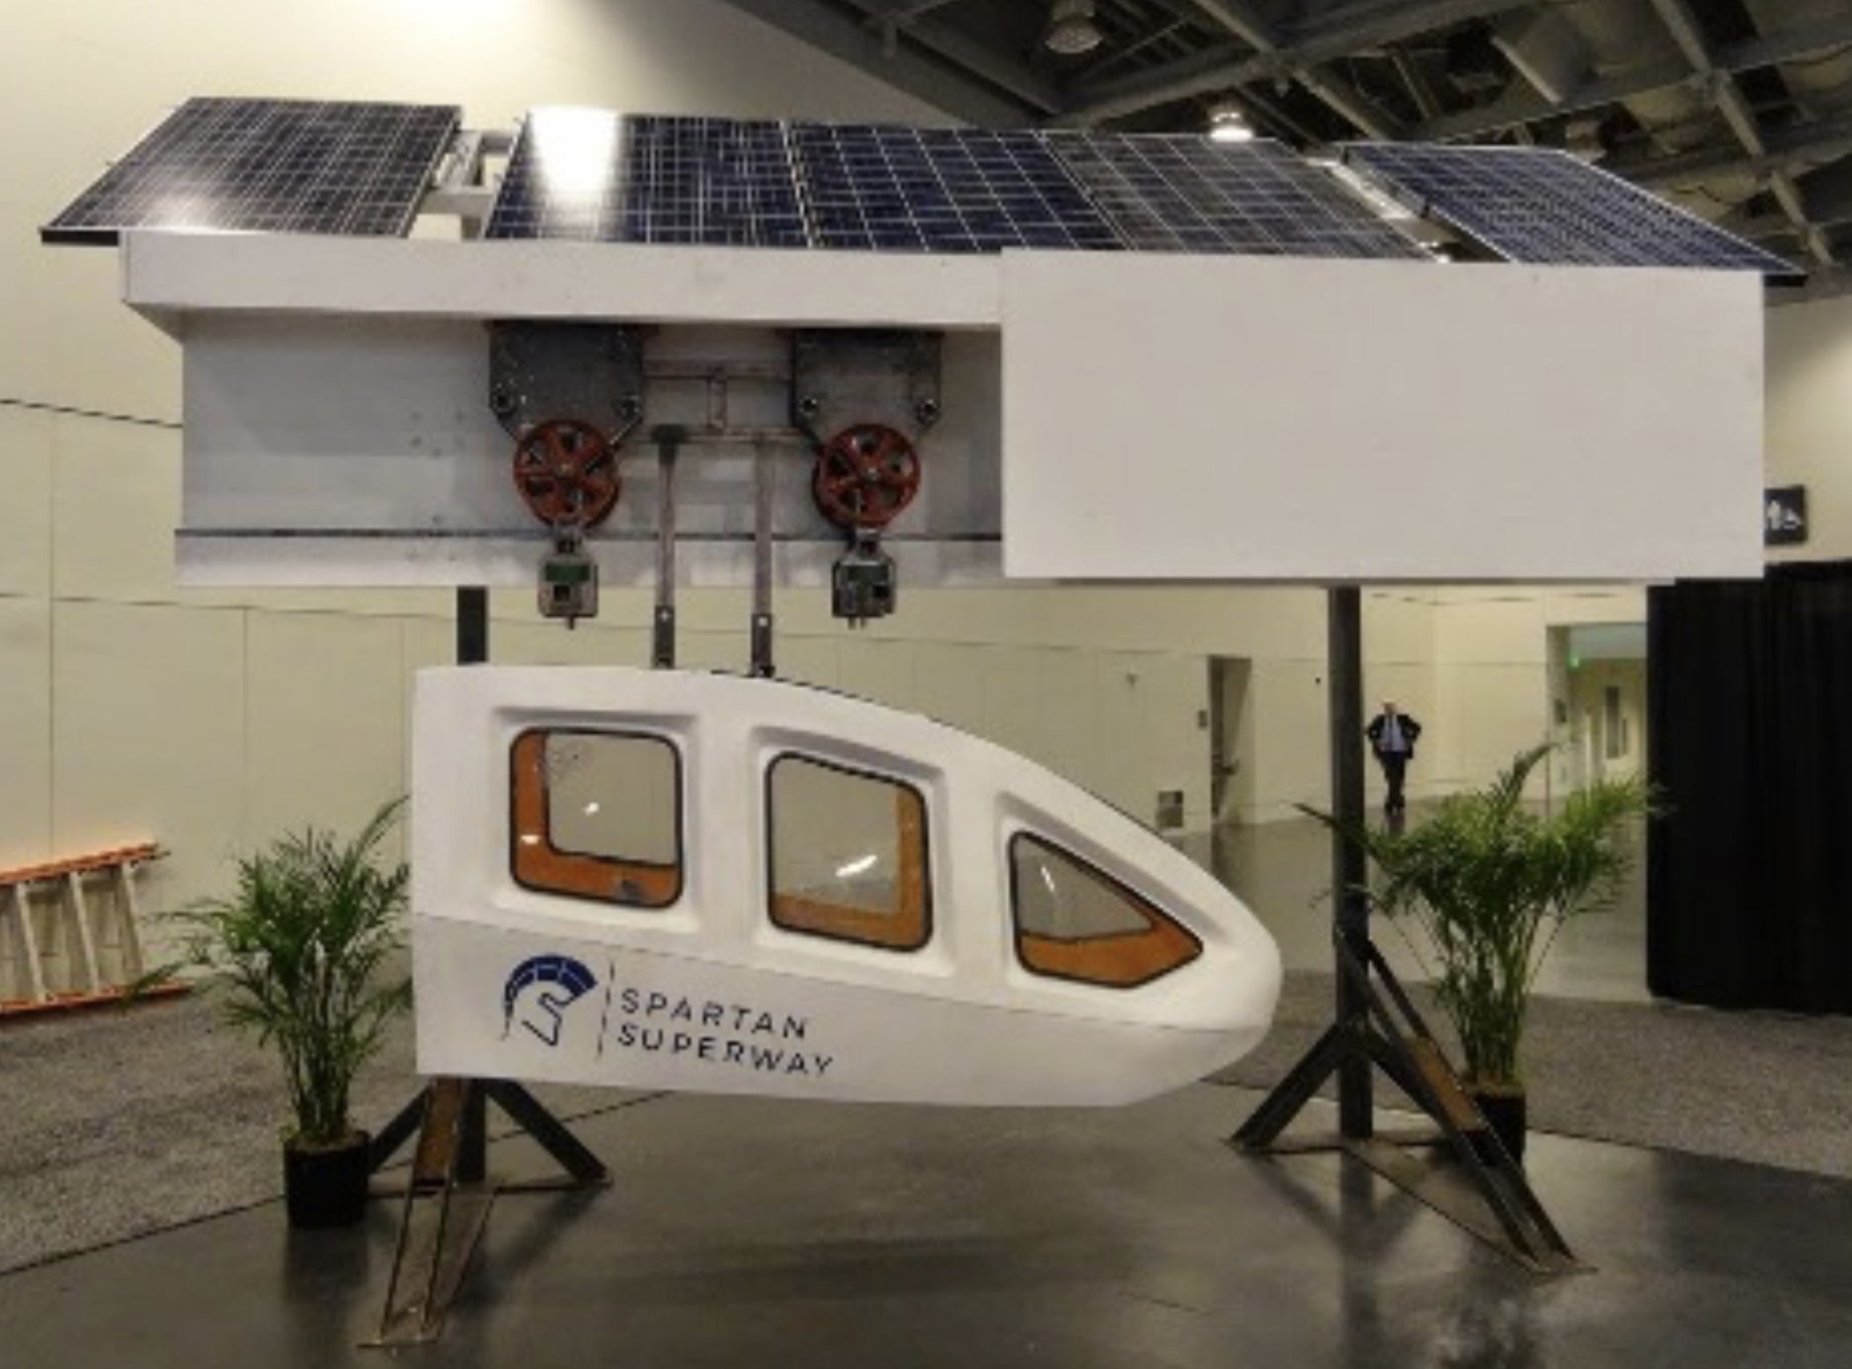
Figure 9: Spartan Superway with its clean energy source

This autonomous transportation idea is helping with traffic congestion and roads getting blocked because it uses its own track. The track is not sharing a space on the main roads with other transportation systems; therefore, more people are able to travel during the day without sharing the same road with others.

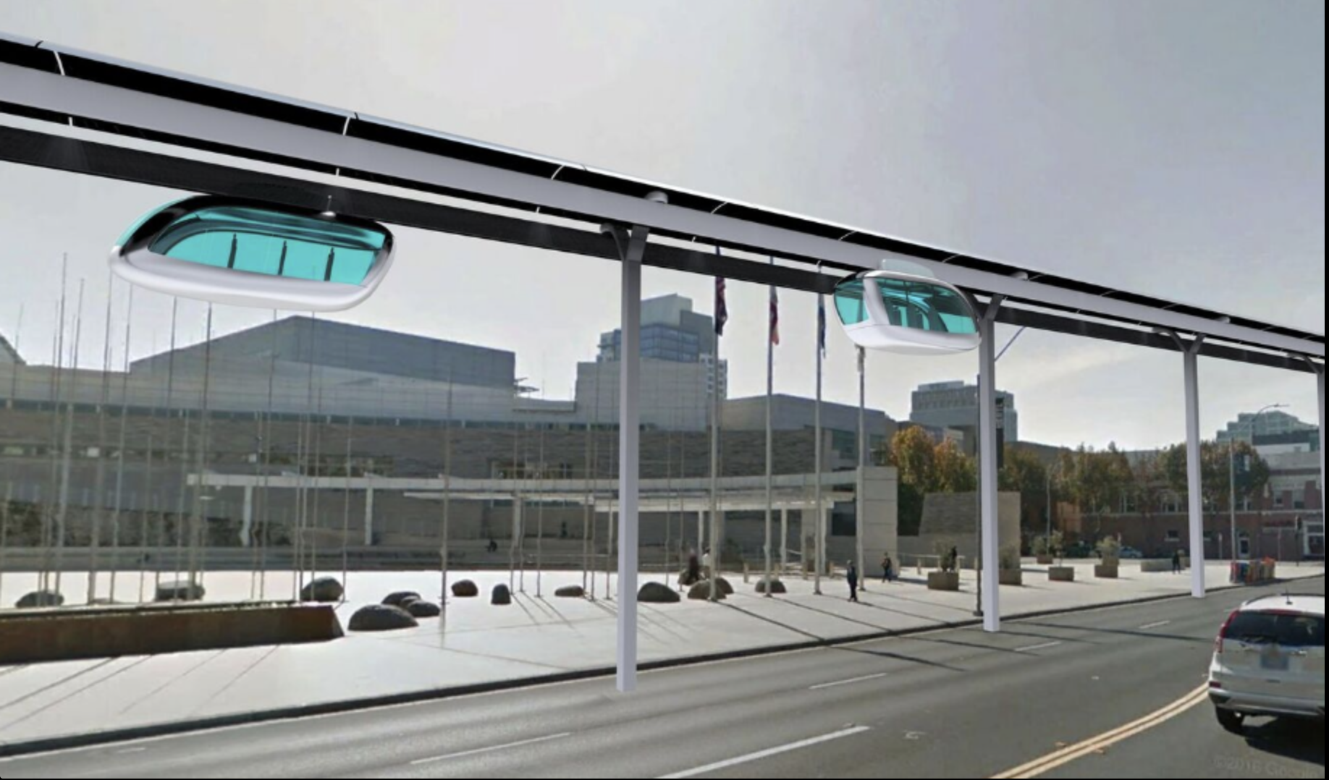
Figure 10: Spartan Superway track idea for the future

Being able to travel without sharing roads with other can help to decrease traffic on the main roads. In this case, roads won’t get blocked and the safety of road will increase. Based on the CARSURANCE report there are nearly 40,000 fatal car accidents per year in the United States, and each day more than 90 Americans die in accidents. Also, 2 million drivers experience a permanent injury every day. This report it’s a prof that roads are not safe place anymore, but Spartan Superway is here to solve this for the better. This new way of transportation keeps our roads safe and decrease these reported number of death and injury due to an accident. Spartan Superway is the solution that will create a report of zero injury and death due to car accidents.

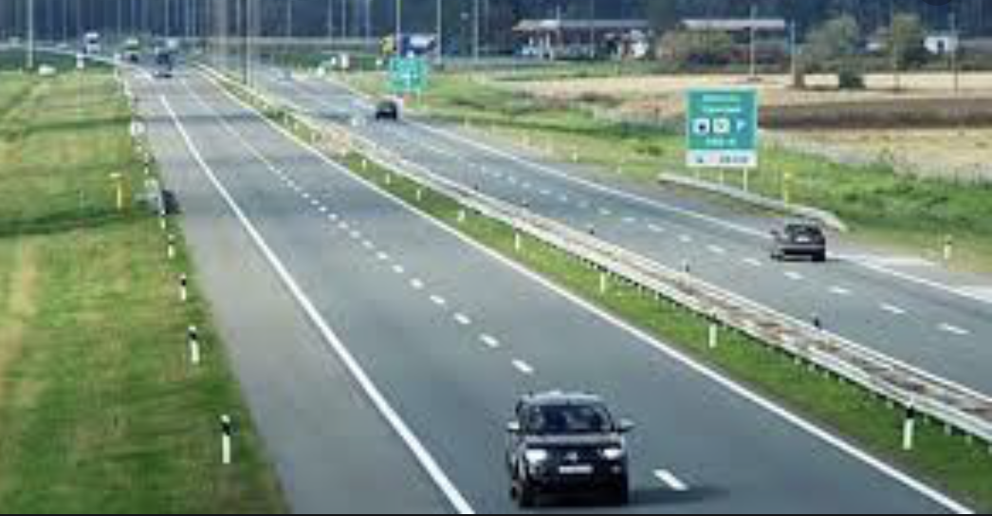
Figure 11: safe roads when more transportation system being used such as Spartan Superway

Another good benefit of using Spartan Superway is saving time and being productive. People spend hours and hours of their day sitting through traffic but using Spartan Superway help people to travel and reach their destination without wasting their valuable time. This is the solution for people to become more productive with the time they save by not getting stuck in traffic.

Figure 12: saving time and being productive by using autonomous transportation

More importantly Spartan Superway is here to help with climate change. Our team is working to have an autonomous transportation that use clean energy. Spartan Superway has zero harm to the environment since it’s using clean energy. There is no foil burning and there is no greenhouse gas emission into the atmosphere; therefore, the threat to the climate change is gone with Spartan Superway. Other transportation such as: cars, trains, airplanes are burning fossil for their fuel which they add a large portion of greenhouse gases into the atmosphere. Furthermore, Spartan Superway is clean energy user and it’s an autonomous transportation that reuse its clean stored energy. Here in Spartan Superway we believe we have the solution to current mobility problem, and our goal is to have everyone in our environment to join us and help to save our society, our environment, and our world.


Figure 13: use clean energy will save our world

- Objectives
Our full-Scale Team have a desire to design and build the 11-meter track. Our purpose is to have a track available for our designed bogie to test and improve for better. From August till December of 2019 we have been working on design for the track and uprights. For this reason, we started water jetting track pieces and put together the overall track. Our goal is to have the designed track with its upright done by March of 2020, in this case, we can test and run the bogie. From March to May of 2020 we will be testing the bogie on our designed track to observe any failure, so that we can improve it.

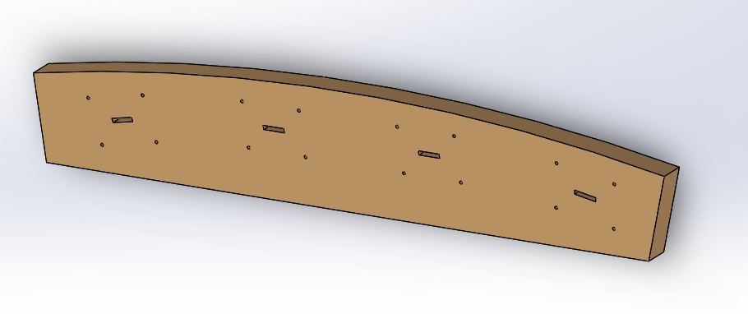

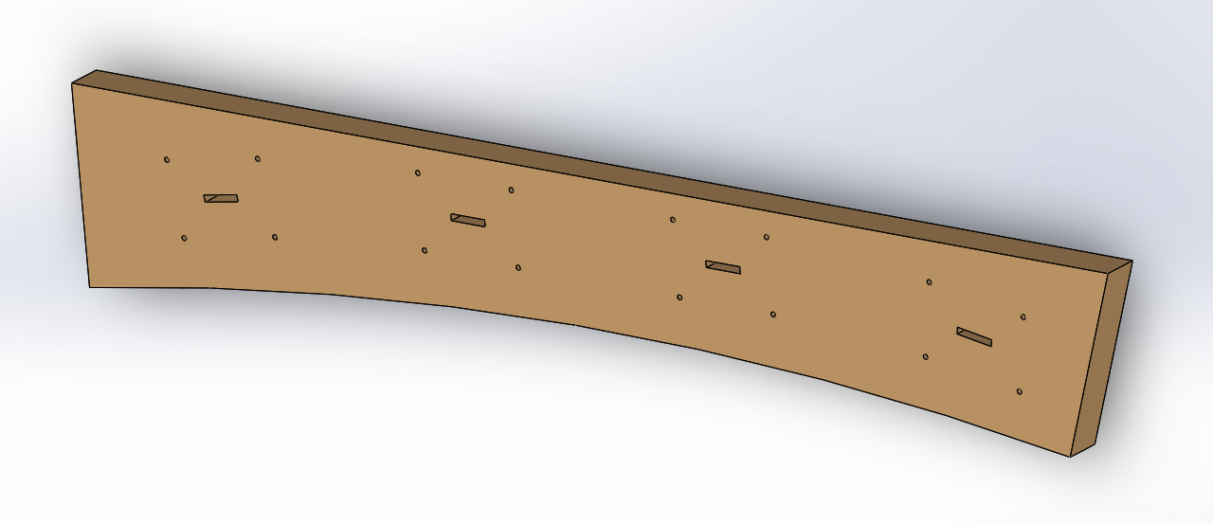

Figure 14: The CAD drawings above shows how the track pieces must be water jetted

Since our team is the first team to design and build the tack for the specific bogie, so we had to use a material that is easy to use, easy to find, and cheap to purchase. Therefore, we used Douglas Fir Wood that is available everywhere and cheap to purchase. Also, the reason we choose wood for our track is because we wanted to be able to hand cut the pieces if we are not able to use the water jetting system at San Jose State University.

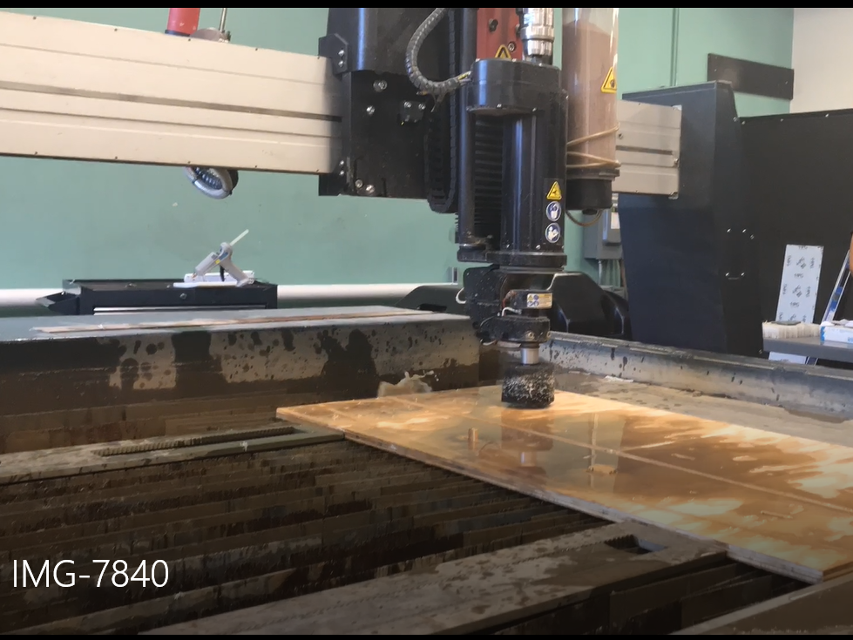
Figure 15: The water jetting system used to cut the track pieces
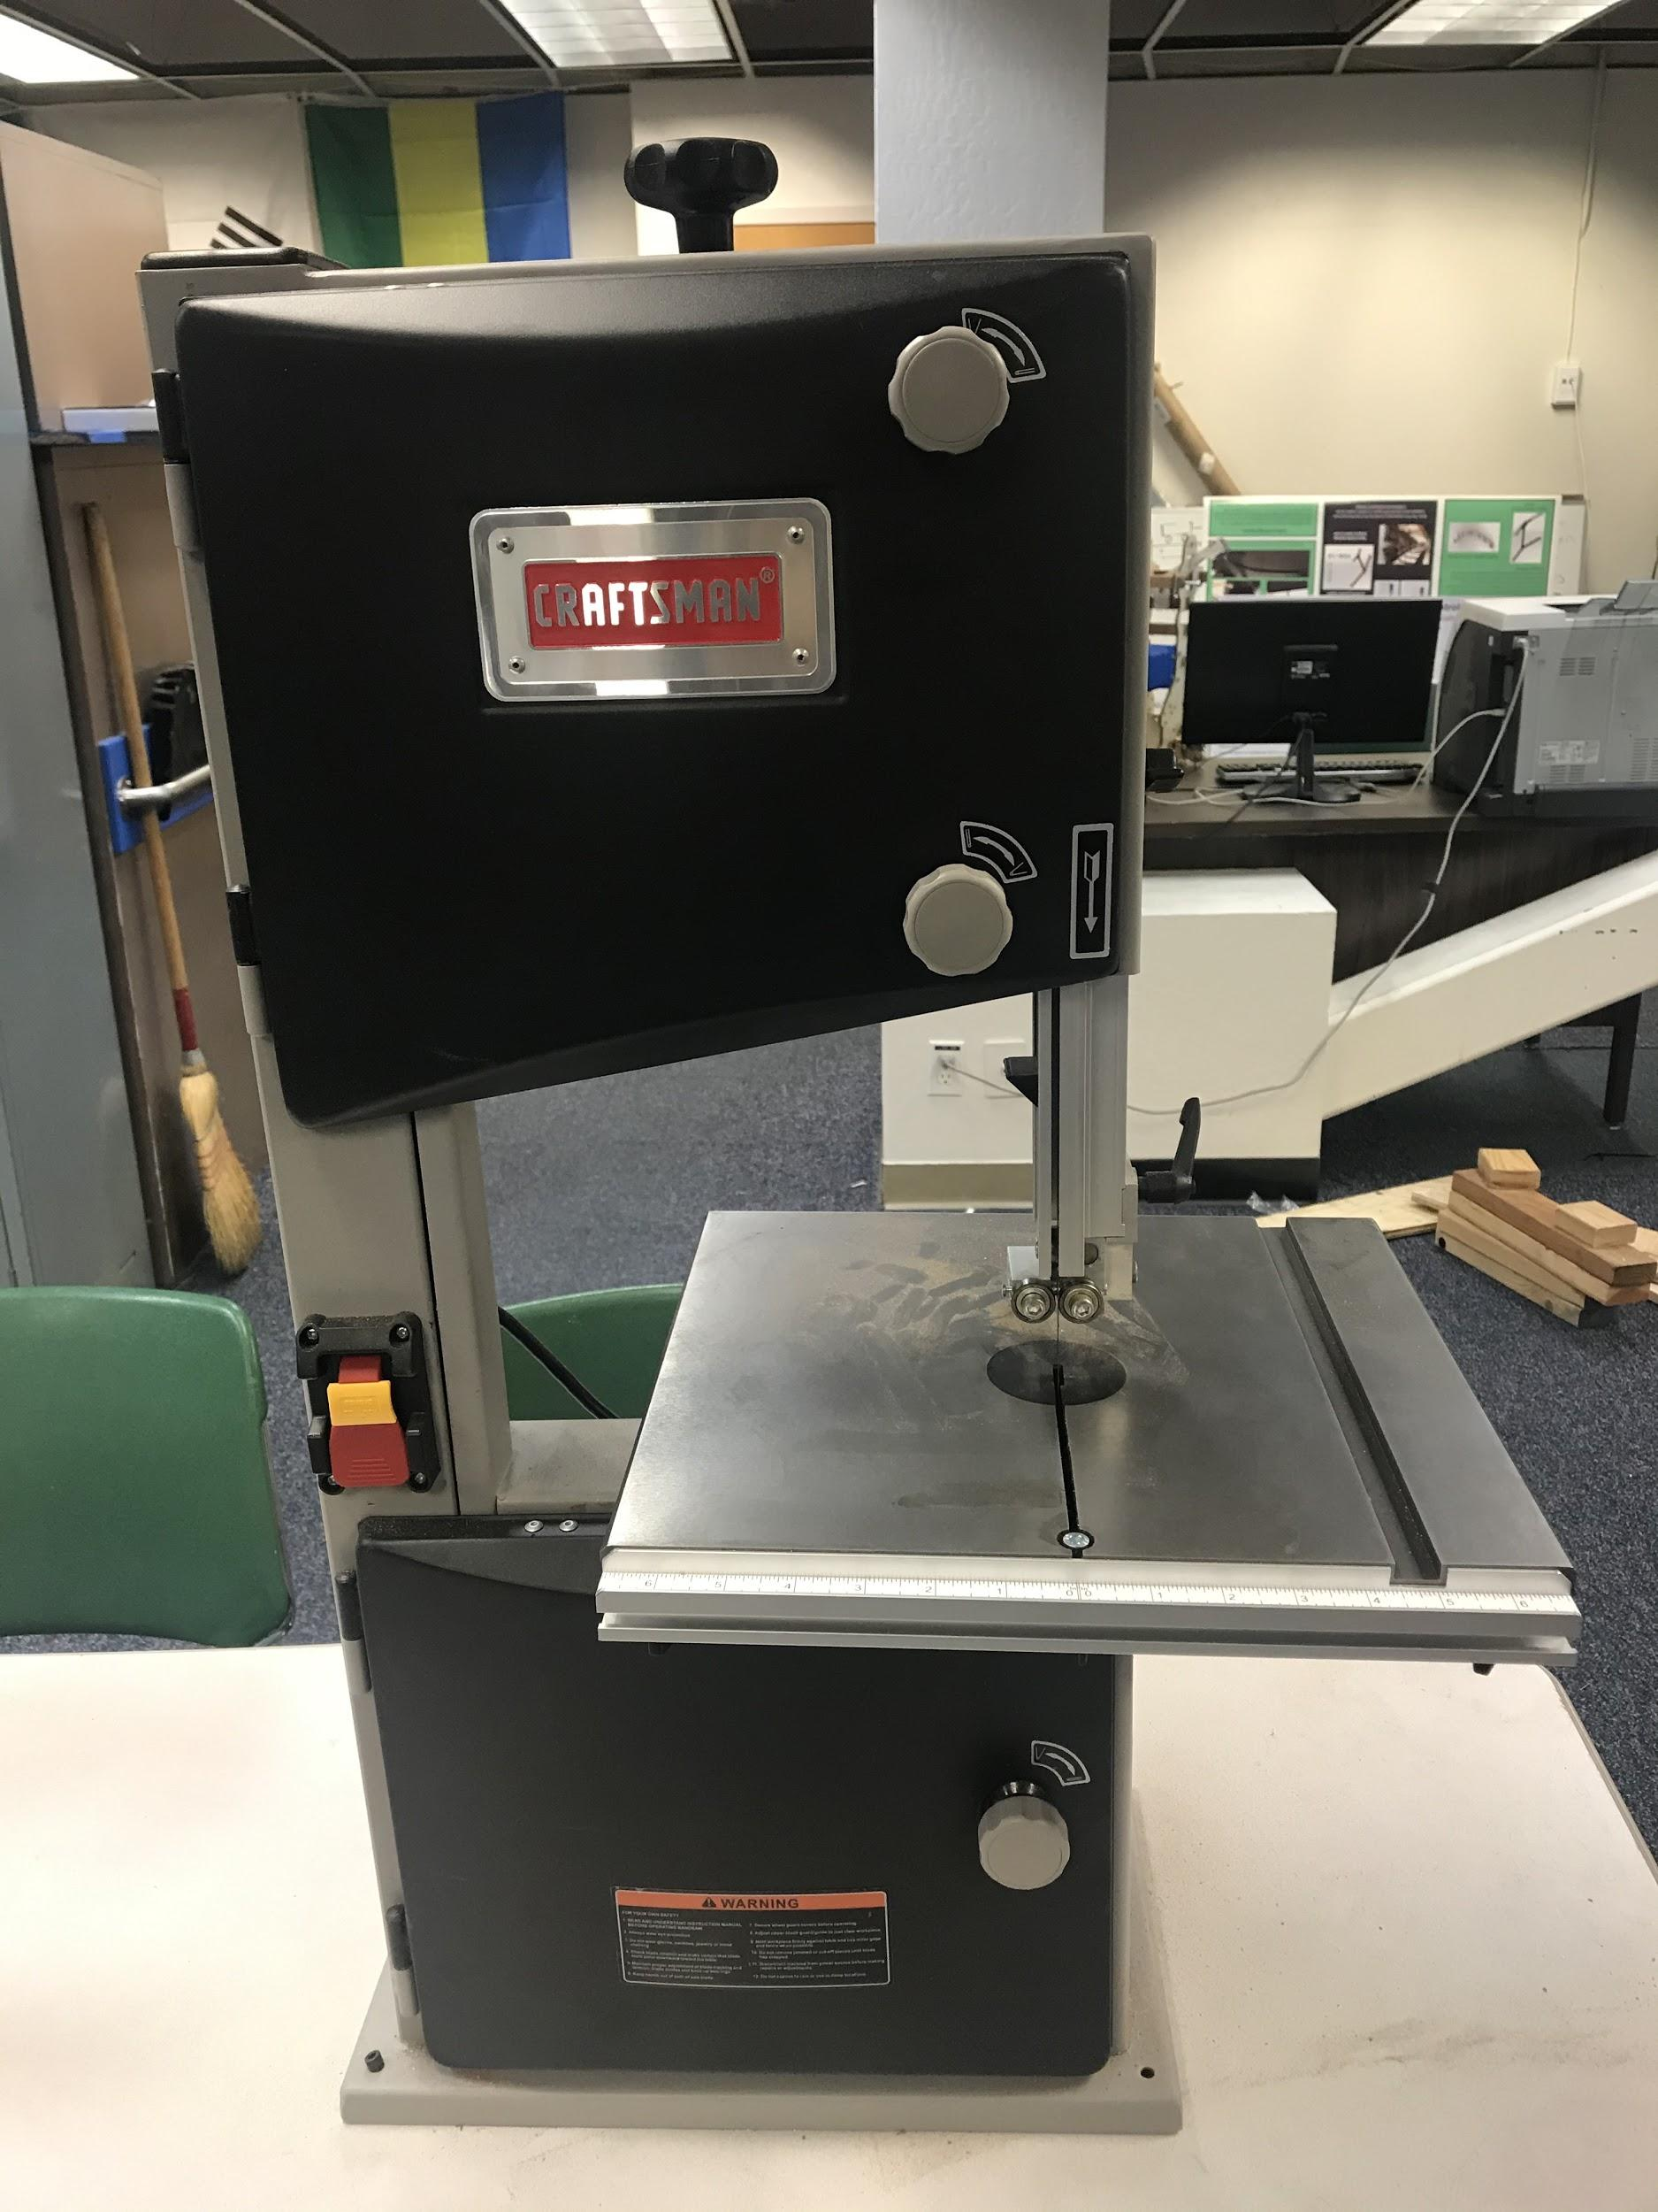
Figure 16: The device used to cut the track pieces when water jetting isn't available

Our team did not have a set budget for our 11-meter track (Full Scale Team), but we have had support from our sponsor Mr. Ron Swenson. He was providing our supplies for our track and everything we needed for our project for the Fall of 2019, and he is willing to give us his support for the Spring of 2020 as well. So far, our expenses for this 11-meter track was $1285 which it covers the woods for the track and its uprights. The prices broken down are in appendices.

- Structure of Project
The 11m Full-Scale Track is divided up into two divisions: the track assembly, and the uprights holding the track. The track assembly consists of the bogie, track pieces, and the switching mechanism. The uprights finding how much to put around the 11-meter track, and where to place them.
The track assembly mainly consists of two waterjet parts. This is mostly handled by Jonathan, but Nina and Neeraj substitute for him when he is not available. The switching mechanism is mainly a task that has the support of external assistance. Bill James of Pods and Carlos Ortega will be assisting Jonathan in creating a functioning switching mechanism for the 11 meters track.
The uprights consist of calculating the forces to be applied to the track during operations and creating a design that can withstand the forces created by the motion of the bogie. Nina and Neeraj oversee the upright design and placement. Nina oversees designing the upright alongside Neeraj, but Neeraj will create the first working upright. Nina and Neeraj will both produce as much uprights needed to support the track by the end of the project.
- State of the Art/ Literature Review
ATN Technology
Automated Transit Network (ATN) is a technology that has existed for a long amount of time. There is a 7-point definition of ATNs as established Advanced Transit Association (ATRA) (Ellis, Fabian, Furman, Muller, Swenson).
- Direct origin-to-destination service with no need to transfer or stop at intermediate stations
- Small vehicles available for the exclusive use of an individual or small group traveling together by choice
- Service available on demand by the user rather than on fixed schedules
- Fully automated vehicles (no human drivers) that can be available for use 24 hours a day, seven days a week
- Vehicles captive to a guideway that is reserved for their exclusive use
- Small (narrow and light relative to LRT and BRT) guideways usually elevated but also at or near ground level or underground
- Vehicles able to use all guideways and stations on a fully connected network
ATN tech at SJSU since 2012
As of 2014, 5 examples of ATN exist and will be discussed in this section.
The Morgantown PRT is one of the first iterations of an ATN in West Virginia University. It consists of a straight, linear railway that has passenger cars with a capacity of 8 to 20 persons.
Masdar PRT has been operating in Masdar City, Abu Dhabi since 2010. This ATN again uses magnetic rails, but also has lithium-battery powered cars. These cars carry 4 adults and 2 children.
Park Shuttle system is another example of an ATN in the Netherlands. The system consists of bus-like passenger cars that move along magnetic rails. Each car can carry 12 passengers.
The Ultra PRT system operates in Heathrow Airport in London. These passenger cars operate on an elevated railway with occupancy of 4 passengers and luggage.
Lastly, the Sky cube system in Suncheon Bay, South Bay has operated since 2013. It consists of a linear guideway like the Morgantown PRT between two stations. The cars carry 6 passengers.
In all these ATNs however, they do not fully utilize the capability of reducing cars on the road and saving the environment. Their routes are restricted as specifically the Sky cube and Morgantown PRT, with their linear routes. If the routes could be expanded upon, then the full benefits of ATNs could be obtained.
Spartan Superway ATN Previous Works
In 2015 Full-scale report, the upright design was greatly modular, the team made great strides on keeping a low deflection of their track design. This was mostly due to the sturdier material chosen for their upright, which was metal unlike this year’s wooden design.
Full-scale 2016 team’s track had a steel and concrete-reinforced design for their uprights. This is good in that it produces lower deflection but reduces this current year’s goal of maintaining ease of manufacturability and modularity.
The team of 2017 & 2018 both had designs that used metal shafts which ease manufacturing, but this still conflicts with this year’s goal of using easy-to-gather materials. However, the 2018 team had solar panels, which would be of great use for the track in the future, for increasing sustainability.
SJSU Full-Scale Subteam Previous Works
Though this is a full-scale team, this idea of a platform to test on has not been an idea in past years or literature in San Jose State University. Past works usually consist of creating a scaled model of the Superway, but no project has been a direct platform to just test designs. This project will be the first of its kind and will aid in the design of other teams to come. However, this project can make use of the methods that other teams have used in their design process, such as FEA analysis on uprights, loading calculations, and features of upright design.
- Design Solution
Background
Before jumping into the final designs of the upright and track it is important to discuss the design goals that both the track and upright must meet, and how the current design fits into these design goals. After that, previous design considerations will be explained, and lastly, this section will discuss the final designs and why they were the best.
Track Design
The track design had to fulfill a variety of different design goals. First, the track needs to be able to support the weight of the 44kg bogie. It is important to note that this specification is different than the upright design specification. In other words, the track needs to support the weight of the bogie traveling at speed in between uprights. In track designs the fewest uprights is most ideal, and because of that, it was an important design consideration for the team that the track has as few uprights. In addition, cheap manufacturing was also an important consideration, so in order to both be cheap but still be strong enough to have fewer uprights, 0.7” thick plywood was selected as material. Second, the track needs to be able to accommodate a multi-wheel bogie design. As a result of the bogie needing to support a multi-wheel design, the track was designed to be flat with an outside and inside piece. The tracking being flat allows for the multi-wheel bogie design to lay on top with secondary wheels on the side pushing against the track. The bogie in question is being supplied by Jpods, and this design specification was given by them. The reason the bogie needs to be a four-wheel design as explained by Bill James from Jpods is, to help with bogie stability and pod support.
The track assembly will mainly consist of two track pieces: an inner peace and an outer piece. These pieces will help accomplish the goal of being able to simplify manufacturing, as well as reduce production time. The inner piece will be made of the same Douglas fir wood as the outer piece. The track parts will be arranged with slots to allow for aligning of the track parts, and then glued together or with bolts if needed. They will be arranged in a staggered pattern, akin to that of Legos.
The switching track parts will be attached to the track as static parts as the switching mechanism will be on the bogie. This 11 meters track’s switching mechanism will emulate that of the small-scale track where modular track parts will be supported at a higher height than the base track pieces to allow for the switching of the bogie.
At minimum the bogie will have 11 wheels, 8 wheels to keep the bogie stabilized vertically to keep attached to the top and bottom of the track. Two wheels will be placed in between the inner and outer track pieces to keep the bogie stabilized vertically. Lastly, one wheel will be attached to a servo and will contact the switching pieces of the track.
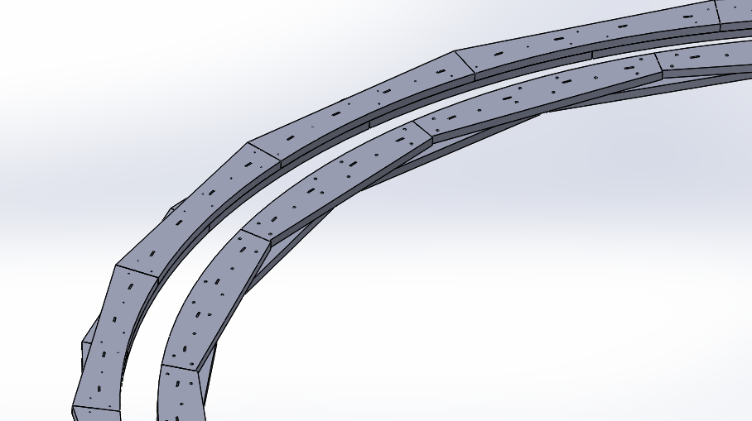
Figure 17: The CAD drawing above shows the way each track piece interacts with each other
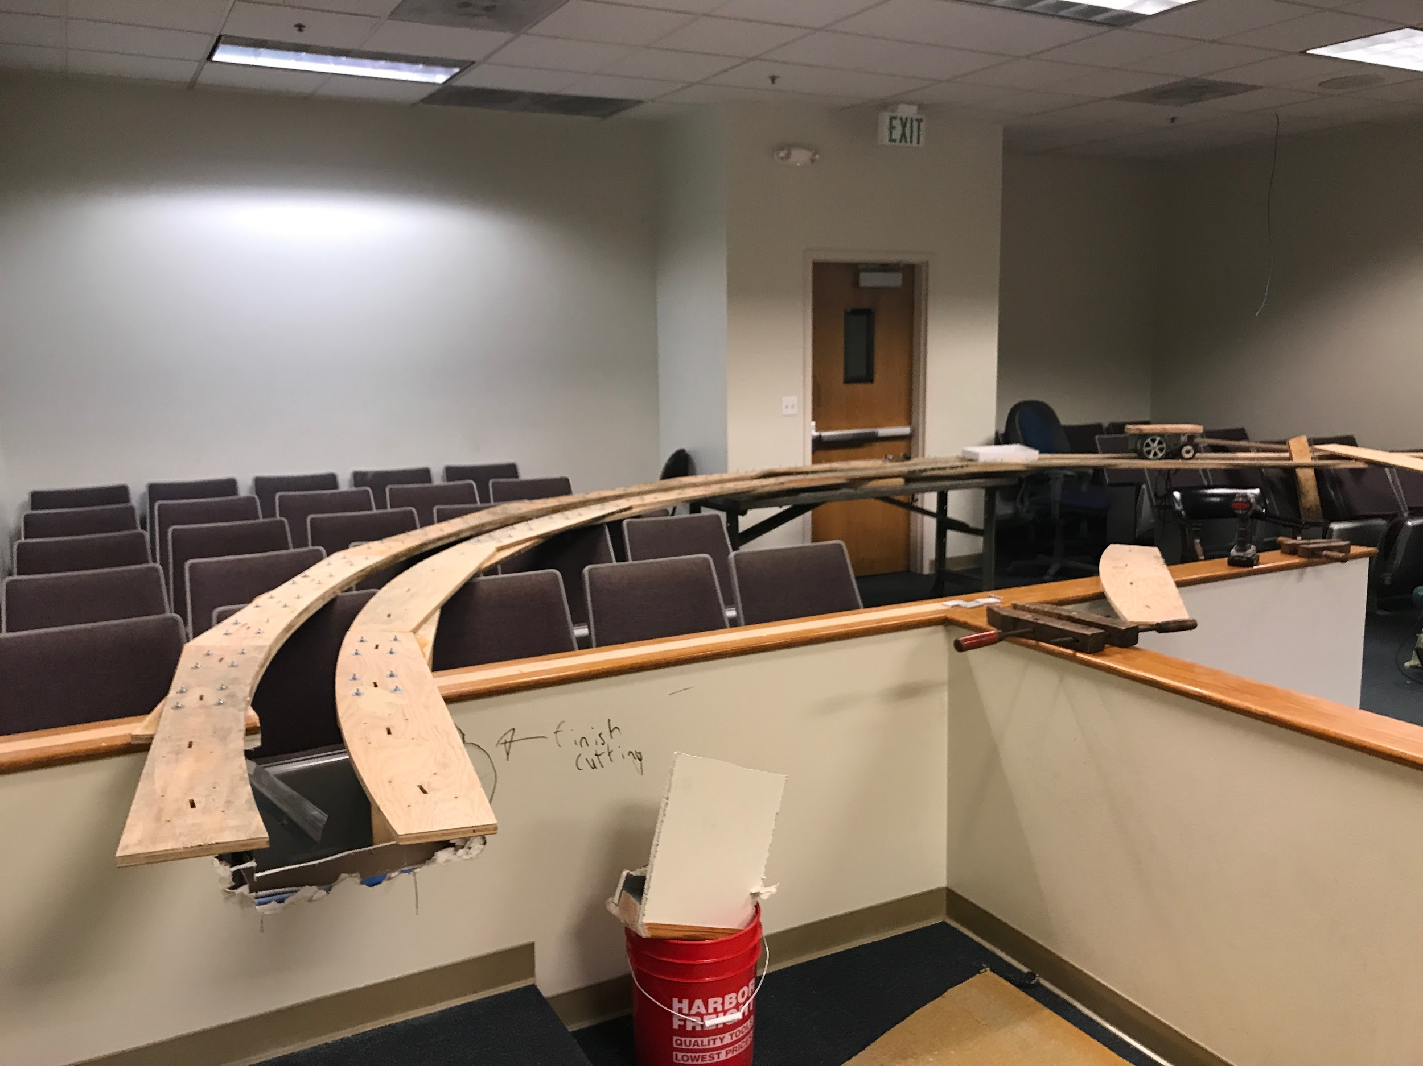
Figure 18: Pictured is the mentioned track pieces in real life
Track Analysis

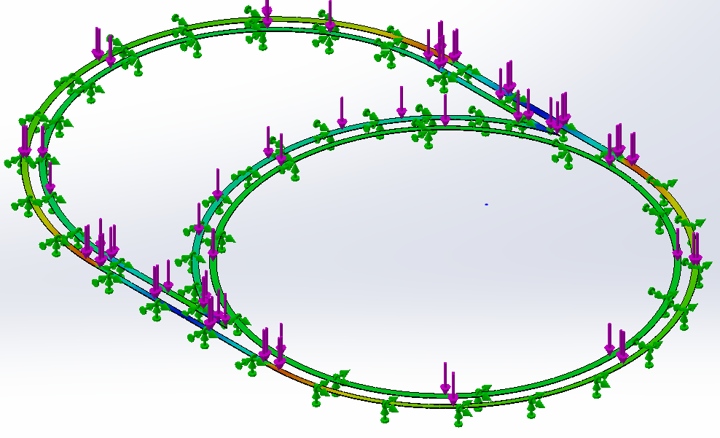
Figure 19: Fea results of track max deflection 1.4mm
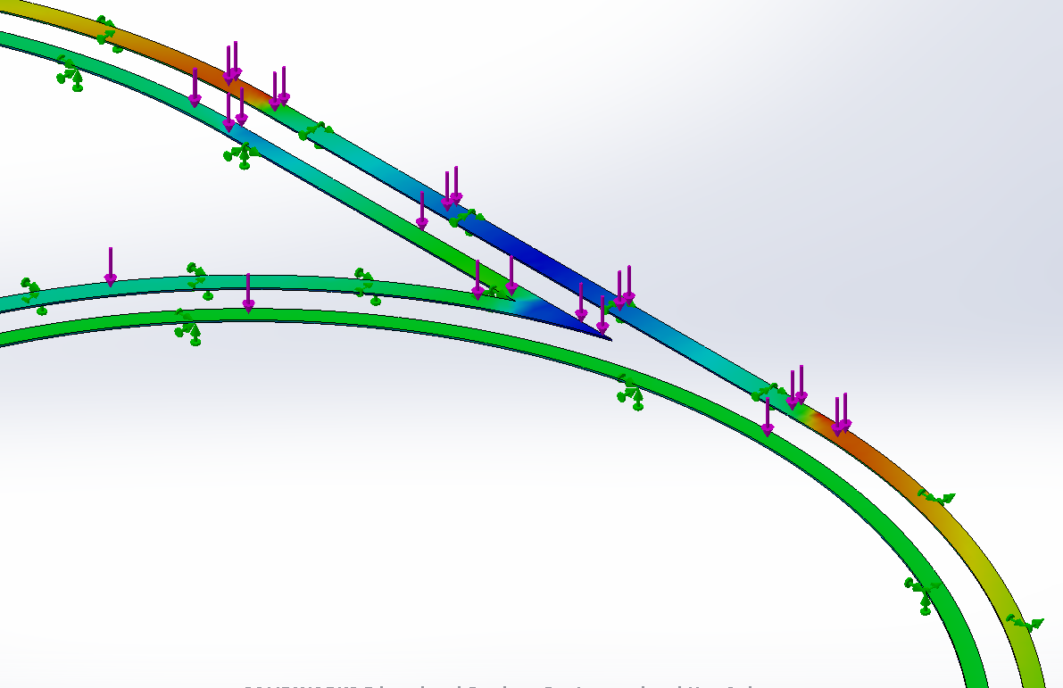
Figure 20: Closeup of FEA
Upright Design
The uprights needed to meet a highly specific set of specifications because the uprights see the most load. The different iterations of the uprights and why the team thought certain designs had promise will be discussed in fine detail, this bit focuses on what the actual design specifications are. To start, the upright needs to be capable of supporting the weight of the track plus a bogie traveling at speed. Specifically, the upright needs to support a static force from the track of 40 kg. Please see appendix figure for calculation on forces. In addition, the track needs to. All these loads need to be supported with less than 5 mm of deflection of the upright as proven by Finite Element Analysis (FEA) with a Factor of Safety (FOS) of 2. If the upright cannot support the weight of the track plus bogie traveling at speed, then is incapable of fulfilling its primary purpose. Next, the upright design needs to allow for the team to study the bogie to track interaction from above and below. In other words, this track is meant to be a testing tool, and in order for the team to successfully test the bogie and track, the team must be able to observe the track from the top, hence it cannot be tall, but also, observe the track from the ground, so it cannot be too short. As a result, the upright must support the track 3 ft off the ground.
Previous Upright Designs
In this section the team expects to discuss some previous designs that were considered, and why the design was eventually rejected.

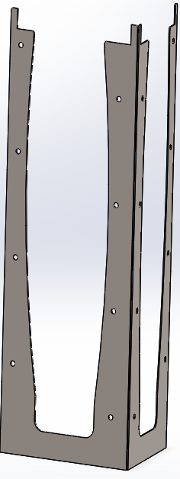
Figure 21: Upright design #1 as suggested by Jacque

The first design that will be discussed in shown above and was originally conceived by Jacque over the summer. This upright design would support the track from underneath and would be constructed from 20-gauge sheet metal. In this upright design the thought was fishing wire would hold together the upright, and as a result, the design would be strong and simple. To show its strength some FEA results are shown below.

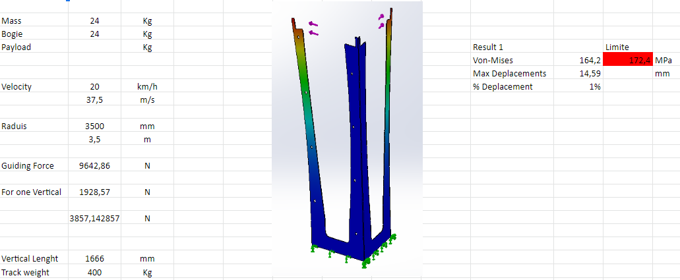
Figure 22: FEA of first upright with results in excel workbook

These FEA models were done with a 24 kg bogie traveling at 37.5 m/s. In this FEA model, the displacement was 14.59 mm under load. The ideology behind this design was that it would be easier and cheaper to manufacture. The final cost for all materials would be $25 per an upright. After some consideration, this design was turned down by the team. One of the main reasons this was turned down was because it did not meet the team’s design specifications. The team does not believe that this design will fail, but in the team’s opinion there was a better design out there. In addition, this design seemed like a manufacturing nightmare. The fishing line that would be used to string the upright together seemed like it would be too complex, winding wire together is no easy task, and the right amount of tension, or the design would fail. Additionally, the sheet metal would be bent manually to achieve the proper shape. Some of the team members have experience with bending sheet metal and getting any degree of precision out of manual bends is near impossible, plus bending sheet metal into that shape would be even more challenging as the base would be difficult to bend with the 3 other pieces sticking up as shown in the picture. Overall, this design proved to be too complex, expensive (compared with other designs), and not strong enough for the purposes of the Full-Scale Team.

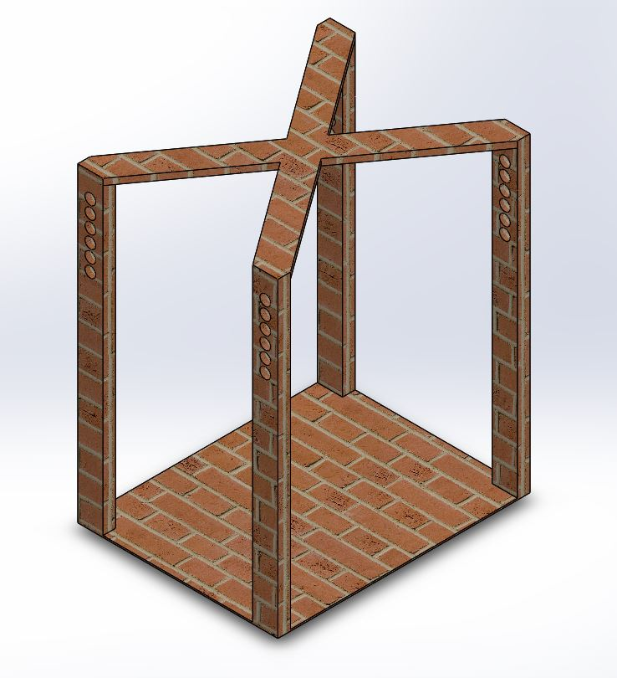
Figure 23: Second upright design consideration

The final alternative design the team considered is pictured in the figure above. Please note that the depicted upright is rendered in brick to help show some finer details of the upright, the actual design consisted of Douglas fir wood. Moving on, this design was first conceived after taking a stroll around the Spartan Superway headquarters. When the team was walking around, the expectation was to find excess materials floating around, and then seeing if the team can make something work from there. After a stroll, the team noticed an abundance of Douglas fir 2x4’s. After requesting permission, the team collected the materials and was able to put together a tentative design. That design is shown above, and the thought process was that the upright the team had designed is going to be cheap to make, easy to manufacture, and sufficiently strong for the purposes of the 11m track.
However, after an extensive conversation with Professor Furman about this design the team decided against it. Before, the reasons for denial are discussed, the initial design will be explained. The premise for this design was for the track to lay on dowels (clothes hanging dowels), and these dowels would have different holes they could fit into, as a result if the ground was not level or if there was an elevation change in the ground this would not affect the track itself and the bogie would simply travel through the middle of the upright. In addition, because of the adjustment capability of the uprights, the uprights could be mounted anywhere without really affecting the track. In other words, the room for which the 11m track resides is a courtroom with different ground elevations, and if this upright design was utilized, then the upright could rest on the raised portion and still allow the track to remain level. However, while this and a couple other features made this design great at first, Professor Furman quickly brought some important flaws in the design. For example, since this upright is designed to be modular and used on straights and turns, the upright has no cross bracing at the base, hence the centripetal force of 560 N would push the upright over. This is something that Professor Furman immediately brought to the team’s attention. Furthermore, Professor Furman also mentioned that the holes are a good idea, but the bogie cannot travel through the dowels if they go through both holes. This was a massive flaw in the design, so within one class session this idea was quickly scrapped for a better more improved design, the final design
Final upright design
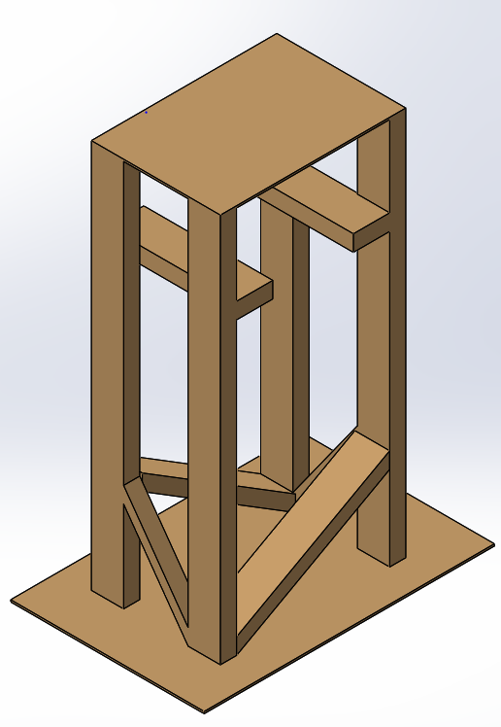
Figure 24: Final upright design

Pictured above is the final design for the upright. This design was checked off by all teammates, Professor Furman, and all advisors. To reiterate, the design goals for the upright are too: support a 560 N centripetal load, 400 N static load, handle bogie traveling at 6.7 m/s, be 0.91 m above the ground (3 ft), have a FOS of 2, and all these conditions must be met while deflecting less than 5mm. Now, this upright design works by having the track lay on the protruding pieces of 2x4 wood. Since the protruding piece (the ledge as the team calls it), has some thickness to it allows the track to be screwed to the ledge. In addition, the bogie will not get stuck on the track because there is space in the middle for the bogie to travel in, unlike the previous design. Furthermore, since the supports at the bottom of the track oppose each other, the upright will not twist under load. The base of the track is purposely wide than the base because there are many square pieces of that size not in use, so this will help with reducing cost. After each nut and bolt is accounted for, the final cost for this upright is $12. This $12-dollar cost is about half the cost of the first upright design. It is important to note, that the $12 cost assumes every everything is purchased out of pocket and not found in the Spartan Superway headquarters.

Final Upright Analysis

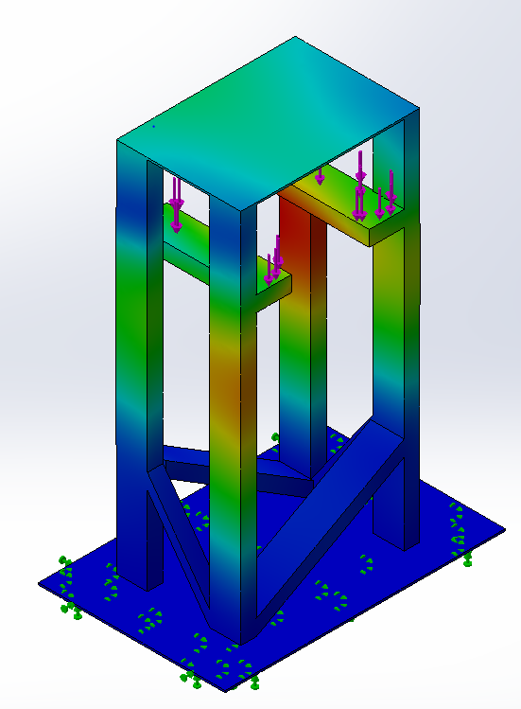
Figure 25: FEA of upright in static loading

In order to prove that the uprights would meet the team’s stringent requirements, a proper FEA model is needed (pictured above). Briefly, an FEA model is only as good as the input, an often-coined phrase is “garbage in, garbage out,” so it is important to discuss the way the model was constrained, and the way forces were applied. For this instance, since static loading is being considered, the base is fixed to the ground, this is to say that essentially the base plate and the ground are one unit. In real life the base plate will be concrete drilled to the floor, so it is safe to say that the ground and the base plate are one. Next, the force is applied directly to the ledge pieces as the track, and it is at that point that the simulation shows 3 mm of deflection. With the 5 mm goal, the FOS can be calculated to be roughly 2. Now, in this simulation the force was applied over the entire ledge and this would be correct and true for the straight sections of the track, but this is not true for the curved sections. In the FEA model, when the forces are applied it is difficult to apply a force to only one miniscule area of an entire ledge, so as a result, the team made an executive decision to not try and simulate the curved sections, but rather add two 2x4’s on each side to triangulate the uprights.

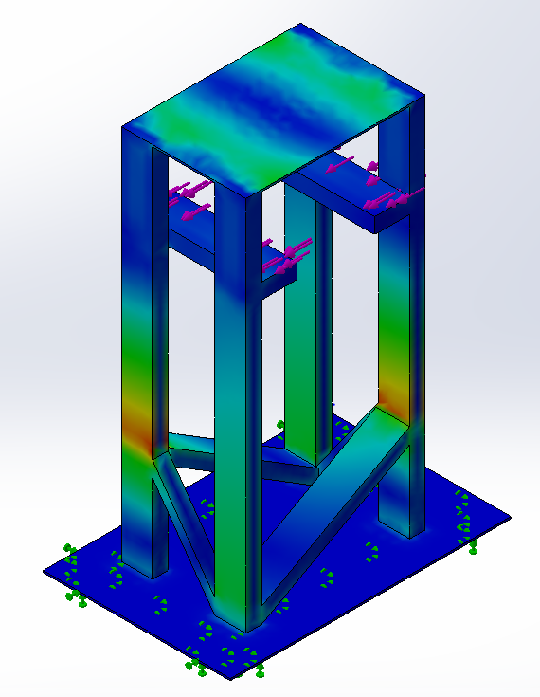
Figure 26: FEA of upright reacting to centripetal forces

Perhaps, the hardest simulation to run was for the centripetal forces. However, before the forces are discussed the upright was constrained the same as the static loading model done previously. The base and ground were considered one unit, hence being fixed. Next, the force of 460 N was applied to the side of the upright against the main 2x4 beams. In other words, the centripetal forces will be pushing outwards in the same direction. It is important to note that the forces are pushing more against the side primary beams than pushing downwards. Since, this upright is for a curved section (see figure: below), most of the force will be pushing against the side, so as a result of that ideology, the force in the FEA model was set to be pushing against the primary beam. In the end, the upright deflected 2 mm in the detrital direction. This 2 mm deflection was in the outboard direction and is different compared with the previous static direction. Lastly, it is important to notice the high stress colors of the upright when facing centripetal forces. Most specifically, earlier in the report it was mentioned that the cross bracing was there to resist torsion, in FEA model it is clear to see that the design works well because it reduces torsion in the high stress areas.

Bogie
Figure 27: Repeated picture to remind reader of upright and track integration

Overall the final design for the upright successfully fulfilled the design goals that the team set in place. It took the team a few iterations to produce a final form for the upright, but all worked towards a prime design. The analysis the team did through Solidworks Simulation proved to be beneficial, and it solidified the teams design, but there are some questions left about the design that need answering. The overall design is sound and will be functional in its current form, but some minor tweaks will take place after some real-life manufacturing.

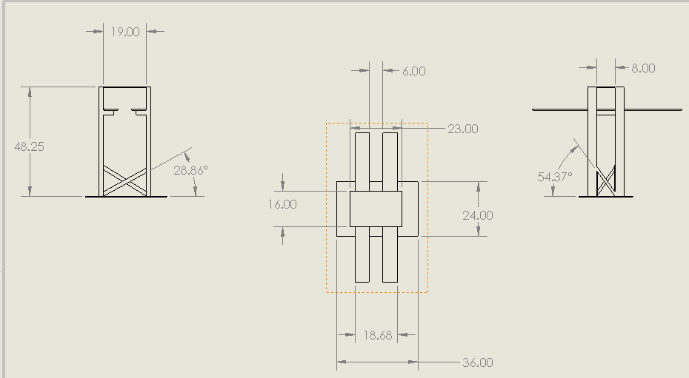
Figure 28: 2D drawing up final upright with straight track piece on top of ledge

The last step for the uprights is a final, highly detailed plan for manufacturing. In this figure above, the precise cut and angle for each piece is highlighted. In a test fabrication run (testing out ideal tools for certain manufacturing tasks), things like bandsaws, miter saws, and even hand saws were tested to see what would be the most ideal, and it turned out that using a hand saw turned out to be the easiest method. The primary reason the hand saw was better is because whenever power saws were used the wood would naturally heat up to the point of smoking, and that would leave a terrible smell in the room where the project resides. Many alternatives do exist, such as using a different blade and such, but ultimately, the hand saw is the easiest and “cleanest” method of cutting the wood. This decision can change for the future, but for now the team is sticking with hand saws.
Regarding materials, the Douglas fir 2x4 beams are stored all around Spartan Superway headquarters, recently, the team walked around and collected an enough for the uprights, so at this point the primary material is sorted. In addition, the hardware envisioned to fix the upright together is #6 2 ½” wood screws. The reason for using this specific size is based off of a recommendation from the Familyhandyman. In addition, wood screws are about $31 dollars for a pack of 500 versus $29 for the equivalent drywall screws (Home Depot). On paper a $2 dollar difference is not much for what is arguably a better product, however, after some research on from the FamilyHandyman, they report that although drywall screws might be cheaper and more readily available, wood screws have a higher shear stress resistance and since the top portion of the screw is not threaded, they are less likely to split the wood. Lastly, in addition to drilling the pieces of the upright together, each piece will be held together with wood a liberal amount of wood glue.

- Conclusions and Next Steps
All in all, the goal of this project is to supply a platform of testing for other sub teams such as Power Module and Wayside. Future teams for Spartan Superway will be able to take data using the 11-meter track. Variables of data will be noted as velocity, acceleration, position, and displacement of the bogie, in addition to noise levels and vibration of the track itself by sensors equipped on the track.
Next steps for the 11 meters track in the spring will be to finalize analysis on the FEA of the uprights and the track. Then the team will manufacture the rest of the track (switch track parts, straight track parts, etc.), and uprights will begin production in the spring as well.
- References
The Family Handyman. “Using Drywall Screws for Woodworking.” The Family Handyman, The
Family Handyman, 24 June 2019.
www.familyhandyman.com/woodworking/using-drywall-screws-for-woodworking/.
Niedbala, M., Smith, J., Sutherland, G., Himanshu, & Shelley. (n.d.). Douglas-Fir. Retrieved
from https://www.wood-database.com/douglas-fir/.
Taylor, M. A. P. “Accessibility Methods.” Vulnerability Analysis for Transportation Networks,
09 June 2017. Web
https://www.sciencedirect.com/science/article/pii/B9780128110102000058.
Fleming, S. “World Economic Forum” Traffic Congestion Cost. 09 March 2019. Web
https://www.weforum.org/agenda/2019/03/traffic-congestion-cost-the-us-economy-nearl-
87-billion-in-2018/.
Retallack, A. E., & Ostendorf, B. Current Understanding of the Effects of
Congestion on Traffic Accidents. 13 September 2019. Retrieved from:
https://www.ncbi.nlm.nih.gov/pmc/articles/PMC6766193/.
Twardy, S. Greenhouse Gases Effect on Global Warming. 7 September 2007. Retrieved from.
https://svs.gsfc.nasa.gov/20114.
EPA - United State Environmental Protection Agency. “Sources of Greenhouse Gas Emissions.”
13 September 2017. Retrieved from.
https://www.epa.gov/ghgemissions/sources-greenhouse-gas-emissions.
Djurkovic, N. Car Surance. “Car Accident Statistics.” 06 December 2019.Retrieved from:.
https://carsurance.net/blog/car-accident-statistics/.
FURMAN, B. U. R. F. O. R. D., ellis, sam, fabian, L., muller, P., & Swenson, ron. Automated
Transit Networks (ATN): “A Review of the State of the Industry and Prospects for the
Future.” 16 January 2018. Retrieved from:
https://transweb.sjsu.edu/research/automated-transit-networks-atn-review-state-industry-
nd-prospects-future.
- Appendices

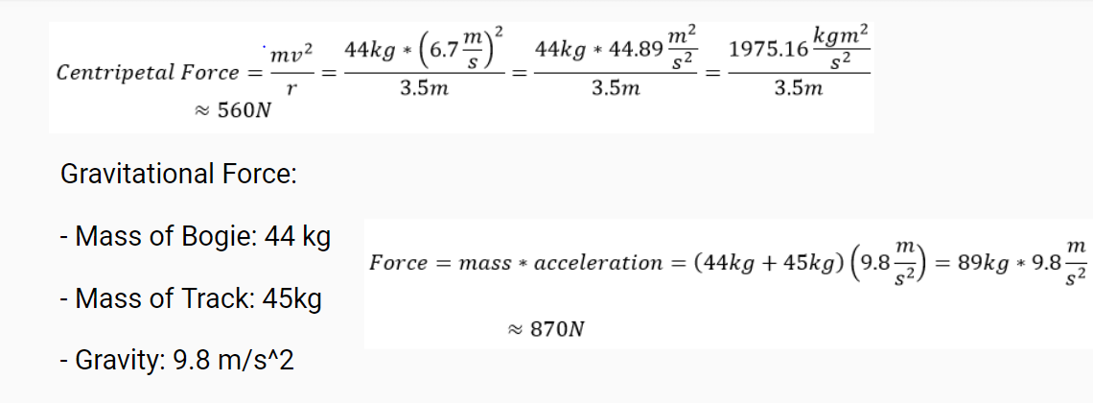
Figure 29: Force Calculations

Name | Quantity | Cost per Unit | Total Cost (w/o tax)
2 x 4 Douglas Fir Wood | 40 | $24 | $960
Gorilla Glue - 62000 | 5 | $5 | $25
2.5 x ½” Wood Screws | 100 | $10 | $50
Waterjet Abrasive Bags | 5 | $50 | $250
 |  |  | $1285

Figure 30: Bill of Materials

Common Name(s): | Douglas-Fir
Scientific Name: | Pseudotsuga menziesii
Distribution: | Western North America
Tree Size: | 200-250 ft (60-75 m) tall, 5-6 ft (1.5-2 m) trunk diameter
Average Dried Weight: | 32 lbs./ft³ (510 kg/m³)
Specific Gravity (Basic, 12% MC): | .45, .51
Janka Hardness: | 620 lb_{f} (2,760 N)
Modulus of Rupture: | 12,500 lb_{f}/in² (86.2 MPa)
Elastic Modulus: | 1,765,000 lb_{f}/in² (12.17 GPa)
Crushing Strength: | 6,950 lb_{f}/in² (47.9 MPa)
Shrinkage: | Radial: 4.5%, Tangential: 7.3%, Volumetric: 11.6%, T/R Ratio: 1

Figure 31: Datasheet of Plywood

