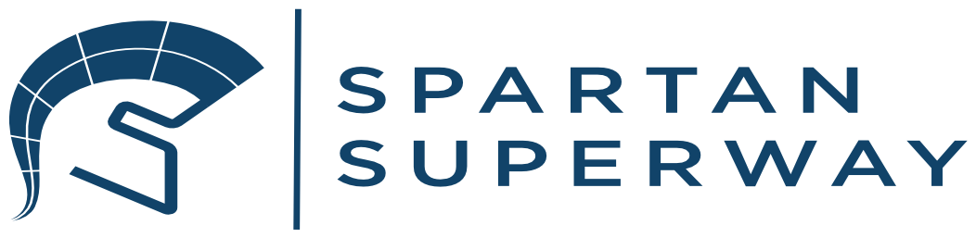
A Solar Powered Automated Transportation Network: Full-Scale Guideway Team
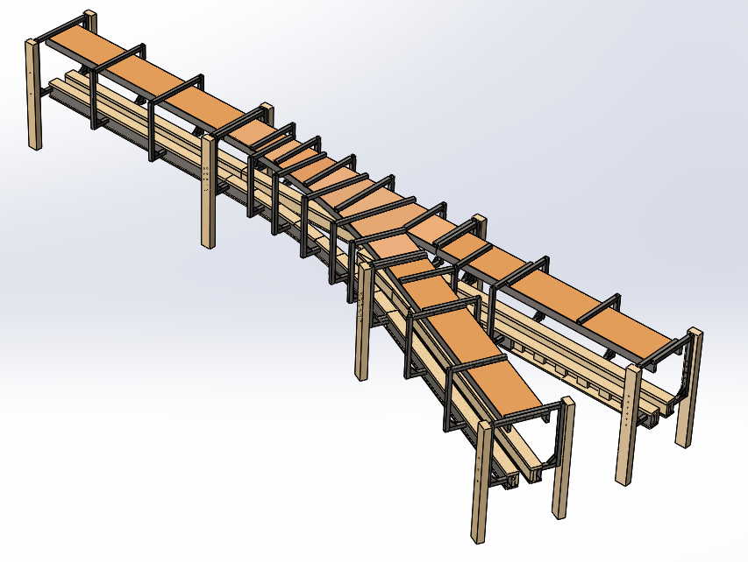
San Jose State University
Mechanical Engineering Department
ME 195B Final Report
May 19, 2019

Advisor:
Dr. Burford Furman
Authors:
David Bunker
Evelia A. Leyva

Abstract
The SPARTAN Superway is an innovative idea that proposes a futuristic approach to public transportation. Instead of adding transportation solutions on the ground, this project offers to install a structure that is positioned above the sidewalks. Furthermore, one of the main purposes of this system is to implement a self-sustaining structure that is both aesthetically pleasing and environmentally friendly. This Senior Project has been in the works for the last seven years and aims to provide cities like San Jose a solution for their transportation issues. This year, the project consists of eleven groups, six of which depends directly on the Guideway team. The teams that were in direct contact with the Guideway team were all of the full-scale teams, from the Bogie teams to the Solar Power team. The focus of the project this year was to re-design and implement a junction using a previous year’s design as inspiration. This year’s goal was to redesign the track, a third rail system as well as a smaller junction system.
Since this year it was decided that we would continue on from previous years, we began by focusing our attention on rebuilding any documents we found corrupted. Initially, we began by continuing with the design inspired by Futran but this was changed in the Spring semester. Since we had to move from facilities, our time was cut in half and we decided instead to continue on with a new design that depended on 2013-2014’s track design. The work was split in between the two of us to complete the junction and the third rail. The third rail went through five different iterations in order to find the best design. The junction went through a couple of revisions before it was designed in order to save us time. The track was redesigned in order to find a better suited design for the Bogie teams while being easier to manufacture. We wanted to make sure that the gap between the tracks was kept a little wider so that the Bogie teams would be able to mount their parts without conflicts. Throughout the semester we ensured that we maintained in close contact with other teams to ensure that everyone’s designs coincided. To end the year, we were able to build a good portion of the track as well as weld everything that was needed for the junction. We were very fortunate that Master Metal was able to donate all the new metal components that we designed for the system since we wanted to ensure that it would be made of metal.
To demonstrate our understanding, we presented our progress five times to the project teams and advisors. Within these presentations we included FEA and all 3D models we created as well as all the different renditions the track went through. We were able to finish up the semester satisfied with our work and findings. Every design that was created was compared to another in order to find the best option for our models. We wanted to ensure that by the end of the semester we would have a functioning junction as well as stable third rail design. Both of these were implemented successfully. Since we were able to manufacture our parts and get past half of the building, we were satisfied with our performance for the school year and are hopeful that our track design will be the final one. We would highly recommend future students to secure manufacturing/sponsors within the first semester to avoid setbacks.

Acknowledgements
We would like to thank Dr. Furman and Master Metal Products for sponsoring this project and allowing us to jump on and input our ideas. We would also like the thank Ron Swenson for his helpful feedback and help; he was always open to new ideas. We would also like to thank Futran for allowing us to take inspiration from their design. This project allowed us to present our ideas and expanded our understanding of the real world of engineering. We are thankful for the opportunity presented to us in this Senior Project.

Sponsors: Master Metal Products, SJSU Associated Students, SJSU College of Engineering

Table of Contents
Abstract 1
Acknowledgements 2
Table of Contents 3
Executive Summary 6
Introduction and Objectives 6
Procedure and Results
Conclusions and Recommendations 9
Introduction 9
Background of Guideway Team 13
Project Description & Objectives 15
Objectives 16
Design Requirements & Specifications 16
Specifications 18
Literature Review (State-of-the-Art) 18
Description of Final Design 20
Analysis & Validation 23
Budget 27
Results & Discussion 29
Conclusions & Suggestions for Future Work 29
Conclusion 29
Suggestions for Future Work 30
Conclusions & Future Recommendations 31
References 32
Appendices 33

List of Figures

Fall 2018 Track Design 7
Spring 2019 Track Design 7
Fall 2018 C-Shaped Track Design 7
Spring 2019 Track Design to Resemble 2018 Design 7
Third Rail Design Spring 2019 8
Segmented Track Rendition 8
Pod-Car Rendition (Bogie Design) 11
Bogie Mounted Onto Guideway 11
Small-Scale Track Design (circa 2015) 12
Half-Scale Track Design (circa 2016) 12
Full-Scale Track Design (circa 2017) 12
Full-Scale Design (circa Fall 2018) 14
Finalized Design 14
2013-2014 Guideway Design 19
Finalized Design 19
Fall 2018 Dimensions 20
Spring 2019 Dimensions 20
CAD Rendition of Junction Support 21
Junction Support 21
Alternative Junction Support 21
Fall 2018 Third Rail Design 22
Spring 2019 Third Rail Design 22
Manufactured Third Rail 22
FOS Obtained 23
Displacement of Third Rail 23
Von Mises Stresses 23
Displacement of Junction Support 24
FOS of Junction Support 25
Von Mises of Junction Support 26
Fall 2018 Budget 27
Built Track 30
Mounted Segmented Track 30

List of Tables

Budget 27

Executive Summary

Introduction and Objectives
The Spartan Superway was created with the intent of providing a sustainable solution to traffic congestion and pollution found in cities like San Jose. In order to achieve this, the Spartan Superway has designed a transportation system that would be built directly above of city sidewalks. This would remove citizens from the streets and would provide a means of transportation that would be both quick and sustainable without interfering with the existing right of ways of roads and railways. The Superway would be available 24/7 since the system is completely automated. The Full-Scale Guideway Team was in charge of designing the track system on which the Bogie would travel on. This team’s work is essential to the overall model because the bogie and its components will be presented on the guideway. To provide a successful design, this semester was dedicated to finalizing all designs to then perform FEA. When the design was approved of from all teams, the guideway components were manufactured and built. The final design was a track assembly that included a junction as well as the third rail. For the final results a straight portion of the track with a small portion of the junction. The curved portion of the third rail was properly mounted and a good portion of the wood was finished.

Procedure and Results
For this semester, our team decided to redesign and modify the track we presented the previous semester (Fall 2018). The reasoning behind this was the fact that the moving of facilities caused us to lose a lot of time. Since the original track was disassembled, we decided to use the track that was made for 2014’s design. The two designs for both semesters is shown in figure 1 and 2. The new track design was much simpler and lowered our budget drastically since it was previously manufactured and made.
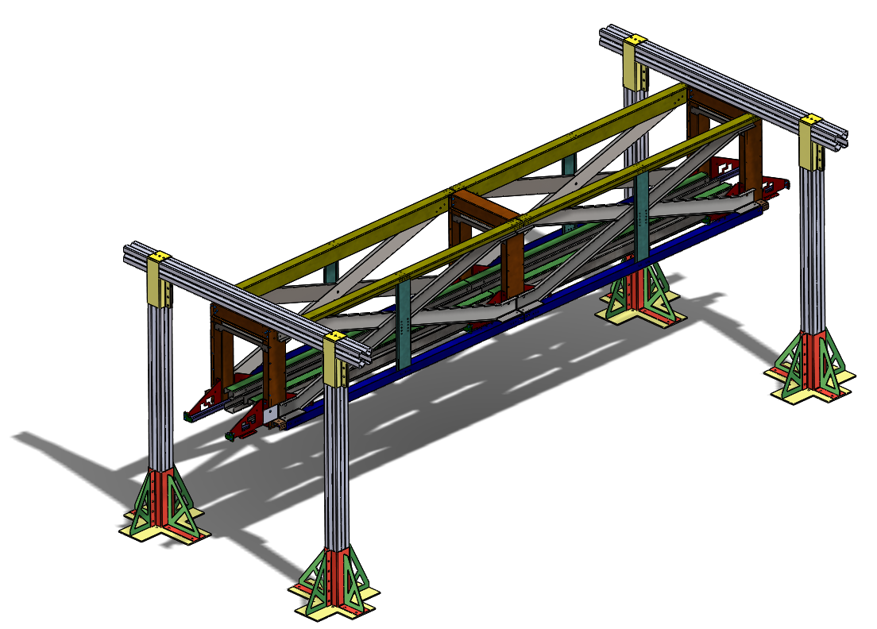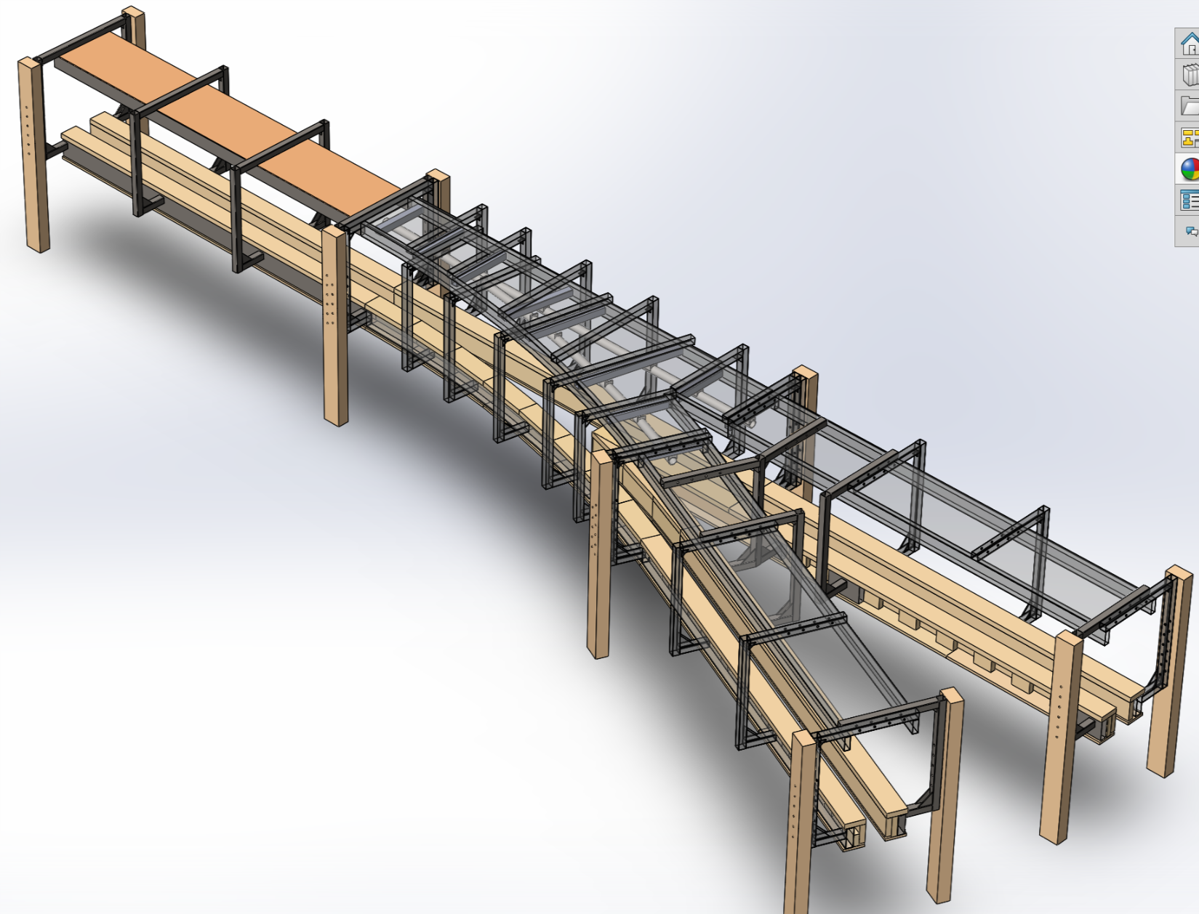
Figure 1 (left): Fall 2018 track design
Figure 2 (right): Spring 2019 track design (clear top showcases third rail, should be wood)

Since the Fall 2018 track was composed of a track shown in figure 3, the new design also implemented a similar shape (figure 4). The difference between the tracks is that the new design is made of wood rather than metal and it will be ideally be surrounded with Aluminum sheet metal for emergency braking applications. As stated previously, the new design decreased the budget drastically and allowed for more money to be spent on perfecting the third rail. Since our goal for the year is to design the junction, bending of the track was essential. We decided that the radius of turns would be kept at 8 meters. However, we also designed a segmented track that would be used in case the manufacturing cost for bending was too high. The new design is made of wood, so it will be cut very similarly to figure 5. The idea behind the segmented track was to piece together the pieces to resemble the curve needed, similar to how stone archways are constructed.
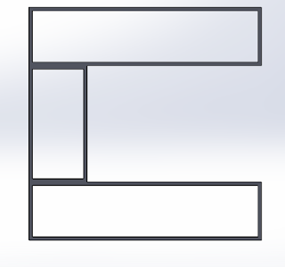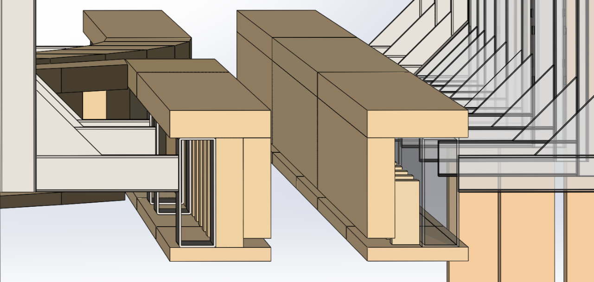
Figure 3 (left): Fall 2018 design for the track; consists of three separate beams (c-shaped)
Figure 4 (right): Spring 2019 finalized track design
Figure 5 (below): Segmented track rendition
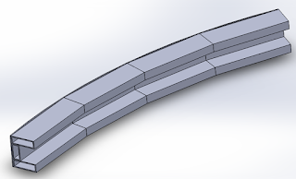
Finally, we also needed to design a functioning third rail that would help support the bogie switching wheels; facilitating the turning for the bogie. This third rail went through five different designs; each design had FEA performed on it and then compared. With a factor of safety of 19 and displacement at less than 1-mm, we found that a tube design would do the trick for our third rail. Figure 6 below shows the final design for the third rail that was manufactured and donated by Master Metal Products.
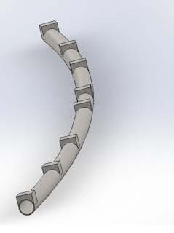
Figure 6 (above): Third rail design that was manufactured

Conclusions and Recommendations
The focus of this semester was to split the work in between the both group members and redesign the track system. Using 2013-2014’s track design, we implemented our ideas to create a new rendition of the track and junction. The new design was much simpler and would require less time to assemble and disassemble. However, too much time was lost due to the fact that we had to move facilities at the beginning of Spring semester. The original wooden track was disassembled, forcing us to start again with the new design. The goal by the end of the year was to implement a successful design as well as get manufacturing finished. We hoped to build the track in time for the final presentation but due to several issues that arose throughout the semester, this was not entirely possible. Communication and outreach were essential to ensure that the bogie system would be able to correlate with the track without issues. If we could recommend anything for the coming students, we would recommend to secure manufacturing during the first semester to avoid issues further down the line.

Introduction
As stated multiple times, the SPARTAN (Solar Powered Automated Rapid Transit
Ascendant Network) Superway is meant to be a transportation solution within urban environments. By relying solely on solar powered energy, the system would run on nothing but clean energy. Since there is no requirement for fossil fuels, the system would remain open to the public and would get them across the city within minutes. With the system being lifted above the ground, it would not require too much space nor its own road. Moreover, there would be no traffic due to the elevation, making traveling within the city much quicker and safer. The system is automated, meaning that there is no human driver necessary to transport users. Since the system is automated, the Superway would be available 24 hours a day, 7 days a week. Passengers would not have to worry about being late as there would be no stops along the way and would instead lead them straight to their destination. The Superway could be the future of transportation as it produces no pollutants, helps relieve traffic congestion and reduces on-ground safety hazards such as car accidents. Cities within the Bay Area could benefit greatly from a system like this within their streets.
Moreover, this project was created with the Automated Transit Network (ATN) key features in mind. The ATN key features are as follows (ATRA, 2017):
- Direct origin-to-destination service with no need to transfer or stop at intermediate stations
- Small vehicles available for the exclusive use of an individual or small group traveling together by choice
- Service available on demand by the user rather than on fixed schedules
- Fully automated vehicles (no human drivers) that can be available for use 24 hours a day, 7 days a week
- Vehicles captive to a guideway that is reserved for their exclusive use
- Small guideways (narrow and light relative to light rail transit (LRT) and bus rapid transit (BRT)) that are usually elevated but that also can be at or near ground level or underground
- Vehicles able to use all guideways and stations on a fully connected network

The Superway is automated in order to get the passengers from point A to point B without any stops, satisfying (1). The Superway Bogie was designed to only carry one person or a very small group of people as seen in figure 7, satisfying (2). Again, the system is completely automated, allowing the user to hop onto a bogie without relying on a schedule, satisfying (3) and (4). The Superway also relies predominantly on the simple, lightweight track design used for this specific system, satisfying (5) and (6). Finally, this year’s track design, bogie design and bogie components had to come together as one as shown in figure 8, satisfying (7).
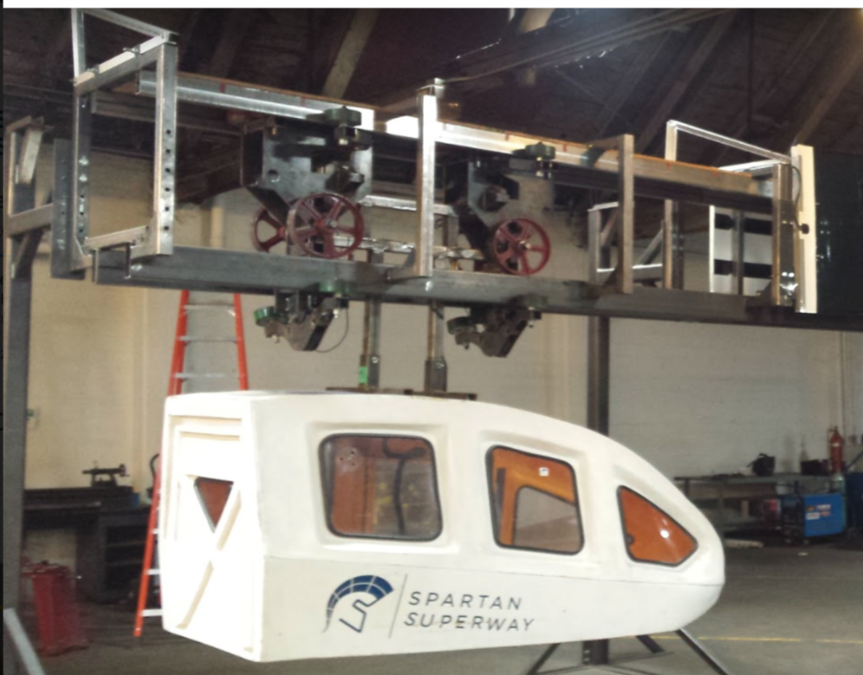
Figure 7 (above): Possible pod-car design used to transport passengers
Figure 8 (below): Bogie mounted onto track
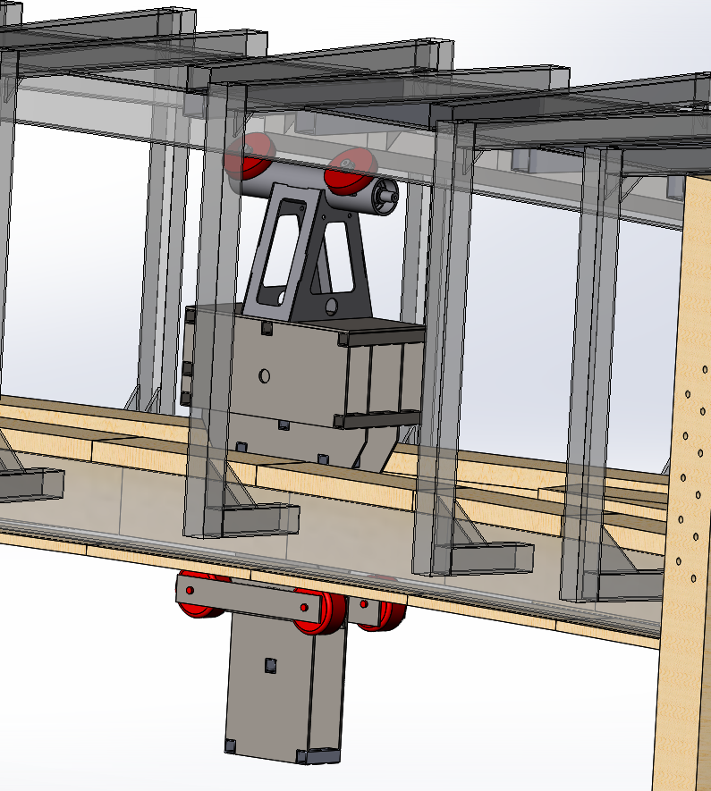
In accordance with the Mineta Transportation Institute, only five ATN operational features are found around the globe. Many of these systems have been successfully implemented and used, but each lacks in one ATN key feature each and every time. Due to how relatively new the ATN industry is, commercialization is not expected soon as there are only a handful of supporters who see the true potential of the industry. However, this industry holds potential due to its benefits and sustainability. If a system similar to the SPARTAN Superway is implemented within a city, traffic congestions and harmful emissions are expected to decrease drastically.
Furthermore, San Jose State has committed itself to create an ATN/PRT system that relies on renewable resources for the past seven years. The SPARTAN Superway is an interdisciplinary team initiated in 2012 by a group of roughly 30 students. Initially, the Superway was dependent of students of multiple backgrounds (Mechanical, Civil Engineering, Software Engineering, Business, Urban Planning etc). Over the past seven years, this Senior project has produced small-scale proof of concept, half-scale operating system and full-scale designs presented at Maker Faire 2013-2018. Figures 9-11 show progress that has been made throughout several years. With the constant guidance from Ron Swenson and Professor B. Furman, the SPARTAN Superway has flourished and is hopefully in its final stages. The Superway is meant to provide a clean energy transportation solution for urban cities and this Senior project aims to implement that solution.
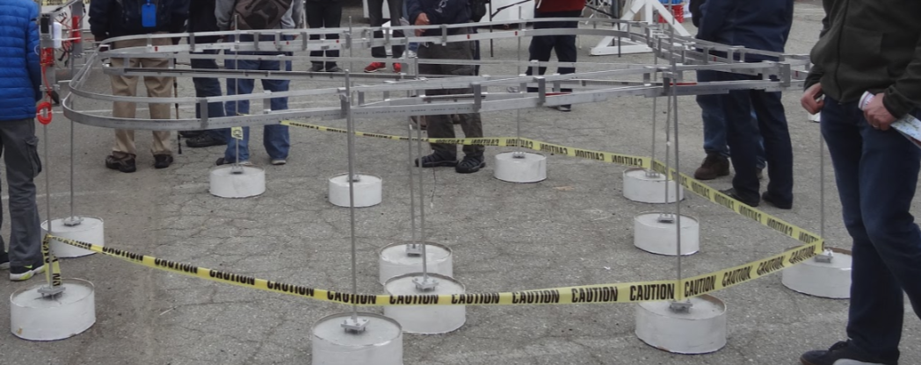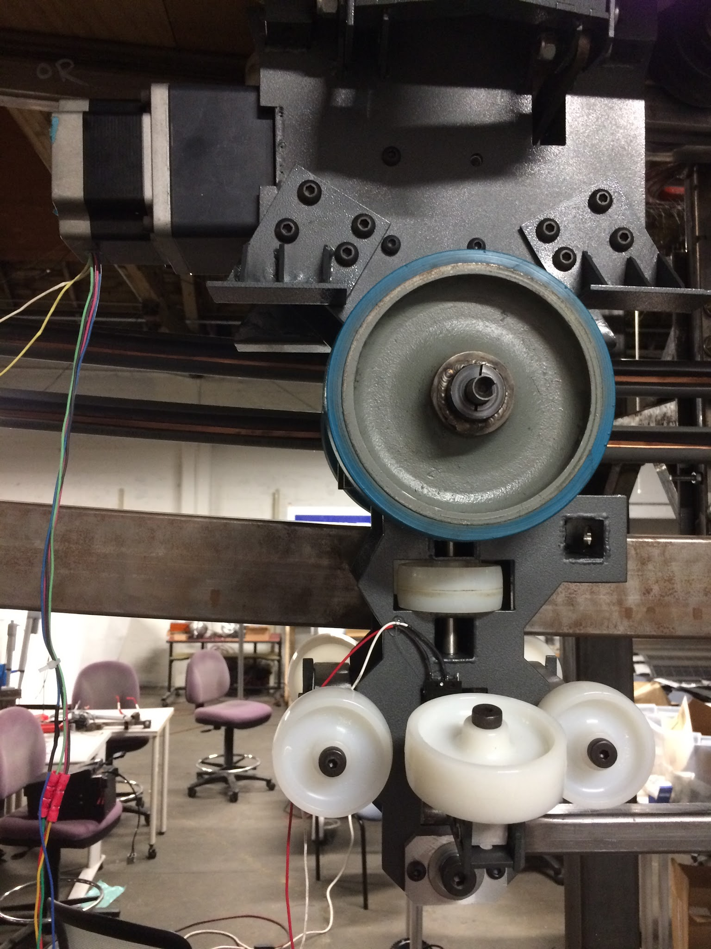
Figure 9 (left): Small-Scale track design made 2015
Figure 10 (right): Half-scale track/bogie design made 2016
Figure 11 (below): Full-Scale design made 2017
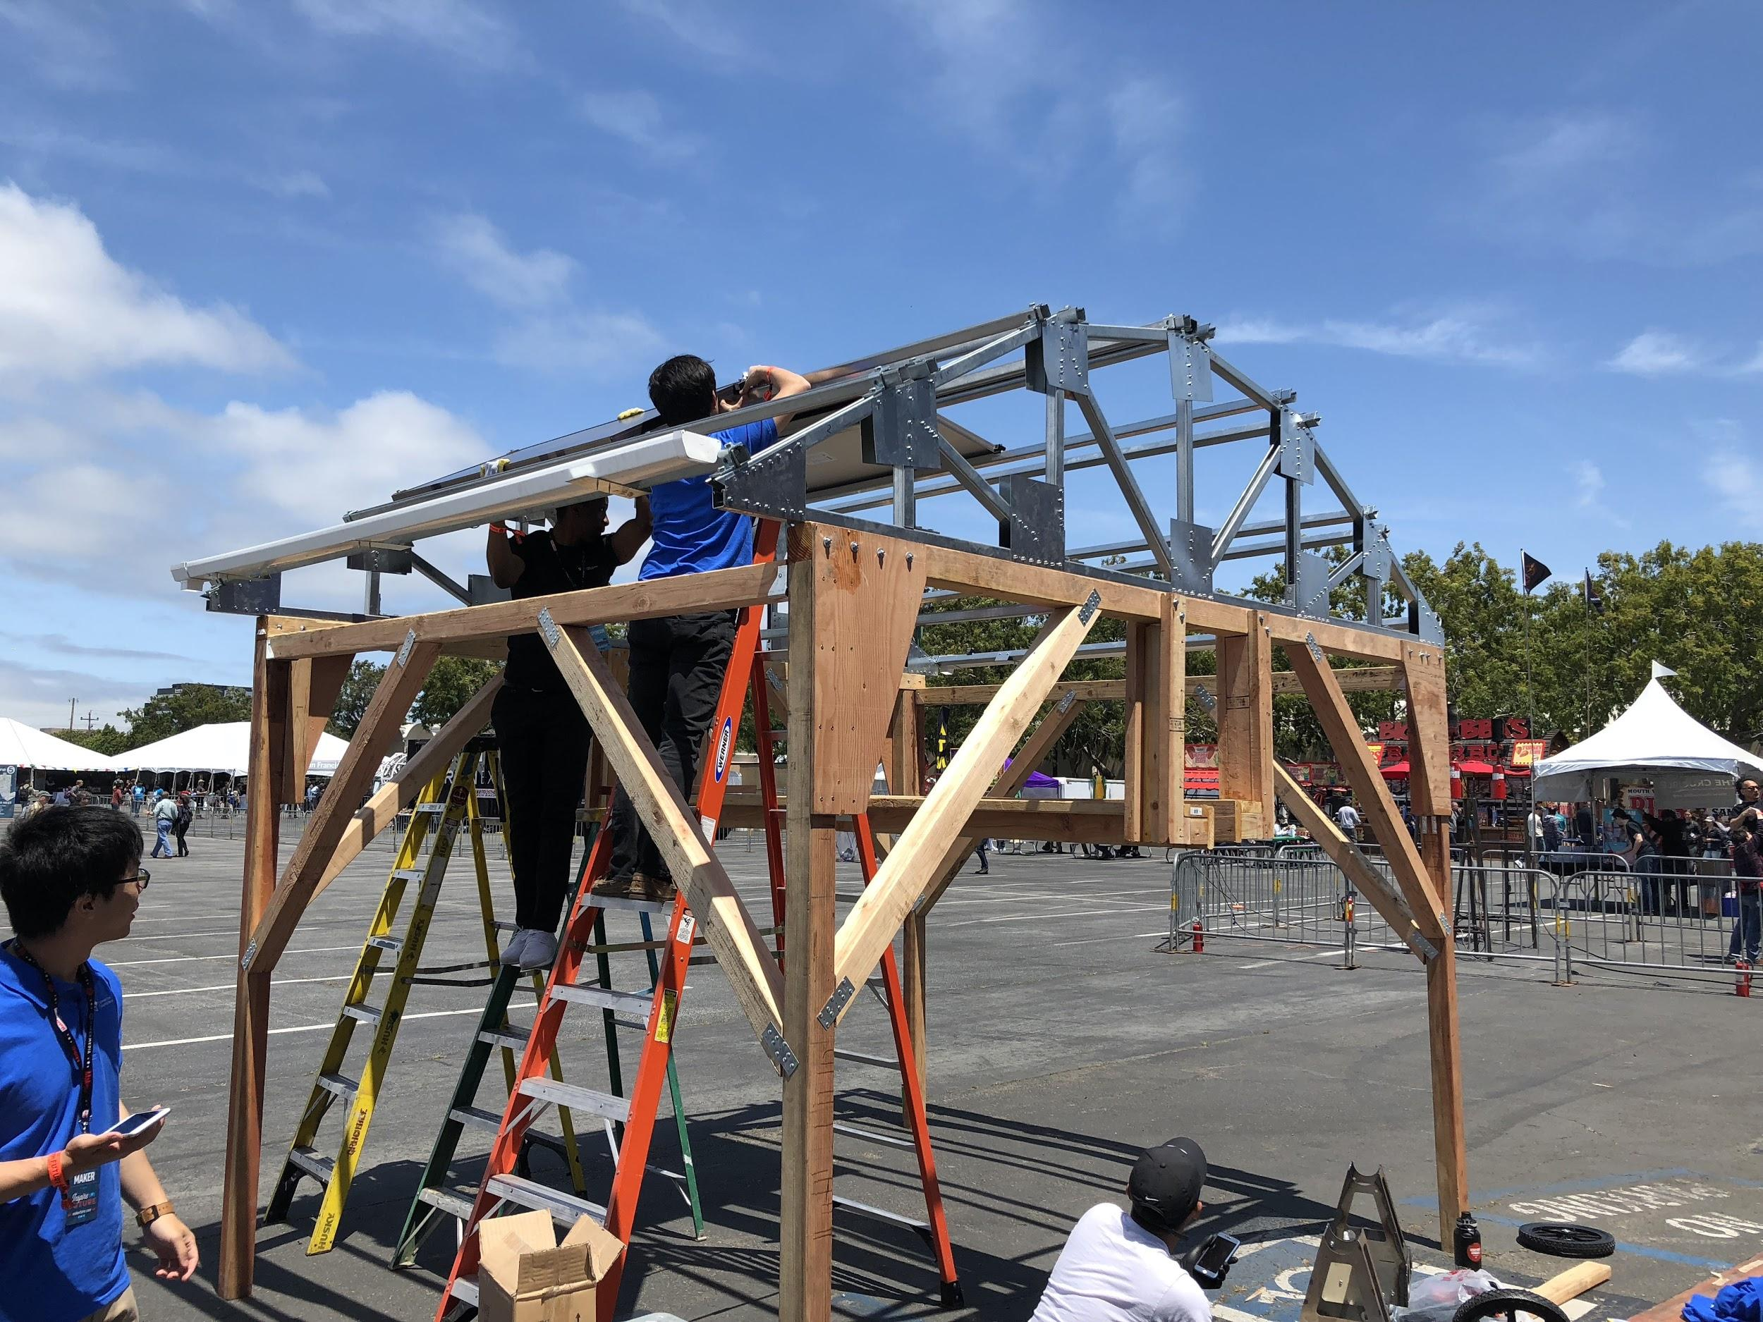
In the following sections, we will begin by describing our latest design and why it differed from our Fall 2018 design. Then, the objectives we had set early on last year will be listed as well as the progress that was made for each. Our design requirements and design specifications will also be stated and commented upon. This report will also explore the inspiration behind this ATN system as well the research that was done to finalize its design. All analysis/testing will be included to provide proof of concept as well as the estimated budget that was calculated for the school year. In conclusion, we will discuss our results as well as the recommendations we have for following years.

Background of Guideway Team
The guideway system is essential for the overall success of the SPARTAN Superway. The bogie system along with all of its components depend on a guideway that is stable enough to withstand their weight while simultaneously providing a comfortable ride for the user. Since the straight section of the guideway has been built in previous years, the goal for this year was to design the junction portion of the system. The junction was in need of support as previous designs had failed to render a stable model. David took charge of creating an innovative junction support design, which can been seen in figure 12. Furthermore, the guideway was also in need of a third rail system to aid the switching mechanism on the bogie as well as provide extra support at the junction split. Evelia took charge of designing the third rail, and after five renditions, a tube-shaped rail was chosen (figure 6). These designs were shared with the full-scale teams to ensure that their components would integrate onto the track with ease. We were aware that the previous year’s track and bogie designs were not compatible after manufacturing, causing the teams to change their dimensioning last minute. In order to avoid making the same mistake, we kept in communication with each team by constantly updating them on any change that was made. We were able to create two finalized designs by the end of each semester, both of which included the junction and third rail design solutions. However, after the move of facilities and the disassembly of wooden track, we decided to take the 2013-2014 design and implement our ideas onto it. The final design that was chosen can be seen in figure 2; figure 13 shows the third rail mounted onto our system as well as a glimpse of the junction support.
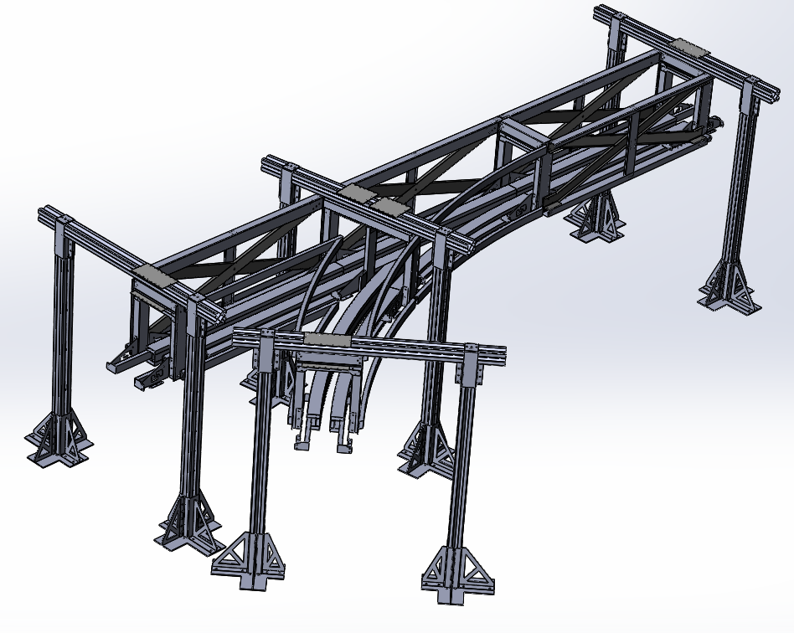
Figure 12 (above): Full-Scale design made Fall 2018
Figure 13 (below): Finalized design with third rail and junction support

Project Description & Objectives
For the academic year of 2018-2019, the Guideway team was composed of two members. Due to this, it was decided early on that all work would be equally distributed between both students, David and Evelia. David took lead on the designs and focused his attention on the junction design. Evelia took lead of the FEA and took focused her attention on the third rail design. However, both students took equal responsibility for manufacturing and building the track system. Most of the work consisted of rendering several different designs to compare which would be the optimal design.
Despite having to start over Spring 2019, files from the 2013-2014 school year were graciously provided by Dan Espinoza. Due to this, time management was optimized and both members worked together to add their renditions to the system. When FEA was performed and the design was confirmed, we reached out to several manufacturing companies. Part of our system was reliant on metal parts, especially the third rail. Fortunately, Master Metal Products decided to donate the metal parts along with the third rail. This was essential to the project as previous years had mentioned that a wooden third rail would fail. Since Master Metal was able to manufacture the parts out of metal, we felt much more confident with our finalized product. Moreover, both members kept in constant communication with one another and collaborated on assignments (team blogs, designs, FEA). The team also kept in constant communication with the other teams through group messages in “Slack” as well as in person. For this Senior Project, communication was key.

Objectives
For the 2018-2019 school year, the Full-Scale Guideway Team focused its attention on several things. First of all, a junction support system was needed in order to properly model and use a junction rather than just a straight section of track. Within this, a new track design was made and the radius of curvature was set. Since the junction ties in with the curving portion of the track, this objective tackled two things at once. Secondly, the implementation of a third rail system was very important. The third rail would assist the bogie in choosing a direction as well as taking some of the load in order to provide a safer and more comfortable ride. The design and implementation of the third rail needed to coordinated with the bogie teams in order to assure that all of the pieces came together as one. Thirdly, the team wanted to keep the design as close as possible to previous renditions. Ideally, the track system should be made of metal to ensure a strong structure. However, the final design was made of both wood and metal in order to drastically reduce overall costs. Lastly, communication was key; by keeping in close touch with other teams, the team was able to implement a track that would benefit everyone. In retrospect, our objectives were:
- Design the junction system on the track to provide a stable junction model
- Design the curved section of the track to ensure passenger comfort
- A third rail will be design and manufactured to ensure switching support for the bogie
- We will collaborate with other full-scale teams to ensure support of the bogie

By the end of the Spring semester, we were both very satisfied with our productivity and ability to tackle each objective successfully.

Design Requirements & Specifications
The primary goals and objectives of the SPARTAN Superway guideway team are specified in the list below. These requirements are predominantly based on the Automatic Transportation Network (ATN) key features. The ATN key features are further explained in the Literature Review section below. Moreover, the requirements presented below are also based on the work of numerous students over the years. As has been stated, the 2013-2014 track design was used as inspiration because it was already built.
- The SPARTAN Superway guidway shall be an urban structure that is both slender and aesthetically pleasing
- The guideway shall include a junction section to allow the bogie to turn. The junction section must remain stable and must support the weight of the bogie without issue. The junction section must be supported properly.
- The guideway shall have a third rail support system to help the bogie switch directions. This third rail must be able to support the bogie without issue. It must also be made out of metal as a wood rendition is not strong enough (Summer 2018)
- Dimensioning should remain consistent throughout the year. By maintaining constant dimensions on the guideway the bogie teams will not have to alter their design multiple times.
Specifications
Design specifications were also set early on in the Fall semester. Below are the specifications:
- The turn radius must be 8-m
- The third rail must begin 0.3-m before the junction or turn
- The third rail must coincide with the switching wheels
- The third rail must hang at about 1” from the top
- Bogie will weigh 2400-kg in the real world
- The Solar Panel Truss System will weigh a maximum of 350-kg
These specifications were brought about through discussion between the teams and within the Guideway Team. After the previous year’s report was regarded, the Guideway Team needed to decide what this year would be focused on. The design specifications were all met by the Guideway Team by the end of the semester.

Literature Review (State-of-the-Art)
Automated Transit Networks (ATN) and Personal Rapid Transit (PRT) can both describe a mode of transportation that is driverless. Unlike city buses or the CalTrain, both ATN and PRT deliver users from one location to the next without any stops along the way. This mode of transportation is rarely implemented, but when it is, the results are positive. As of today, five main PRT systems exist around the world; for instance Masdar City PRT in Abu Dhabi, Morgantown PRT at West Virginia University, the Terminal 5 shuttle in Heathrow Airport, Rotterdam’s nearby Park Shuttle, and the nature park shuttle in South Korea. Moreover, ATN systems are known for the fact that they are not tied to a set schedule in the same way that other transportation methods are. Because of this, ATN systems would be considered a 24/7 service for every kind of person; whether they are alone, in a group, disabled, old or young, they will be able to use this service as needed (ATRA 2017). Moreover, the ATN key features the the guideway team focused on were: Small guideways usually elevated but also at or near ground level or underground (narrow and light relative to LRT and BRT); vehicles captive to a guideway that is reserved for their exclusive use; and vehicles able to use all guideways and stations on a fully connected network.
Keeping this idea in mind, San Jose State University began contributing to ATN technology through the start of the Spartan Superway. This project was offered as a Senior Project for both engineering and business majors, urban planning students and volunteers. In 2012, the Spartan Superway became an official project under the careful eye of Dr. Burford Furman and Ron Swenson. During the course of seven years, the project grew and developed into the final stages. After the seventh year, the project showed promise of being finished soon and become a part of history for the city of San Jose.
During the 2012-2013 academic year, the team flew out to the Podcar City Conference in Washington DC, where they earned first place for their twelfth scale prototype. In 2013-2014, the team attended Maker Faire 2014 and Intersolar 2014 where they presented a 16ft (5m) full-scale straight section of the guideway. During the 2014-2015 academic year, the team used a motorized switching mechanism patented by Beamways that was integrated into the bogie, the twelfth scale model not had control software, and various improvements were made to the cabin, suspension, and controls systems. Concepts for a 65ft (20m) half scale model capable of switching tracks, going up and down a slope of 30%, were created in the 2015-2016 academic year. The focus also shifted towards a smartphone user interface designed by software engineers that was able to mimic the way a user would actually interact with the system. The previous two years (2016-2017, 2017-2018) the team was able to introduce the concept for the third rail, junction, and a partnership with Futran/Milotek. This latest academic year focused more on wrapping up what previous years had done. The Guideway Team focused their attention on the junction and third rail in order to start finishing up the project. Other teams began focusing their attentions on the aesthetics, functionality and scalability.

Description of Final Design
The Spring semester design has been very different from the Fall semester design. Since the facility in which the Superway began was taken back by the owner, we had to move all supplies over to a new facility. The wooden track that inspired the Fall semester design was disassembled and the only track that was left was the 2013-2014 design. In consequence, we both decided to take this track and modify its design to fit our design requirements and specifications. Both the old and new track are pictured in figures 14 and 15 below. The goal was to ensure that the third rail system as well as our proposed junction system would be added to the track. The main goals last semester were essentially the same but instead with the Futran-inspired design.
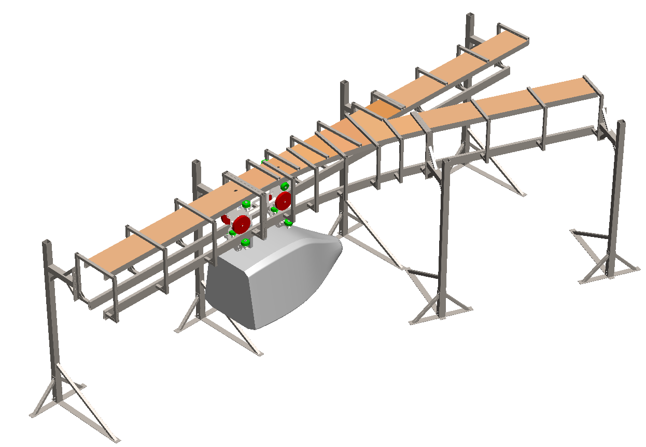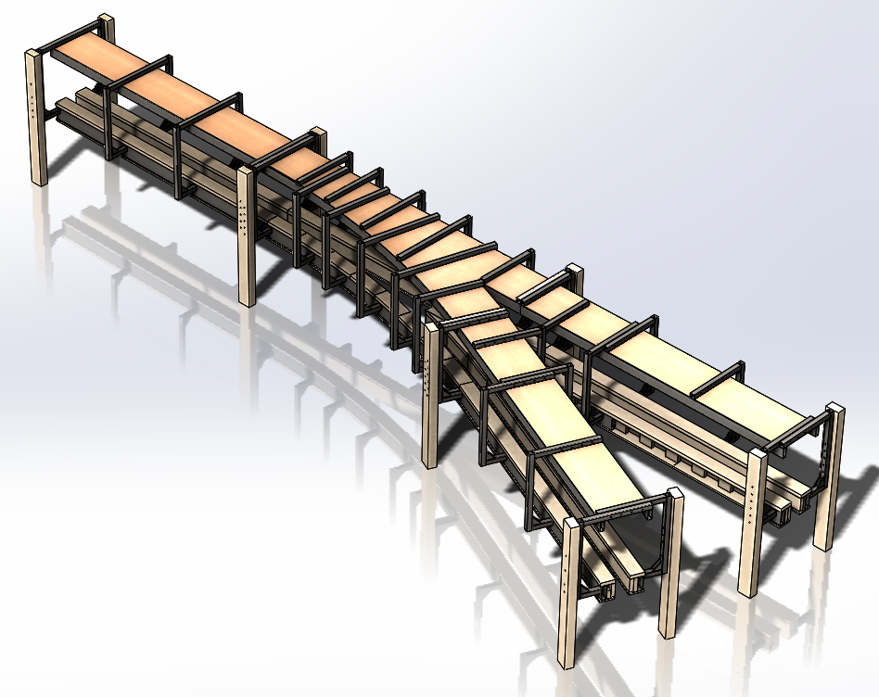
Figure 14 (left): 2013-2014 guideway design
Figure 15 (right): Proposed spring design

The track from the previous design was altered to resemble our previous track design. The reasoning behind this was that we needed to maintain similar dimensions in order to decrease the changes in design for the bogie teams. Our track design was the only design that drastically changed, therefore we wanted to make it as easy as possible for other teams. Figures 16 and 17 compare the dimensioning between the two track we designed.
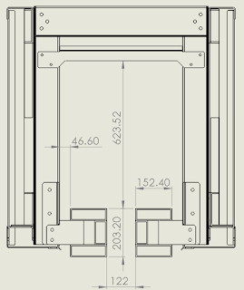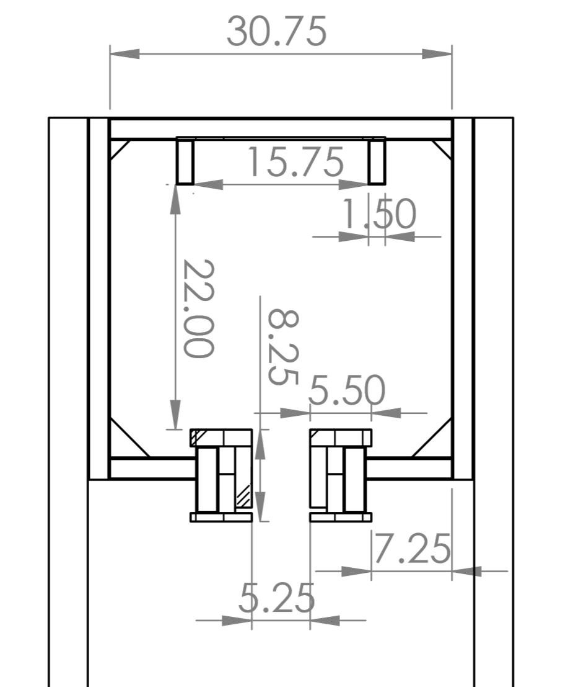
Figure 16 (left): Fall 2018 dimensions
Figure 17 (right): Spring 2019 dimensions

Furthermore, the junction support system was also designed. Since previous years had failed to design and build a proper and stable junction system, we provided a possible solution. Figure 18 below showcases the junction support design that is meant to stabilize the junction as well as provide support for the guideway. We were able to manufacture these supports out of metal thanks to Master Metal Products. Figure 19 showcases the supports after David welded the pieces together. Figure 20 showcases an alternative junction design. However, this design was too costly therefore it was put aside.
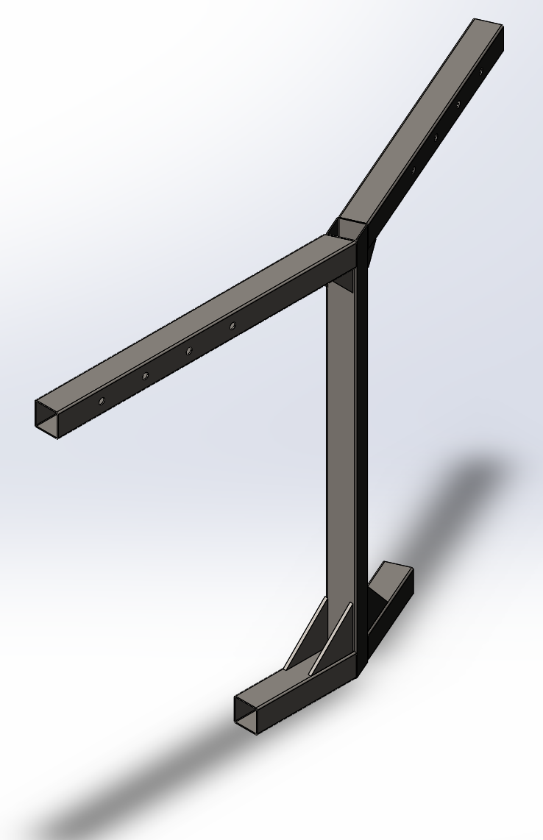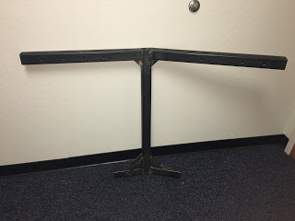
Figure 18 (left): CAD rendition of junction support
Figure 19 (right): Junction support
Figure 20 (below): Alternative junction support design
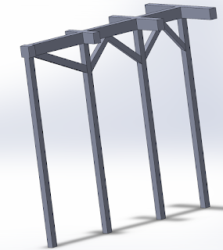
In addition, the third rail support system was redesigned in order to meet manufacturing requirements and lower the budget. We had previously decided to use a “diamond-shaped” third rail which would have been a 2x2 beam turned at a 45° angle. However, most manufacturing companies around the San Jose area could not bend this or it would be too costly. We decided instead to redesign the third rail. Below are both designs in comparison (Figures 21-23)
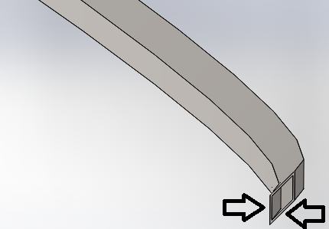
Figure 21 (left): Fall 2018 third rail design
Figure 22 (right): Spring 2019 third rail design
Figure 23 (bottom): Manufactured third rail
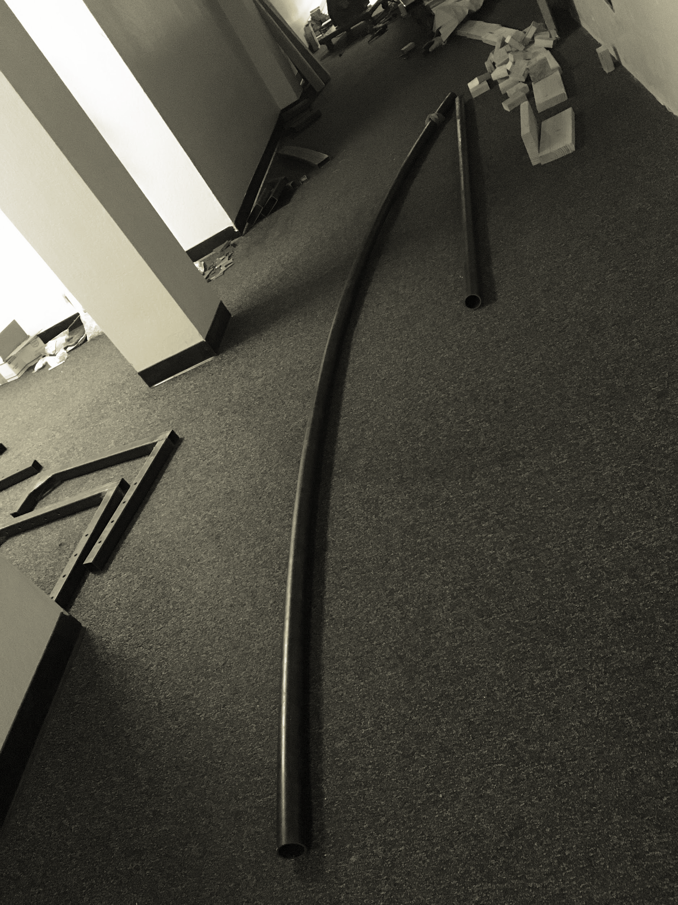
All in all, our final design for the school year was implemented successfully.

Analysis & Validation

For our analysis, both members relied on one another to help with the FEA. However, some issues arose with certain assemblies, causing the team to reiterate their designs and mates regularly. These issues were mostly caused by interferences within the assemblies and poor mates. However, we were able to successfully render FEA results for our designs. Appendices A-D showcase the results that we were able to render for third rail system last semester. Figures 23-25 show the three different results we were able to obtain for the newest third rail design.
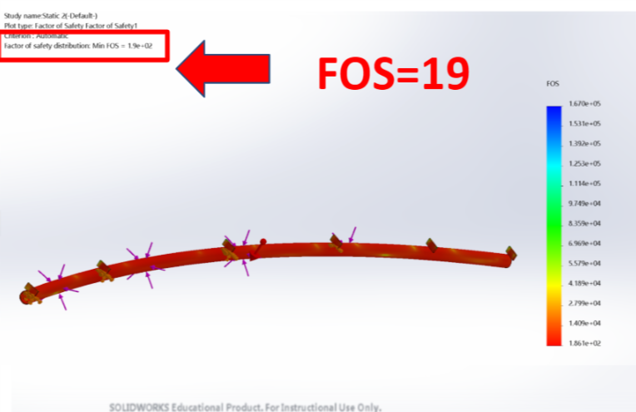 Figure 23 (left): FOS obtained 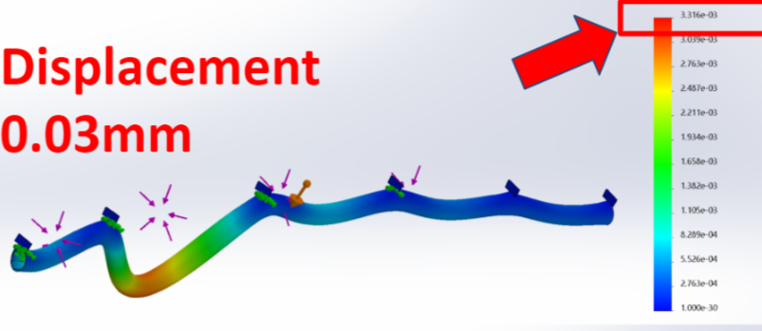 Figure 24 (left): Maximum displacement
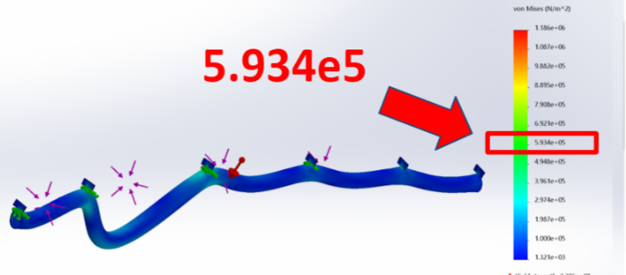 Figure 25 (left): Von Mises Stresses

Further analysis was conducted to ensure that our track system would also be able to remain stable and supportive. The results of this analysis, shown in the following figures, show that this is a feasible design. A force of 25000 N was applied for the analysis giving a factor of safety of 2.1 for the junction rails, and 2.8 for the straight rails while having less than 1 mm of deflection in both cases (Appendix E). Moreover, since the 2013-2014 track was built and presented no issues with being able to withstand the bogie’s weight, we are certain that our design will succeed. We also decided to run some FEA on the junction supports (figures 25-27).
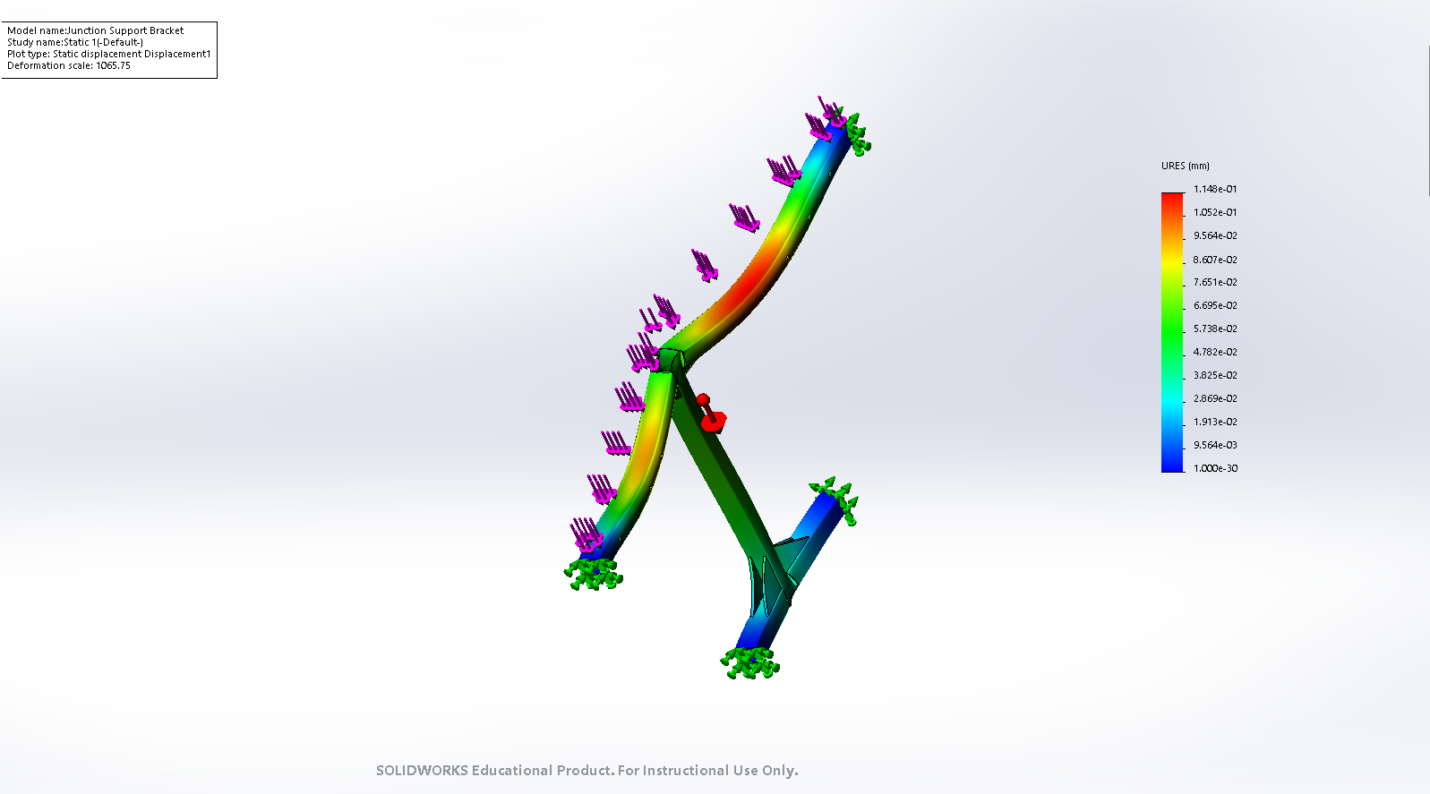
Figure 25 (above): Displacement FEA for junction support (Maximum is 0.115mm)
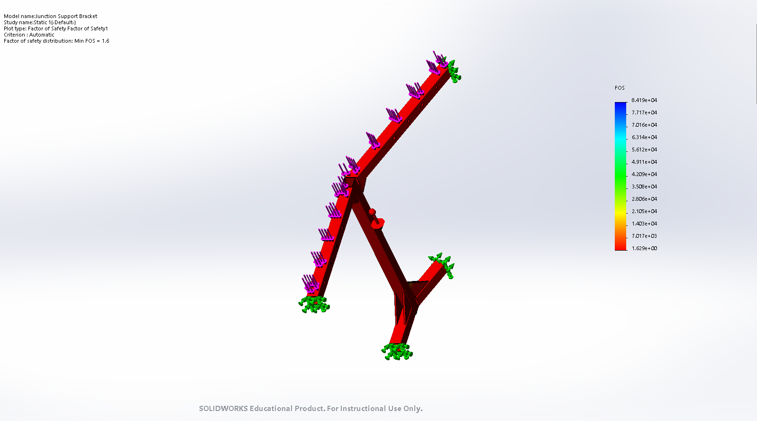
Figure 26 (above): FOS FEA for junction support (Maximum is 1.63)

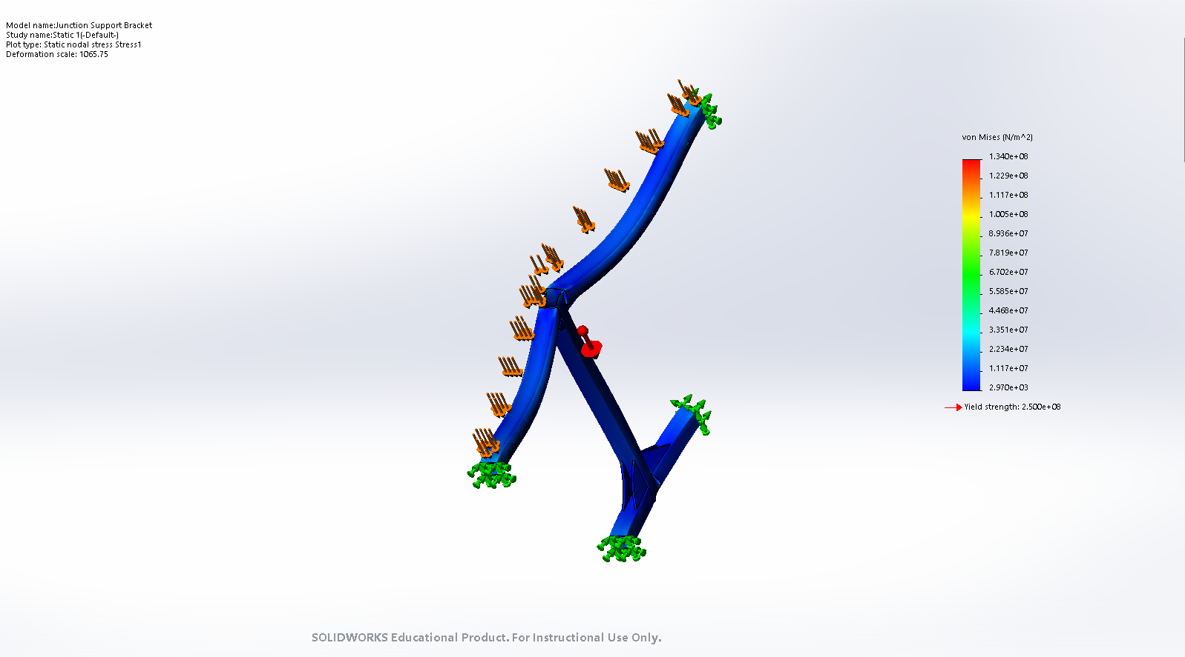
Figure 27 (above): Von Mises FEA for junction support (Maximum is 2970 N/m^2)

Budget
Our budget for this semester decreased drastically due to the new track design. In the Fall semester when the plan was to construct the entire track out of metal our estimated cost was upwards of $12,000 based off the quote that the 2017-2018 team had received. Due to our design changes to modify the existing full scale track we did not have to worry about manufacturing the entirety of the track drastically reducing our over all cost. Finally Master Metal Products graciously donated all the metal components, as well as the labor to cut, drill, and bend them to our project as well, reducing our overall cost even more. In figure 28 below, the Fall 2018 estimated budget is shown. Table 1 showcases our current budget.
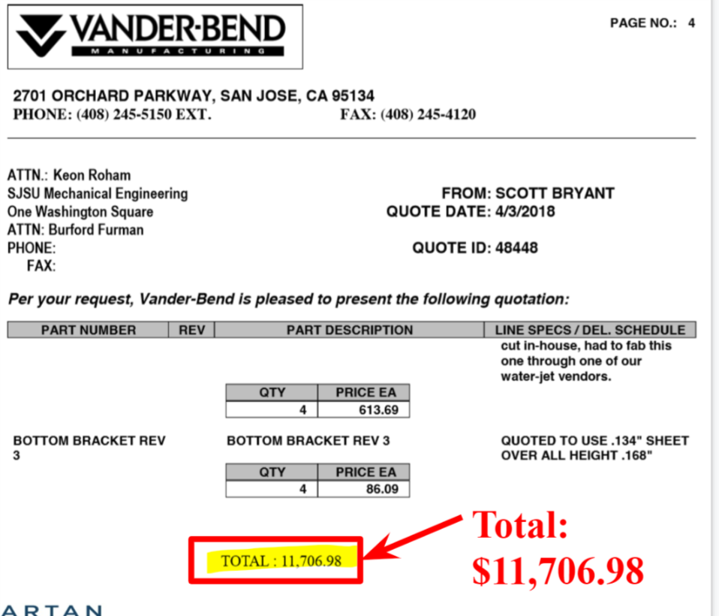
Figure 28: Estimated 2018 Fall budget

Part | Quantity | Unit Cost | Total Cost
2x2 Steel Tube | 34 | Donated | $0.00
2x6 Lumber 10' | 16 | $9.00 | $100.00
1x6 Lumber 10' | 9 | $10.00 | $90.00
2x4 Lumber 8' | 2 | $3.00 | $6.00
4x6 lumber 6' | 8 | $8.50 | $68.00
Hardware | 1 | $231 | $231.00
2x6 Steel | 6 | Donated | $0.00
Flanges 3.6" | 12 | Donated | $0.00
Flanges 1.6" | 6 | Donated | $0.00
Fabrication | 1 |  | $0.00
 |  | Total Cost | $495.00

Results & Discussion
After analyzing our design with FEA, we began to build. The results we were able to obtain reassured that our design could be accomplished. Moreover, since we are using an older track design, we had to trust their positive results. Since the track was successfully built and their reports supported this, we were not too worried about the bogie’s effect. Due to all of the positive reinforcements, we went ahead with our design and believe that it is finalized. The junction should ideally be stable while the third rail should ideally provide switching support. If all has been measured correctly, we will soon be looking at a functioning track.

Conclusion & Suggestions for Future Work
Conclusion
In retrospect, our design was successful. We were not able to finish building the entirety of the track, but we were able to build what is shown in the figure below. We were also able to successfully meet all of our design specifications and requirements. Our biggest worry this semester was not securing funding or a donor by the end. Manufacturing of the third rail was essential as other teams had failed when making a wooden rendition. Fortunately, we were able to manufacture our third rail.
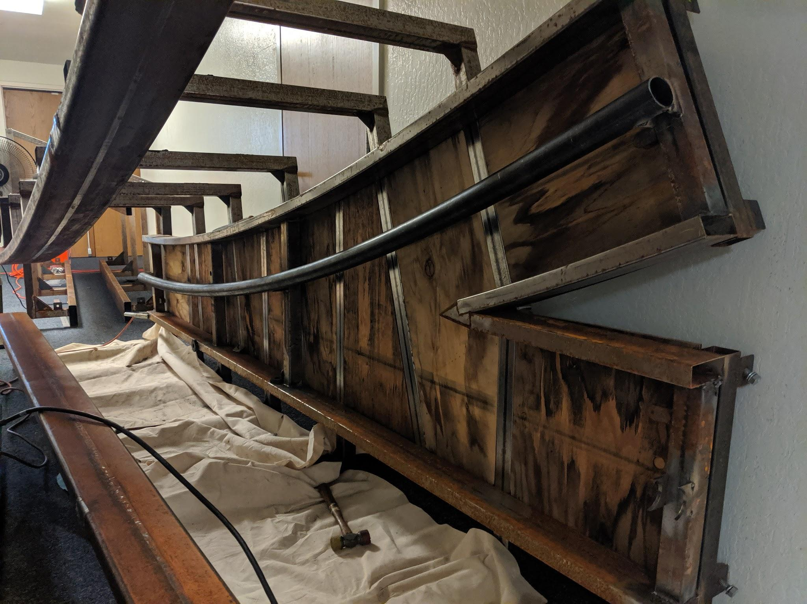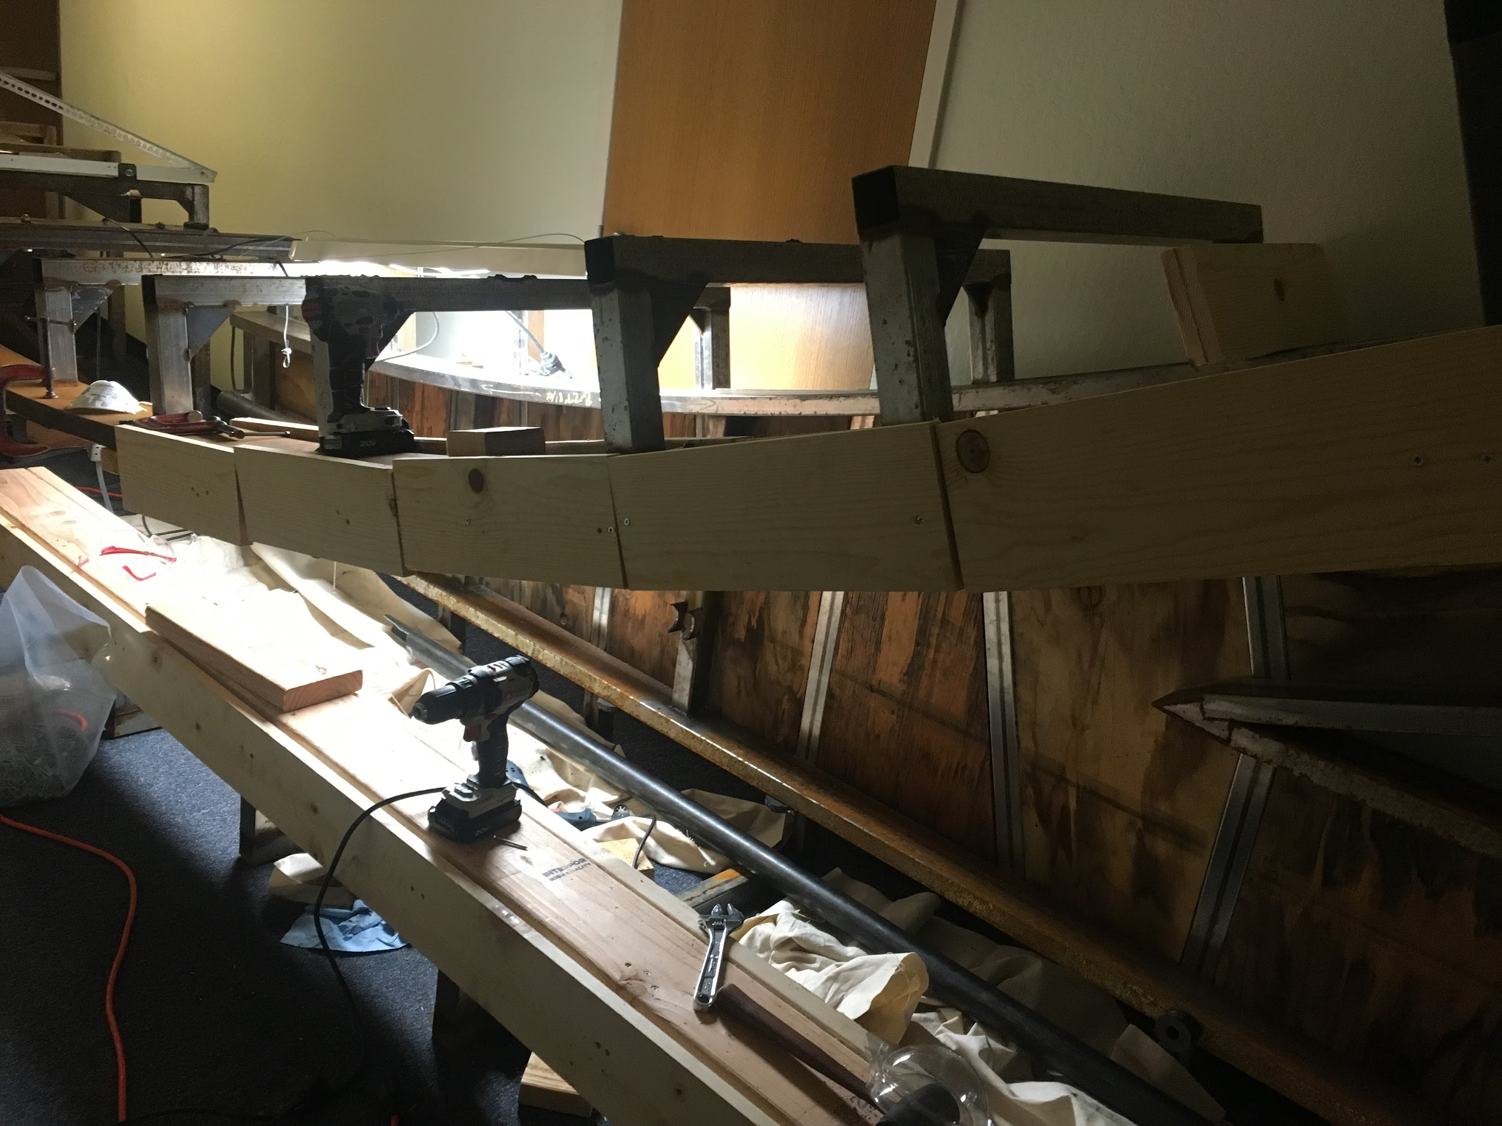
Figure 29 (left): Track that was built with curved third rail mounted
Figure 30 (right): Mounted segmented track design

We have been able to design and implement the missing pieces from previous semesters. By designing the junction and feeling confident in our design, we have pushed this project forward. We were also able to successfully implement a new track design that helps out the new design of the bogie. The new bogie design required this new design in order to “hug” the track with wheels, much like the half-scale bogie design. The new track design also bridged part of the gap, allowing the bogie similar dimensions to the previous semester. This allows the other teams to maintain their designs. Lastly, our junction support design as well the third rail design were also successfully implemented and manufactured. Both of these were manufactured out of steel.
Our largest downfall for the year was not being able to fully assemble the whole length of track that was planned due to a couple reasons. The biggest hurdle was the Superway moving buildings between the Fall and Spring semesters. Due to this move and the size of the full scale track, we were not able to get the track moved to the new location until after spring break giving us only about 6 weeks to find manufacturing and construct our design. The second hurdle we had was limited access to the new building. Up until about 2 weeks before the semester ended we were only able to get access to the building to work on the track when another team was there due to only a few students having a key to the building. This greatly limited the time that we were able to work on building our track and put us greatly behind schedule. The largest hurdle we had, and the main reason we could not fully assemble the full track, was the space we had to work with in the new building. Due to the size of the track it requires a large open space, but the rooms in the new building with enough space for us to assemble the track did not have doorways large enough for the track components to fit through. Because of this we were limited to building the track in the hallway, and due to the limited width we were unable to assemble the junction because it requires both sides of the track to support which would not fit in the space we had. While we could not built the track to the point we wanted, we did all the metal fabrication for the track and future teams should be able to finalize the assembly if adequate space is cleared for it.

Suggestions for Future Work
After redesigning the track system twice in a school year, we would highly recommend to not do so. If a completely new design is not created, the guideway team has a higher chance of succeeding and will be more efficient. An entire semester’s worth of work was tossed aside once the track was disassembled, forcing us to work on another design rather than finding manufacturers early on. Future teams could avoid this by either securing a donor or funding from the very first semester. They could also avoid inefficiency by working with the designs they are given rather than ignoring them. The guideway is in its final stages, focusing on a sharper turn would be the next step. The junction design we focused on was solely for the turning into/out of a station. We were not able to design a junction section for a wider or sharper turn. We would highly recommend next year’s team to begin by building while simultaneously designing a wider junction. It should be noted that the track is made out of wood. Our intention was to wrap the wood with an aluminum sheet in order to allow braking systems and wayside power to operate more efficiently. However, if the track could be manufactured out of metal, that would be the best option.

Conclusions & Recommendations
All in all, this project has been quite an experience for the both of us. We experienced working with multiple groups to come together as one as well as how much time goes into manufacturing. This project also taught us plenty about the impact the SPARTAN Superway could have. This unique project took the issue of transportation and revolutionized it. By providing users with a faster and safer alternative to buses, trains and vehicles, this project could impact the lives of many. By allowing them to get from point A to point B without any stops, the SPARTAN Superway could become the future of transportation. Since very little ground space is needed and it runs on clean energy, the Superway is the greenest alternative city goers would have. In addition, the Superway would provide the elderly, disabled and poor a solution. Due to this system running on clean energy no profit would be made from it, allowing many to use its services without worrying about payment. Moreover, the system would not be dependent on schedules, allowing it to run 24/7. This could potentially save users hundreds in case of an emergency as it could be used to get a passenger to a hospital across the city much quicker than an ambulance. Each member of this project believes that the SPARTAN Superway or a very similar system can change how we view transportation today.

References
Advanced Transit Association, Inc. (ATRA). PRT Application Characteristics retrieved
December 15th, 2017 from http://www.advancedtransit.org/advanced-transit/comparison/prt-characteristics/
Baldassari, E. (2016, September 22). Report: Bad roads, public transit top list of Bay Area’s most-needed transportation projects. Retrieved December 13, 2017, from http://www.mercurynews.com/2016/05/11/report-bad-roads-public-transit-top-list-of-bay-areas-most-needed-transportation-projects/
Furman, B., Fabian, L., Ellis, S., Muller, P., & Swenson, R. (2014). Automated Transit Networks (ATN): A Review of the State of the Industry and Prospects for the Future (pp. 1-240, Publication). San Jose, CA: Mineta Transportation Institute. Doi:2014949891
MHI. (2015). CMAA. Retrieved December 16, 2017, from http://www.mhi.org/cmaa
Press, A. (2015, August 26). Bay Area Commuters Waste 78 Hours a Year in Traffic: Study:. Retrieved December 13, 2017, from https://www.nbcbayarea.com/news/local/Bay-Area-Commuters-Waste-78-Hours-a-Year-Stuck-in-Traffic-Study-322982141.html

Appendices
Appendix A: Von Mises, Displacement and FOS for Solid Triangular Shape
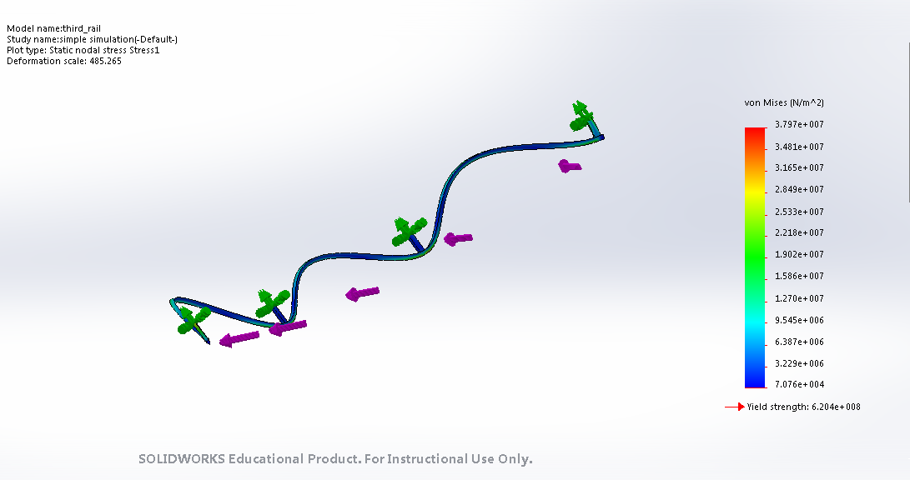 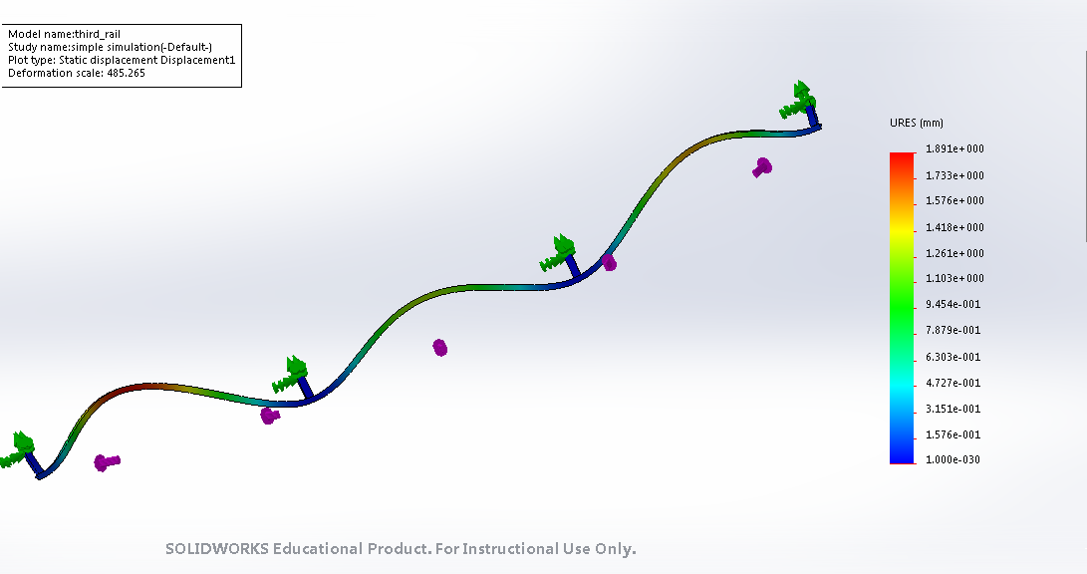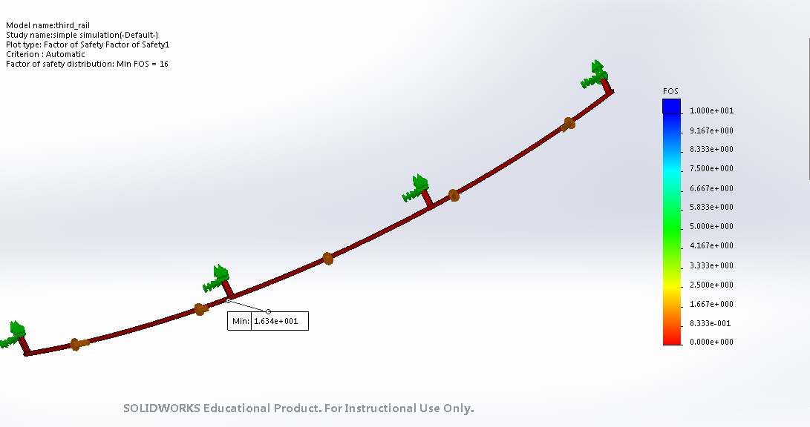16

Appendix B: Von Mises, Displacement and FOS for Hollow Diamond Shape
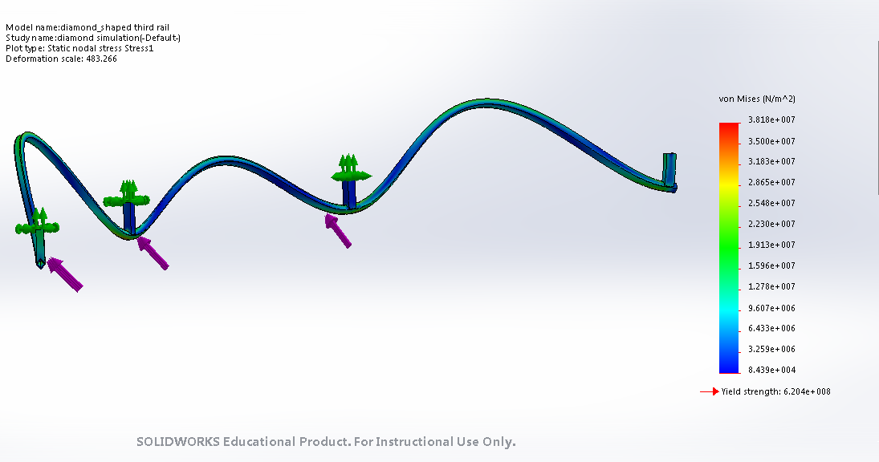 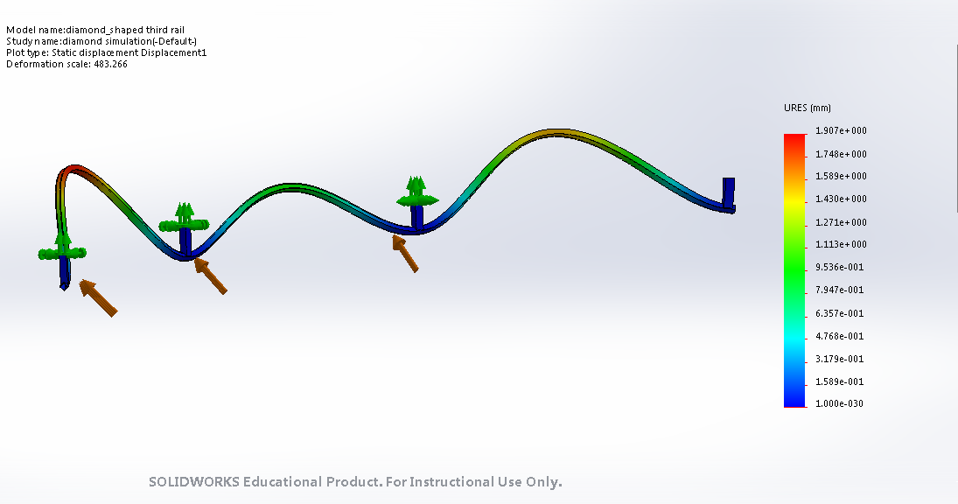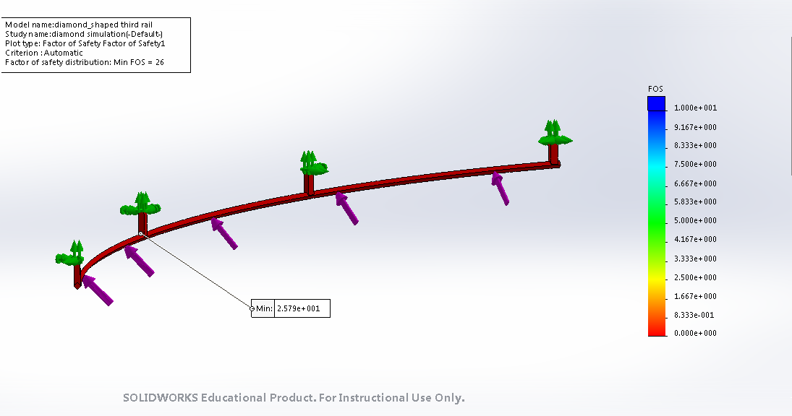26

Appendix C: Von Mises, Displacement and FOS for Hollow Triangular Shape
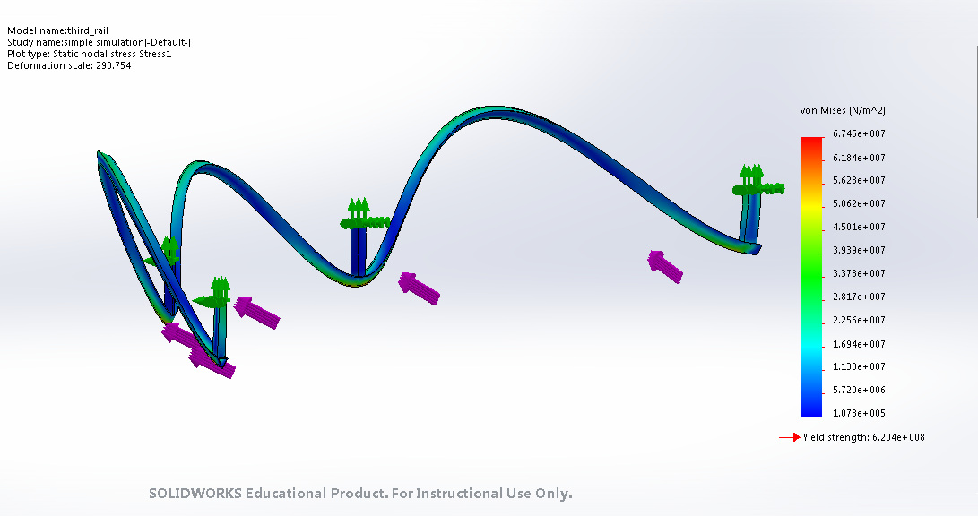 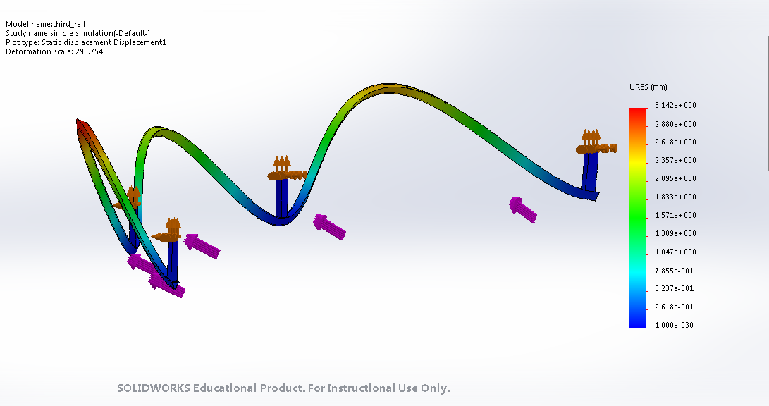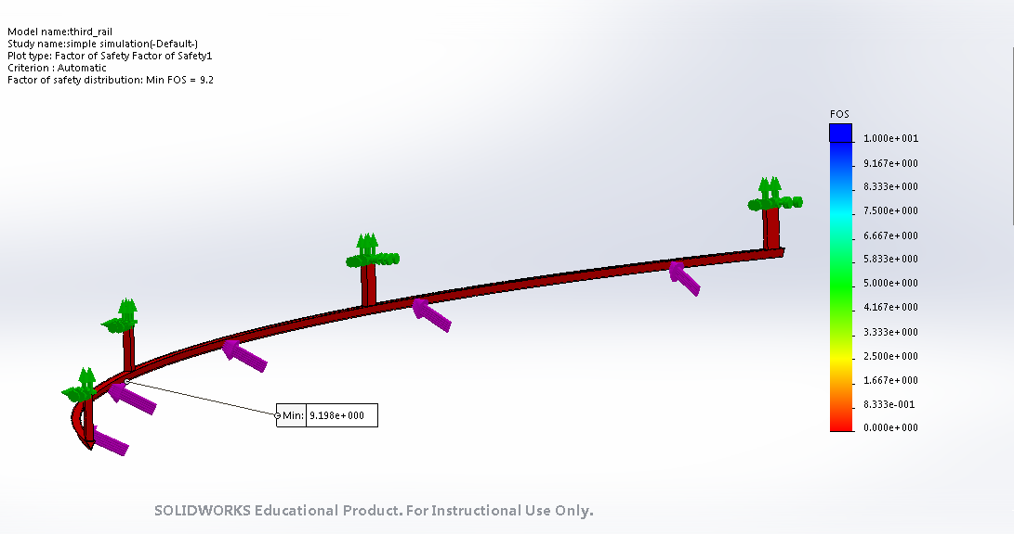9.2

Appendix D: Von Mises, Displacement and FOS for Solid Diamond Shape
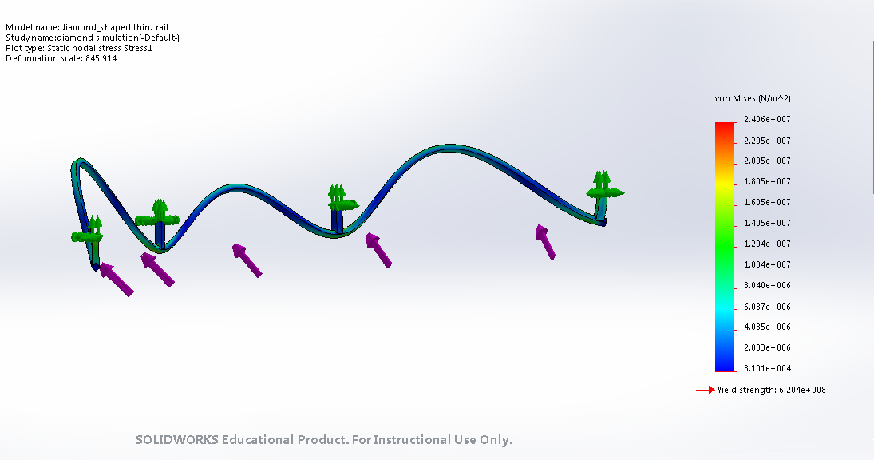 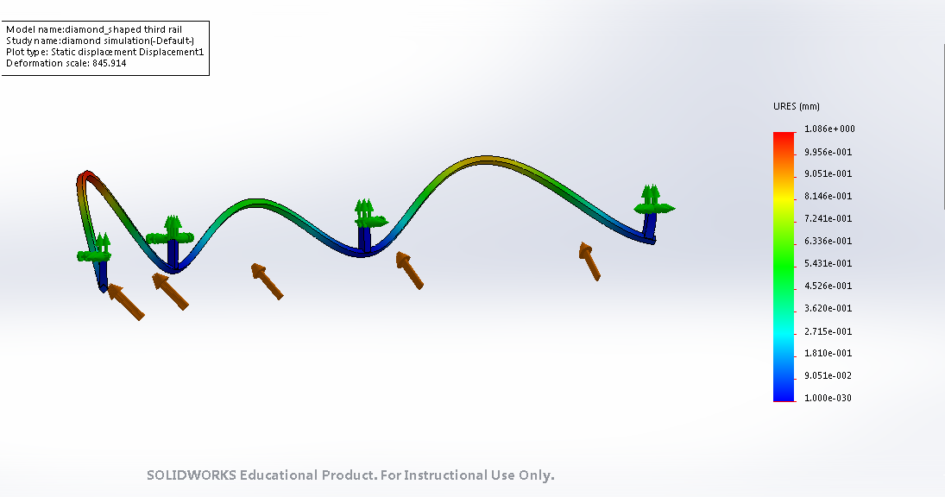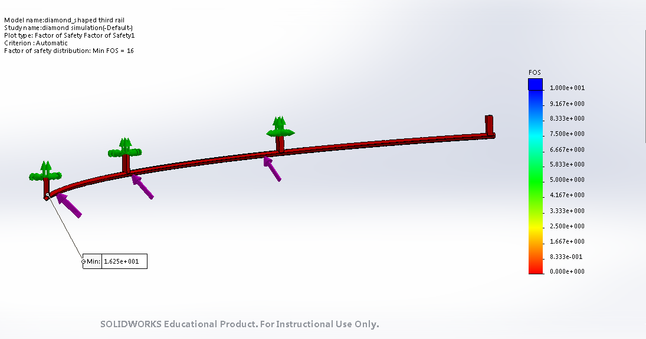16

Appendix E: Von Mises, Displacement and FOS for track
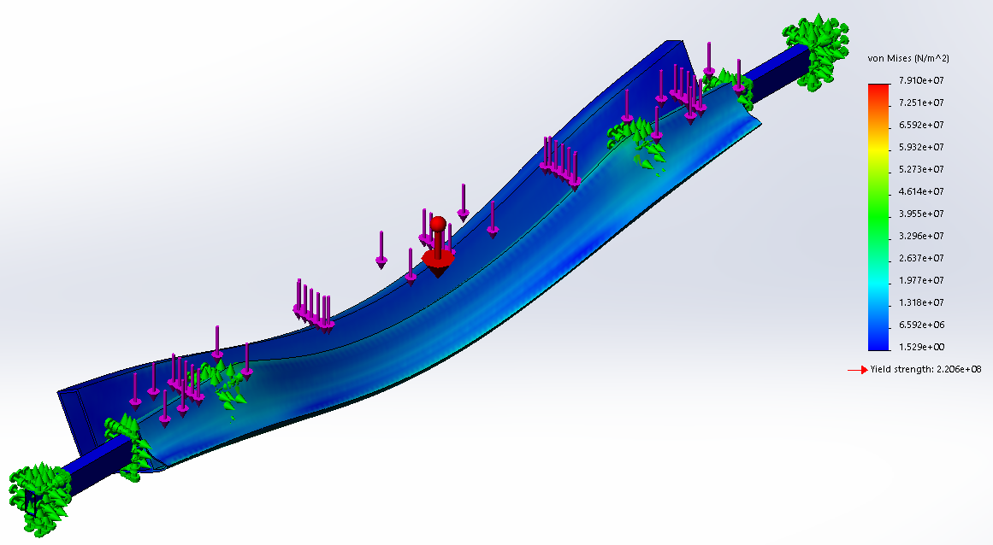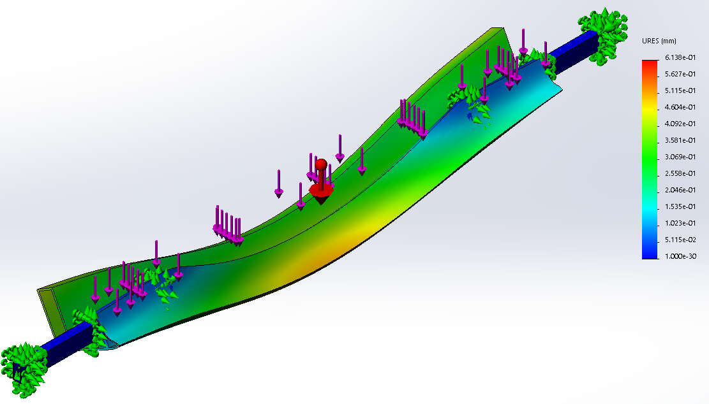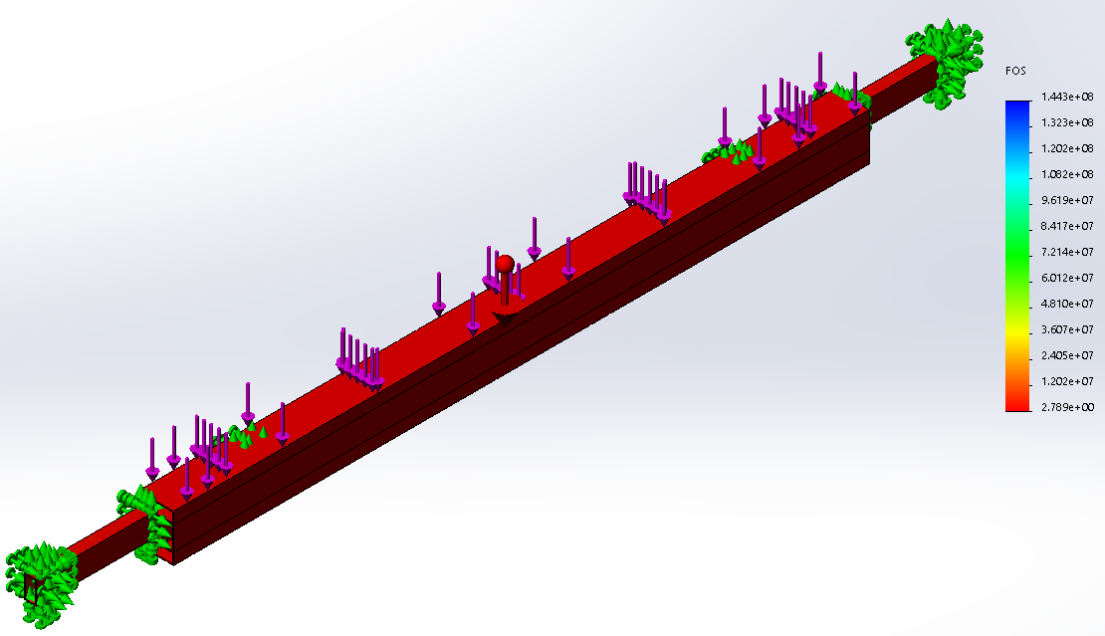

Appendix F: Gantt Chart for Spring Semester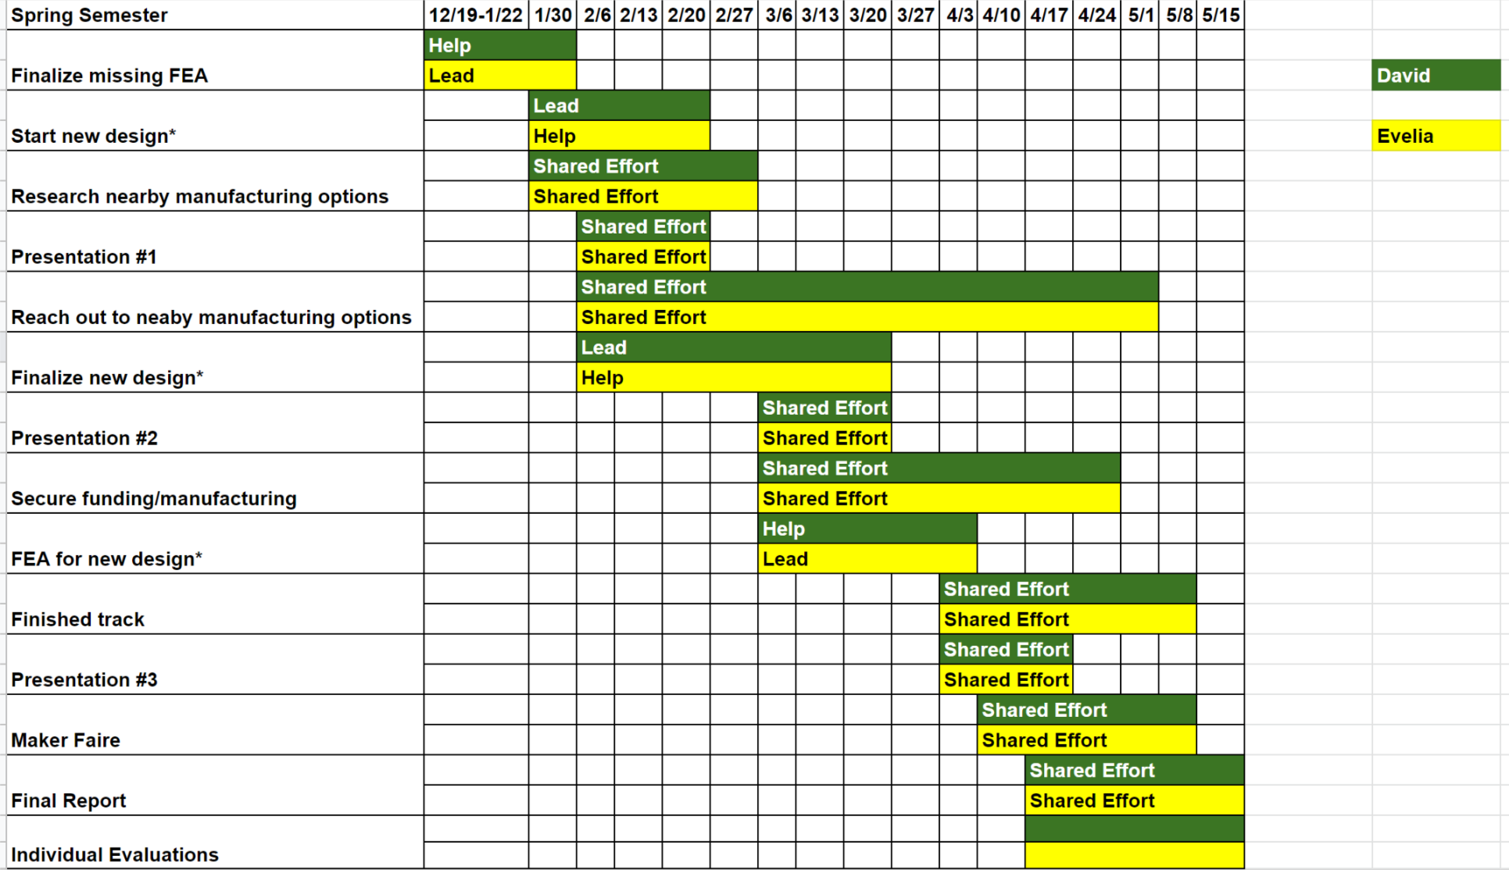

Appendix G: Drawings for main junction support bracket.
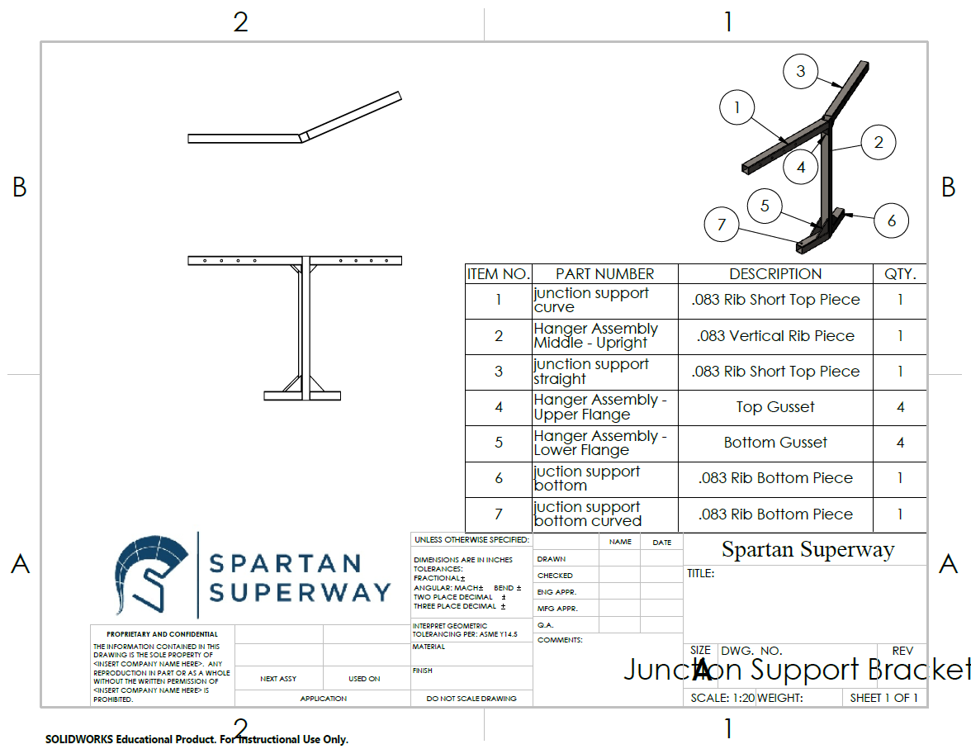
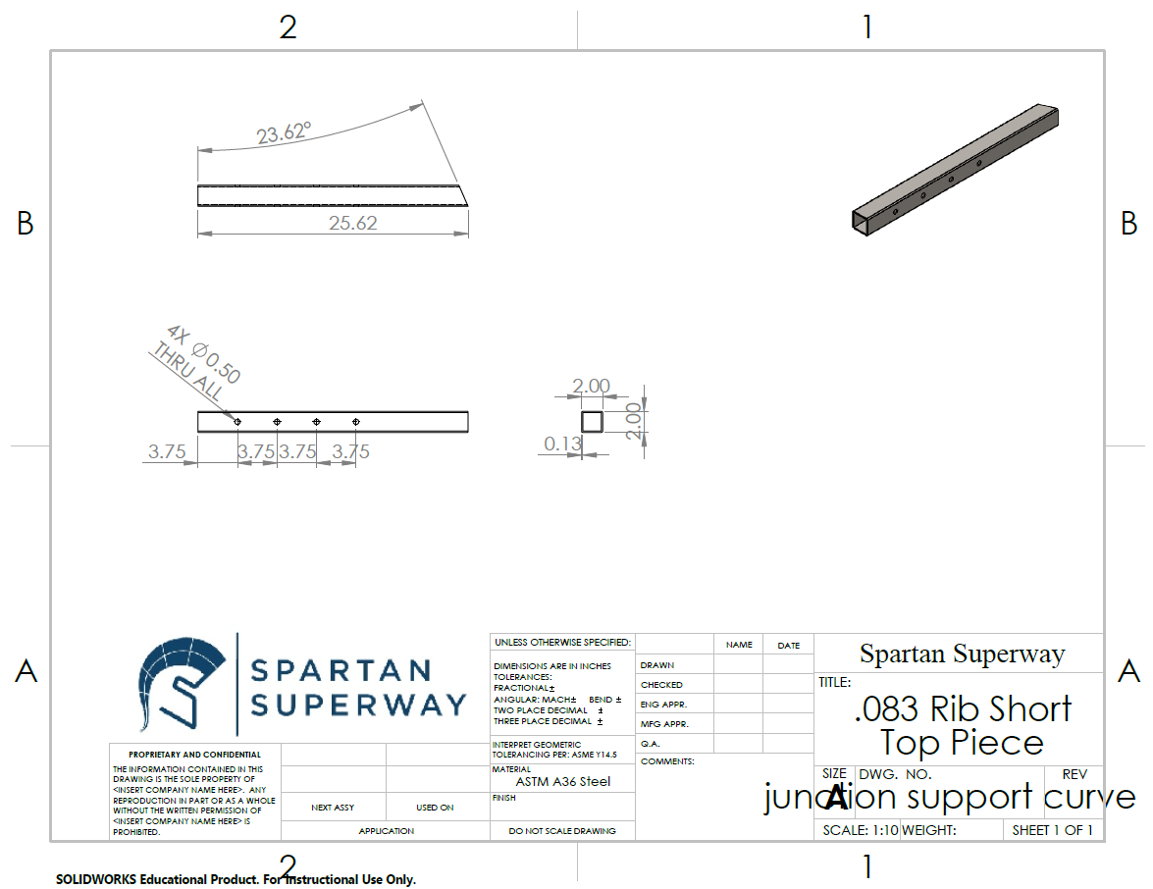
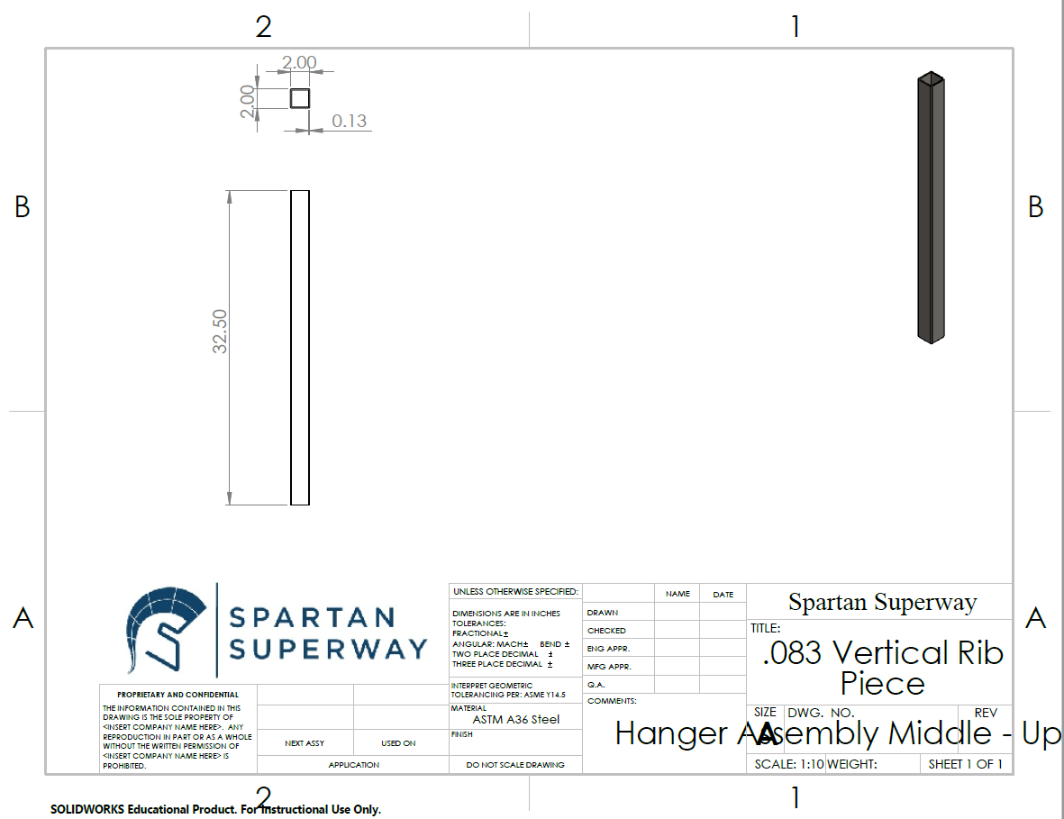
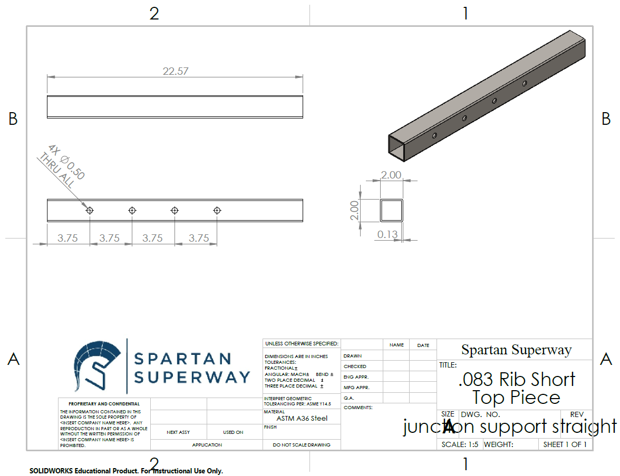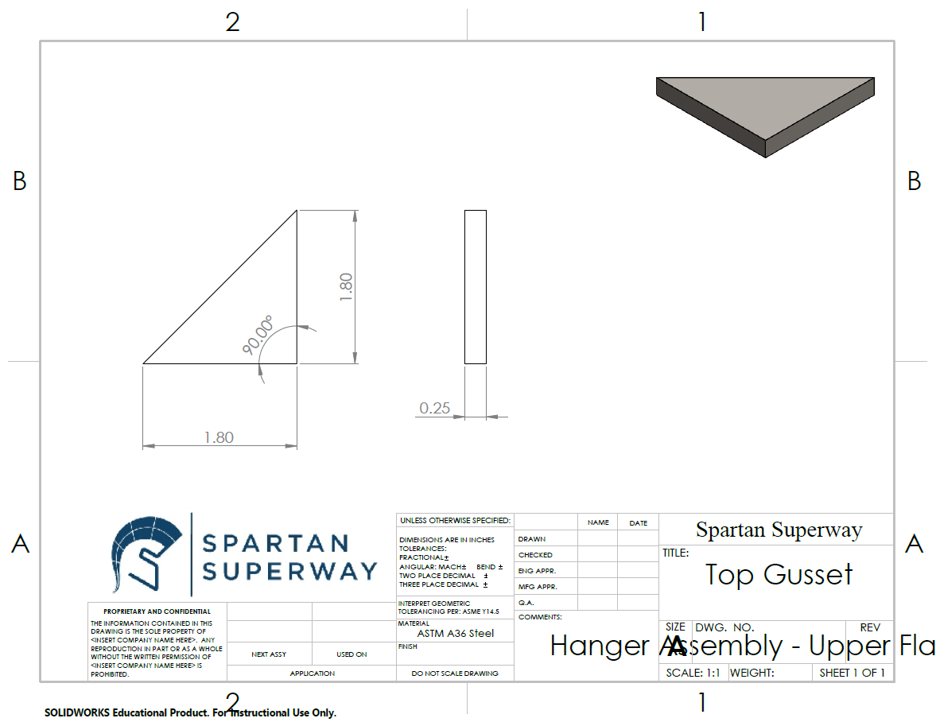
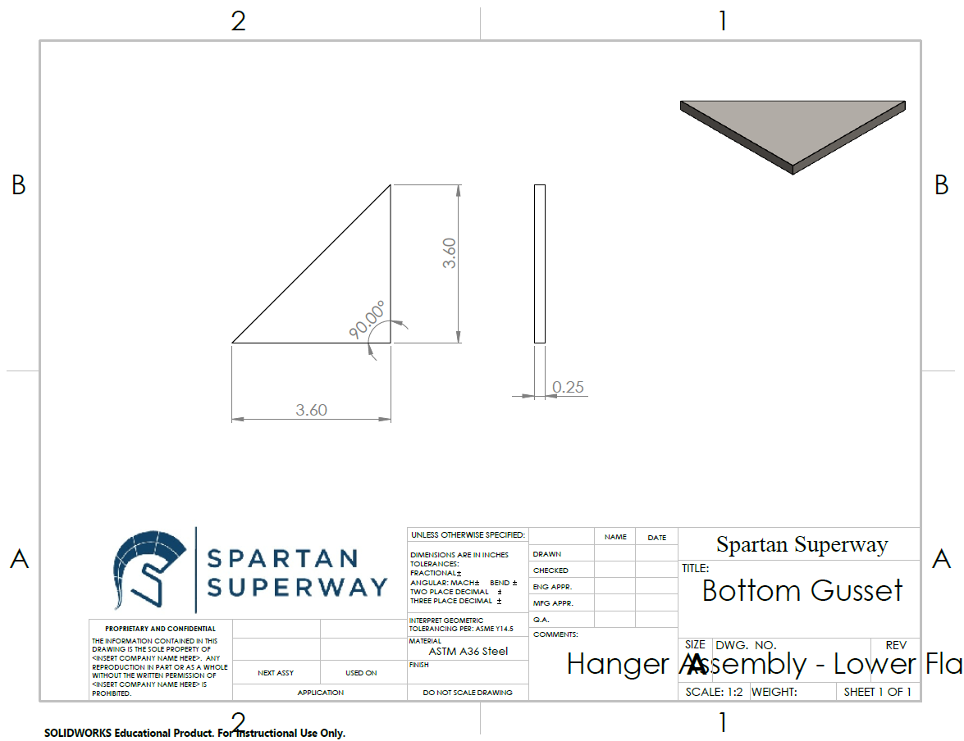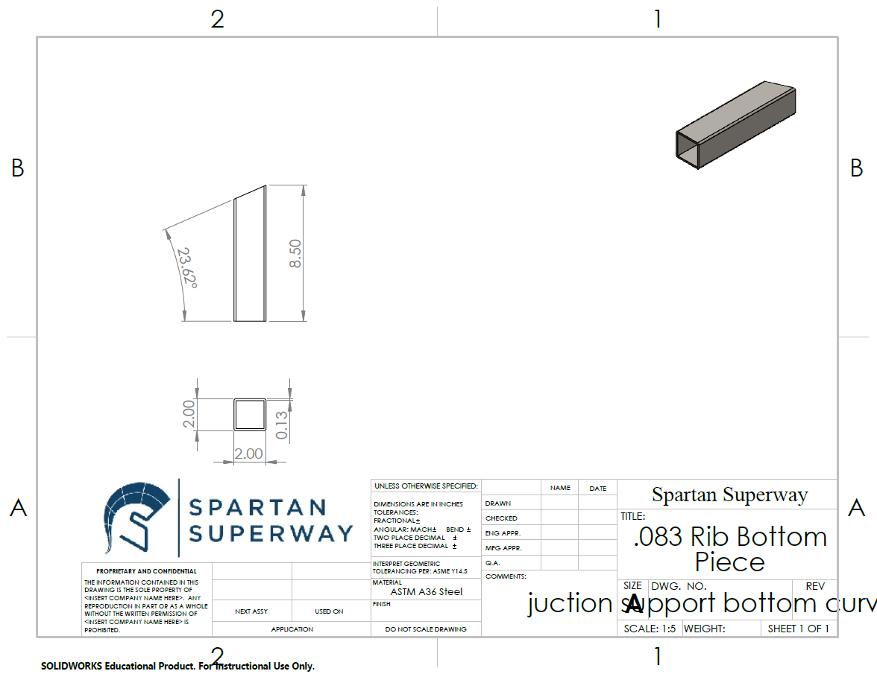
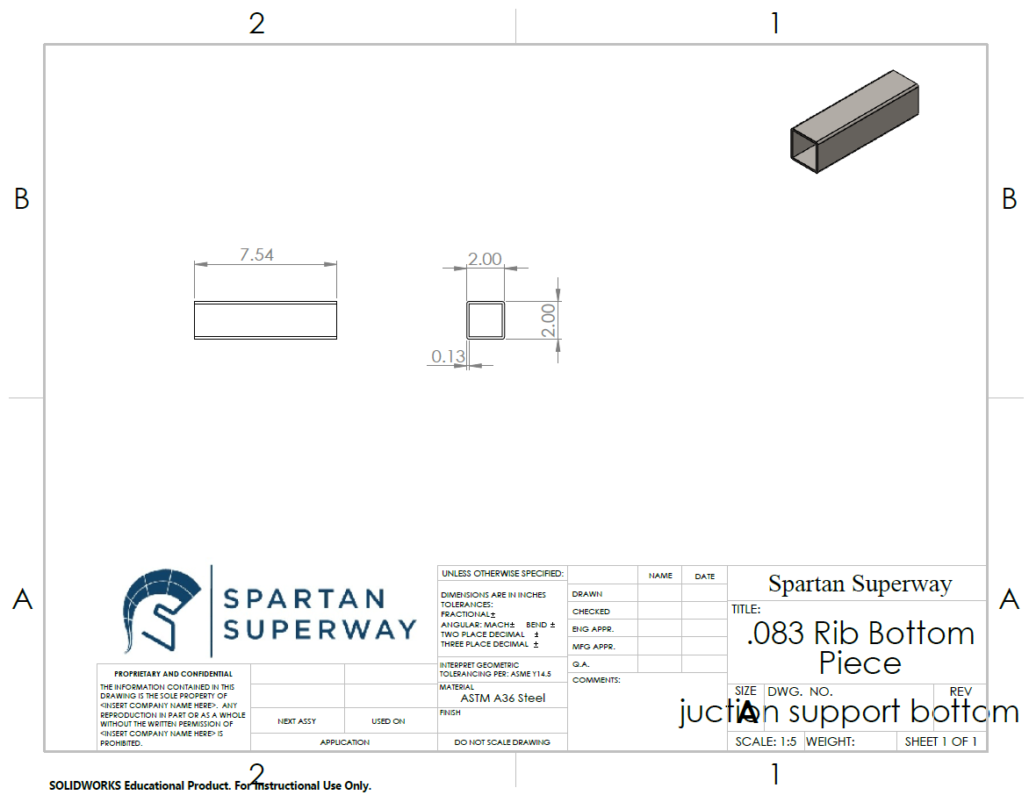

Appendix H: Drawings for third rail and mounting flanges.
