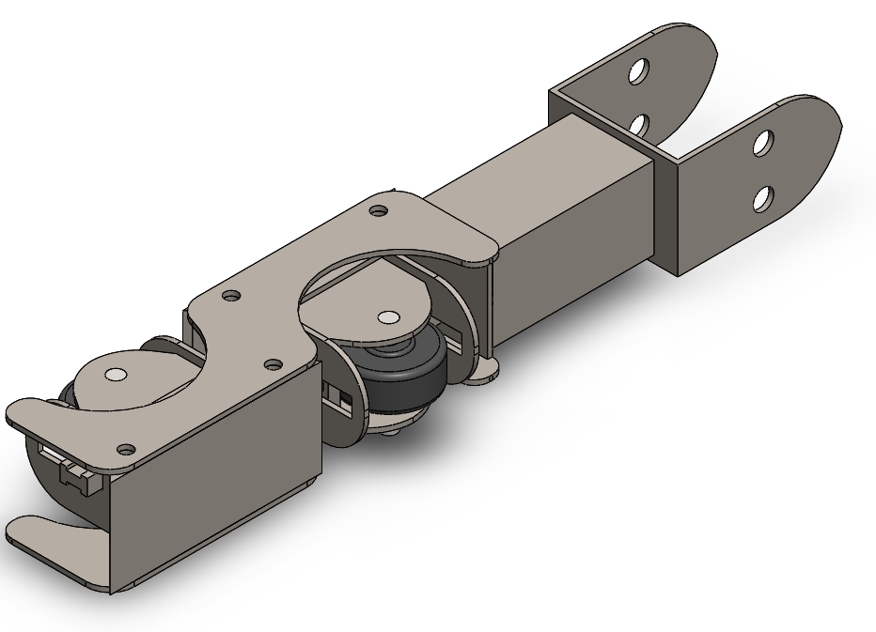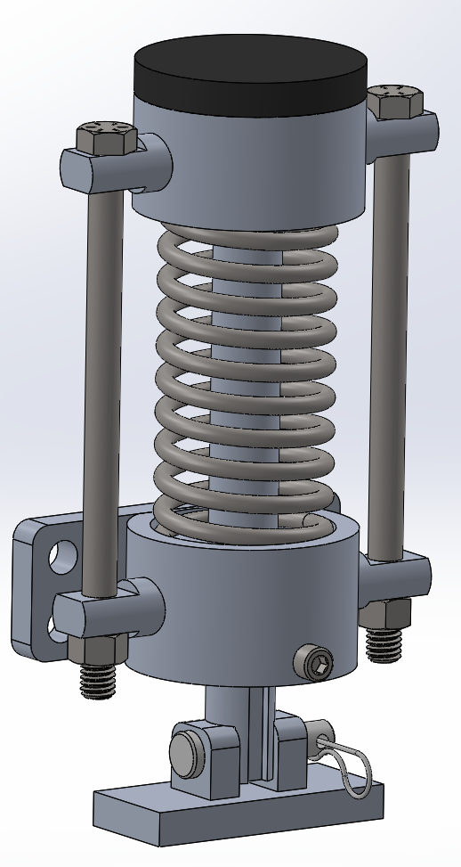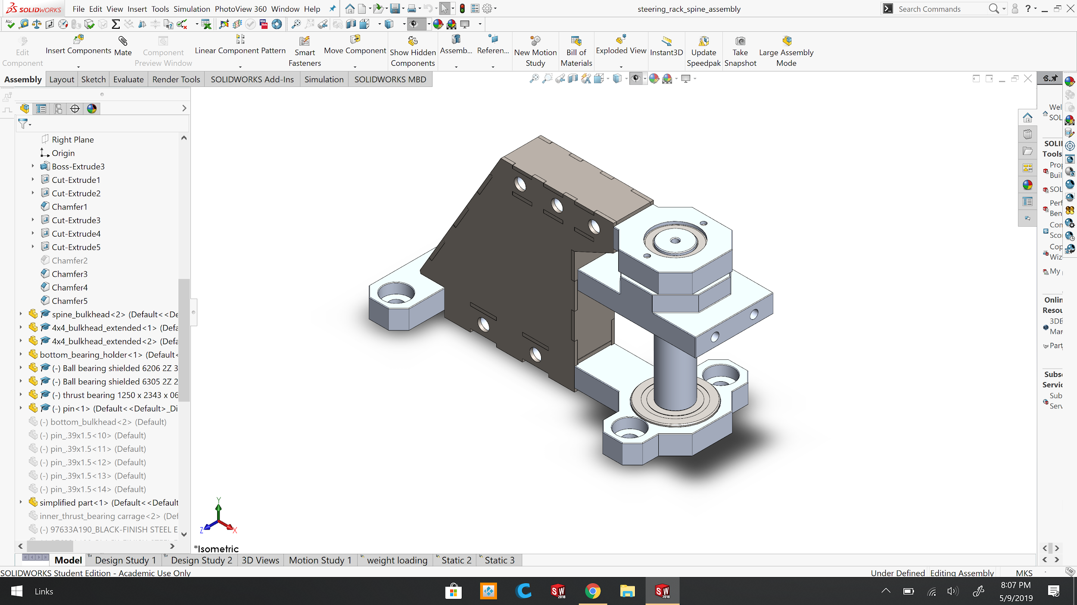
Solar Skyways Design Collaborative Report:
A Solar Powered Automated Rapid Transit Ascendant Network

Full-Scale Steering and Emergency Braking Team
Final Report

Akashpreet Sandhu
Jaspreet Singh
Joshua Morales

5/19/2019



Abstract
The sub-team focused on improving the current articulation, enhancing the guide arm systems, and adding an emergency braking system. The current articulation system had many problems. One of the problems with the articulation system is that it was very heavy. The articulation system had a total mass of 9kg. Another problem with the system was the assembly process. The articulation system was constructed using 13mm thick steel and had to be welded together. This made maintenance on the system almost impossible. Due to its design, the whole system would need to be replaced if any of it was damaged. The redesign fixes all these problems with the system. This was done by a total redesign of the articulation structure and using design methods that mimic Dan Espinoza's bogie design. The new design for the articulation system allowed parts to be easily manufacturable. With the use of different materials such as aluminum and steel, the mass of the system was reduced from 9 kg to 3.92 kg. The articulation system is now modular, this means that if a part were to break it can easily be removed without having to replace the whole assembly. The articulation system allows the wheels to turn up to 15 degrees, increasing its ability to take tighter turns from the last revision.

Secondly, the sub team worked on a redesign of the guide arm for the two-bogie system. The guide arm on the bogie is required to have a spring-loaded assembly. The current guide arm design fails to accomplish its goal. The purpose of the guide arm is to keep the bogie on the track and to keep the bogie centered on both straight and curved sections of the track. The previous design has over 3 mm design on both sides of the guide arm wheel, which made it unsuccessful in keeping the bogie centered. The spring-loaded guide arm wheel assemblies were added on both sides of the guide arm. The wheels would be preloaded, so even when traveling on a straight section of the track, both sides of the guide arm will stay centered between the gap of the tracks. Additionally, the wheels and spring assembly implements a slotted design to allow for compression of the wheels when the bogie enters curved sections of the track. While designing, the main constraints include 12 cm track gap, the 1 m/s speed of the bogie for testing, and the curved track radius of 8 meters. The guide arm design is complete with mounting on the slave bogie and drive bogie. The Spartan Superway will require a total of 3 guide arm assemblies. The FEA was completed on all designed components, and the outcome was that all components have a factor of safety higher than 2 and keep the mass of each guide arm assembly below 15 kg. The team was able to successfully manufacture and assemble the guide arms to their respective bogies; however, students were not able to test the performance of the guide arms on the track.

A secondary braking system needed to be implemented on the bogie for emergency situations. An emergency braking system has never been implemented on the bogie in the past years, so it was designed from scratch. The sub team designed an emergency electromagnetic braking system which aimed to stop the vehicle traveling at 1 m/s within 0.61 meters. The system encompasses an electromagnet with a large spring which activates during emergency situations or if power is lost to the system. This design encompasses several components such as a brake pad, electromagnet, spring, slider rod, and bracket. Initially, the braking system was going to be mounted between the tracks, but after analysis, it was determined that this location was not suitable. The braking system will be mounted under the bogie and the brake pad will press against the bottom of the track to stop the vehicle. There will be a total of 2 braking systems on the vehicle for prototype testing, where they will be installed on the slave bogie. The number of braking systems is proportional to the speed and mass of the vehicle. For prototype testing, two systems were sufficient, however, more systems will be needed for a real-world application. Furthermore, the braking system will be able to retract to its original location using a spring compressing mechanism. During the designing phase, manufacturability was kept in mind to reduce cost and make the design easy to manufacture. Maintenance was also kept in mind, as the braking system can be fully disassembled and inspected. A finite element analysis has been completed for the design and the system has a factor of safety greater than 4. Next, the system was manufactured in house using machine tools. After the manufacturing process, the system was tested, and it performed as expected. The system went through rigorous testing and it achieved all testable design specifications such as compressibility and functionality. The electromagnets are able to successfully release the braking system, which quickly allows the brake pad to move upward. Unfortunately, the track is still not complete so testing the braking system on the vehicle may happen in later months or by next year’s team, however, it should function as designed and should be able to stop the vehicle within 0.61 meters.

Acknowledgments
We would like to give credit to Dan Espinoza for helping us throughout our design and manufacturing phase.

Dr. Burford Furman for helping with complex calculations, feedback during presentations, suggestions for possible design changes, and suggestions for manufacturing designs.

Additionally, we would like to give thanks to Ron Swenson for feedback during presentations, inspirational stories to keep the teams motivated, and bringing in industry leaders to give insight.

Eric Hagstrom for keeping the BlogSpot organized which is helpful for viewing other team’s progress and providing feedback on blog posts.

Table of Contents
______________________________________________________________________________

Abstract 1
Acknowledgments 2
Table of Contents 3
List of Figures 5
Executive Summary 7
Introduction: 7
Objectives: 7
Articulation 7
Guide Arm 7
Emergency Braking System 8
Design Solutions: 8
Conclusion 10
Introduction and Project Description 11
Background and Context 12
Description of Subteam and Objectives 12
Objectives: 13
Guide Arm 13
Articulation 13
Emergency Braking System 13
State-of-the-Art/Literature Review 13
Guide Arm Design 16
Design Specifications 16
Prime Design Explanation 17
Supporting Analysis 18
Manufacturing of Design 18
Articulation Design 20
Design Specification 20
Prime Design / Manufacturing of Design 20
Supporting Analysis 24
Emergency Braking Design 27
Design Specifications 27
Prime Design Explanation 27
Supporting Analysis 30
Manufacturing of Design 32
Analysis/Validation/Testing 33
Project Expenditures 33
Conclusions and Suggestions for the Future 34
Guide Arm 34
Articulation 35
Emergency Brakes 36
Conclusions and Recommendations 36
Appendices 39
Appendix A 41
Appendix B 40
Appendix C 43
Appendix D 45
Appendix E 50
Appendix F 54
Appendix G 56
Appendix H 59
Appendix J 62

List of Figures
______________________________________________________________________________

Figure 1. Exploded View of the Articulation system 8
Figure 2. This is a CAD model of the final guide arm design on a mock-up track attached to the drive bogie. 9
Figure 3. 3D model of the emergency braking system 10
Figure 4. The model used to determine the forcing frequency (Grassie, 2012) 16
Figure 5. This is an image of the rapid prototyping which was done for the spring-loaded wheel assembly. 18
Figure 6. This is an image of the assembled and manufactured drive bogie guide arm. 18
Figure 7. A partial exploded view of the sub-assembly depicting the location of spring. 20
Figure 8. A depiction of the drive bogie guide arm in fully compressed condition inside the guideway gap. 20
Figure 10. Assembled Articulation Structure. 22
Figure 11. The bearing system used for the articulation of wheels 22
Figure 12A. Top flange bearing carriage used to hold flange bearing. 12B. Bottom flange Bearing Carriage used to hold flange bearing 23
Figure 14. Assembled articulation system installed on the bogies chassis. 24
Figure 15. Finite element analysis, axial loading performed on the articulation system to simulate the weight of bogie 25
Figure 16. Articulation system housing panels. 26
Figure 17. Connecting rod with slot to allow passage of axle 26
Figure 19. Final design 3D model(left) and manufactured design(right) 28
Figure 20. Emergency Braking Exploded View 29
Figure 21. E-brake parts manufacturing process 31
Figure 22. Several manufactured parts of the E-Brake system 32
Figure 23. E-brake system mounted and assembled on the test station 33
Figure 24. The total expenditure of the team is $949.72. 34
Figure 1B. Free body diagram for the forces acting on the guide arm assembly 40
Figure 2A. This is the specifications for the selected spring for guide arm. 42
Figure 3A. This depicts the waterjets components with a naming scheme to keep an inventory. 43
Figure 3B. The images depicted the milled rod for the tabs, and components that were turned on the lathe which were used to hold spring in place for guide arm. 44
Figure 4A. The components were first tack welded together to help keep the components aligned during the welding. 45
Figure 4B. This illustrates the TIG welded sub-assembly components. 46
Figure 5A. The measured mass of the drive bogie guide arm is about 3.9 kg. 47
Figure 6A. This is a depiction of FEA Study showing the minimum factor of safety of 7.4 for the drive bogie guide arm with 200 N load (in the orange arrows). 48
Figure 6B. The slave bogie guide arm has a minimum factor of safety of 7.4 with maximum loading condition. 49
Figure 7A: FEA of deployed braking system. The minimum factor of safety is 4. 50
Figure 7B. FEA of armature and pin. The minimum factor of safety is about 8.4. 51
Figure 8C. Thrust Bearing for axial loading 55
Figure 9A. Factor of Safety FEA 59
Figure 9B. Displacement Chart FEA 59
Figure 9A. AGPtek 130 lb Electromagnet Specifications 60
Figure 9B. Spring Specifications for Emergency Braking System 61
Figure 10A. This is the team’s complete bill of materials. 62

Executive Summary

Introduction:
The current transportation methods are no longer efficient ways of traveling. The heavy dependency of the transportation sector on automobiles has introduced many problems. Firstly, both private and public transportations lack efficiency. The streets of developed cities all face the same problem of congestion. Many people attempt to avoid congested methods of commuting by using BART, which is an aging method of transportation. Another big problem with the current modes of transportation is the contribution to air pollution. Global warming, health, and the environment are issues that require immediate attention. Furthermore, the transportation sector is responsible for a large portion of the greenhouse gases which are produced. Congestion on the streets only makes the matter worse. It is known to be costly, and lead to more emission of greenhouse gases, which have a negative impact on the environment. Automated transit network (ATN) systems provide a solution to solve the current problems facing transportation. The Spartan Superway project is working on an ATN system which can be implemented in developed cities by using lifted guideways. Another key feature of ATN systems is the on-demand service for riders that provides efficiency in commuting. A unique feature of the Spartan Superway is the implementation of solar canopies on the guideways to enable implementation of renewable energy.

Objectives:
This sub team was in charge of designing three main components of the bogie, Articulation system, Guide arm system, and Emergency Braking system. Each system has its own objectives that needed to be achieved.

Articulation
- The structure should be easy to assemble and disassemble for maintenance
- The mass of the overall articulation system should be reduced to less than 7 kg
- The articulation system should allow for 15 degrees turn for either right and left turns

Guide Arm
- Assembly should be spring loaded
- Will fit inside the 13.4 cm gap of the tracks
- Will have a mass less than 15 kg
- Must have a factor of safety greater than 2
- Interchangeable components

Emergency Braking system
- Stop the vehicle in an emergency within 0.61 meters at an estimated load of 400kg (estimated mass of prototype vehicle) traveling at 1 m/s
- Must have a method to reset the emergency braking system
- Prevent the slider rod from rotating during brake deployment
- Must have a factor of safety greater than 2

Design Solutions:
The Sub-team has been able to provide design solutions that would immensely improve some aspects of the bogie. This team was in charge of improving the articulation system of the bogie wheels, enhancing the guide arm for the bogies, and adding an emergency braking system to the bogie design. The main improvements made to the articulation system include weight reduction in design and easy manufacturability. This is achieved by designing a modular solution that implements 3 mm thick steel sheets shown in Figure 1.
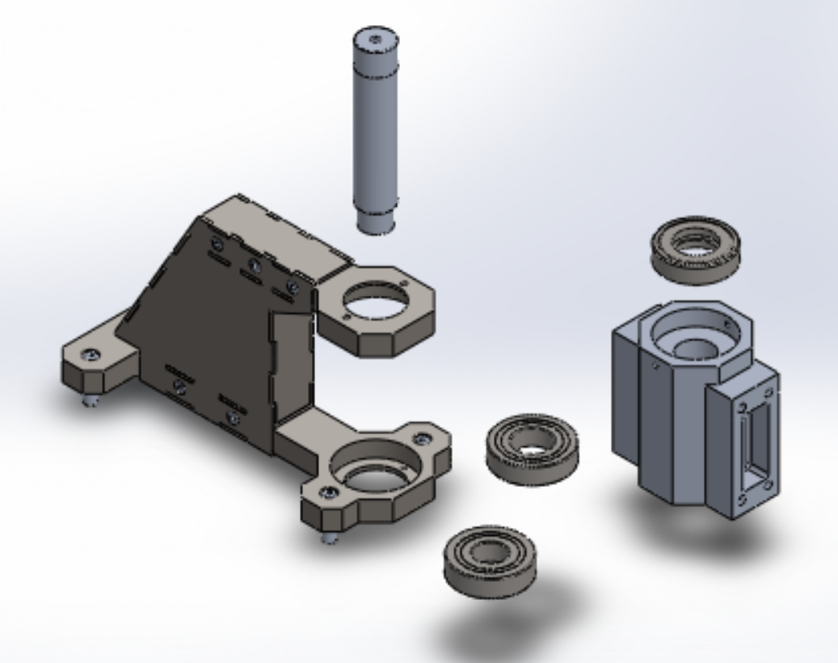

Figure 1. Exploded View of the Articulation system

Next, the team improved the guide arm design by incorporating a spring-loaded wheel. The springs on the wheel are preloaded to help keep the bogie centered on the track at all times. Figure 2 shows the final guide arm design attached to the drive bogie. The improved articulation system and guide arm should allow for better bogie performance around curved sections of the track.

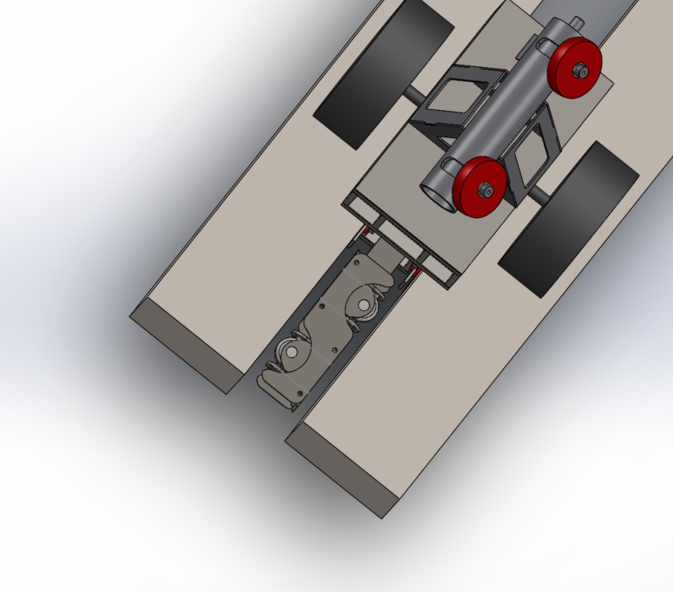

Figure 2. This is a CAD model of the final guide arm design on a mock-up track attached to the drive bogie.

Previously, the bogie lacked an emergency braking system. The team provides a design solution which will allow for both passive and active use of the brakes. This design is shown below in Figure 3. The design implements the applications of a strong electromagnet, spring, and automotive brake pad. The solution is designed to automatically engage the emergency braking system when power is lost to the magnets or through user input.

Figure 3. 3D model of the emergency braking system

Conclusion
The sub team successfully designed and manufactured an articulation system, guide arms, and an emergency braking system. Using forcing calculations and maximum loading conditions for each of the systems, students performed FEA on each of the designs to validate the criteria of the minimum factor of safety of 2. Furthermore, students were able to successfully test most of the target specifications for each of the systems. However, there were a few design specifications that could not be tested due to the absence of a track. Without a track, the emergency braking system could not test if it is able to stop the bogie in its required distance. We were not able to test the guide arms for proper fitment on the track. Even though these systems work as predicted, there is always room to improve on these systems. The three systems will serve as a good starting point for the next group of students.

The sub team successfully designed an articulation system, guide arm, and an emergency braking system. The team met all the required specifications and design goals. The articulation system, guide arm, and emergency brakes were successfully manufactured and tested. With the use of rapid prototypes, the team was able to test the functionality of each design. Furthermore, the FEA results for all the designed components illustrate high factors of safety. This semester the full-scale articulation, guidance, and e-brake system used the central shop for manufacturing. The team used services such as water jet, welding, CNC, to construct most of our parts. There were some parts that needed to be manufactured by us using the available lathe and mill in the makerspace. By early May 2019, the team was able to successfully complete all objectives.

Introduction and Project Description
Transportation is an essential pillar of human lives; The evolution of transportation has increased human mobility over the decades. Nevertheless, transportation in many cities has changed from a mark of success for humans to problems they have to face in their daily commute. The first problem is the congestion many people face on roads mostly due to the use of personal vehicles. Caltrans reports that Californians on average spend a total of about 62 hours in traffic annually (California Department of Transportation, 2018). This traffic congestion also has economic effects such as the time that citizens are not being productive, and extra costs like gasoline wasted while the car is not moving. Graham (2015) estimates this yearly cost of traffic congestion to 13.3 billion dollars just for the areas around LA. The worst part of this congestion on roads is that the problem is projected to get worse. Bay Area alone experienced a traffic increase of over 80 percent between 2010 and 2016 on freeways (Baldassari, 2016). The other main problem of the current ways of transportation remains on their dependency on fossil fuels.

The second problem that California faces is an environmental issue concerning global warming. This problem of global warming is closely tied to California’s dependency on automobiles. In the United States, the EPA estimates that automobiles contribute to 75 percent of the Carbon Monoxide pollution produced (Nagle, 2015). The air pollution is not only harmful to the environment, but also to humans. High Traffic zones are known to negatively impact residents living nearby due to concentrations of pollutions. Kelso (2009) concluded from his study that children within 50 meters of congested streets are more prone to asthmatic bronchitis, hay fever, and eczema. This illustrates that pollution caused by the transportation sector endangers the life of youth. This will only continue to get worse as the number of automobiles and population increase on the roads. For 2015 to 2017, each year California’s sales for new cars and trucks were above 2 million, and that number is expected again for 2018 (Nikoewsk, 2018).

This problem of traffic congestion and air pollution requires more innovative solutions. Widening roads, adding express lanes, and implementing alternatively fueled vehicles are not adequate solutions. The solution to this growing dilemma is an alternative way of transportation which is both time efficient and environmentally friendly. Moreover, California needs to invest in the future of public transit system which is personal rapid transit (PRT). A personal rapid transit system consists of an electrical driverless fleet of pods that allows riders to travel without any stops in between the initial station and final destination (Mrad et al, 2014). These systems are automated and designed to be an on-demand service for customers; this removes the need for riders to schedule their commute according to the times of traditional public transit systems. The PRT system is also designed for multiple stations in each city to allow for alternative routes ensuring there are no additional stops for riders during their travel. San Jose State University’s engineering department has been working on their idea of a PRT system called the Spartan Superway since 2012. The Superway is aiming not only to be inner-city public transit but also long-distance travel such as San Francisco to San Diego. The goal of the project is to have the transit system powered by solar panels which are mounted over the tracks as a canopy. There are some states outside of the United States who are planning to incorporate PRT into their city. For example, Abu Dhabi, part of UAE, plans on eliminating all existing intercity public transportation and replacing it with PRT (Mrad et al, 2014). California should push to modernize its public transit system by adopting a system like personal rapid transit.

Background and Context
The requirements of the sub-team arrive from its need to provide additional safety and stability systems to the full-scale bogie design. The bogie design of the Spartan Superway is in such a way that there is no way to keep the bogie moving from left and right on the Superway. Traditional transportation systems have wheels that lock onto the track. For example, trains use concave wheels that help to keep bogie centered during both straight sections and curved sections of the track (Liszewski, 2017). However, the full-scale bogie uses cylindrical wheels, so it is not possible to imitate a train. Thus, one of the goals of the team is to create a guide arm that fits in the guideway gap to help keep the bogie centered. Another design that needs to be updated on the bogie is its articulation system. The current system only gives the bogie a limited range of motion. Because of this, the bogies front wheels will not align properly with the current track design which would need a turning angle of at least 15 degrees. Another flaw with the current design is that it is not modular. The current articulation systems structure is made from one piece of 13mm thick steel sheet. Apart from making the system very heavy, this also makes it hard to work on or perform maintenance on it. The new articulation system aims to have better turning, less mass, and a much simpler assembly and disassembly. Many types of vehicles such as cars, trains, trucks have an emergency braking system in case the primary braking system fails. The Spartan Superway is no exception and an emergency braking system is needed because safety is a major priority in the Spartan Superway Project. People riding the vehicle need to be safe in emergency situations such as power cutoff or system failure. Additionally, the emergency braking system will prevent the vehicle from colliding with another vehicle on the track.

Description of Sub team and Objectives
The sub team focused on two aspects for the full-scale bogie. The first was creating a complete passive steering system. The second focus of the team was to create a fail-safe emergency braking system for the PRT system. The complete passive steering system includes two subsystems which include guide arms and articulation systems. The objective of the guide arm is to keep the bogies centered along all sections of the guideway and minimizing undesirable left and right swaying of the bogie on the guideway around curved sections. The articulation system allows the front wheels of the bogie to follow the track when the bogie is taking a turn. The articulation of the bogie will reduce the amount of wear on the wheels allowing for more time in between tire maintenance and replacement. The articulation system was designed to be modular. This allows the operator to quickly and easily replace any part of the articulation system that is damaged instead of replacing the whole system. The mass of the articulation system has been reduced drastically, with the use of different materials such as aluminum and steel we were able to design a system that is lighter, stronger and more efficient than the previous revision. The objective of the emergency braking system is to quickly stop the vehicle in emergency situations. Passengers aboard the vehicle will be secure with a secondary braking system which is on standby. Furthermore, the braking system is designed for easy maintenance. Together, the emergency braking, articulation, and guidance system will provide a safe and smooth ride for passengers.

Objectives:

Guide Arm
- Assembly should be spring loaded
- Will fit inside the 13.4 cm gap of the tracks
- Will have a mass less than 15 kg
- Must have a factor of safety greater than 2
- Interchangeable components

Articulation
- The structure should be easy to assemble and disassemble for maintenance
- The mass of the overall articulation system should be reduced to less than 7 kg
- The articulation system should allow for 15 degrees turn for either right and left turns

Emergency Braking system
- Stop the vehicle in an emergency situation within 0.61 meters at an estimated load of 400kg (estimate mass of vehicle prototype) traveling at 1 m/s
- Must have a method to reset the emergency braking system
- Prevent the slider rod from rotating during brake deployment
- Must have a factor of safety greater than 2

State-of-the-Art/Literature Review
Two terms used analogously are PRT and ATN, both focus mainly on the same idea. They refer to a transit system consisting of pod cars with the ability to provide origin to destination service. The main goal of origin to destination service is no intermediate stops between the origin and destination that is where the name personal rapid transit system arrives from (Furman et al., 2014). It can provide this individualized service to is riders using an automated network of pod cars and guideways. The purpose of PRT is to be able to reduce the number of gas-powered vehicles on the road, this, in turn, will reduce the amount of harmful emissions being produced by these vehicles. One of the main features of these vehicles is that they are driverless, so they could be in operation 24 hours a day. This will reduce vehicle accidents on the road. These vehicles also do not produce any type of harmful emissions since they powered by electricity. ATNs are already being used in many parts around the world. In 2011 Heathrow, one of the world busiest airports implemented the first commercial PRT system. The pod system was able to get passengers from the car parking into the airport. This greatly reduced the number of buses driving on the airport reducing emissions. One benefit of these pods is that they were always available for passengers compared to buses that would take a 10-minute round trip. Another benefit is that the pods drive on separate guideways, this means that passengers won't get caught up in traffic and will get a guaranteed journey time. The pods also use about 75% less energy than the buses. The integration of the PRT system to Heathrow Airport has made transportation of passengers more efficient and safer (Ultra Global, 2013).

The Spartan Superway is an interdisciplinary project at San Jose State University which aims to design a Personal Rapid Transportation system. One of the main features of the Spartan Superway is to create a personal rapid transportation system for the city of San Jose. Spartan Superway has continuing research and development to be able to make a system that is efficient, low cost, and convenient. The Spartan Superway is taken many things into consideration when designing the vehicle and track, like the current size of the roads in Silicon Valley, and large structures that could get in the way such as trees, highways, buildings, and train tracks. The Spartan Superway has developed three bogies for a PRT, a full scale, half scale, and 1/12th scale. The Spartan Superway is also a unique PRT design because of its use of lifted guideway system allowing implementation into already developed cities like San Jose. Lastly, the Superway plans use the lifted guideways for mounting of solar canopies, which will provide renewable energy for operation. Due to these reasons, the Spartan Superway stands on the leading each when it comes to the PRT industry so far.

The purpose of the articulation system is to allow the bogies wheels to follow the track when the bogie is making turns. Articulating the wheels will reduce the amount of wear on the wheels and the number of times the wheels need to be maintained or replaced. The articulation for the original bogie was a major component that needed to be fixed. Traditionally when trains need to change tracks, the track rails have a switching mechanism that direct the train in either a straight path or a turning path. This railroad switch was only able to pick between two positions. This design would not work for the Spartan Superway bogie because the track does not have any moving parts, the turning mechanism needed to be designed into the bogie.

Most bogie structures have wheels that are connected with an axle. A traditional bogie frame is able to turn by the curve of the track using its front wheels which are guided by the rail. However, this design requires a lot of force to move the wheels in a different direction. This is because the bogie is carrying almost all of the weight of the vehicle. When traveling at high speeds the bogie will have a natural tendency of traveling in a straight line (Piers Connor, 2018). The design of the new articulation system needs to allow the wheels to articulate without the need of excessive force.

Typical bogies have a structure that is only supported at the wheels, but for the Spartan Superway, many components will be mounted on it. Because of this reason, the articulation system needed to be redesigned from the ground up to be able to fit in the limited space of the bogie. The articulation system being designed for the bogie will allow the front and rear wheels to articulate from a pivot point directly in the middle of the axle of the front and back wheels. The design incorporates a system of bearings. This will allow the wheels to pivot easily without much force.

Various types of emergency braking systems were analyzed to see if something similar can be implemented on the bogie. Car braking systems were analyzed since the bogie will have a similar mass of a minivan in real world deployment. Train emergency braking systems were analyzed to see how a train stops in an emergency event. Trains were heavily researched since the train bogie rides on a metal track that has similar wheels as the Spartan Superway bogie. Trains use several different types of brakes such as an air brake, engine brake, and regenerative brakes. Regenerative brakes or dynamic brakes may not be the best option to stop the bogie. Regenerative and dynamic brakes do not work as well as the speed of the vehicle decreases, however, they work great at high speeds. Dynamic braking becomes ineffective once the locomotive reaches speeds of 6 mph and mechanical brakes need to be applied for a full stop (Kral & Beltramin 2011). The second option for the bogie was disc brakes using air or hydraulics. Trains use a combination of brakes during an emergency stop, but air brakes provide the majority of stopping ability. The air brake works in an interesting fashion, as the brake applies when there is a loss of air in the system. The air brake will cause a brake pad to press against the side of wheels or a brake rotor.

Since train wheels and track are made of metal, the wheels may slip. During emergency train braking, wheels may lock and slide across the track which will cause permanent damage to all wheels. During emergency braking, the wheels can lock and cause flat spots. This is caused by the locked wheel grinding on the track (Larson n.d.) This was an issue for the Spartan Superway bogie because wheels are extremely expensive and would have to go through several sets of wheels during the emergency braking testing. Furthermore, an air compressor and an air tank would need to be on board. This will take up heaps of space which could be needed for other components such as supercapacitors. Furthermore, sizing the air tank and compressor would be extremely difficult. Cost is also an issue and custom parts will have to be manufactured, which will be extremely expensive. On the other hand, a hydraulic disc brake system can be used with the bogie but is also as complex as the air brake mechanism. In addition, thermal calculations would be needed to size the brake rotors for the bogie.

It was determined from the research that none of these systems can be directly integrated into the Spartan Superway bogie. Initially, the team was going to implement a hydraulic disc brake system, but the amount of time available and the complexity of the system pushed this aside. The team decided to go with a friction brake which will push against the track to stop the bogie. This design is more economical, effective, and will reduce the complexity of the project.

The spring-loaded guide arm design was first designed with consideration of implementing a damper. The role of the damper in the system would be to first make the system stable. This would ensure that the guide arm does not experience resonance as the guide-arm wheels move along the track. The vibrations would be a result of imperfections in the track. These imperfections would be providing the forcing frequency which the spring in the assembly endures. In a study done by Grassie (2012), the railway imperfections were measured using the model provided in Figure 4. The study concluded that for light railway tracks, most prominent imperfections occur at a wavelength of 30 mm. This gives a forcing frequency of about 33.33 Hz.

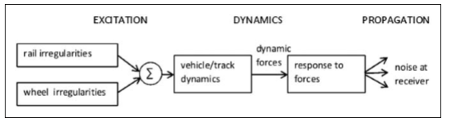
Figure 4. The model used to determine the forcing frequency (Grassie, 2012)

Guide Arm Design

Design Specifications
One of the main design specifications for the new design of the guide arm was to incorporate a spring-loaded wheel assembly. The goal of the spring-loaded assembly was first to help keep the bogie centered on the track. Additionally, the spring-loaded wheels of the guide arm will reduce vibrations to the bogie and reduce wear to bogie wheels. Lastly, the spring-loaded assembly would improve the performance of the bogie around curved-sections of the track. Another design specification deals with the packaging of the guide arm. The guide arm assembly is to be located between the gaps of the track. The gap between either side of the track is 13.4 centimeters. This means that the guide arm assembly design is limited to a width of 13.4 cm. The next aspect of the design was optimizing the solution; this deals with keeping the weight of each guide arm assembly below 15 kg. Also, easy assembly for all of the guide arm parts is essential. The reason for this remains fast and efficient maintenance which is only possible with interchangeable parts. There will be two guide arm assemblies mounted on the slave bogie, and one on the drive bogie. Thus, it is important to have as many interchangeable parts as possible for maintenance and easy assembly. Lastly, all the components of the guide arm assembly should have a minimum factor of safety of 2.

Prime Design Explanation
Before arriving at the final design solution for the guide arm, students went through multiple design iterations. There was also rapid prototyping done on one of the design iterations of the guide arm wheel assemblies presented in figure 5. The result was a design solution that meets all of the design specifications required. The final design includes a total of 13 main components. Also, students were able to change the design to no longer use 5 mm thick steel; instead, only implement 3 mm thick steel to making welding easier and decrease the cost of the material. Figure 6 illustrates the completed guide arm assembly of the prime design. There is one spring-loaded wheel assembly on each side of the guide arm to help the guide arm be centered between the track. The spring-loaded wheel assembly has slots to guide the movement of the wheels as shown in Figure 7. The tabs that run inside of the slot have a rectangular design to prevent the wheels from pivoting in the slots. Figure 7 provides the exploded view of the wheel assembly to illustrate the implementation of the spring. The spring is located inside of the wheel assembly. Another important feature of the design is to be able to fit the 13.4 cm gap of the tracks. In the fully compressed state, the assembly only occupies about 8.7 cm between the tracks.

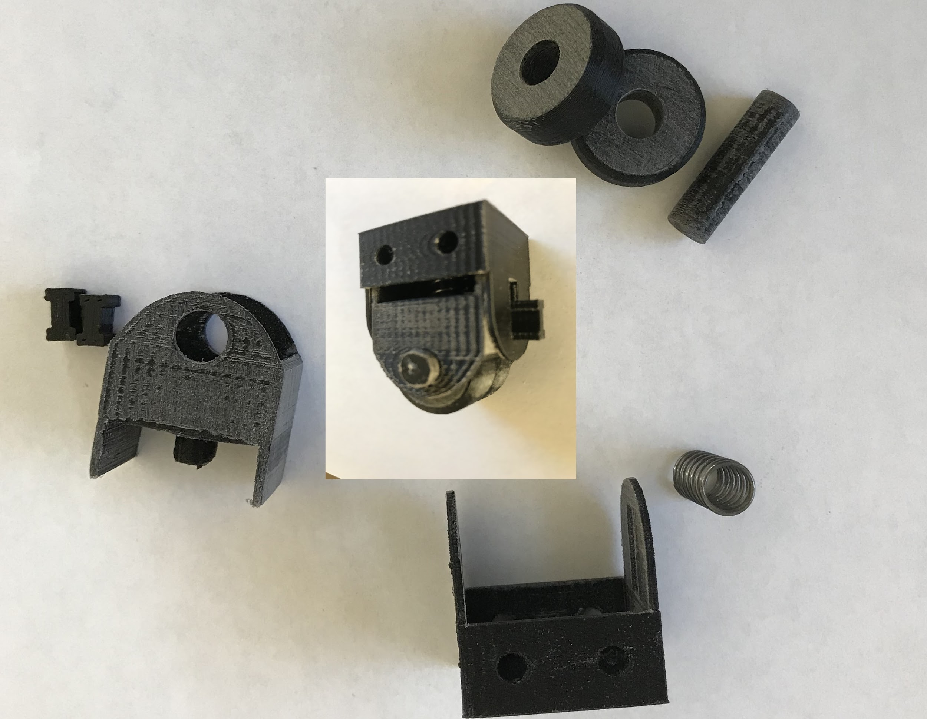

Figure 5. This is an image of the rapid prototyping which was done for the spring-loaded wheel assembly.

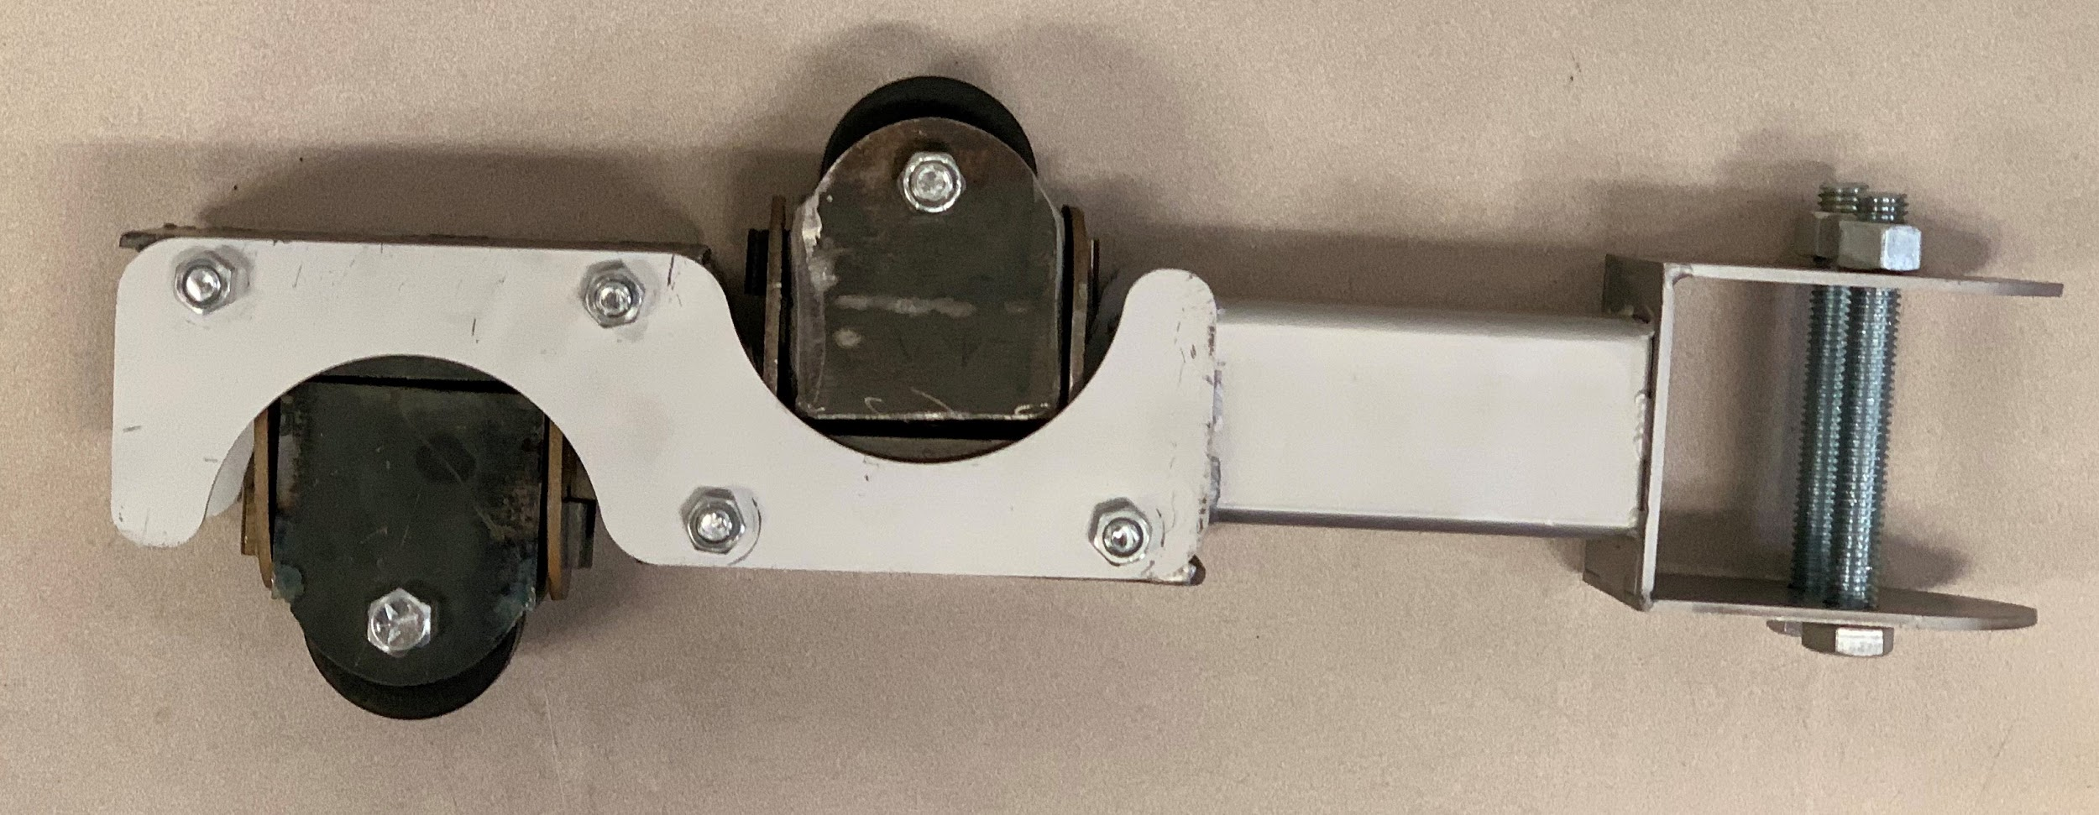

Figure 6. This is an image of the assembled and manufactured drive bogie guide arm.

Supporting Analysis
Force analysis was completed with the guide arm which was necessary for assisting in choosing the correct spring (for prototype testing). The guide arm assembly is going to experience the most amount of force when it enters the curved section of the track after going through the switching section of the track. The main force which would be acting on the guide arm during this time stands to be a centripetal force. However, the total centripetal force acting on the assembly must be doubled because there are two spring-loaded wheel assemblies in opposite directions. The maximum force that would be exerted on the whole guide arm is calculated to be about 192 Newtons as shown in Appendix B. This information was then used to find the spring with the corresponding spring stiffness rate. The loading force for then used to perform finite element analysis using SolidWorks.

Manufacturing of Design
When designing solutions, it is important to keep in mind the design will be manufactured. This was one of the reasons for switching from 5mm to 3 mm thick steel stock for the design. The main hardware for the design such as wheels, spring, square tubing, and mounting hardware such as bolts, nuts, and washers were purchased from McMaster Carr; details about the selected spring are provided in Appendix B figure 2A. The waterjet from the central shop was used to cut most of the components from the 3 mm thick steel sheet shown in Appendix C figure 3A. The slot runners were milled from ⅝ in diameter rod down to square tabs. The rod was also turned on the lath to reduce the diameter and then use the component to hold the spring in place inside the sub-assembly. The milled and turned components are shown in Appendix C figure 3B. Then the pieces of the guide arm were TIG welded together creating to assemblies. Appendix D illustrates the tack welded sub-assembly parts. One is the arm itself and the other is the sub-assembly which contains the wheel and spring.

Analysis/Validation/Testing
For the guide arm, there are some design specifications that the design needs to achieve. Firstly, the design needs to have a spring-loaded assembly and have interchangeable components. It can be seen in Figure 7. that the sub assembly incorporates a spring, and the sub-assembly is interchangeable between the slave and drive bogies. Another design specification was to minimize the mass of each complete guide arm assembly keeping it below 15 kg. Using a hand-held scale, students measured the mass of the guide arms which can be seen in appendix E figure 5A and figure 5B. The slave bogie guide arm has a measured mass of about 4.5 kg, whereas the drive bogie guide has a mass of around 3.9 kg. Also, it is essential that all designs meet a minimum factor of safety, the goal for the guide arm design was to have a minimum factor of safety of 2. Using the calculated maximum loading conditions, FEA was performed on both the slave and drive bogie guide arms. Appendix F figure 6A and figure 6B show that both the guide arm designs have a minimum factor of safety of 7.4, which is well above the minimum of 2. Another important specification for the guide arm was to fit inside the guideway gap of 13.4 cm. Figure 8 illustrates that the guide arm fits inside the guideway gap with space for the wheel to be compressed. Students were able to connect the three guide arms to their respective bogies; however, students were not able to successfully test the operation of the guide arms.

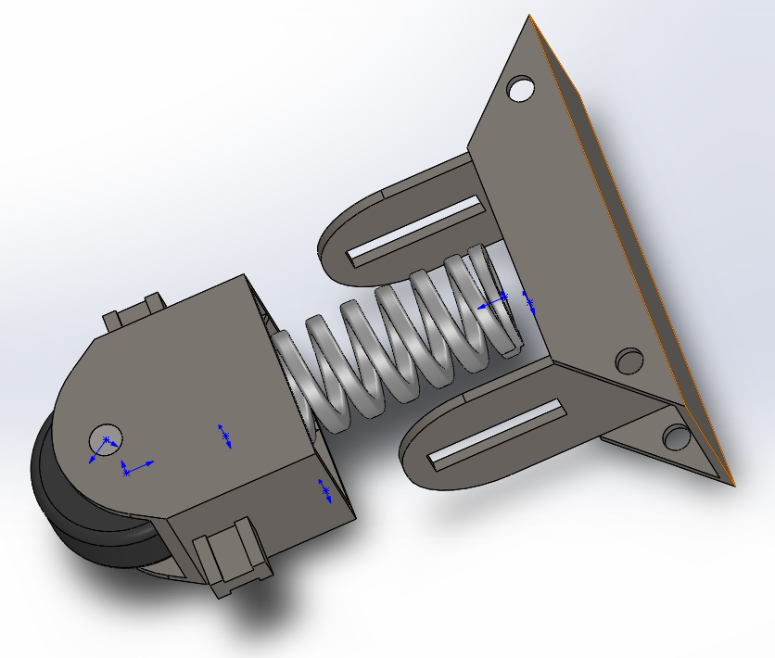
Figure 7. A partial exploded view of the sub-assembly depicting the location of spring.
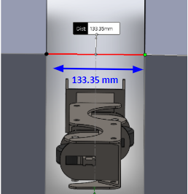

Figure 8. A depiction of the drive bogie guide arm in fully compressed condition inside the guideway gap.

Articulation Design

Design Specification
When designing the articulation system, there were a few design requirements that needed to be considered. First, the design needed to be easy to manufacture. Second, the design needed to be easy to assemble and disassemble. Third, the design needed to allow the wheels to turn 15 degrees in either direction. And lastly, the design needed to weigh less than the last system while still being strong. All these requirements were being considered while designing the new articulation system.

Prime Design / Manufacturing of Design
When designing the new system, manufacturability was highly considered. Each part needed to be designed in a way that could be easily machined in the shop. Cost was another factor that was considered when designing. To keep the design of the articulation system uniform with the rest of the bogie the structure was designed using 3mm steel sheets. These panels have tabs around their parameter that allow them to easily connect with other panels, shown in Figure 9. The tabs help with alignment of the structure and allow the manufacturer to easily weld panels together. These panels can also be cut from a single piece of 3mm steel which will greatly reduce weight and cost. Figure 10 shows the structure assembled.
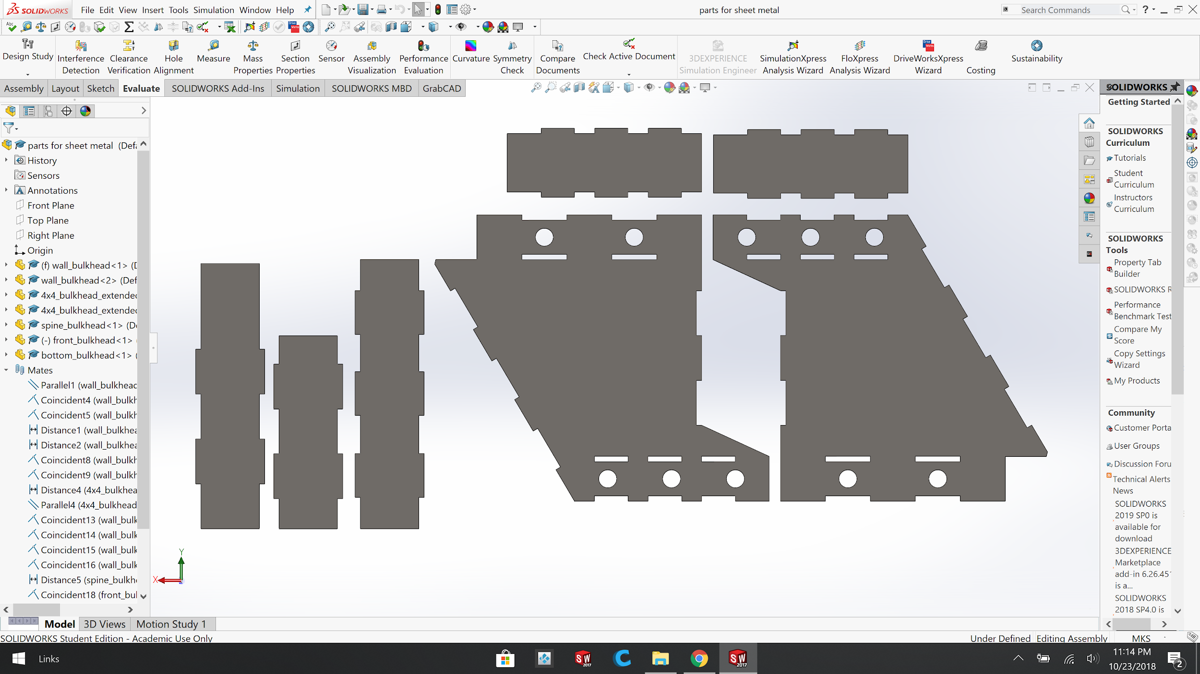
Figure 9. Panels for Articulation Structure.
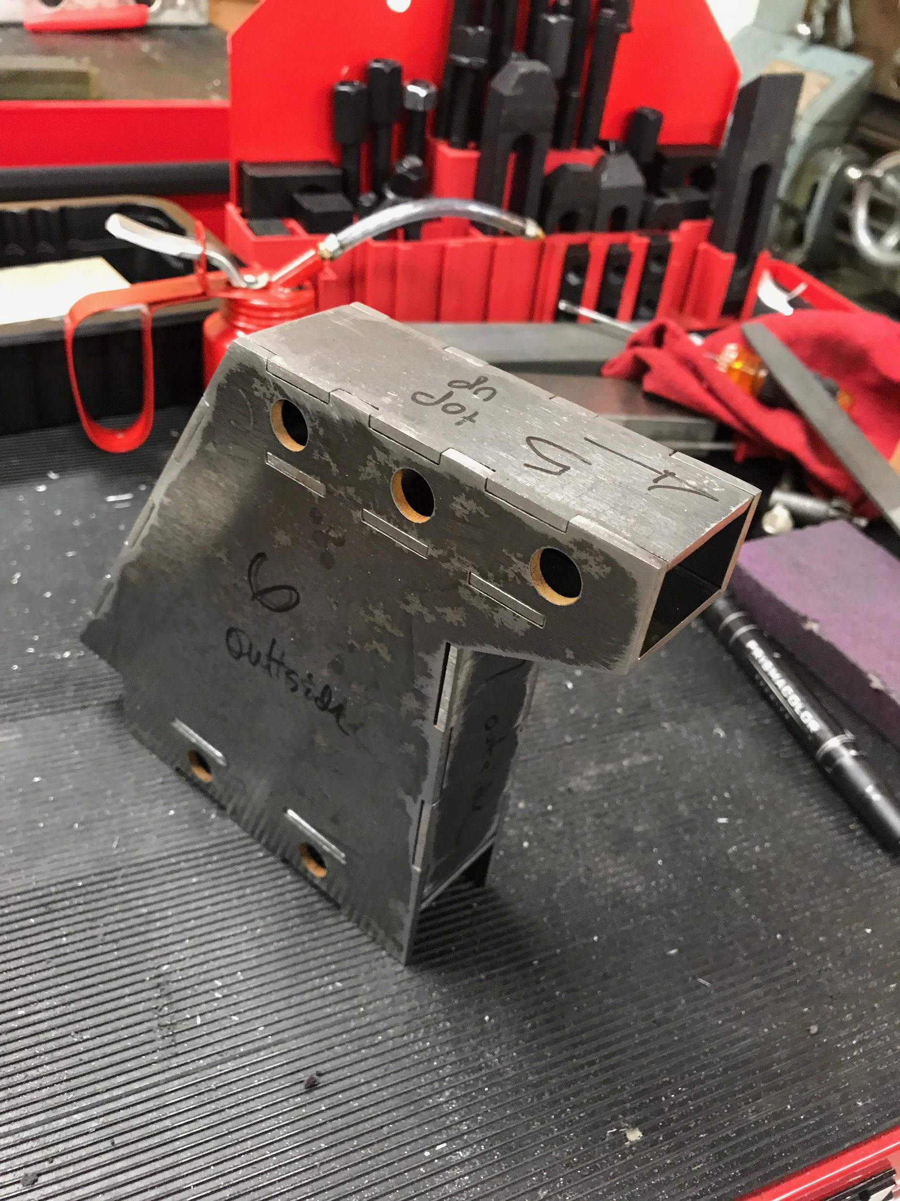

Figure 10. Assembled Articulation Structure.
The Articulation system allows the wheels to pivot with the use of a system of bearings. The system is shown in Figure 11.

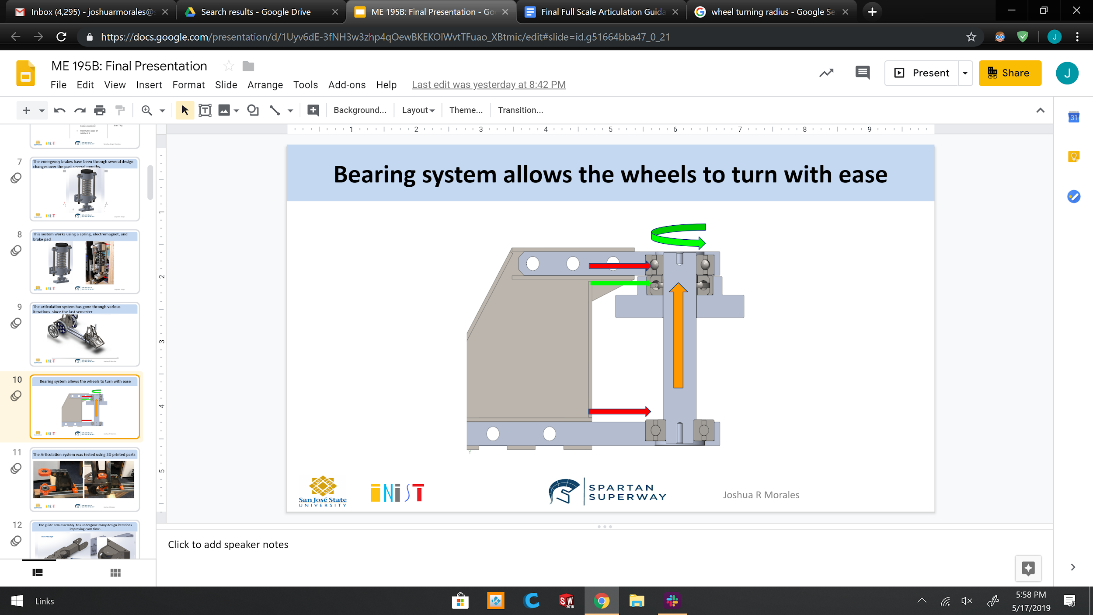

Figure 11. The bearing system used for the articulation of wheels
This design allows the middle component, which is connected directly to the wheels of the bogie, to spin freely under load. This is possible with the use of two flange bearings, shown in red. These flange bearings are responsible for taking in any radial load that may come when the bogie is turning. The flange bearings keep the middle connecting rod upright, which help keep the wheels of the bogie upright. The thrust bearing, shown in green, can handle any axial load. This load comes from the overall weight of the bogie. The weight of the bogie will push up on the middle component, shown in orange. This will compress the thrust bearing up against the top flange bearing. The top and bottom flange bearing are mounted on an aluminum housing as shown in Figure 12A and B. The thrust bearing is placed in an aluminum mount that connects directly to the housing of the slave bogie.
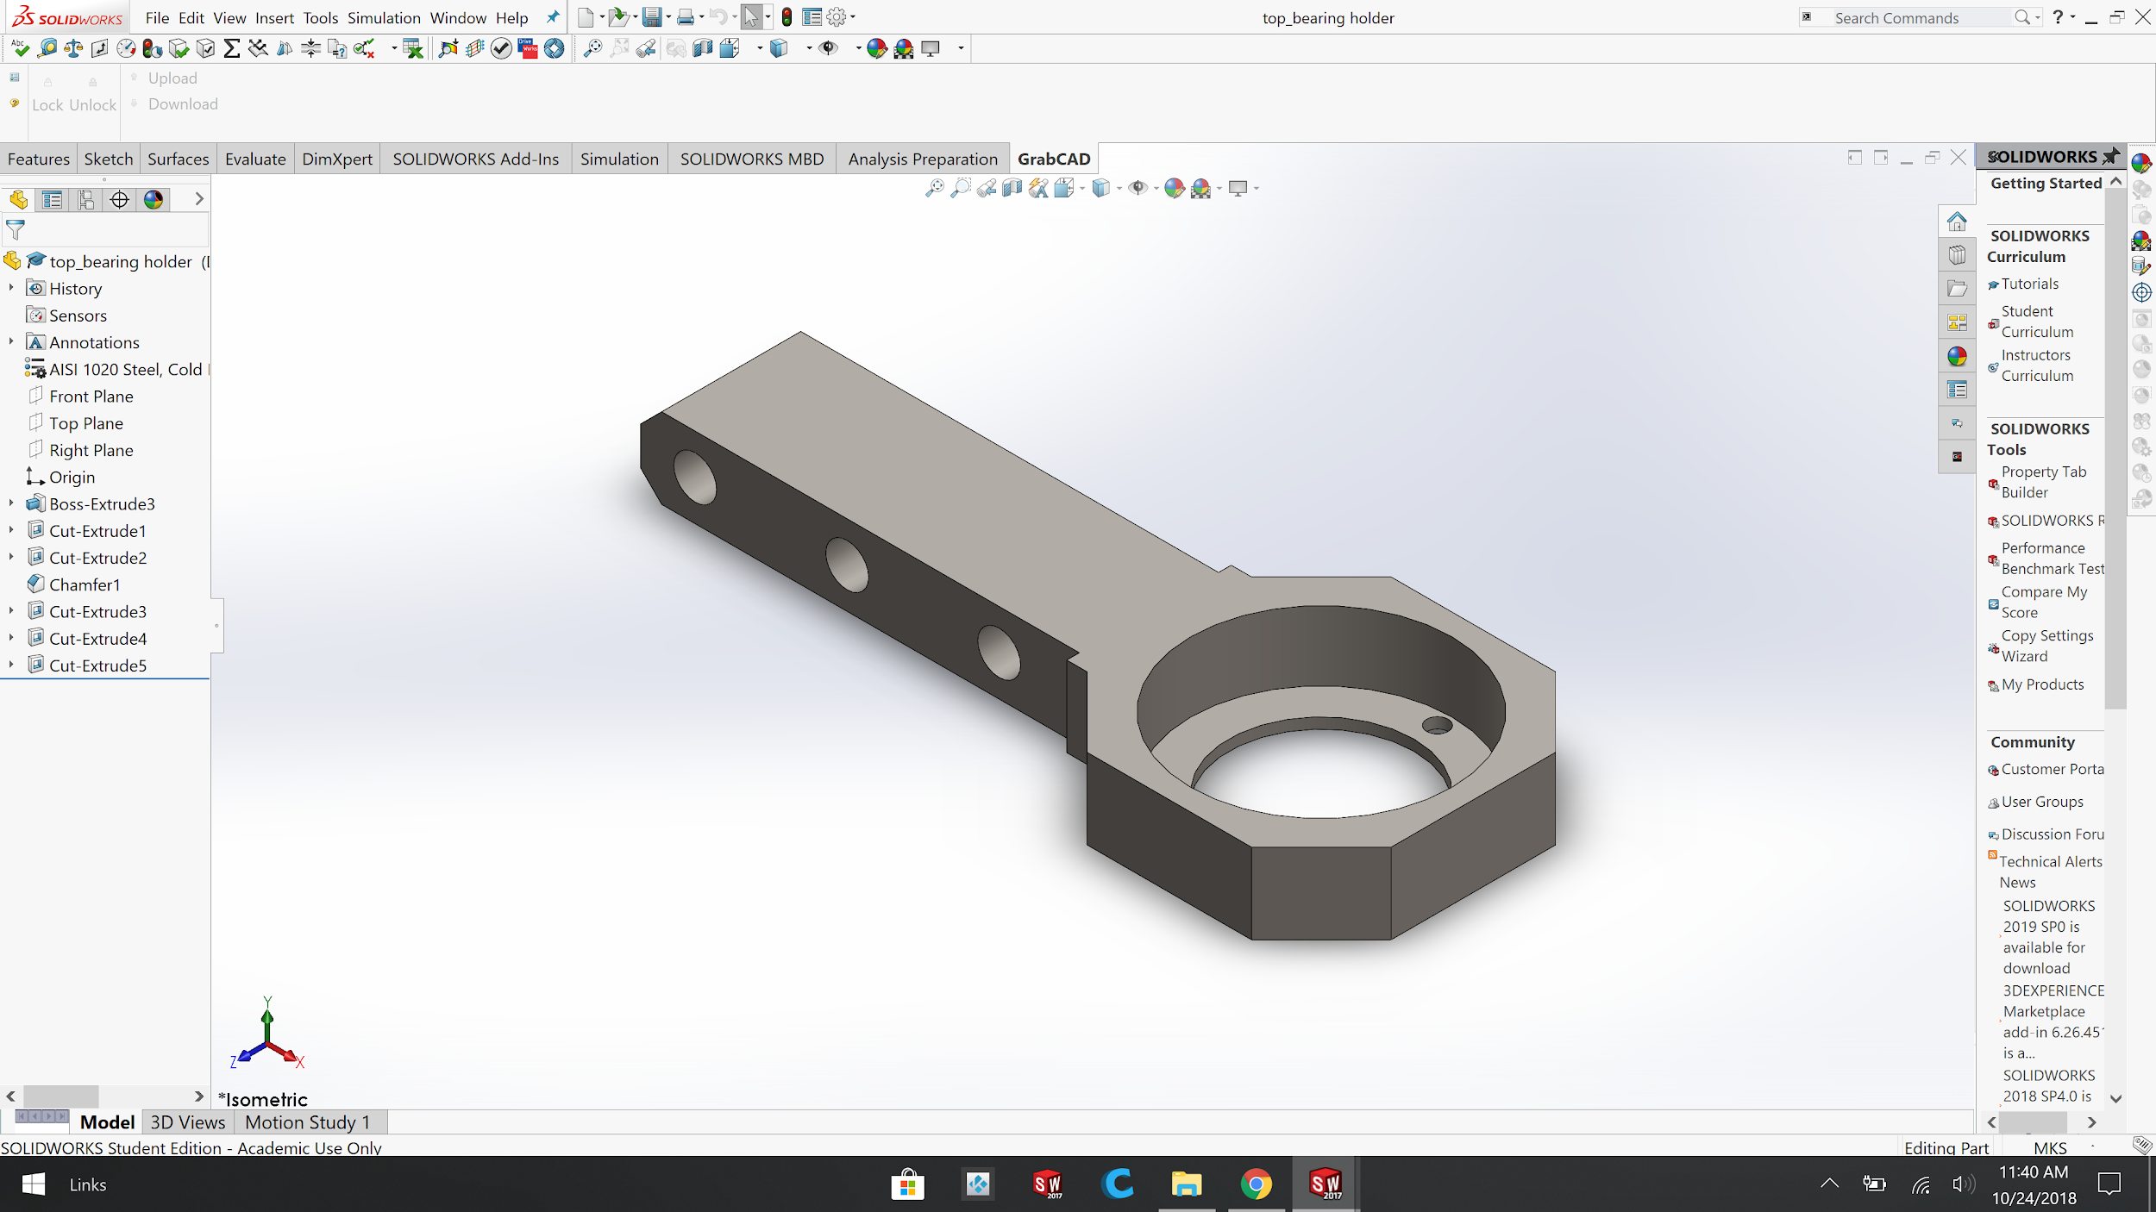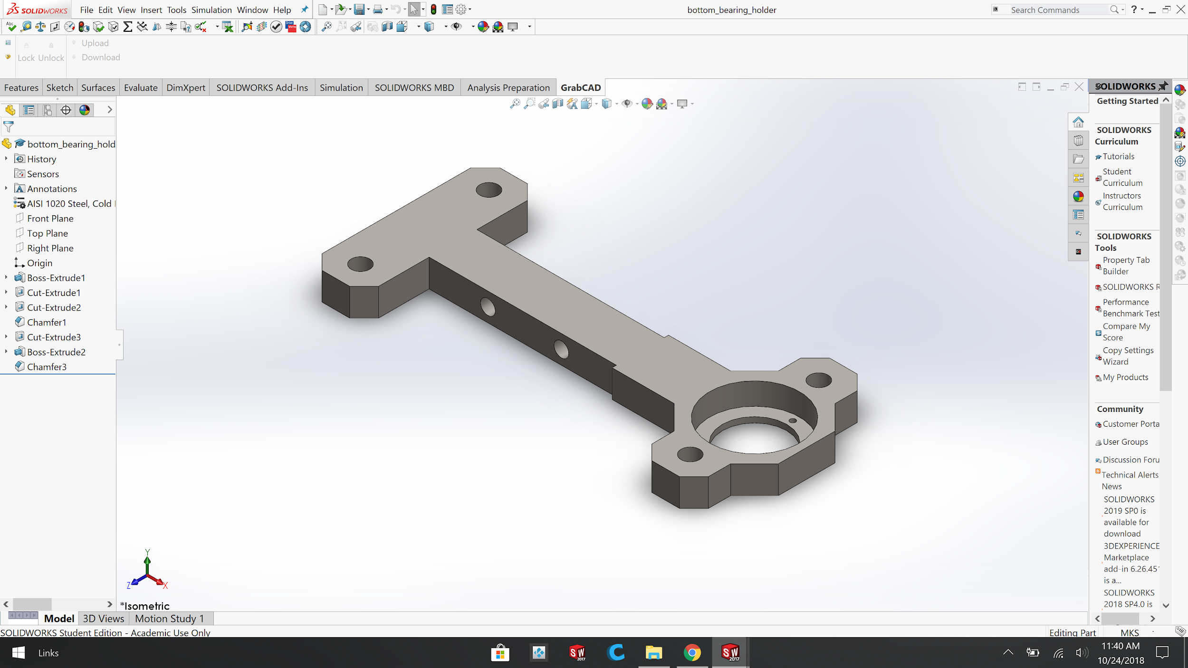

Figure 12A. Top flange bearing carriage used to hold flange bearing. 12B. Bottom flange Bearing Carriage used to hold flange bearing
Both parts can be machined out of 6061 aluminum. These bearing carriages mount on to the main articulation structure using 7/16 machine screws Figure 13. The bottom bearing carriage has mounting points that allow the articulation system to be securely mounted on the chassis of the bogie (See Appendix G, Figure 5F). The original design used pins and snap rings to hold these in place. Due to manufacturing difficulties, the pins were replaced with 7/16 grade 8 machine screws. Changing from pins to machine screws reduced cost in manufacturing and reduced potential problems with proper fitment and clearances.
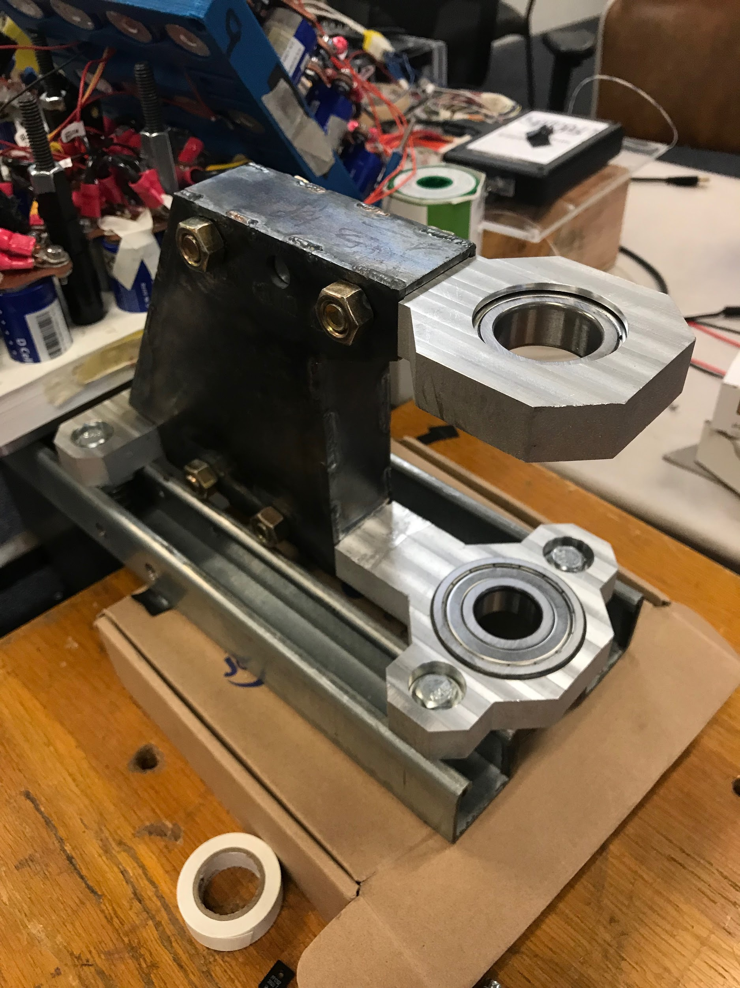
Figure 13. Articulation system with 7/16 grade 8 machine screws
The complete articulation system can be seen in Figure 14. This articulation system allows the wheels to have a turning radius of 30 degrees on when the system is installed on both the front and back wheels. The overall dimensions of the structure are 11.3 cm x 30.5 cm x 16.4 cm. Due to the design requirements from other teams we were only able to install one articulation system on the front wheels. Installing articulation to both front and rear wheels would require an increase in the length of the chassis of the bogie. This reduced the turning radius to 16.3 degrees, which is still above the required design specifications.
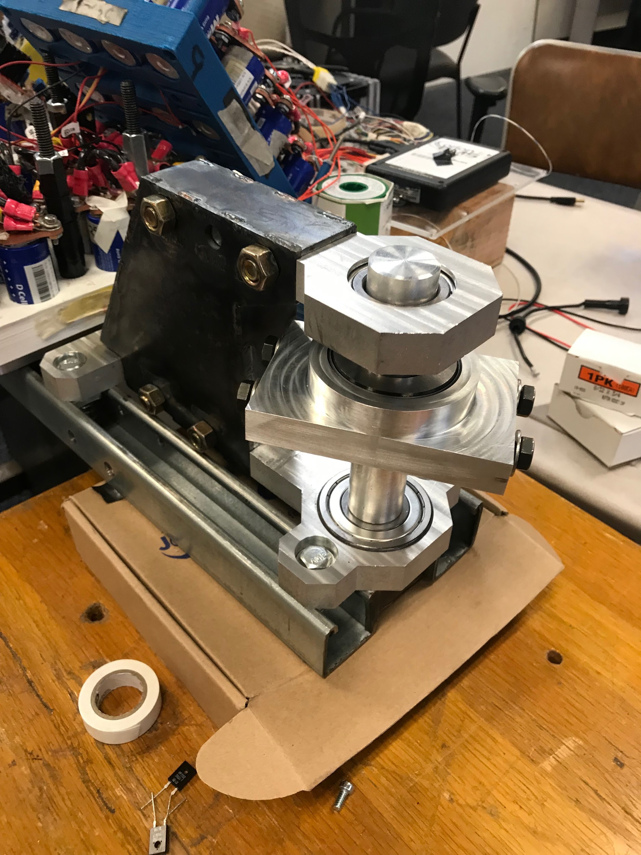

Figure 14. Assembled articulation system installed on the bogies chassis

Supporting Analysis
This articulation system needed to withstand 2500 kg of mass. Finite Element Analysis was performed to see if the design was structurally capable of supporting the weight of the bogie plus its payload. Figure 15 shows the overall structure being loaded with an axial load that equals the weight of the bogie plus the payload.
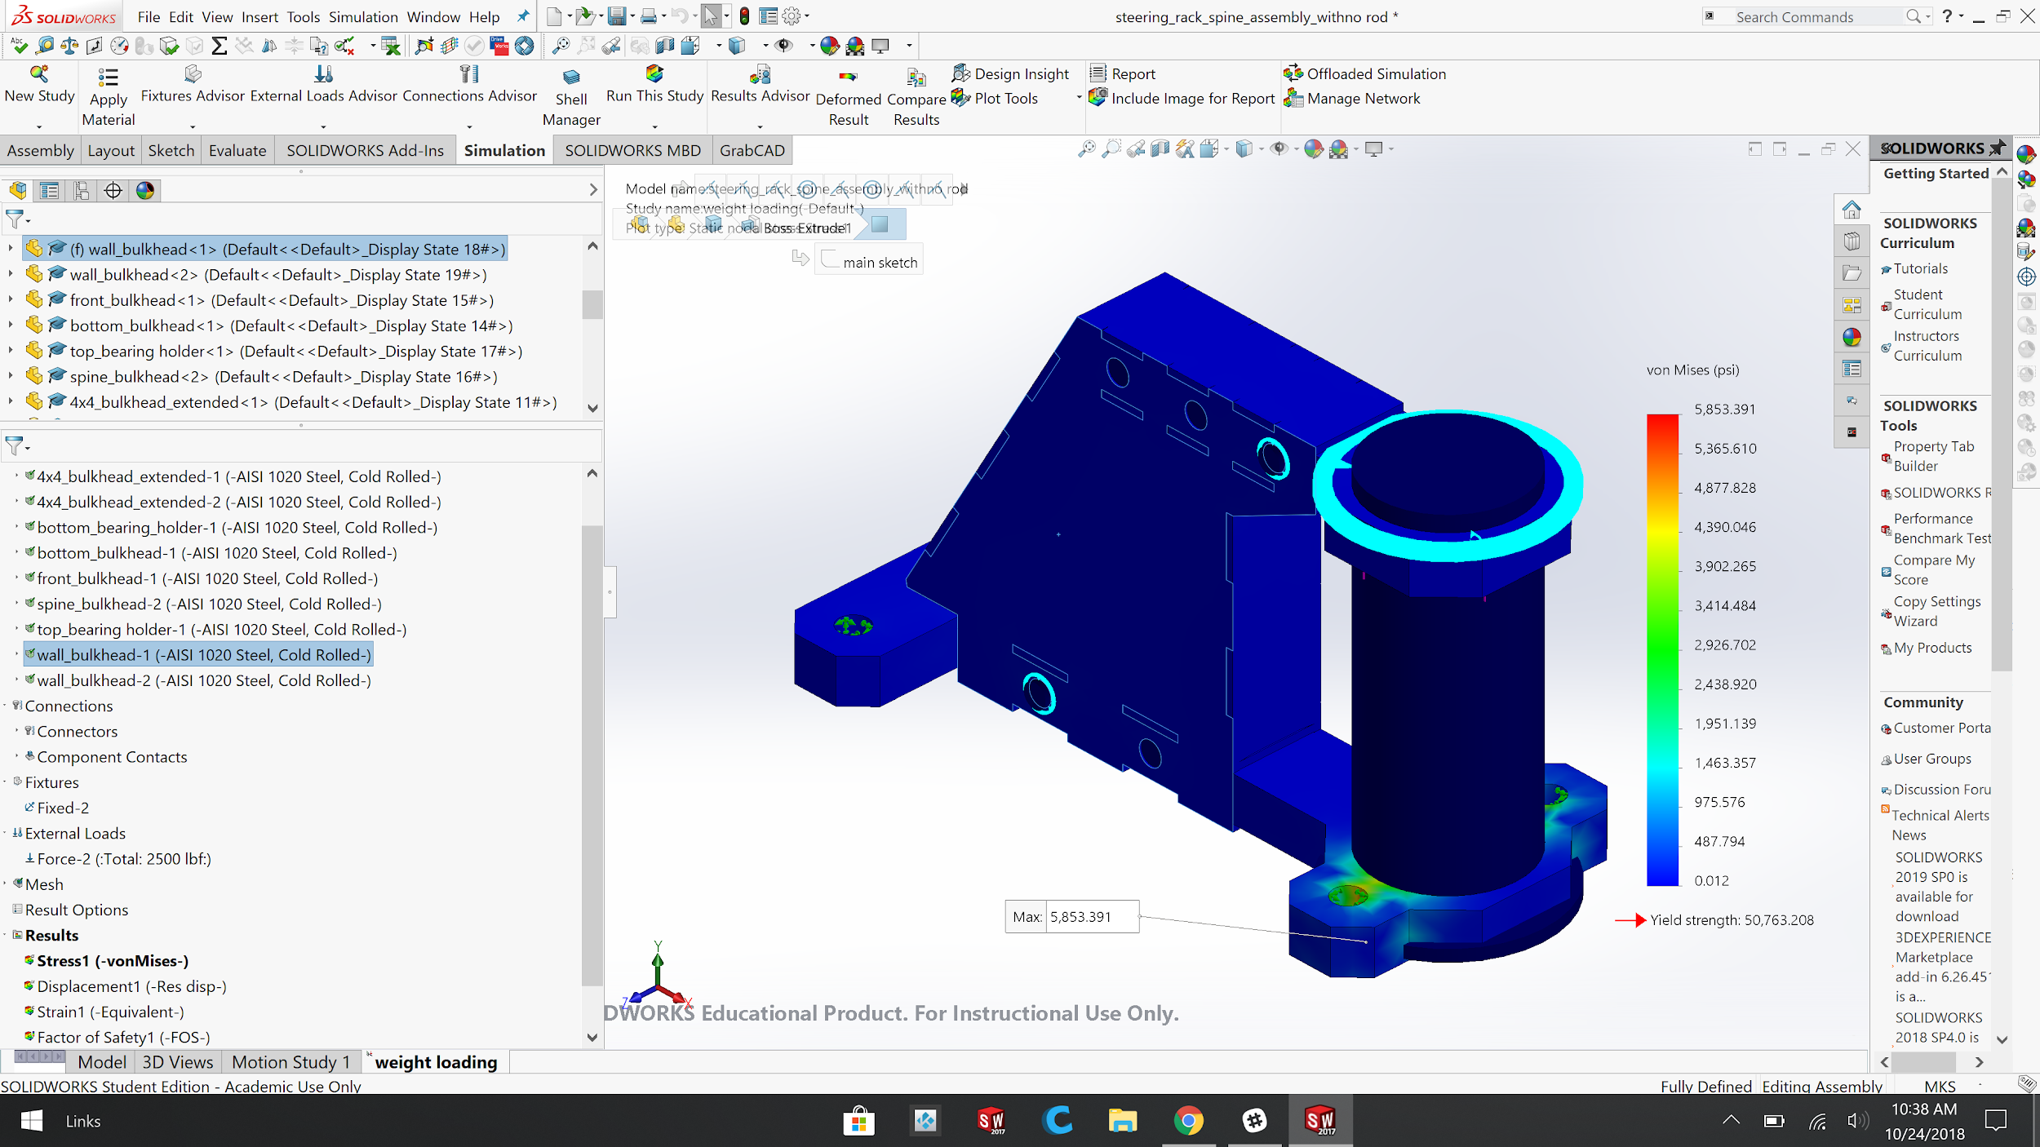

Figure 15. Finite element analysis, axial loading performed on the articulation system to simulate the weight of bogie
The study shows that the overall structure is well below the yield strength of the material. Further analysis shows that the factor of safety for the structure is 8.61 (See Appendix G Figure 5A). The structure does have small amounts of displacement, around .00362 mm (See Appendix G Figure 5B). This displacement is caused by the upward force due to the weight and payload forcing the wheels up against the top bearing carriage. The bearings used on this design needed to be capable of supporting this weight. The top and bottom flange bearings have a radial load of 2404.0 kg and 1950.4 kg respectively. While the middle thrust bearing has a thrust load capacity of 3265.9 kg. Specifications for each bearing can be found in Appendix F Figure 4 A, B, and C. The overall mass of the bogie has decrease.

Many changes were made this semester to make the manufacturing of the articulation system possible. The main part that was changed this semester is the change from steel to aluminum parts. The original design was designed for a real-life application. This semester the main goal was to design a bogie to take to Maker-Faire. Because of this, the overall weight that the articulation system needed to support was reduced drastically. We took advantage of this change and changed some steel parts to aluminum. This change lowered the overall weight of the articulation system and reduced cost and lead time in manufacturing. Another change was the pins used to hold down the top and bottom bearings. Due to delays in the central shop, the team opted out to use machine screws instead of pins. This change eliminated the need for machining and any interference issues that could come from manufacturing. The articulation system was tested using 3D printed parts. This allowed us to test the turning angles and clearance of all of the components before machining parts out of aluminum. Pictures of 3D printed parts are in appendix F.

The articulation system was manufactured at the central shop. The first parts that were manufactured were the housing, shown in figure 16. These parts were manufactured using a water jet. The next step was to sand them down so that they could easily fit together before being welded.
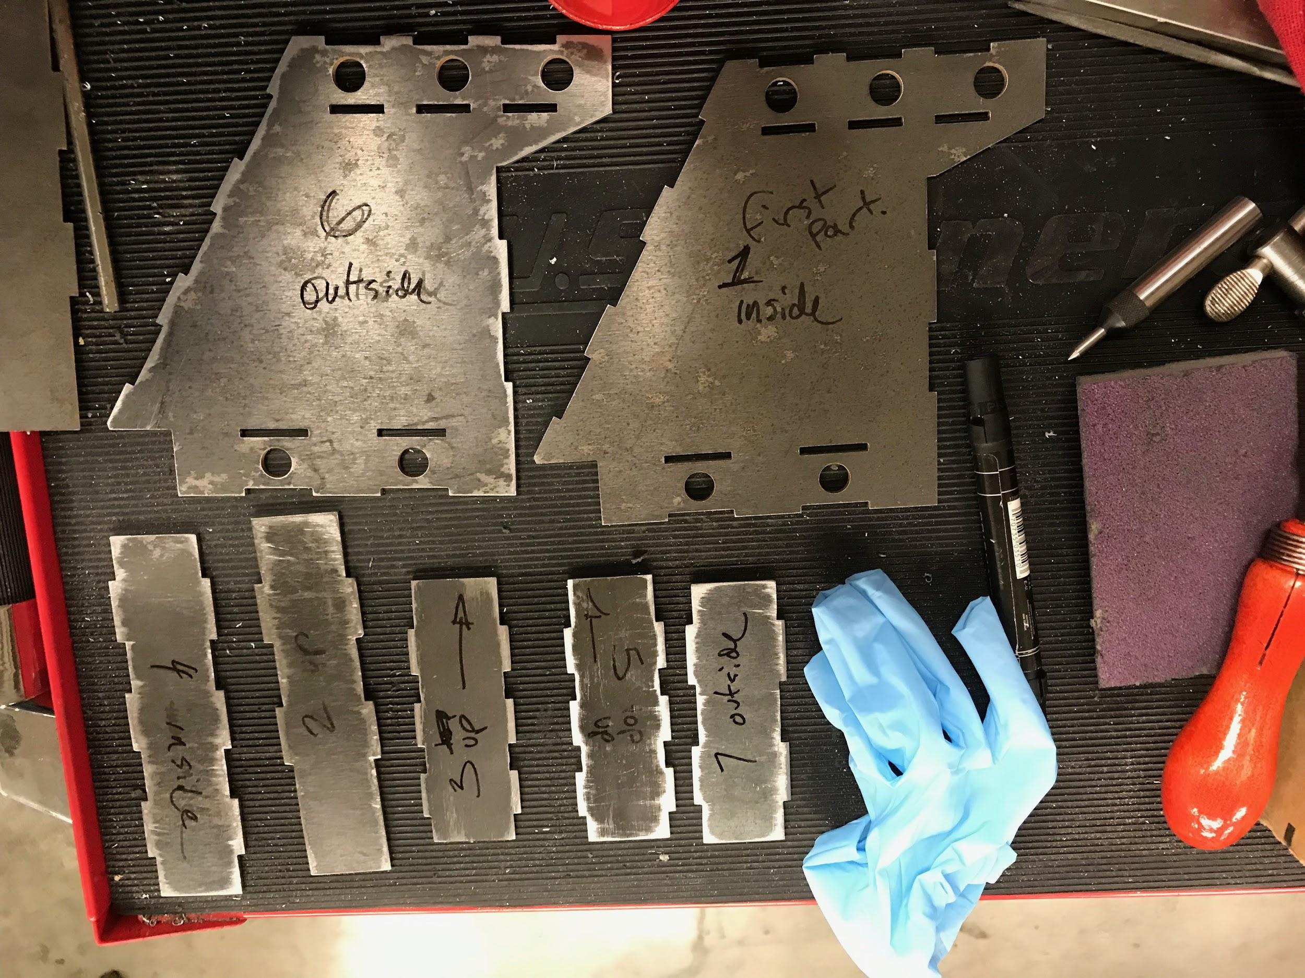

Figure 16. Articulation system housing panels
The bearing carriages were manufactured using a water jet and a CNC machine. Then they were milled so that they were able to fit correctly in the housing of the articulation system. The connecting rod was machined on a lathe. The connecting rod had to fit into different size bearings, because of this it had different diameters at different lengths. A slot had to be made after with a mill to allow the axle to pass through. A picture of the connecting rod is shown in the following figure 17.

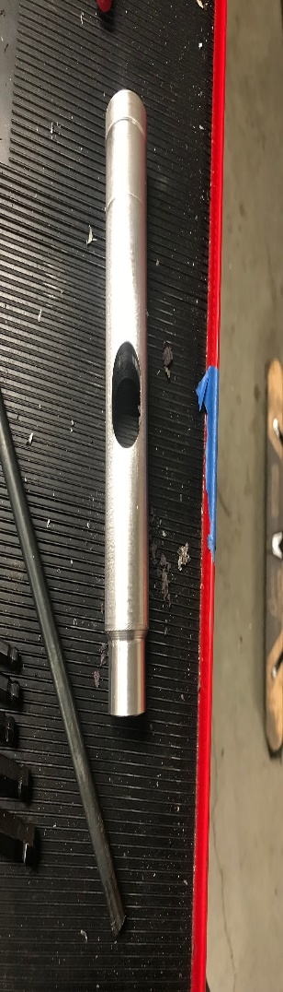

Figure 17. Connecting rod with slot to allow passage of axle
The final steps in manufacturing included creating a bigger slot on the housing of the slave bogie. This was done using a torch. We then needed to create mounting points for the thrust bearing housing. This was done by using an aircraft drill. Due to the shape of the housing and limited space we were not able to use standard length drill bits. The aircraft drills, with their longer length, allowed us to create concentric mounting points.

Emergency Braking Design

Design Specifications
There were several design requirements for the braking system. First and foremost, the emergency braking system will need to be deployed when power is cut to the system. Additionally, the design should be deployable with the onboard control system. For example, if there is a runaway situation where the vehicle is not stopping, the emergency brakes will be deployed to stop the vehicle. The system should be able to stop the fully loaded prototype vehicle travelling at 1m/s within 0.61 meters and the minimum factor of safety of yield needs to be two. The design should also have a method to reset the brake system after deployment. Additionally, the design should be able to be disassembled, inspected, and serviced. Another design requirement is that the inner slider rod should not rotate during brake deployment. Space was not a big issue since the braking system will be mounted below the bogie on the suspension pole.

Prime Design Description
Over the course of several months, the design of the emergency braking system went through many design changes. Each design iteration solved several issues until the design was finalized. A rapid prototype of the design was made to make sure that the design functions as intended. This is shown in Figure 18. The final design is shown below in Figure 19. This system incorporates several components such as brake pad, spring, slider rod, a brake reset mechanism, slider assembly, and armature. This system will utilize an electromagnet to hold the armature, which is a rectangular piece near the bottom of the design. The electromagnet is not in the CAD illustration but is utilized in the physical design.

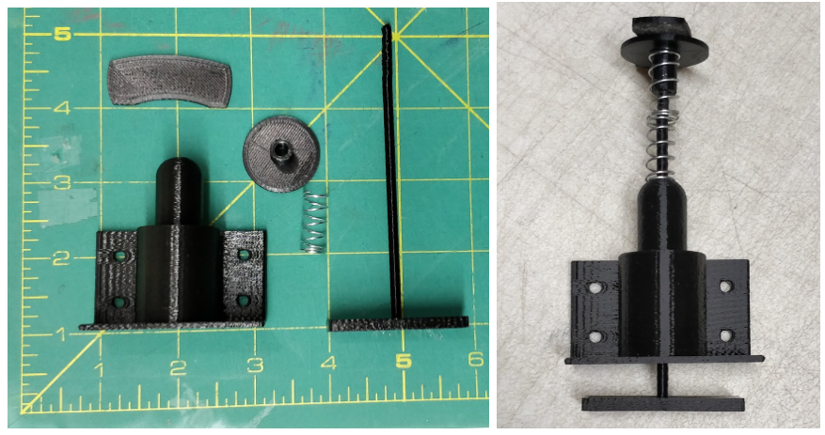
Figure 18. Early prototype of E-brake mechanism

The overall dimensions of the final design are 7.5 cm x 11.4 cm x 21.3 cm. The total mass of the system is 1.3 kg with an additional 1kg for the electromagnet. This totals the mass to 2.3 kg per braking system. The design is made from 6061 aluminum alloy, where the spring and hardware is steel. The system uses a 15.2 cm x 4.9 cm steel compression spring to force the brake pad into the bottom of the track. During normal vehicle operation, the spring will be compressed, and potential energy will be stored. This energy will be stored to be used in an emergency event. The spring will be kept in compression using an electromagnet. This magnet will be attached to the bottom of the armature and will hold the armature in place. With the electromagnet holding the armature, the braking system will be active and ready to deploy. During an emergency situation, the electromagnet will release the armature and the spring will decompress and apply a force to the brake pad. The brake pad will press against the bottom of the track to stop the vehicle. The braking system will be mounted on the suspension pole under the bogie. This is shown in Figure 23.

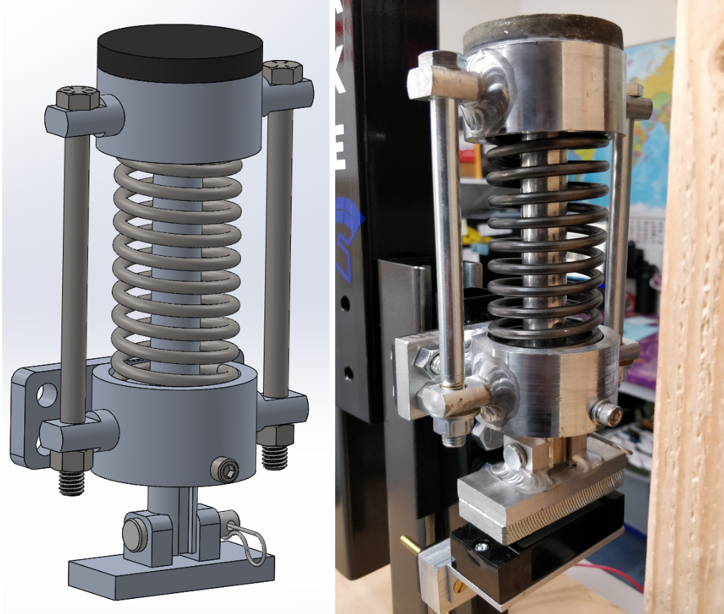

Figure 19. Final design 3D model(left) and manufactured design(right)
The design also features several key features. After testing of the rapid prototype, it was found that the inner slider rod can rotate if a torque is applied on the top of the brake pad during brake deployment. To alleviate this issue, a slot was made on the rod. This slot will align with a machine screw which is located outside the circular slider assembly. This will prevent the rod from rotating during brake deployment. Furthermore, there needed to be a method to reset the brakes back to the original state after brake deployment. Cylindrical pins were added to the sides of the design. These pins have a hole which allows a long bolt to pass through. The nut on each bolt can be tightened using a wrench or impact driver to reset the system back to active conditions. An exploded view of the design is shown below in Figure 20 which shows all components in the system.

This design is made for the prototype version of the Spartan Superway vehicle. A larger system will need to be made for real deployment. The design will remain the same but will be scaled to a larger size. Additionally, the material of the system will change from aluminum to steel for further strength.

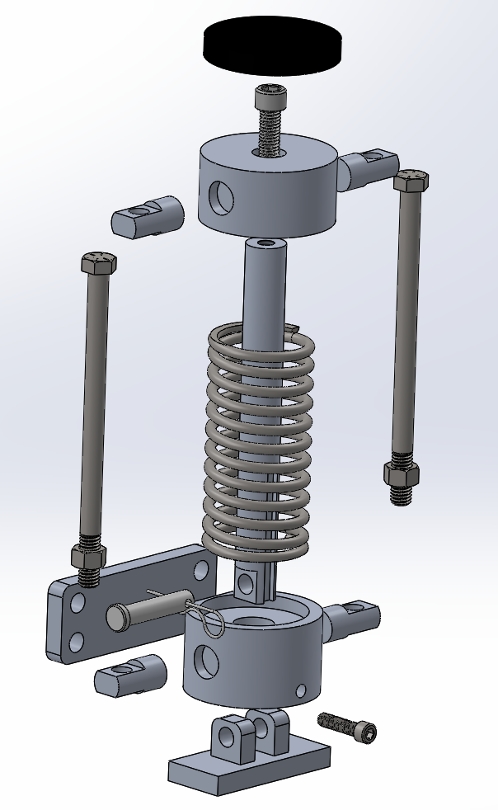

Figure 20. Emergency Braking Exploded View

Supporting Analysis
The first step in the calculation was to find the total force needed to stop the vehicle within 0.61 meters. The estimated mass of the fully loaded slave and master bogie prototype is 400kg. The max speed of the bogie roughly 1 m/s (2mph). Utilizing the work-energy method, the total kinetic energy of the vehicle can be found.

$KE=0.5mv^{2}=0.5*400*{.89}^{2}=158.42 Joules$(1)
$Work = Force * Distance$ (2)
$$158.42 Joules÷0.61 meters = 260 Newtons$$

There will be two braking systems utilized on the bogie
$$260÷2 = 130 Newtons per system$$

Therefore, 130 Newtons of frictional force from each assembly will stop the bogie within 0.61 meters (2ft).

The brake pad that will be used with this system has a friction coefficient of 0.55 with iron. On the other hand, steel has a friction coefficient which is slightly lower than iron. Therefore, it is estimated that a friction coefficient of 0.45 is possible with a steel track. The coefficient of friction would have to be an assumption since it cannot be determined without testing.

$Frictional Force = μ * Normal Force$(3)
$130 N= 0.45 * Normal Force$
$$Normal Force = 288.8 Newtons per system$$

Therefore, each spring needs to provide 288.8 Newtons (65 Lbf) of force on the steel track to stop the vehicle in 0.61 meters.

From these calculations, a spring was selected that could provide at least 288.8 newtons of force. Furthermore, an electromagnet was sized, and it was determined that a 578-newton holding magnet will be used to hold the spring. The spring that was selected has a maximum load of 578 Newtons and a spring rate of 6.7 newtons per millimeter. The spring is 15.2 cm long and has an outer diameter of 4.9 cm. Details of this spring are shown in Appendix H Figure 6B.

The electromagnet requires a current of 150 mA at 12v.
$Power = 0.15A*12v =1.8 Watts per system$ (4)
Detailed electromagnet specs are shown in Appendix H Figure 6A

The next step was to perform finite element analysis using SolidWorks on all the components. During the analysis, the spring was removed and replaced with equivalent forces. First, a static analysis FEA was performed on the deployed brake assembly. A minimum factor of safety of 4 was achieved. This is shown in Appendix E Figure 3A. Next analysis was done on the armature and pin and a minimum factor of safety of 8 was achieved. This is shown in Appendix E Figure 3B. Lastly, an analysis was done to simulate the spring compressor compressing the spring back to its original state. A minimum factor of safety of 13 was achieved. This is shown in Appendix E Figure 3C.

Manufacturing of Design

Manufacturing of the braking system was mostly done at Makerspace. Manufacturing took about seventy hours, as it was all made by a manual lathe and end mill. Each system had about 11 parts to manufacture. These parts include four side pins, one top piece, one bottom piece, one rod, one bracket, one armature plate, and two armature supports. An example of the machining process is shown below in Figure 21 and completed machined parts are shown in Figure 22 below. Furthermore, a circular brake pad was cutout of a brake lining material using a hole saw. The aluminum welding work was done by a specialized aluminum welding shop. All the hardware for the design was purchased from Ace Hardware. The original plan was the permanently attach the braking system to the suspension pole, but after further thought, it was determined that this was not the best idea. The brake pad should ideally be about a quarter of an inch away from the bottom of the track at all times. It was determined that an adjustable mechanism should be used since manufacturing defects can occur in the track. Professor Furman gave a unique idea to mount a sliding unistrut on the sides of the suspension pole to make the brakes adjustable. The sliding mechanism was completed, making both brakes adjustable.

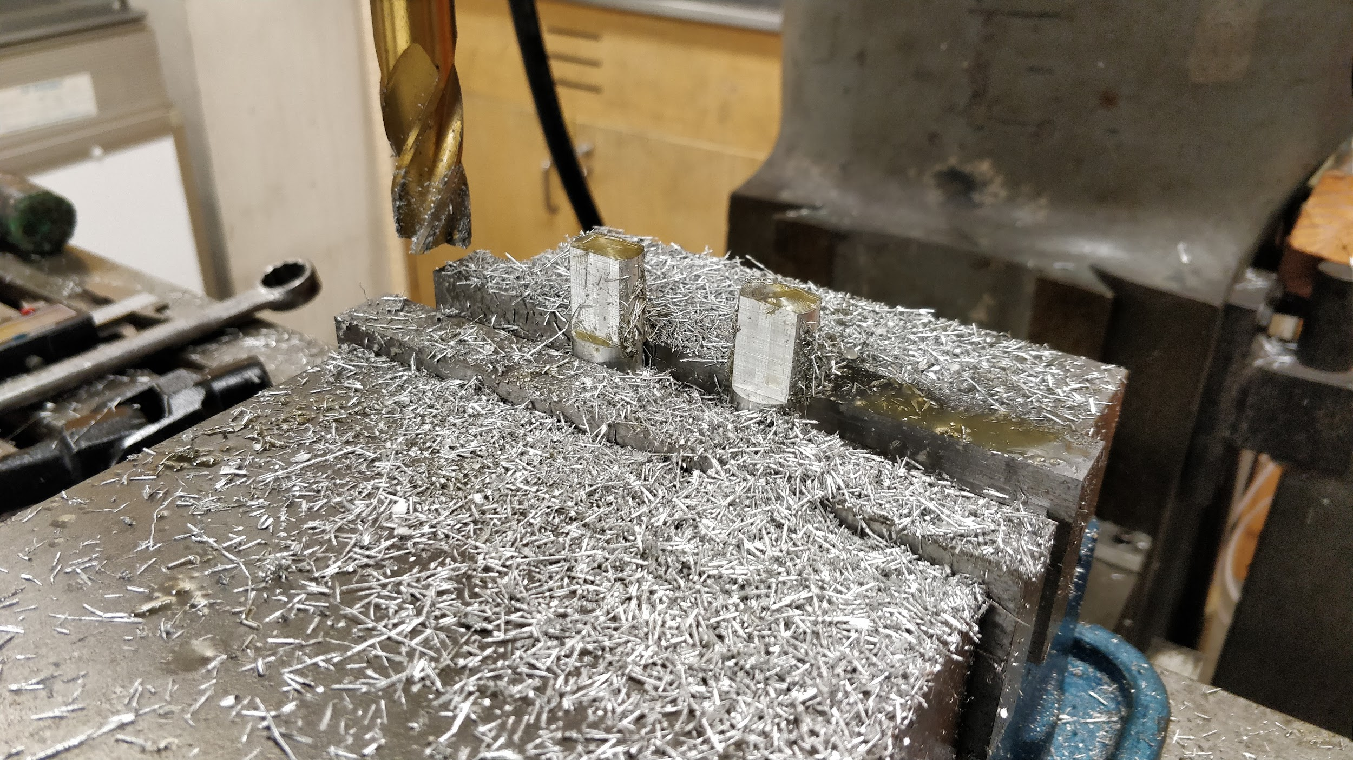

Figure 21. E-brake parts manufacturing process

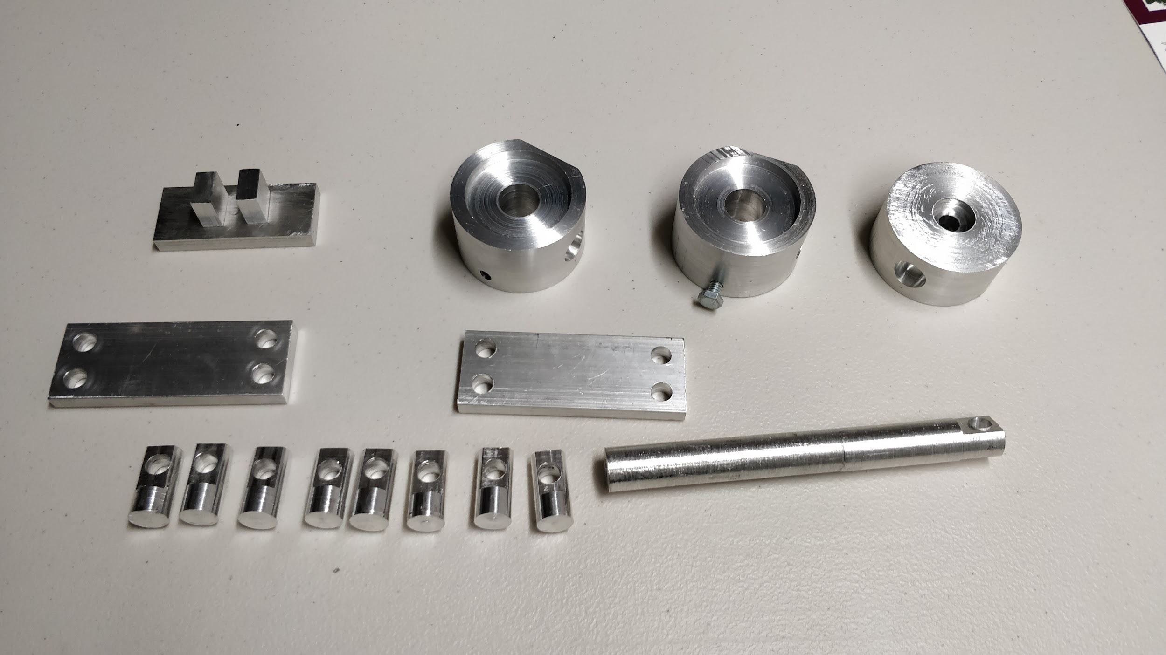

Figure 22. Several manufactured parts of the E-Brake system

Analysis/Validation/Testing

The braking system had several goals and specifications. Testing began right after the system was assembled together. Each braking system is preloaded to 400 newtons, so an apparatus had to be made for safe testing as shown below in Figure 23. During the testing phase, both systems were cycled multiple times using an electromagnet. The 578-newton electromagnet was successfully able to hold a 400-newton system stationary. As the power to the magnet was cut, the system sends the brake pad upward using the preloaded spring. After the system is deployed, it must be reset back to original conditions. The two bolts on each side of the assembly were tightened, and this allowed the spring to be preloaded back to 400 newtons. During this process, the armature plate returns to its normal position. In the next steps of the testing process, the system will be mounted underneath the slave bogie. Unfortunately, this may not happen this semester as the track is not fully completed. Additionally, the track would also need to have metal underside for testing, as wood would not work. The system will be tested to see whether the vehicle stops within 0.61 meters, which is the calculated value.

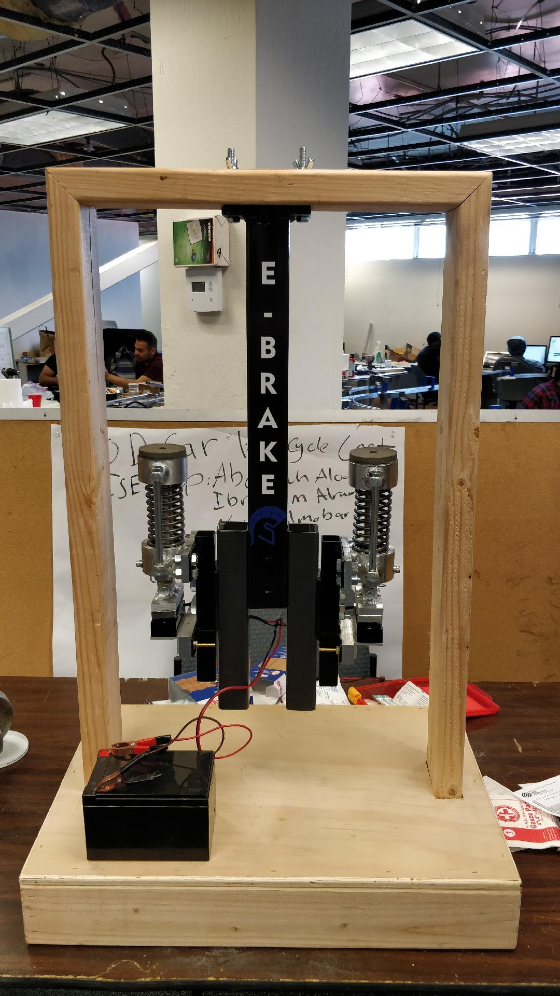

Figure 23. E-brake system mounted and assembled on the test station

Project Expenditures
The team was in charge of building three systems which included: articulation system, guide arm system, and emergency brakes system. Building these three systems ended up costing around $950.00. Figure 24 breaks down the total expenses into three groups. The first is the expenditures on acquiring metal stock for the three systems, and the other two groups are expenditures on parts and welding costs. A detailed breakdown of team’s expenditures are provided in the Bill of Material as part of Appendix J. The total $950.00 helped to fund one articulation system, 2 emergency brakes systems, and three guide arm assemblies. Students also calculated the cost of each systems assembly. One articulation system assembly approximately cost $173.00, a complete guide arm assembly costs about $138.00, and one emergency braking assembly cost around $160.00.
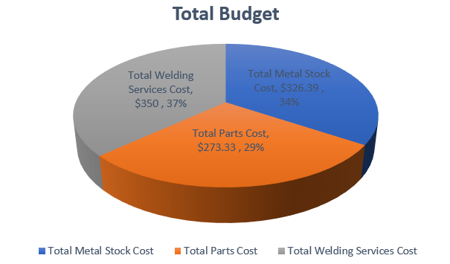

Figure 24. The total expenditure of the team is $949.72.

Conclusions and Suggestions for the Future

Guide Arm
The current guide arm meets the design specifications; it has a high minimum factor of safety. Additionally, it has a much lower mass than the target 15 kg specification. Furthermore, the spring-loaded sub assembly will not only help to keep the bogie centered, but also reduce wear to the bogie wheels and noise to the cabin. The interchangeable subassembly for the slave and drive bogie simplifies both the manufacturing process and maintenance process. The guide arm assembly also will fit inside the 13.4 cm gap determined by the guideway. Nevertheless, there always remains room to grow and improve, and the guide arm design is no exception.

Being part of the Spartan Superway has been a great learning experience, and it has helped me grow as both a person and an engineer. One of the biggest benefits of working on the Spartan Superway has been the aspect of working in coordination with multiple teams. This has helped me improve my organizational and communication skills which are important skill sets for all successful engineers. Furthermore, working in teams has also illustrated to the students' importance of well-planned projects. Students learned that for the successful execution of projects it is important to acknowledge your dependencies for the project. Also, then have a planned contingency in place if there are any unforeseen changes in the plan.

There are some suggestions that can be implemented by the next group of students. The end goal of Spartan Superway is implementation into the real world which will require the bogie to travel at much higher velocities and carry a higher payload. Thus, this will make it a necessity to implement dampers into the sub-assembly shown in figure 7. This will be required for creating a stable system to deal with the irregularities of the guideway. Furthermore, the incorporation of the damper will make the motion of the sub-assembly smoother. Another change for future groups to consider is the orientation of the sub-assemblies. Currently, they are aligned horizontally; however, the design would benefit from having the two subassemblies stacked vertically on top of each other. This would also the guide arm to maneuver around a smaller guideway radius. Moreover, this reduction in the total length of the guide arm will reduce stress on the mounting holes from the guide arm to the bogies due to a decrease in the moment arm.

Articulation
The design of the articulation system met all of the design specifications that were selected at the beginning of the project. The system has a turning angle of over 15 degrees, it is able to be assembled and disassembled easily and the total mass was reduced by less than half of the original mass. This was made possible by using superior design techniques, a better selection of materials and using efficient manufacturing processes. Working in the Spartan Superway has been a rewarding experience. It has taught me how to work efficiently with teams. One of the main skills I've taken away from this experience is the ability to communicate efficiently. It is very important to communicate with other teams especially if your components affect others. Communication is key when creating any engineering project.

There are some things that could be improved on the articulation system. For example, the mounting points on the housing of the slave bogies do not align properly with the thrust bearing holder. Because of this, the bearing holder is mounted to the housing only using two bolts. To fix this problem, the next group would need to make one of the holes bigger to allow for more clearance of the machine screw. Another interference comes from the connecting rod and the axle. The axle is located slightly off center to the connecting rod and this causes some problems with trying to install the axle. To fix the problem, a connecting rod with a larger outer diameter would need to be made with would mean that a new set of bearings would need to be used to fit the new diameter. With a bigger diameter, we will then be able to cut out a larger slot for the axle to pass through freely. The next problem comes from the housing of the slave bogie. (see Appendix 5) The cut out made for the articulation system is not big enough and causes interference with the articulation system. This is not a big problem as it still allows for a turning angle of 16.3 degrees but making the cut out larger will let the wheels turn without friction.

Some improvements that the next team can bring to the system is to make all of the parts to be manufactured in one machine. The bearing holders were designed in a way that required multiple machines to be manufactured. If the next team could design these parts so that they could be made using only one machine, that would reduce the manufacturing time and possibly reduce any potential problems over time.

Emergency Brakes
Design goals and specifications for the emergency braking system were met. The braking system exceeded expectations and worked better than expected. The system was deployed multiple times to make sure all aspects of the design are working to spec. The original design goal for a factor of safety was a minimum of 2, and the braking system turned out to have a factor of safety of 4. The compression system worked as expected and it was able to reset the system after the brakes have been deployed. Unfortunately, the braking system was not installed on the vehicle and tested because the track is not currently ready. The bottom of the track would also need to have steel sheeting for the brake pad. Additionally, the system would also need to be deployed to test the slider rod rotation prevention mechanism.

Working on the Spartan Superway project has been a great experience. Working in a larger team of about 25 people has prepared me for entry in the engineering industry, as I will be collaborating with multiple people. In this project, it was extremely rewarding to be able to design apart from scratch and see it undergo the various stages of development such as designing, prototyping, testing, and manufacturing. I also improved my design skills using SolidWorks, which will help me become a better engineer.

The braking system can still undergo many improvements. Next years’ Spartan Superway team can improve this system in several areas. Firstly, the compression system can be improved by adding a hydraulic mechanism. This will allow the compression process to be much faster, as it currently takes about several minutes to reset the system. Even better would a wireless method which can reset the system from a distance. This would help out tremendously, as the vehicle will be suspended high in the air and hard to access. Another area of improvement is the size of the system. The current system is about 21.3 cm in height and this can be reduced to prevent bending during braking. The current system has a factor of safety of four, but the height should be decreased to save space and reduce bending loads on the system.

Conclusion and Recommendations

Overall, the team was able to successfully achieve all its main goals. This included building an articulation system to help the bogie wheels to rotate. Furthermore, the team also manufacture a design to keep the bogie center as it traveled along the guideway. Lastly, the team also increased the safety of the Spartan Superway by providing a secondary braking system in case of emergency. The incorporation of the three systems will ensure a safe and comfortable ride for its users. Observing the achievement of these goals independent, do not give the true impact of the sub team. The goal of the sub-team was to help take one more step towards the implementation of Spartan Superway in the real world. Implementation of Spartan Superway is essential as current ways of transportation are becoming unsustainable for the future. As the population grows, there a growing competition of land usage and traffic on roads. Additionally, there is the aspect of reducing emissions which is crucial in protecting Earth’s environment. The promise of the Spartan Superway to solve these issues while increasing efficiency in moving people makes the project a desirable solution.
The Spartan Superway is an excellent project for students to gain experience. There are several recommendations for improvement for this program. This project needs to be expanded where more students are working. Some of the teams such as chassis and track need to be larger since these teams are the backbone of the project. There needs to be better communication with teams especially teams that have others depending on them. The next step of the project after successful prototyping is obtaining public support and funding to have larger scale prototyping. Furthermore, the project needs a deeper dive into regulations and city codes of prospective cities. This is an essential step because it is necessary that the project meets and exceeds the regulations and standards of the industry.

References
Baldassari, E. (2017, September 20). Traffic on major bay area freeways has grown 80 percent
since 2010. Retrieved from https://www.mercurynews.com/2017/09/18/report-
traffic-on-major-freeways-has-grown-80-percent-since-2010/
California Department of Transportation California State Transportation Agency. (2018).
California transportation by the numbers. Retrieved from
http://dot.ca.gov/budgets/docs/Ca-Transportation-by-Numbers.pdf
Furman, B., Fabian, L., Ellis, S., Muller, P. & Swenson, R. (2014). Automated transit networks
(ATN): A Review of the State of the Industry and Prospects for the Future. MTI Report
No. 12-31, pp. 220.
Kelso, J. M. (2009). Atopic diseases, allergic sensitization, and exposure to traffic-related air
pollution in children. Pediatrics, 124(Supplement 2). doi:10.1542/peds.2009-1870r
Kral, J. F., & Beltramin, S. F. (2014, September 11). US20140252999A1 - Continuously variable
dynamic brake for a locomotive. Retrieved December 15, 2018, from
https://patents.google.com/patent/US20140252999
Larsson, K. (n.d.). Wheel damage and maintenance of SCA Skog wagons (Rep.). Retrieved
December 15, 2018, from KTH ROYAL INSTITUTE OF TECHNOLOGY SCHOOL OF
ENGINEERING SCIENCES website:
https://kth.diva-portal.org/smash/get/diva2:1057256/FULLTEXT01.pdf
Liszewski, A. (2017, March 13). The reason trains have angled wheels is incredibly clever.
Retrieved from
https://gizmodo.com/the-reason-trains-have-angled-wheels-is-incredibly-clev-179321301
3
Mrad, M., Chebbi, O., Labidi, M., & Louly, M. (2014). Synchronous routing for personal rapid
transit pods. Journal of Applied Mathematics, 2014, 1-8.
Nikolewski, R. (2018, February 22). California vehicle sales exceed 2 million for third straight
year. Retrieved from https://www.sandiegouniontribune.com/business/energy-
green/sd-fi-car-sales-20180222-story.html

PRC Rail Consulting Ltd. (2018). The Railway Technical Website. Retrieved from
http://www.railway-technical.com/trains/rolling-stock-index-l/bogies.html

Ultra PRT. (2011, September 15). Retrieved from http://www.ultraglobalprt.com/wheres-it-used/

Appendices

Appendix A
Calculations 1A. Damper Calculations for Guide Arm

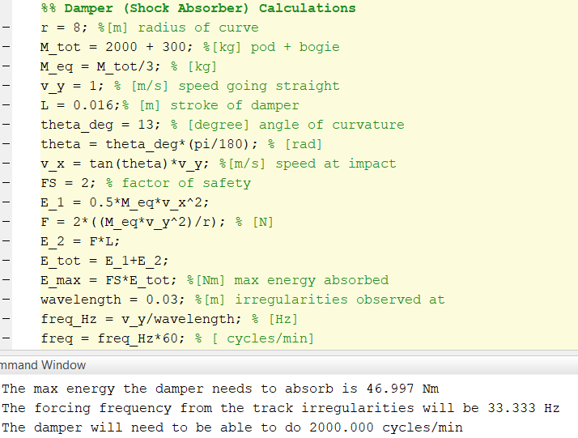

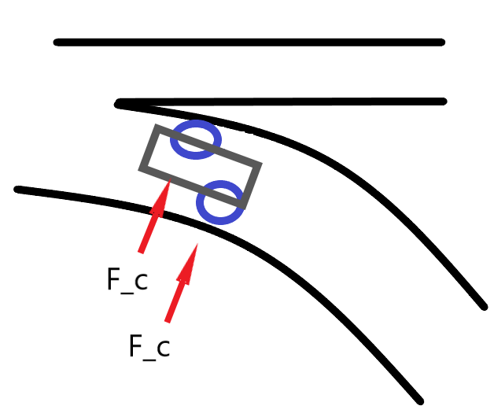

Figure 1B. Free body diagram for the forces acting on the guide arm assembly

Appendix B
Calculations 2A. Spring and force calculations for guide arm
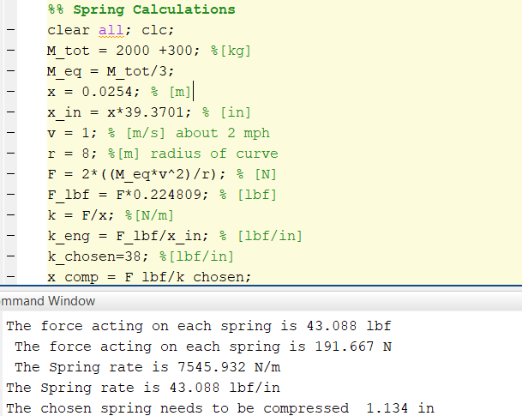

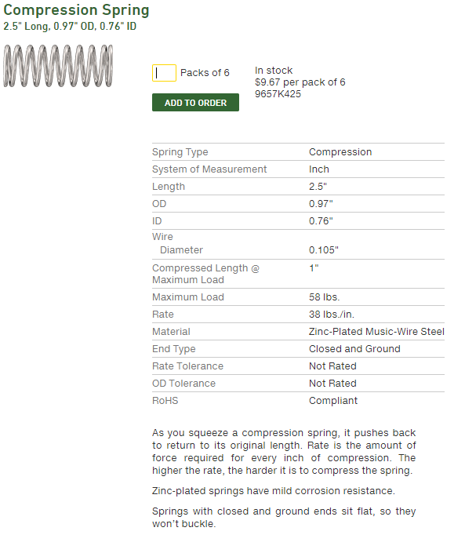

Figure 2A. This is the specifications for the selected spring for guide arm.

Appendix C
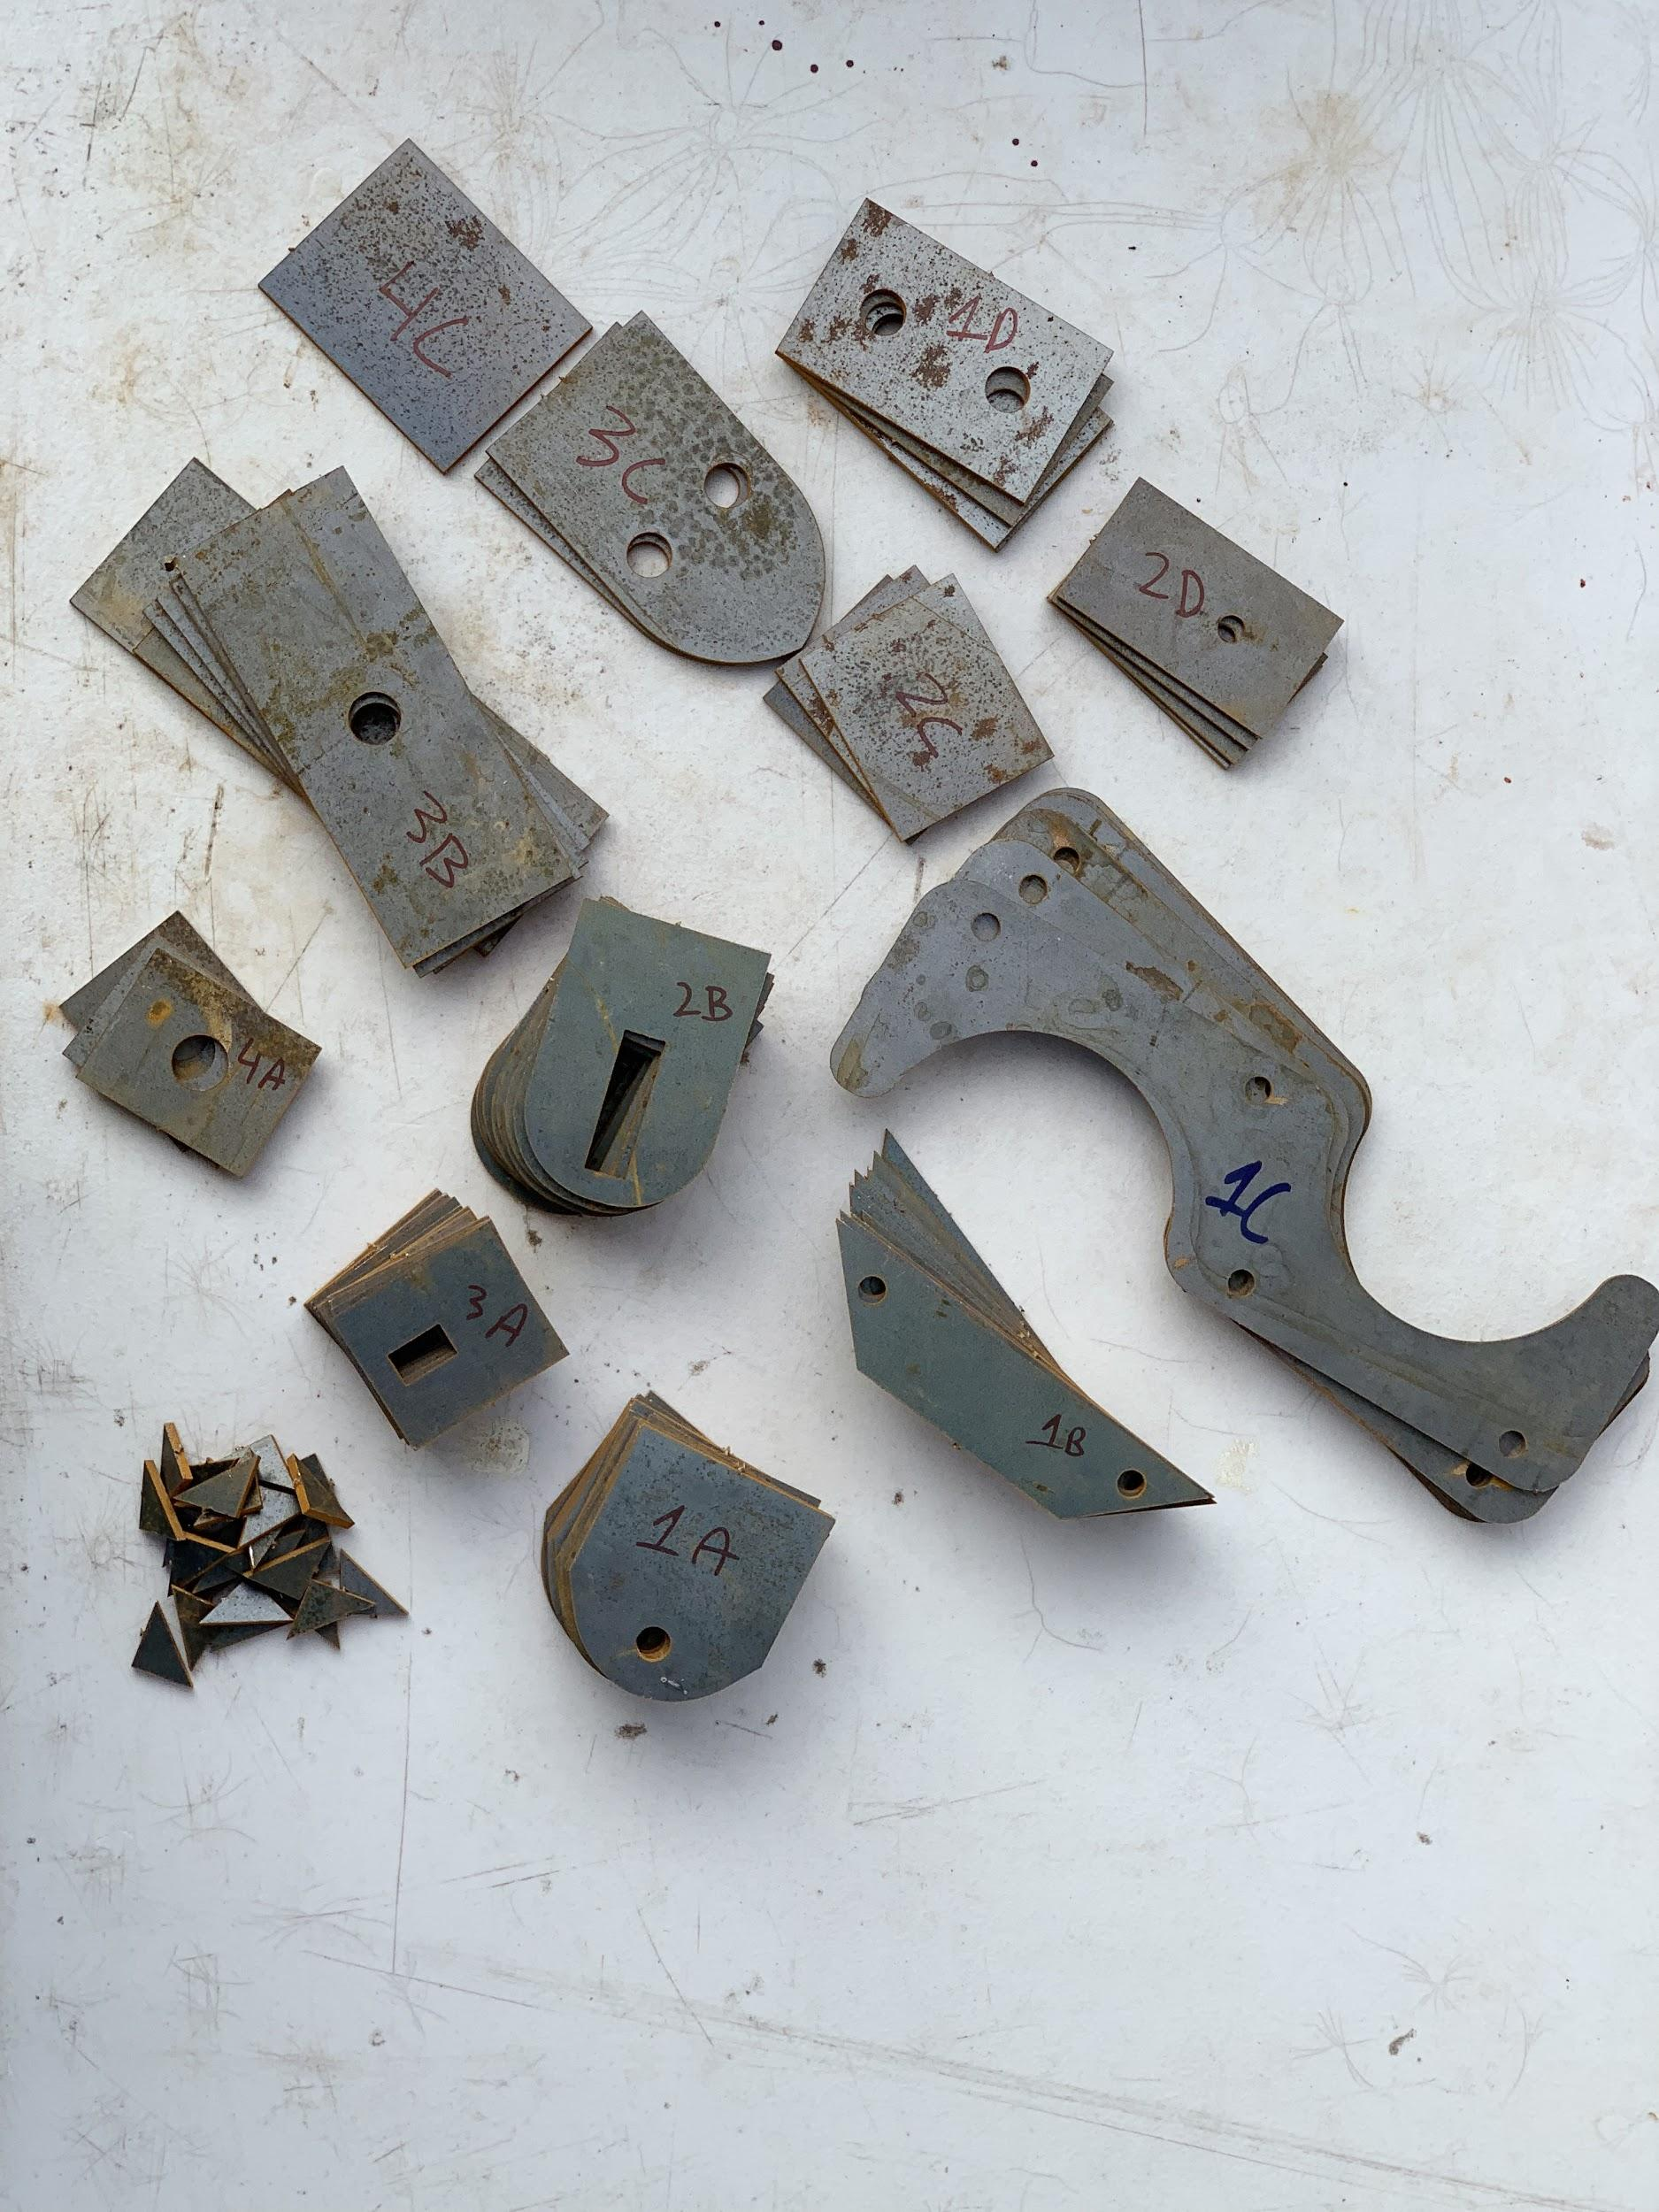

Figure 3A. This depicts the waterjets components with a naming scheme to keep an inventory.

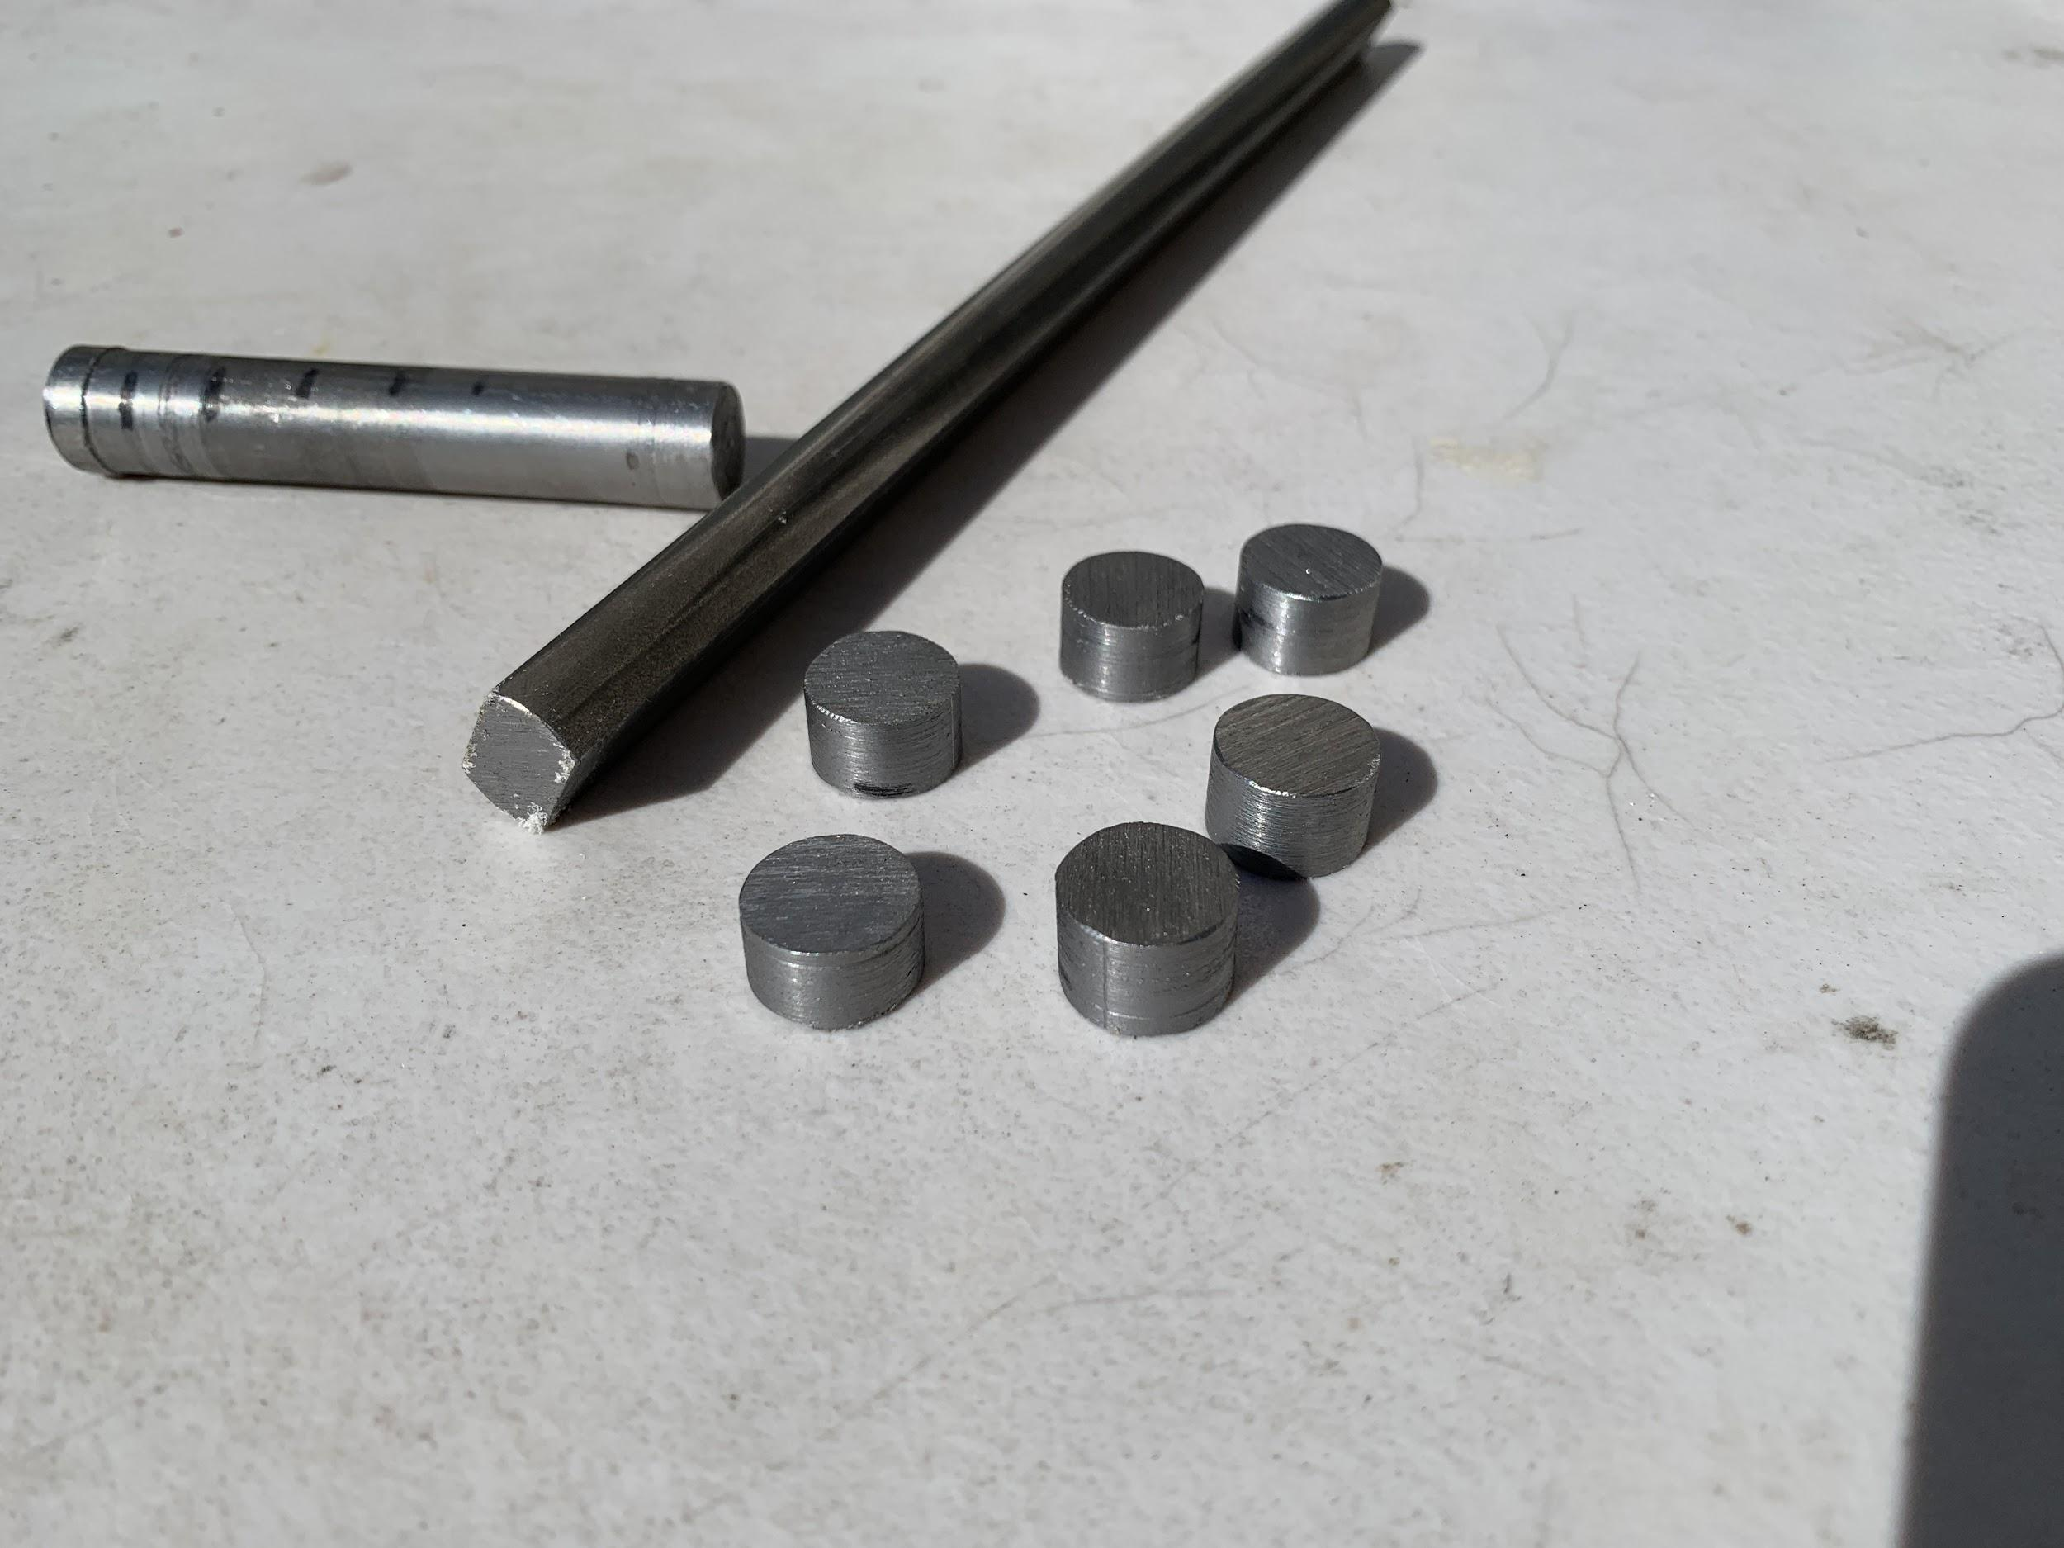

Figure 3B. The images depicted the milled rod for the tabs, and components that were turned on the lathe which were used to hold spring in place for guide arm.

Appendix D

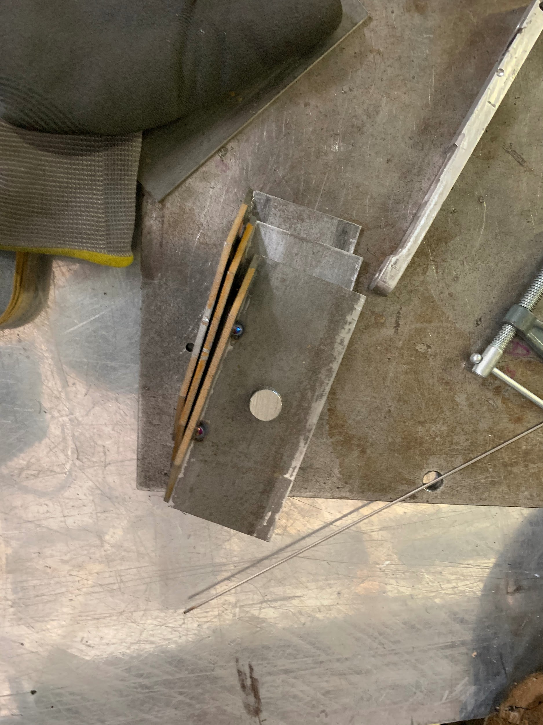

Figure 4A. The components were first tack welded together to help keep the components aligned during the welding.

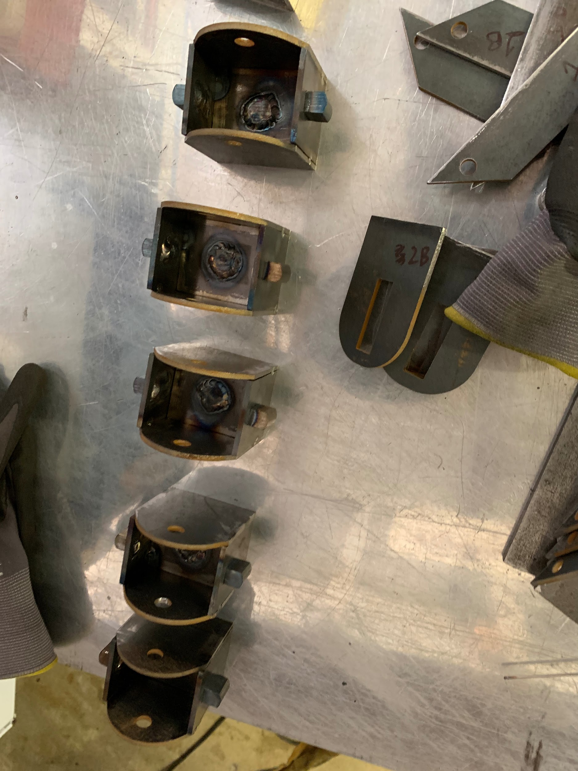

Figure 4B. This illustrates the TIG welded sub-assembly components.

Appendix E

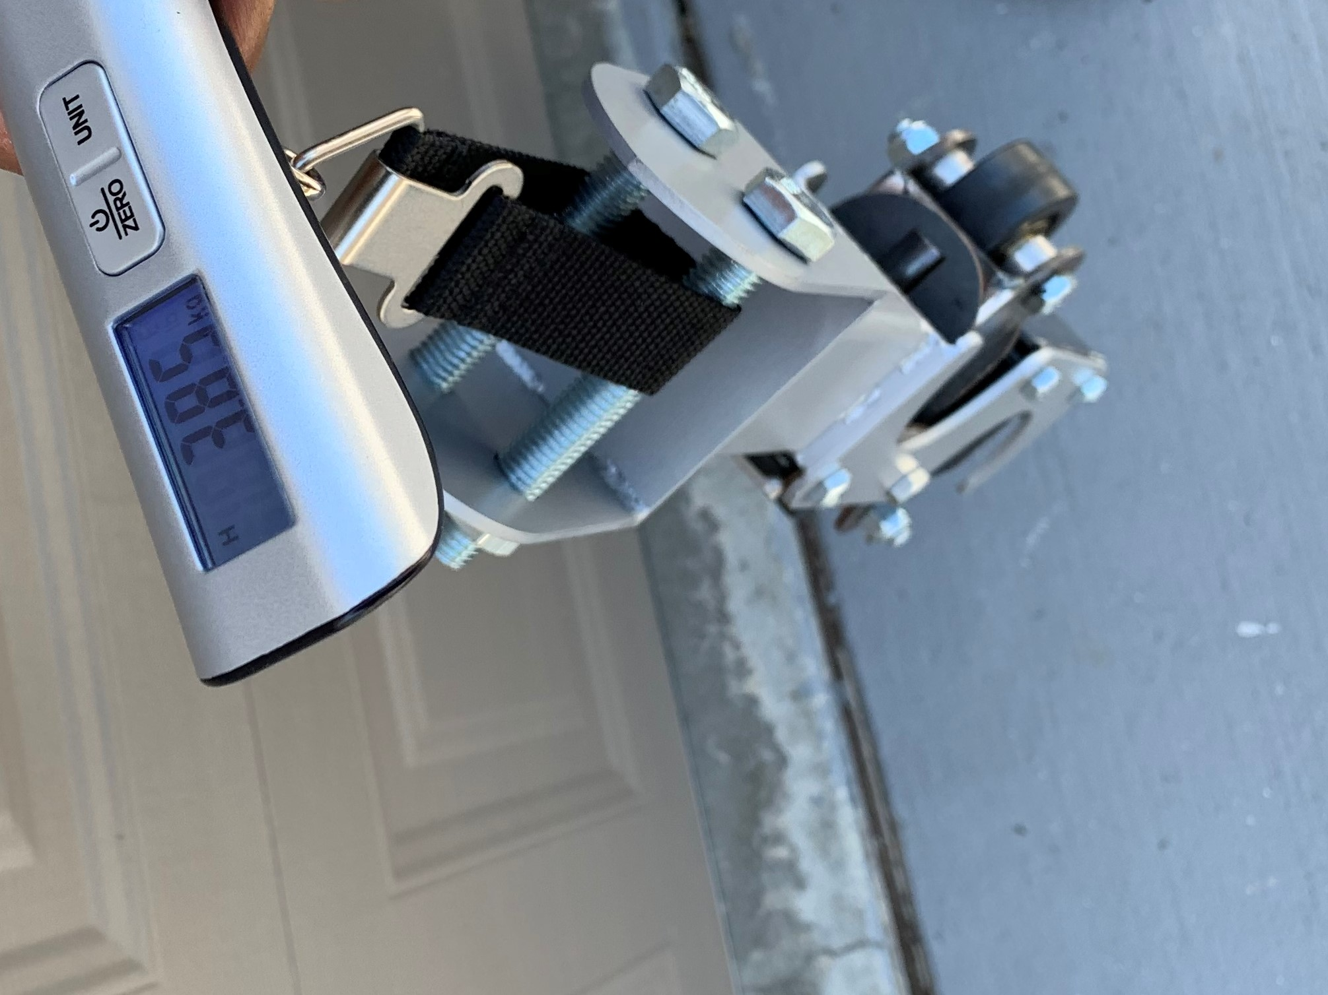

Figure 5A. The measured mass of the drive bogie guide arm is about 3.9 kg.
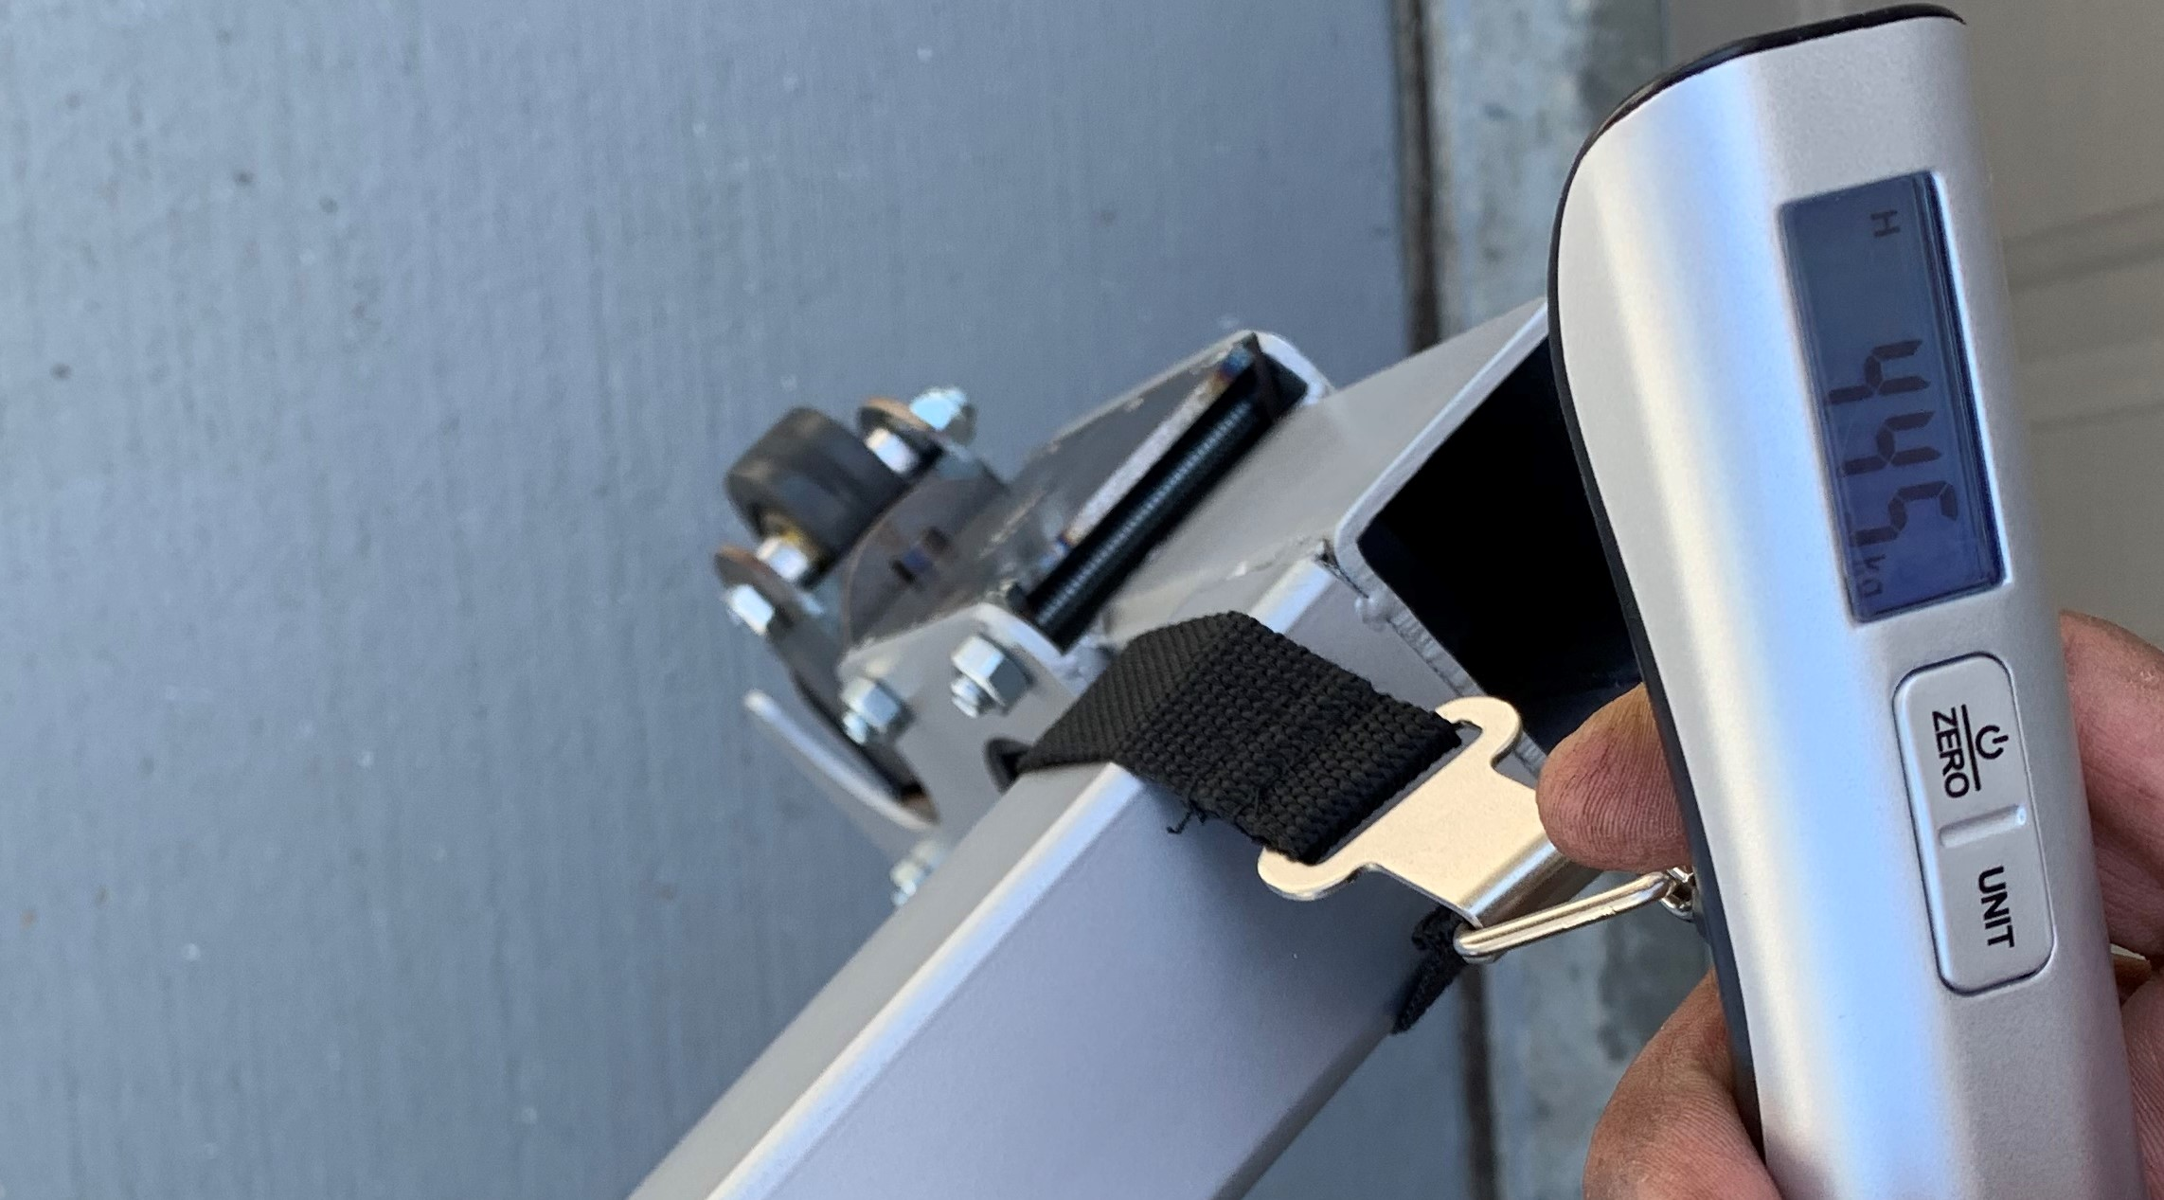
Figure 5B. The measured mass of the slave bogie guide arm is about 4.5 kg.

Appendix F

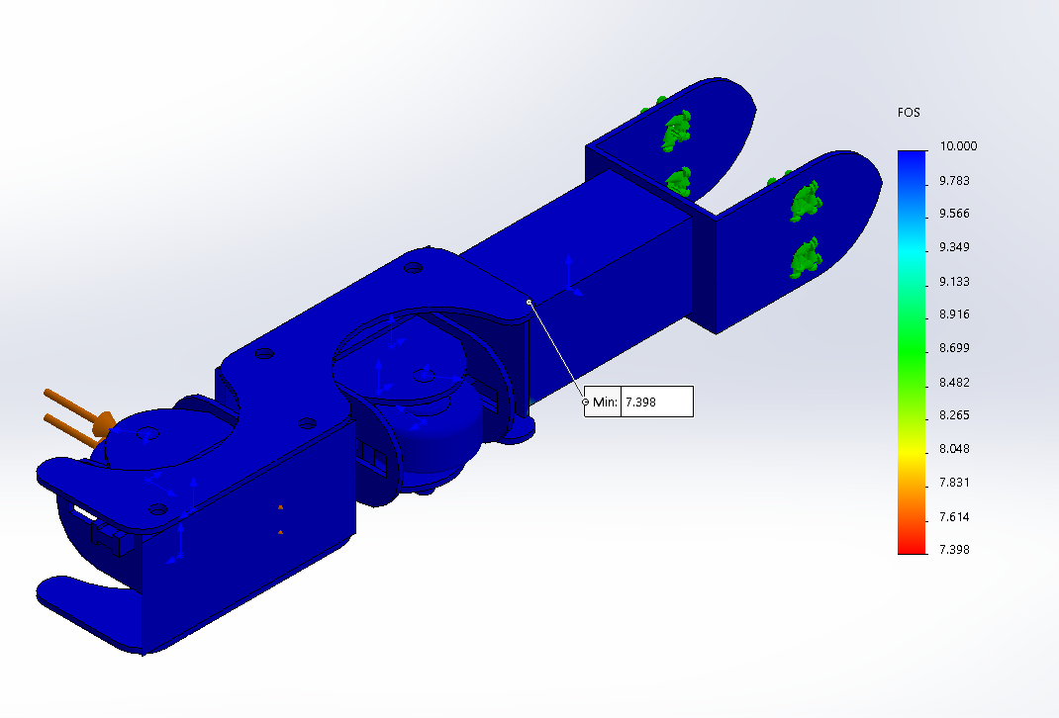
Figure 6A. This is a depiction of FEA Study showing the minimum factor of safety of 7.4 for the drive bogie guide arm with 200 N load (in the orange arrows).

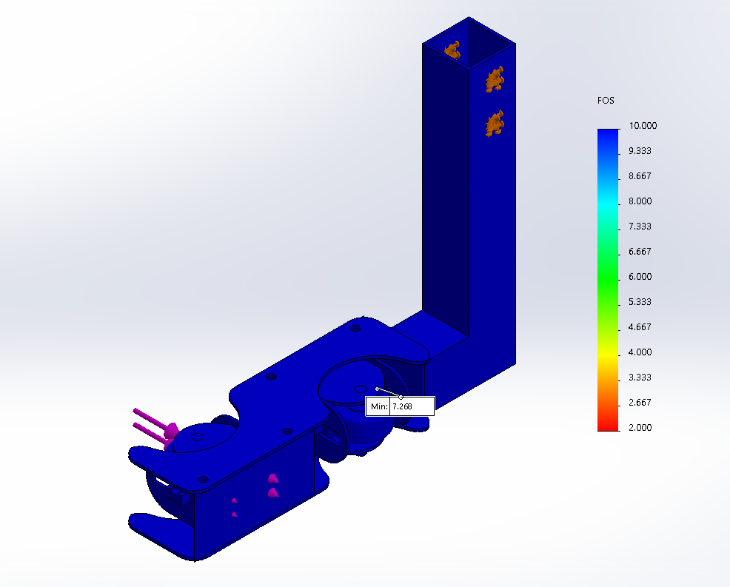

Figure 6B. The slave bogie guide arm has a minimum factor of safety of 7.4 with maximum loading condition.

Appendix E
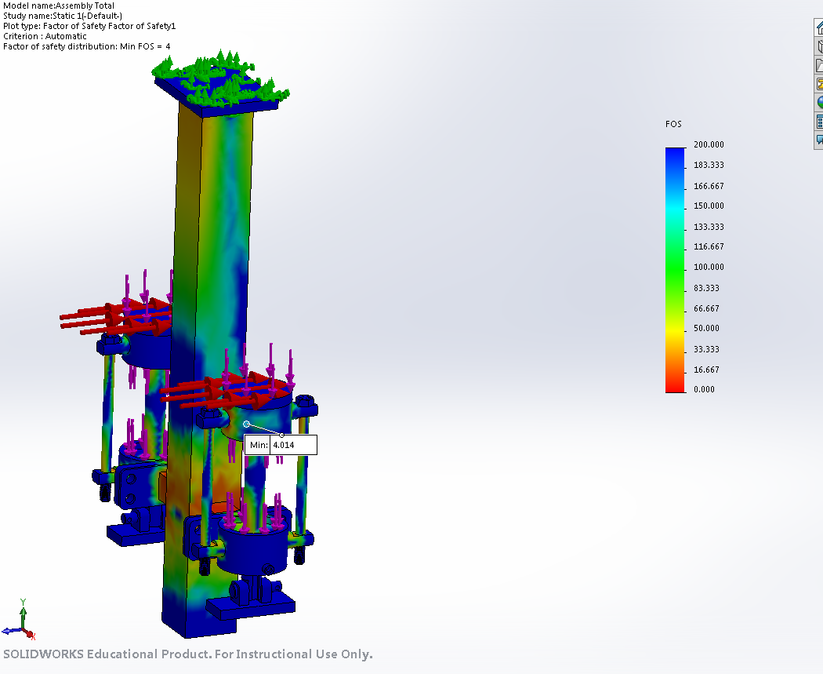

Figure 7A: FEA of deployed braking system. The minimum factor of safety is 4.

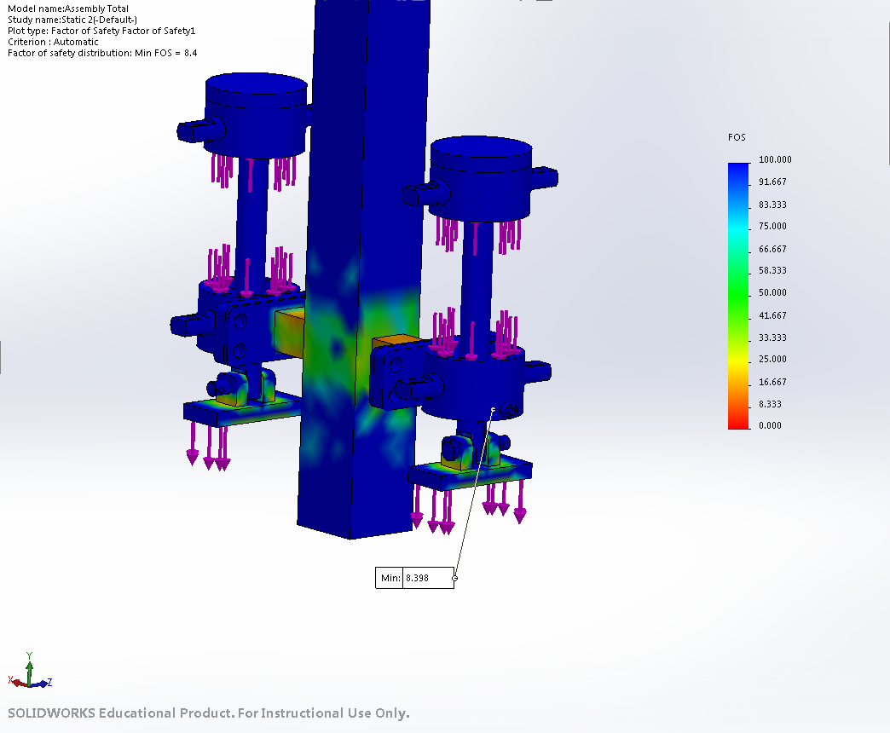

Figure 7B. FEA of armature and pin. The minimum factor of safety is about 8.4.

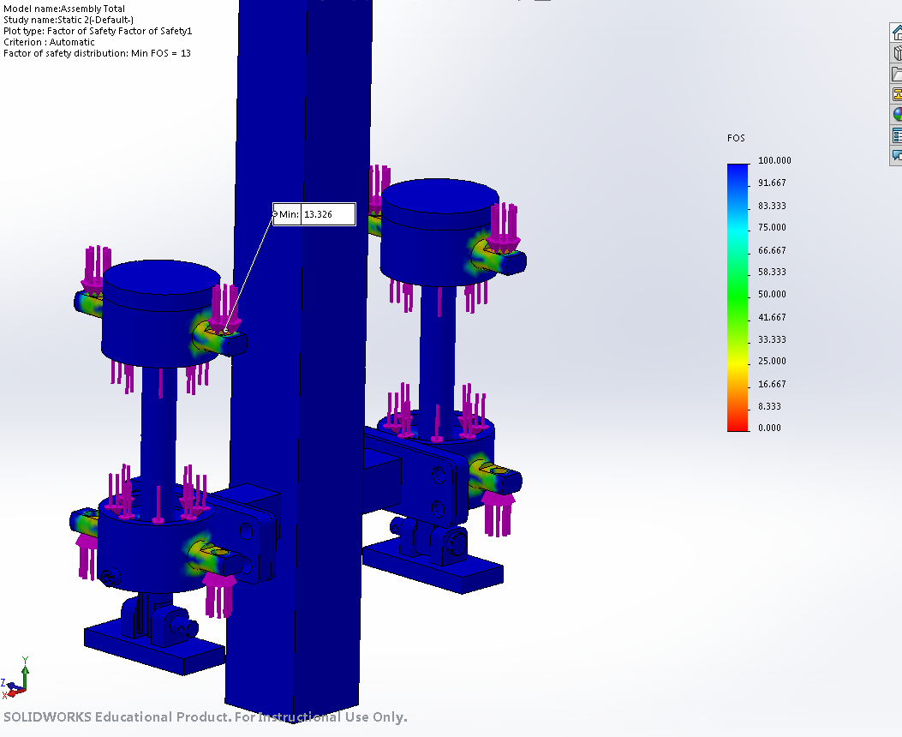Figure 7C. FEA of spring compressor mounts. The minimum factor of safety is about 13 for both top and bottom mounts.

Appendix F
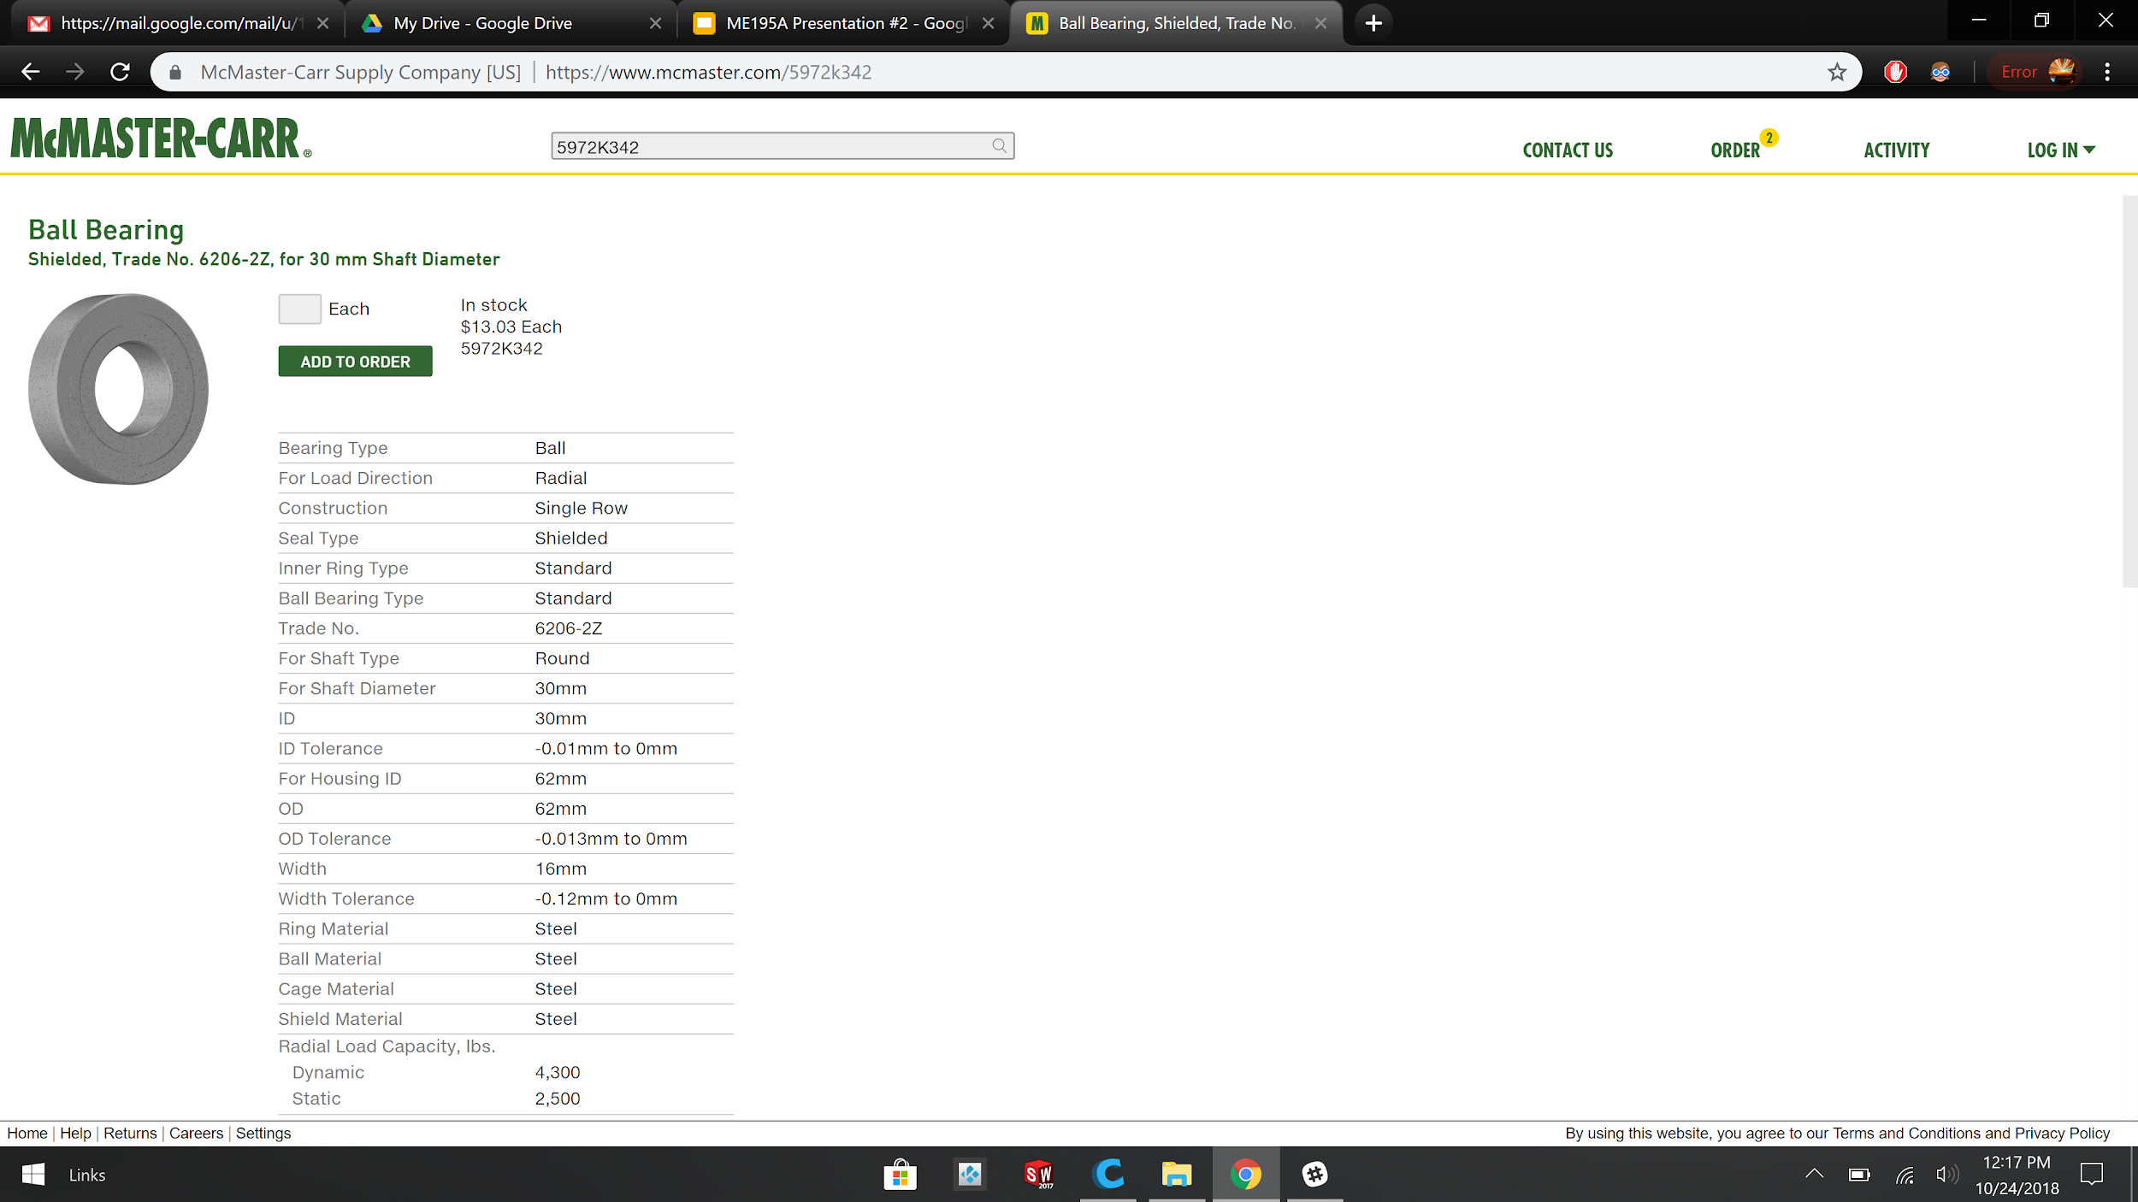
Figure 8A. Flange Bearing for radial loading
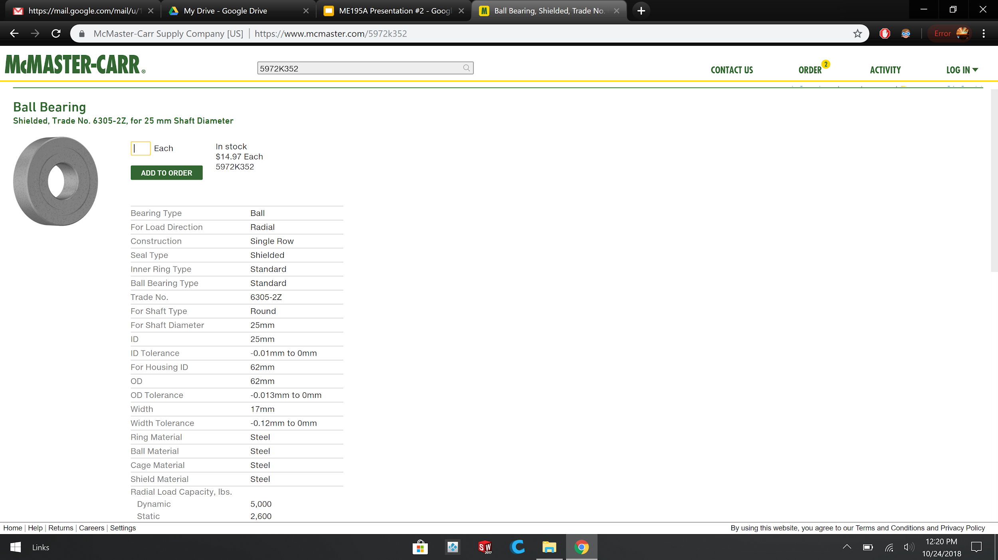
Figure 8B. Flange Bearing for radial loading
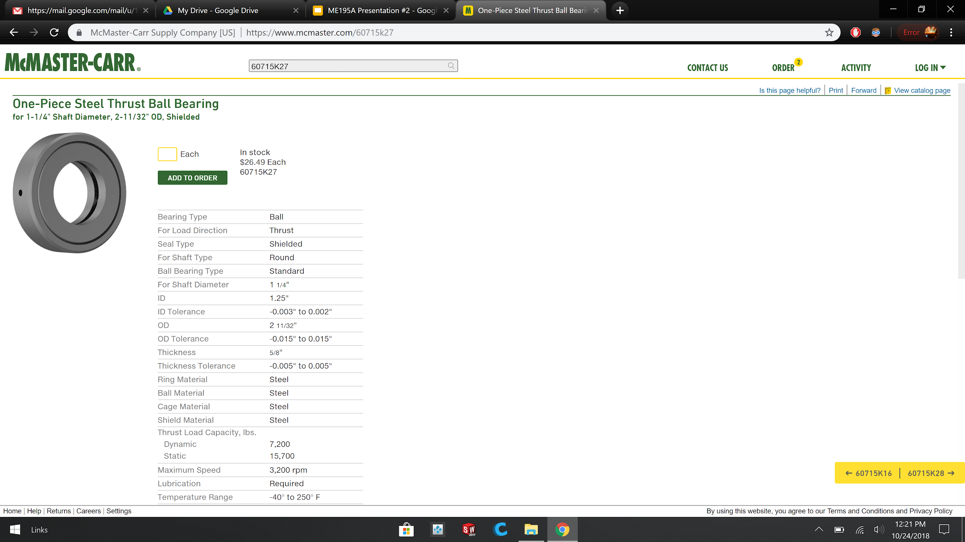

Figure 8C. Thrust Bearing for axial loading

Appendix G
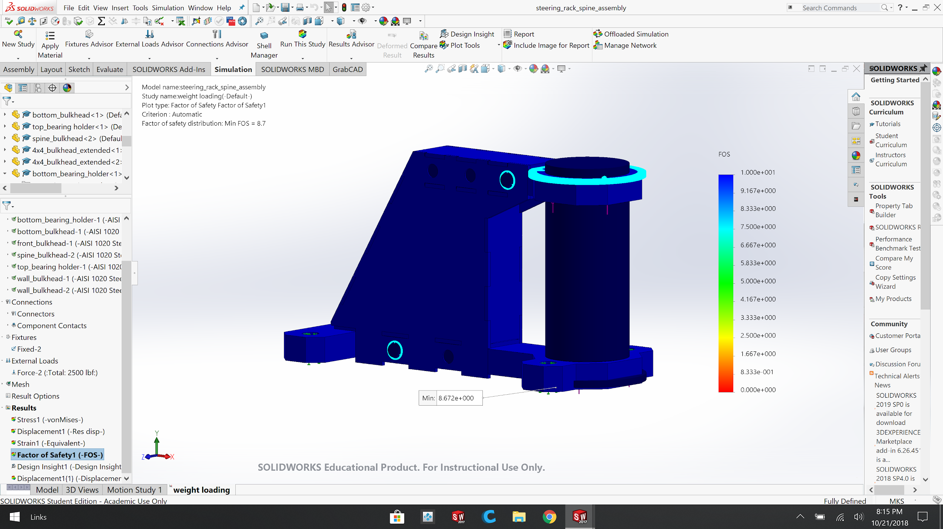

Figure 9A. Factor of Safety FEA
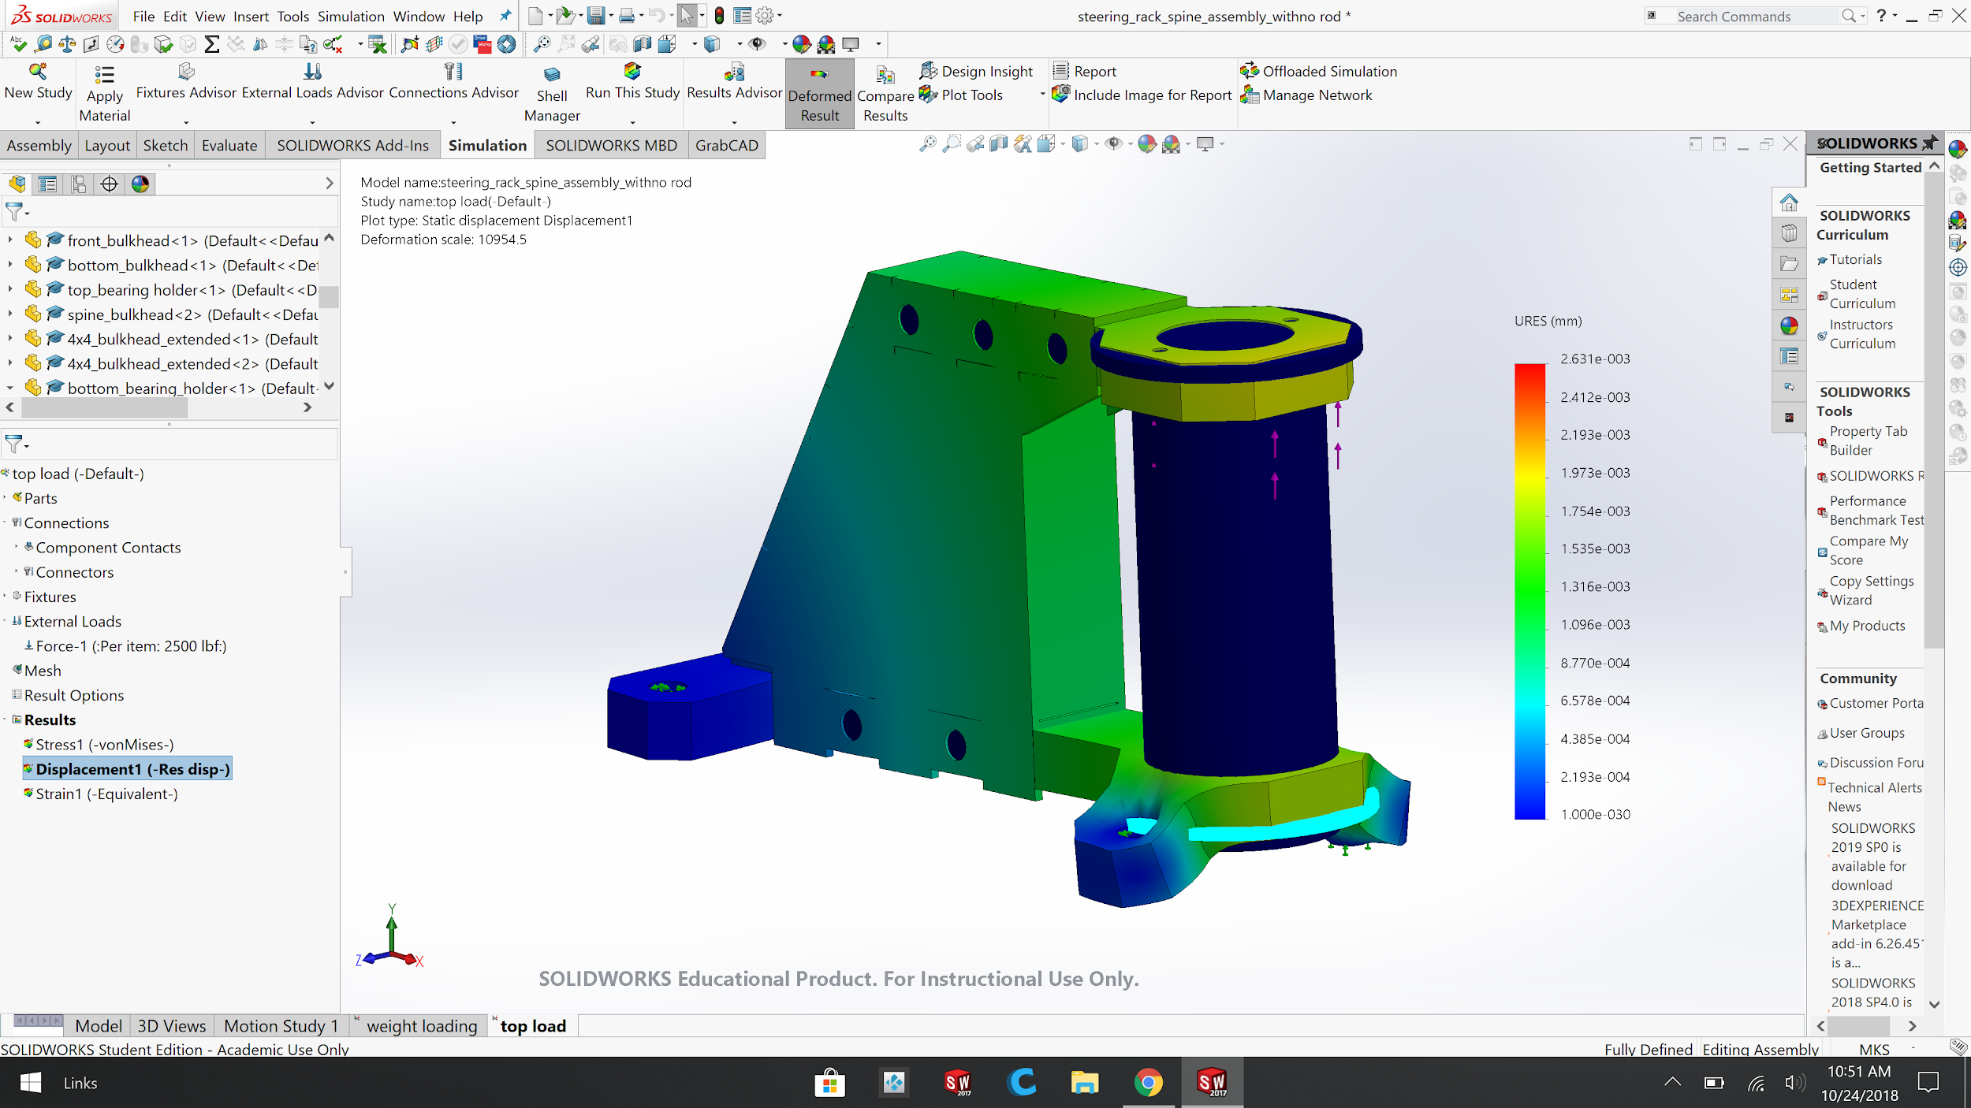

Figure 9B. Displacement Chart FEA
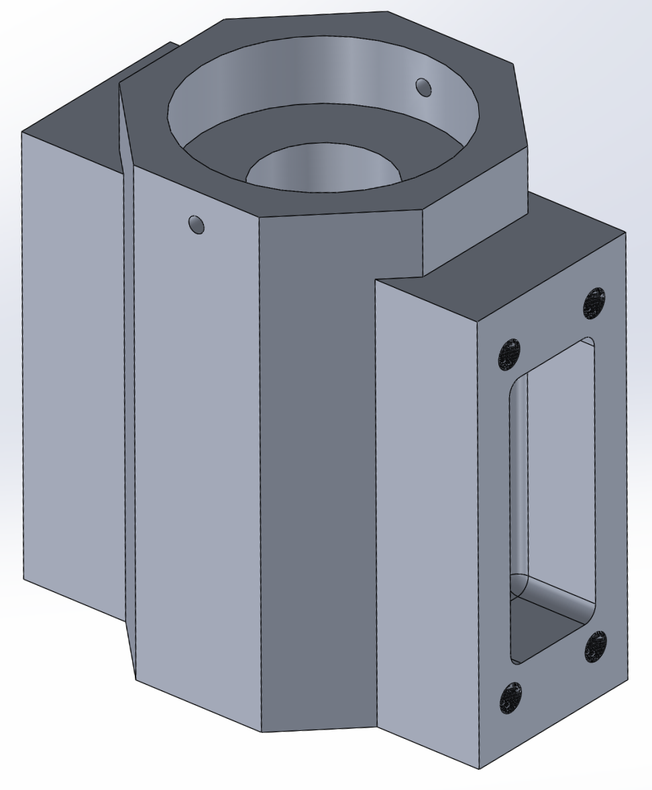
Figure 5C. Original design of Thrust Bearing Carriage
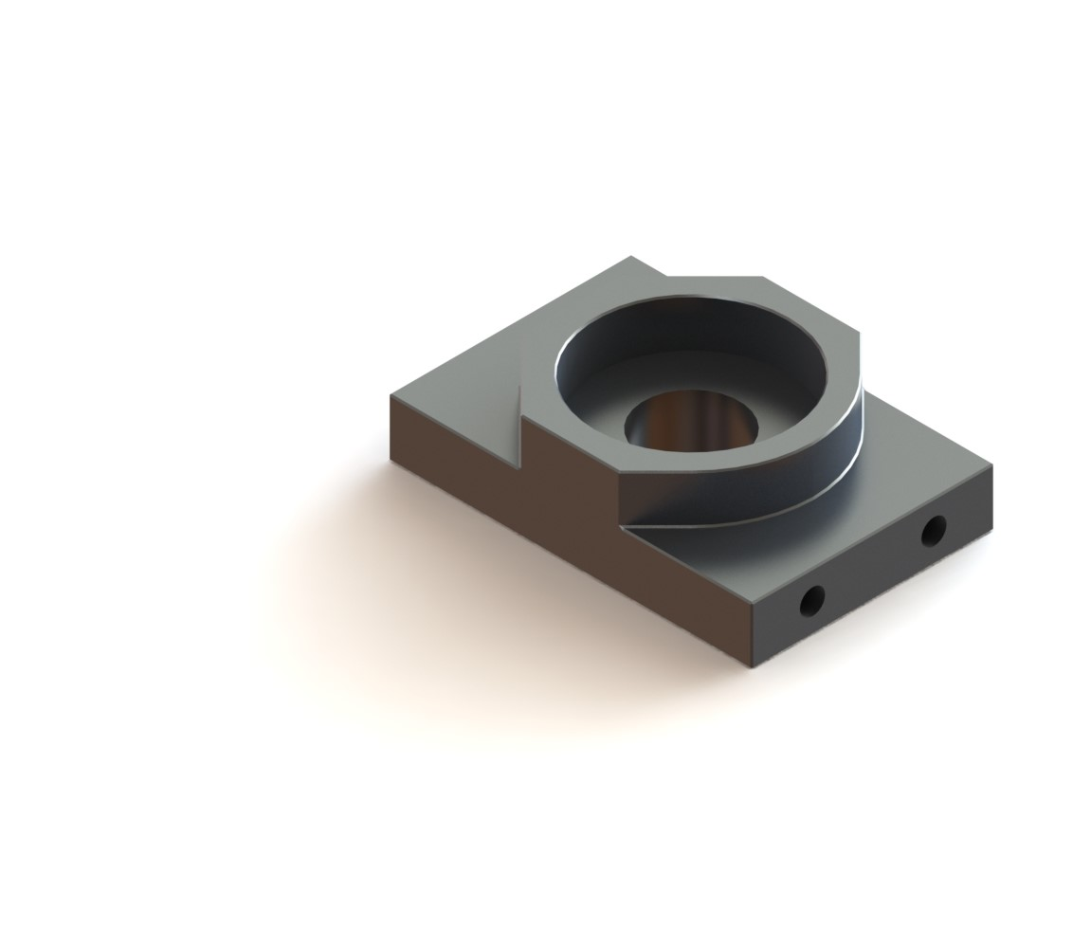
Figure D

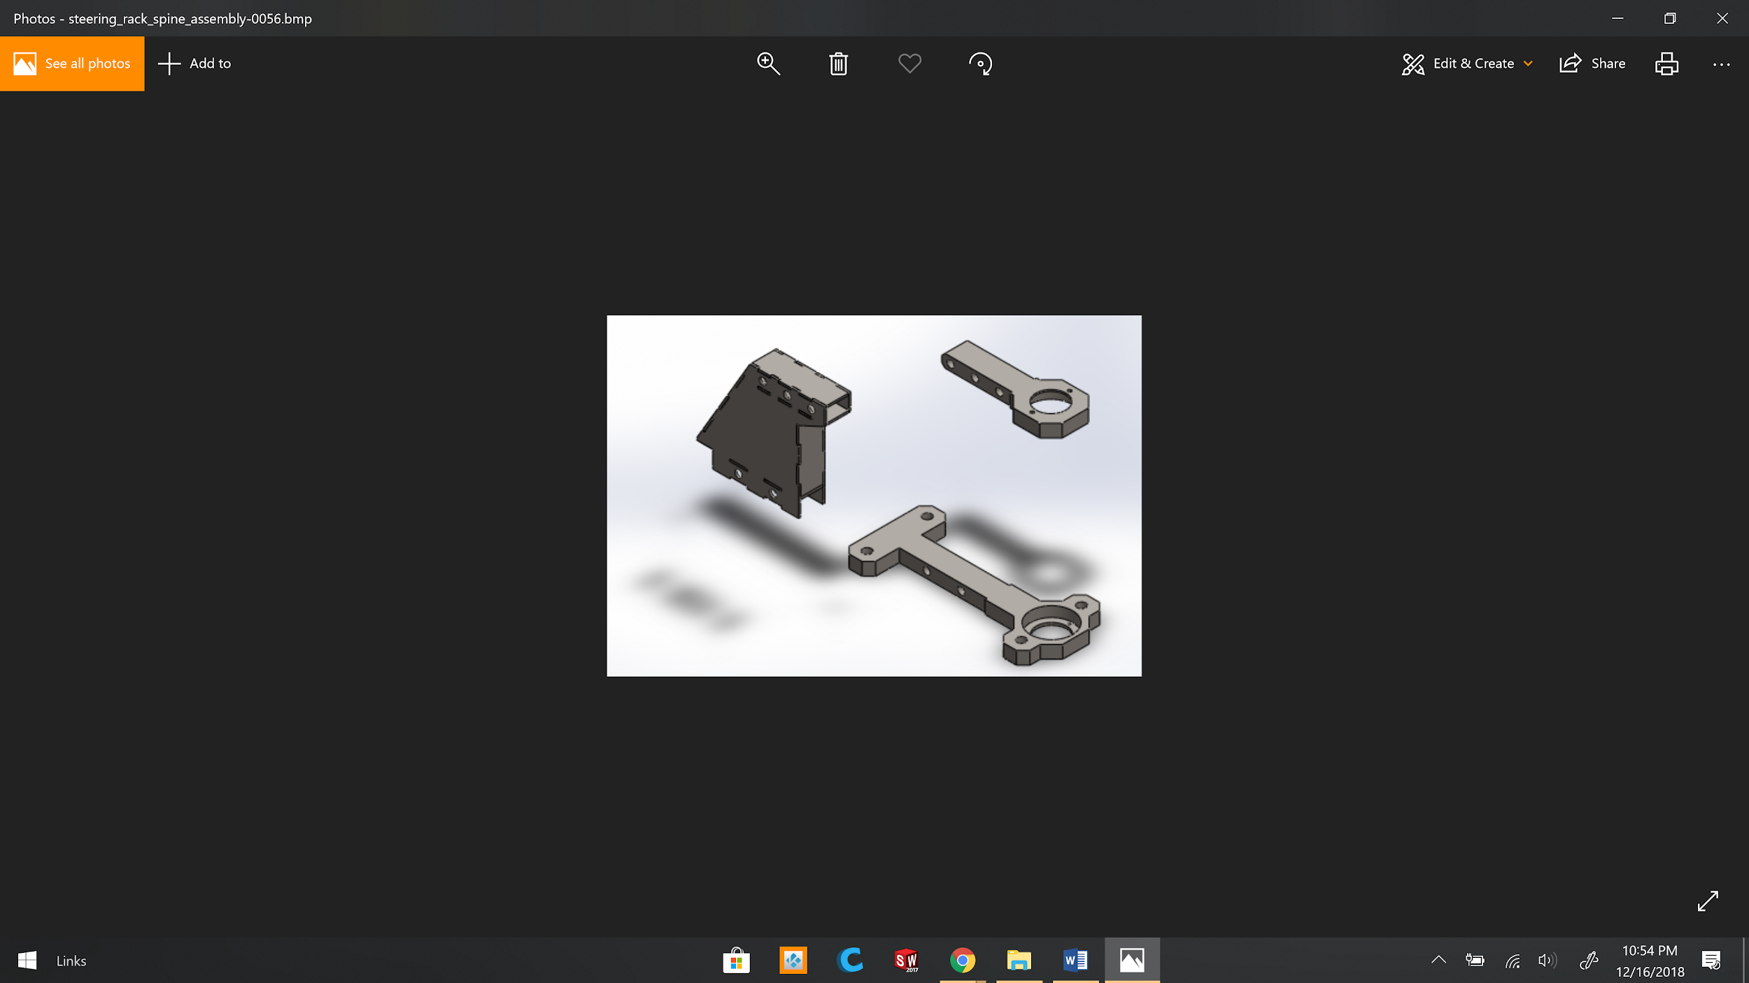
Figure 5E: Exploded View of Bearing Carriages
Figure 5F: Articulation System wheel housing structure installed

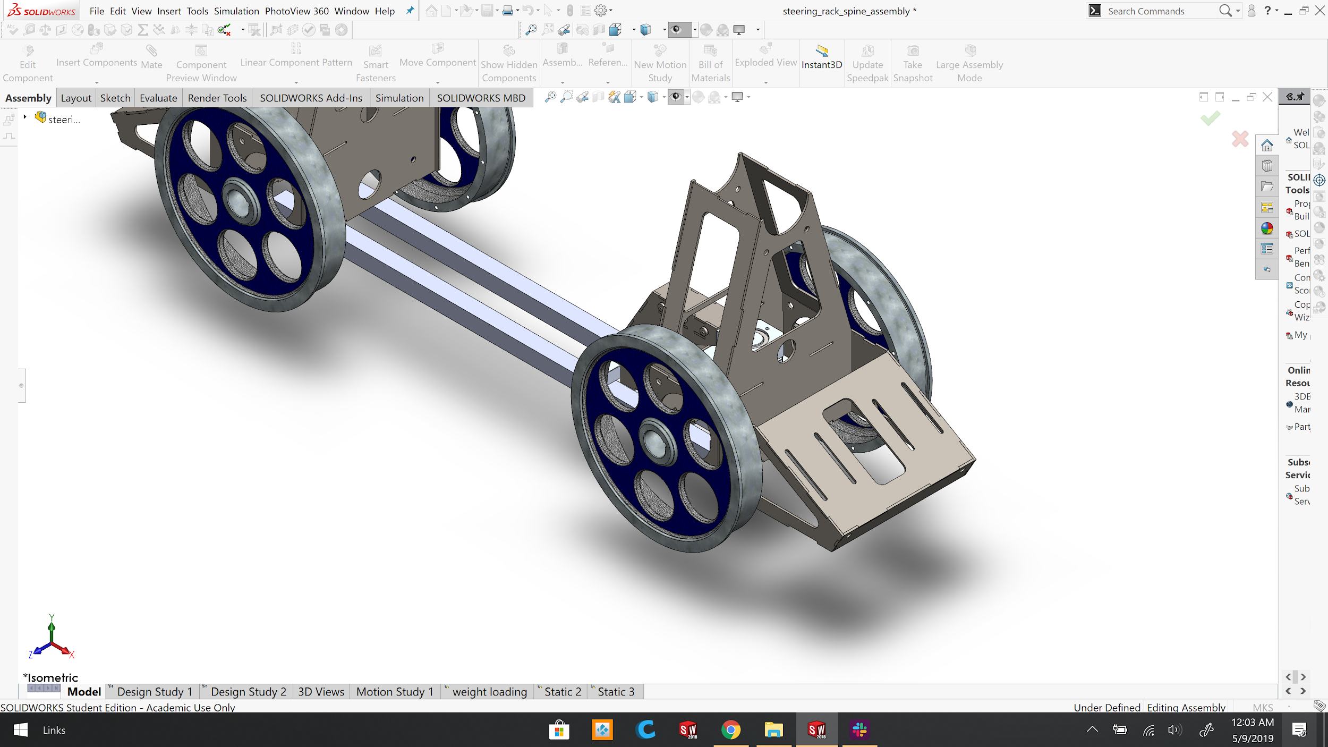
Figure 5G: Articulation System Mounted on Chassis of Bogie.
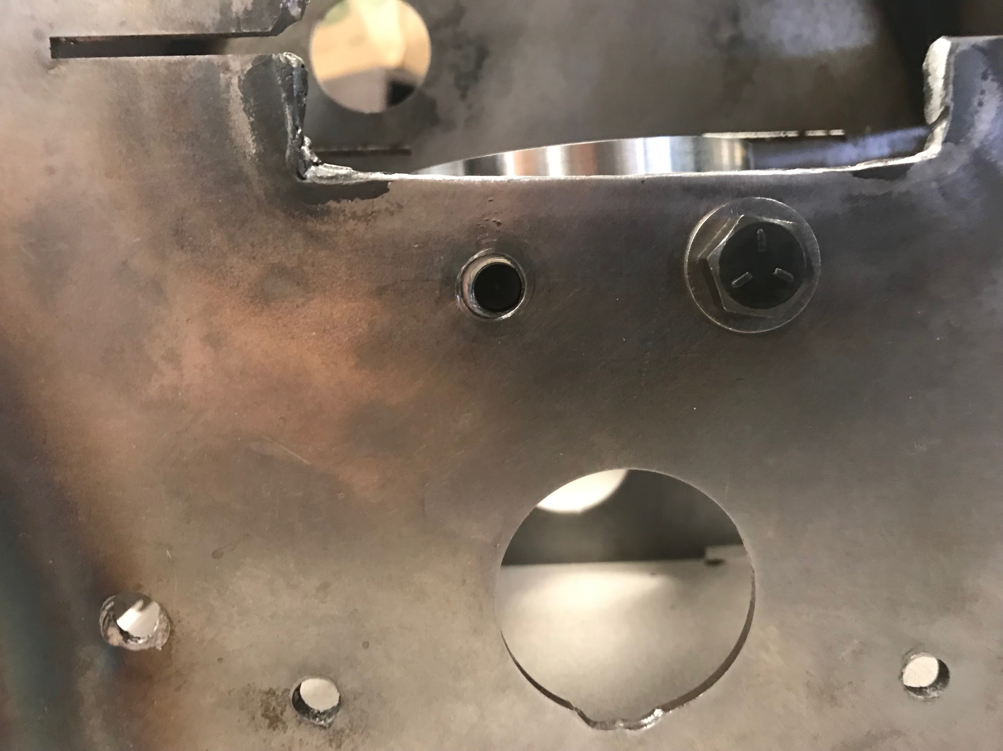
Figure 5H: Mounting points clearance problem.
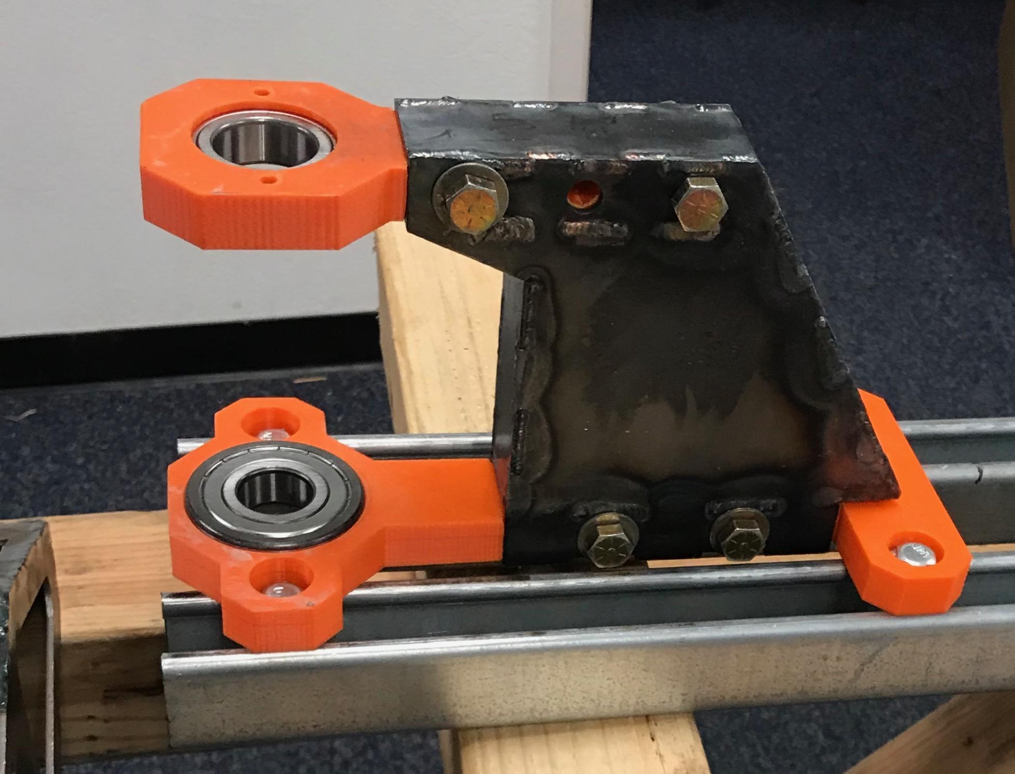
Figure 5I: 3D Printed prototype

Appendix H
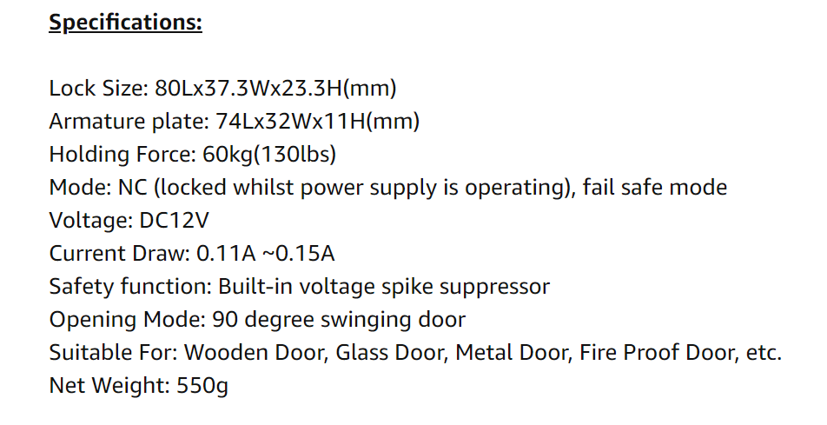

Figure 9A. AGPtek 130 lb Electromagnet Specifications

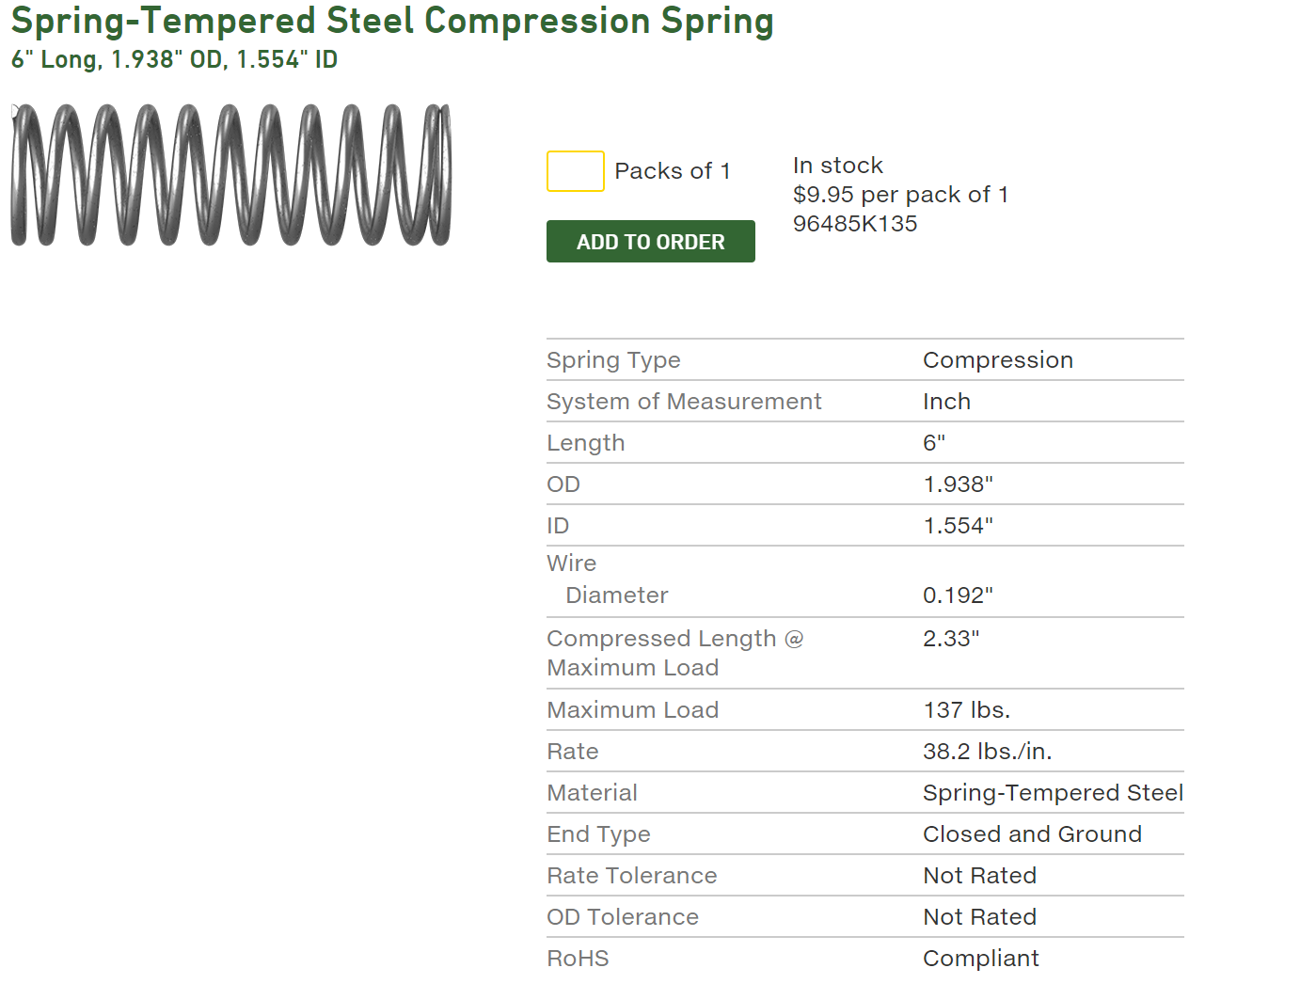

Figure 9B. Spring Specifications for Emergency Braking System

Appendix J
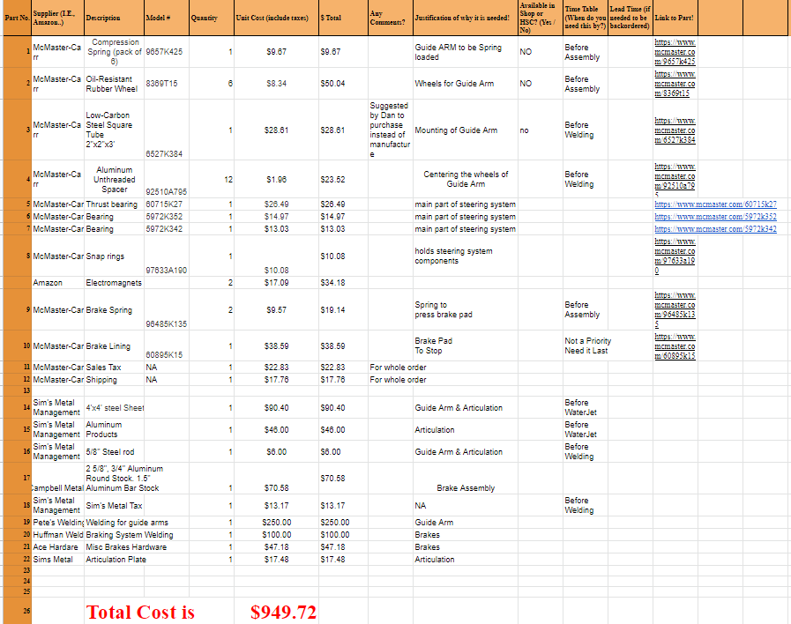

Figure 10A. This is the team’s complete bill of materials.

