Small-Scale Model Team
Charles W. Davidson College of Engineering
San Jose State University
ME 195B Senior Design Project II, Section 4
Dr. Burford J. Furman
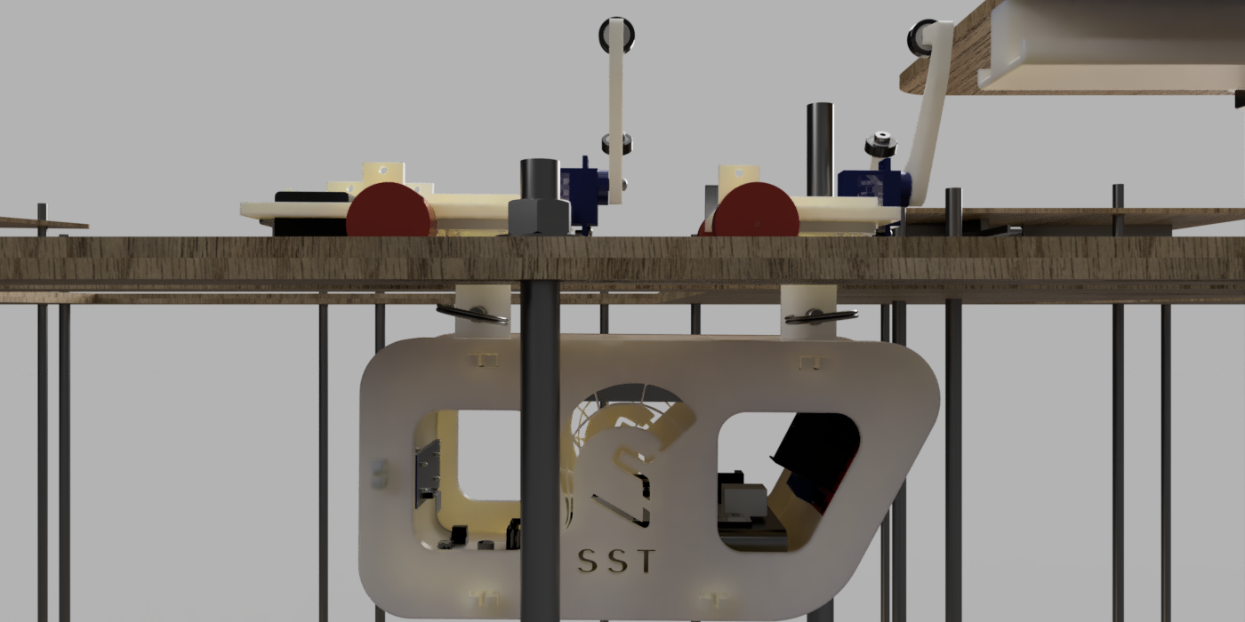

May 15, 2020

By: Julio de Pereda Banda, Asmaa Darwish,
Shane Fatehi, Justin Ghieuw, Lissette Romero

Abstract
The Small Scale team developed a 1/12 scale proof of concept for the SPARTAN Superway which included an innovative guideway, a reliable bogie, an intelligent controls system, and a user-friendly iOS app. This proof of concept is vital to the success of the Superway project as a whole because it can expose younger generations to the idea of the project and of this form of transportation. In addition to increasing exposure to younger generations, having a working model can attract the interest of investors.
There were three main challenges that the 2019/2020 Small-Scale team faced when taking on this project. First, the prior guideway was not reliable, interchangeable, or transportable. Second, the bogie did not have a dependable y-switching mechanism that would prevent the pods from falling off the track. Lastly, the old controls system lacked user-friendliness. These issues were solved by redesigning the guideway to be easier to assemble and disassemble through a cake layered track design, incorporating another set of wheels to the y-switch on the bogie, and developing an intelligent anti-collision controls system through the use of an ultrasonic sensor. These new changes to the guideway and bogie, along with the development of a custom app, make this year’s Small-Scale project unique. Due to the Covid-19 situation, the completion of the building of the guideway was interrupted, hence a heavy emphasis was directed towards creating thorough Solidworks models and animations. Regardless, the FEA analysis of pieces of the guideway yielded acceptable results, the simulated y-switching mechanism functioned correctly, an app was developed to establish a connection between the team members’ phones and the pods, and a coherent Arduino sketch resulted in a reliable control system.

Acknowledgments
The Small-Scale Team would like to thank Dr. Burford Fuman, Mr. Ron Swenson, and Eric Hagstrom for their help throughout the year. A special thanks to Mr. Swenson for providing SPARTAN Superway teams with a place to work on the project along with all of the necessary materials and accommodations. Thank you Jacques-Hariel Ango and Bill James for providing suggestions and examples for building the guideway and bogie. All of these mentioned people allowed the Small Scale team to embark on a journey of knowledge that will be valuable in the team’s future endeavors.

Table of Contents
Abstract 2
Acknowledgments 3
Table of Contents 4
List of Figures 6
List of Tables 9
1. Executive Summary 10
2. Introduction 12
2.1 The General Problem 13
2.2 Introduction to ATN 15
2.3 Superway ATN Development 16
2.4 Societal Impacts 17
2.5 Prior work on ATN at SJSU 18
2.6 Project Structure 19
3. Project Objectives 20
4. Requirements and Specifications 21
4.1 Guideway Specification 21
4.2 Bogie Specifications 22
4.3 Controls Specifications 23
5. State of the Art Literature Review 23
5.1 ATN around the world 23
5.1.1 Wuppertal Suspension Railway 24
5.1.2 Morgantown Personal Rapid Transit System 25
5.2.3 Ultra Rapid Transit at London Heathrow Airport 25
5.1.4 Cabinentaxi PRT in Hagen, Germany 26
5.1.5 JPods 27
5.2 Past Superway Teams 28
5.3 Bluetooth Low Energy Research 33
6. Final Design 35
6.1 Guideway Design 36
6.2 Bogie Design 44
6.3 Controls Design 51
6.3.1 iOS App 51
6.3.2 Electronic System 57
7. Analysis 65
7.1 Guideway 65
7.2 Bogie 73
7.3 Controls 78
7.3.1 iOS App 78
7.3.2 Electronic System 83
8. Results 84
8.1 Guideway 84
8.2 Bogie 87
8.3 Controls 88
8.3.1 iOS App 88
8.3.2 Electronic System 89
9. Conclusion and Recommendation for Future Work 90
9.1 Guideway 90
9.2 Bogie 92
9.3 Controls 92
9.3.1 iOS App 92
9.3.2 Electronic System 94
9.4 Small-Scale Team as a Whole 95
References 95
Appendices 99
Appendix A: Guideway Drawings 99
Appendix B: Bogie and Guideway Y-Switch Drawings 104
Appendix C: Guideway Corner Support Drawing 107
Appendix D: Guideway Hardware Drawings 108
Appendix E: Bogie Y-Switch Hardware Drawings 112
Appendix F: Pod Assembly Drawing 116
Appendix G: Bogie Assembly Drawing 119
Appendix H: BOM Cost for Pod/Bogie 122
Appendix I: Setting Up Xcode 123
Appendix J: Small-Scale Slider App Code to connect to BLE 126
Appendix K: Anti-collision System 130
Appendix L: BLE Test with LED 131
Appendix M: BLE Test with Anti-collision System 132
Appendix N: Line_Hello_World 134
Appendix O: Barcode Test 136
Appendix P: Final Sketch Rev 1 137
Appendix Q: Master Final Sketch 140
Appendix R: Motor DataSheet 145
Appendix S: HM10 DataSheet 146
Appendix T: Pixy2 DataSheet 147
Appendix U: Ultrasonic Sensor DataSheet 148
Appendix V: BOM Cost for Guideway 150

List of Figures
Figure 1. Assembly of the first model of the track ………………………………………....….. 11
Figure 2. 3D Modeled Pod and Bogie Assembly …………………………………………….... 11
Figure 3. The iOS app loading screen ……………………………………………………...…... 12
Figure 4. Total U.S. Greenhouse Gas emissions in 2018 ………………………………..…... 13
Figure 5. SPARTAN Superway Full-Scale Cabin ……………………………………..…...... 19
Figure 6. Division of Small Scale Sub teams………..……………………………………….… 20
Figure 7. The Wuppertal Suspension Railway above traffic …………..………………...…..… 24
Figure 8. Wuppertal Suspended Railway above the city river.……………….……….…….….. 24
Figure 9. Morgantown vehicle steering system ……………..………………………….....…… 25
Figure 10. Urban Light Transit PRT in London Heathrow Airport ………………………...….. 26
Figure 11. Cabinentaxi in Germany stopped developments in ………………………………… 27
Figure 12. Bill James mini model and JPods full scale model ………………………………… 28
Figure 13. The previous year’s aluminum track……………………………………………....... 29
Figure 14. Small scale mobile application ……………………………………...…………….... 30
Figure 15. Connection between two tracks……………………………………..….. ………….. 31
Figure 16. Bogie master-slave ………………………….....………………………………….... 32
Figure 17. Raspberry Pi GUI from 2018-2019 team ……...………………………...…………. 33
Figure 18. Central and peripheral visual representation …………………………………...…... 34
Figure 19. Final guideway with bogie entering right switch …………………………...…….... 36
Figure 20. Guideway dimensions ………………………………………………………..……. 37
Figure 21. Layer cake design of guideway pieces ………... ………………………....………... 38
Figure 22. Top view of guideway assembly …………...………………………...…………….. 38
Figure 23. Right y-switch assembly ………………..…………………………………….…….. 39
Figure 24. Bottom part manufactured using the 3D printer from Makerspace. ……...……….... 40
Figure 25. Exploded view of right y-switch assembly ……………………………...………… 40
Figure 26. Left y-switch assembly …...………………………………….……………………... 41
Figure 27. Two piece y-switch bottom piece ..………..…………………………………….... 41
Figure 28. Y-switch third rail featuring a ramp for smooth transitions ……...……………….. 42
Figure 29. Corner stabilizers located on the opposite end of the y-switch assemblies ….…...... 42
Figure 30. Side view of corner support hardware .………….……………………………….. 43
Figure 31. Steel hex nuts and washers to clamp down each guideway piece ….…………….... 44
Figure 32. Final rendered pod and bogie …..………………………………………………… 44
Figure 33. Exploded view of pod design ……………………………………………………….45
Figure 34. Exploded swivel design connection ….…………………………………………… 46
Figure 35. Bogie snap fit connection design ...………………………………………………... 47
Figure 36. Gears on the front bogie platform …...………...…………………………………... 48
Figure 37. Gap in the track ...……………………….…………………………………………. 48
Figure 38. Final bogie and pod design ...…………………………………….…………….….. 49
Figure 39. Close up of the rendered y-switch ….………...……………………………………. 49
Figure 40. Left arm on bogie y-switch has enough clearance as bogie traverses corner ….….. 50
Figure 41. Storyboard view of iOS app ..……………………………………………………..... 52
Figure 42. Main tabs of iOS app ……………….. ……………………………………………... 52
Figure 43. Team info sub tab ……………………….………………………………………….. 53
Figure 44. Project overview main tab and subtabs, left to right respectively ……………….…. 54
Figure 45. Pod ordering tab and subtab ……………….…………………………………….… 54
Figure 46. iOS app map tab ……………………………………………………………............. 55
Figure 47. Main interface of BLE connection testing app …………………………………..…. 56
Figure 48. Fritzing wiring diagram of all components ……………………………………..….. 58
Figure 49. Flow chart of first revision of final Arduino sketch …………………………..……. 62
Figure 50. Station positions around the track …………………………………………...……... 63
Figure 51. Final flow chart of the final Arduino sketch…………………………………..…..... 64
Figure 52. Inner and outer loop paths ……………………………………………………....….. 65
Figure 53. Final guideway with two bogies animation …………………………………….….. 66
Figure 54. Y-switch animation …………………………………………………………...….. 67
Figure 55. Simplified model of the curved parts……………………………………………….. 68
Figure 56. Simplified model of the straight parts.……………………………………….....….. 68
Figure 57. Two forces, each 0.75 lbf, are placed on the edge of the track. ………………...….. 69
Figure 58. Constraints such as displacements and elastic supports were added to the straight.... 70
Figure 59.Visual of total deformation for straight parts with a max deformation of 0.0012 inches. .... 71
Figure 60. Like the straight, displacements and elastic supports were added to the curve …..... 71
Figure 61. Visual of total deformation for curved parts (max deformation of 0.00038 in)...........72
Figure 62. Right y-switch bottom part force analysis. …………………...………………...….. 73
Figure 63. Left y-switch bottom part force analysis ……………...………………………...….. 73
Figure 64. Snap fit tester design ………………………………………………….………...….. 74
Figure 65. Clear render of pod to ensure space for electrical components ………………...….. 75
Figure 66. Animation of bogies swiveling design ……………………………………….....….. 76
Figure 67. Gear design motion analysis ………………………………………….………...….. 78
Figure 68. FEA analysis of the switching mechanism ………………………………...…...….. 78
Figure 69. Output screen with wrong UUID ……………………………………………....….. 79
Figure 70. Lightblue application displaying BLE information ……………………..……...….. 79
Figure 71. Output screen of iOS app …………………………………………………..…...….. 80
Figure 72. Main interface of BLE connection testing app ………………………….……...….. 81
Figure 73. Customizing slider values in Xcode…………………………………………….….. 81
Figure 74. LED being turned on and off with a custom slider app ………………………...….. 82
Figure 75. Assembly of the outer track and inner loop………...…………………………...….. 85
Figure 76. Successful assembly ………………………………………………………..…...….. 87

List of Tables
Table 1. Guideway Design Specifications ……………………………………………....………21
Table 2. Bogie Design Specifications ………………………………………………....………...21
Table 3. Controls Design Specifications ………………………………………………………...22
Table 4. Arduino Pin Connections …..….………………………………………..……………...60

1. Executive Summary
SPARTAN Superway or Solar Powered Automated Rapid Transit Ascendant Network Superway, is a project composed of several teams who are all working on developing a new sustainable form of public transportation for Silicon Valley. This year’s teams consist of Full-Scale, Half-Scale, Small-Scale, Power Module, and Wayside Power Team. The Small-Scale Team in particular is developing a 1/12th scale model which will mimic how the full scale Automated Transit Network (ATN) system will operate. The purpose of this model is to serve as a proof of concept, which can be used to market the SPARTAN Superway during conferences and to educate the public about the project by having a physical working system. The final model includes a fully assembled guideway, bogie, and pod on Solidworks, a set of two custom developed apps, one of which can connect to the pods via a Bluetooth Low Energy module, and a working electronic system that controls the bogie. A complete render of the track, bogie and pod is shown in Figure 1.
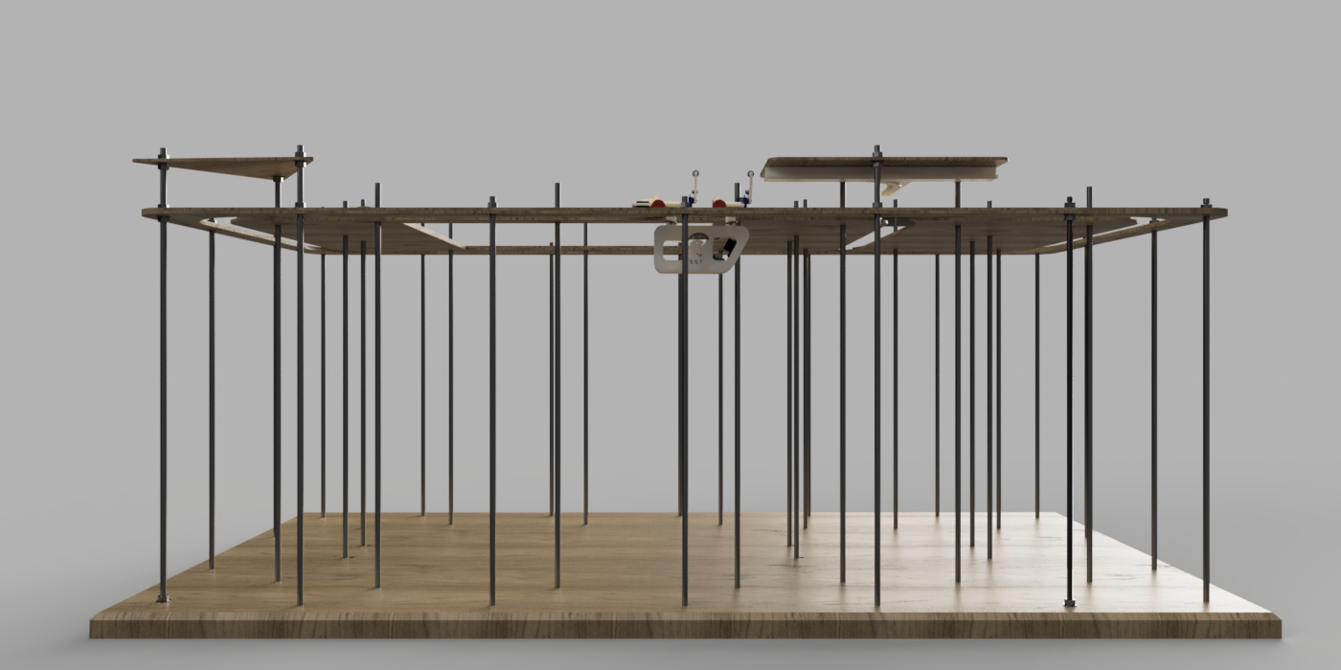
Figure 1. Assembly of the final model of the guideway, bogie and pod.
A refined 3D CAD model of the pod and bogie, shown in Figure 2, was also made. This design successfully improves upon the designs of previous work. It incorporates snap fits, swiveling connections, and a body that is easy to disassemble.
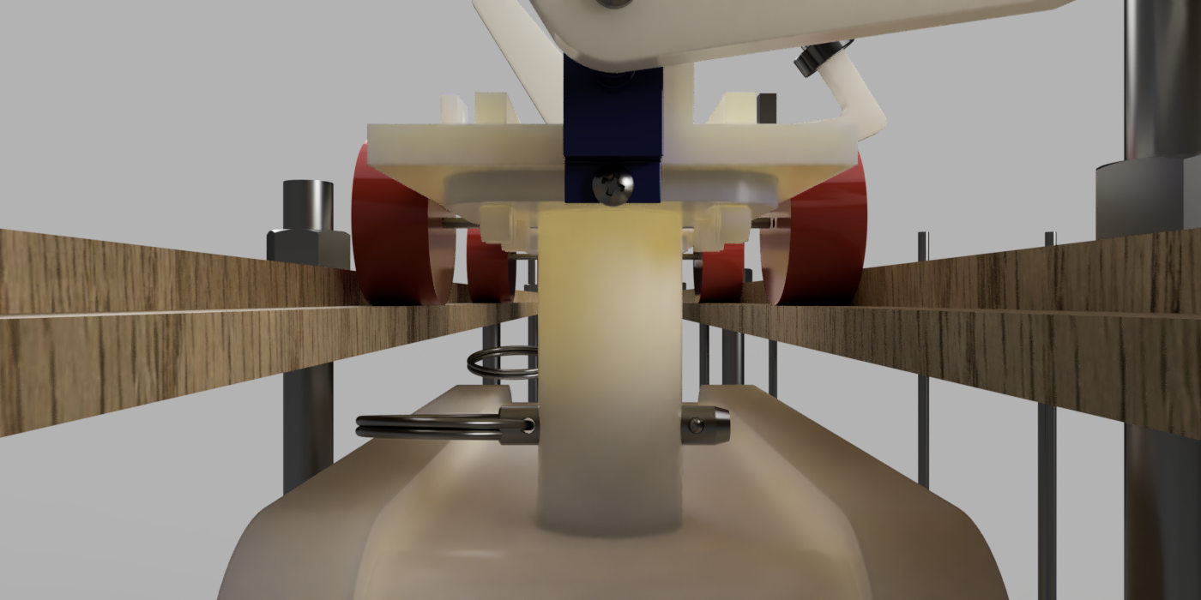
Figure 2. 3D Modeled Pod and Bogie Assembly.
Lastly, the controls team made further progress on the app, Arduino sketch, and electrical hardware. The controls system uses an iOS app in conjunction with a bluetooth module to communicate with the Arduino microcontrollers placed inside the pods to control them on the track. The loading screen of the app can be seen in Figure 3.
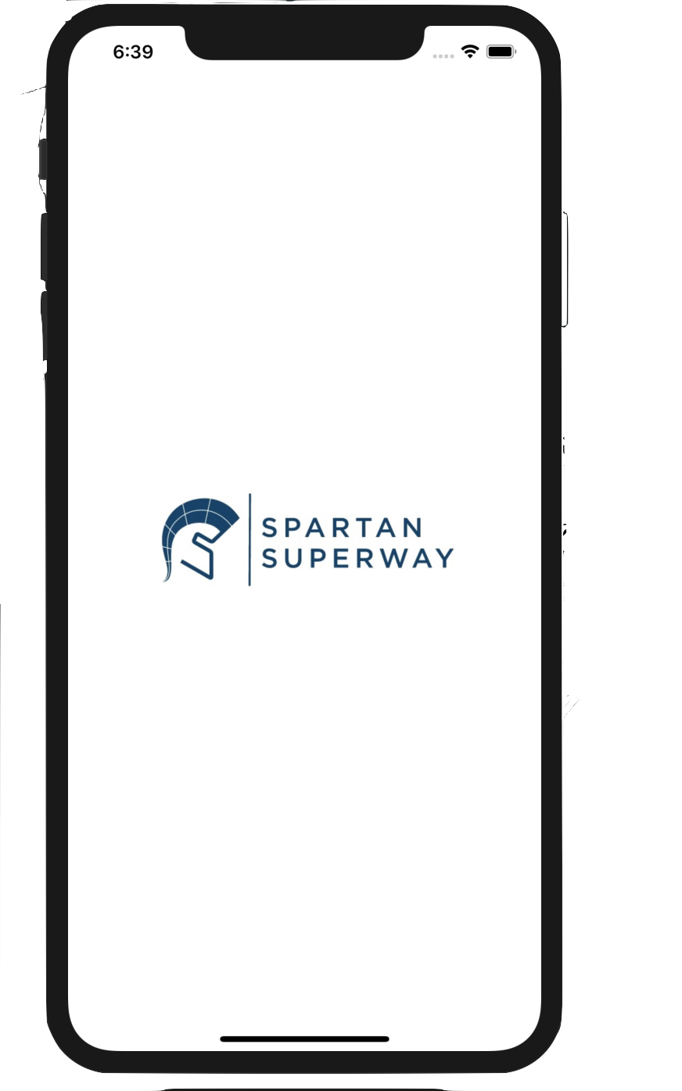
Figure 3. The iOS app loading screen.
The following section of the report will provide an introduction to SPARTAN Superway as a whole, the problem that is being faced that calls for a project like the Superway to be developed, the societal impact that the project could have, along with the overall structure for the remainder of the report.

2. Introduction
SPARTAN Superway is a project started in 2012 by Dr. Burford Furman and Mr. Ron Swenson along with students at the SJSU College of Engineering. This project is an implementation of Automated Transit Networks (ATN). This section will discuss the current problems with transportation and its societal impact in the Silicon Valley and the Bay Area. It will also explain how SPARTAN Superway is a solution to those problems along with the prior work at SJSU. Lastly, this section will also discuss the structure of the Small-Scale team for the 2019/2020 academic year.

2.1 The General Problem
The world is currently facing environmental and societal issues that have never been seen in the planet's 4.53 billion year history. These environmental issues can be directly attributed to the rapid expansion of the human species, especially since the age of the industrial revolution. The math is simple, more humans on the planet using resources at a faster rate than what the Earth can replenish, equals long lasting negative effects. With an increasing population, there is a higher demand for every kind of resource that humans need to keep advancing socially, technologically, and economically. One of the most demanding sectors of resources used is transportation. In 2017, emissions from transportation accounted for about 28.9 percent of total U.S. greenhouse gas emissions, making it the largest contributor to U.S. greenhouse gas emissions (US Environmental Protection Agency, 2020). Figure 4 illustrates how this percentage compared to other sources of greenhouse gas emissions.
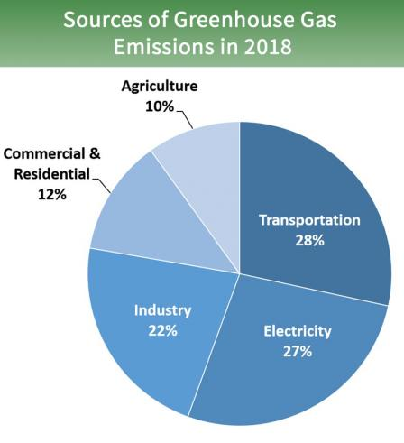
Figure 4. Total U.S. Greenhouse Gas emissions in 2018 (US Environmental Protection Agency, 2020)
With more humans populating the planet, there is an urgency for quicker and more efficient transportation. At the current moment in the United States, people’s top choice of transportation is still the automobile. This presents a significant issue in cities such as San Jose, San Diego, San Francisco, and other highly populated areas with the amount of traffic on the road. What is even more concerning is the fact that per passenger vehicle, 4.6 metric tons of carbon dioxide are emitted per year (US Environmental Protection Agency, 2018). It has been recorded that traffic congestion has actually increased 1.5 times faster than population growth since the year 2000 (Vital Signs, n.d.). Not only does traffic congestion present environmental issues, but it increases the stress level of the people who have to endure it on a day-to-day basis. Traffic also causes people who commute to work on a daily basis to lose anywhere from 42 to 84 hours per year due to sitting in traffic (Andrews, n.d.). This is valuable time that could be used for people to invest in themselves or with their loved ones. Happier and less stressed people have been proven to be more productive at their respective jobs, as well as with their own personal goals.
In major cities, specifically in the Bay Area, current public transportation alternatives such as BART, VTA Light Rail, and buses are not ideal solutions as they are crowded, inefficient, and do not provide an overall pleasant experience that encourages people to continue using public transportation. With the current world pandemic, these crowded forms of public transportation will not be ideal any time in the near future. Furthermore, despite millions of dollars being invested into biking infrastructures in the Bay Area, people still select their personal vehicles as their form of transportation, even if it is a 7 minute trip to the grocery store. Other alternatives to biking and public transportation are services like Uber and Lyft; however, these methods still contribute to the greenhouse gas emissions and are not solutions that solve the root problem.
In addition to this, parking is a hassle in any major city, this is especially true for San Jose and in particular SJSU. On the first day of classes in the Fall 2019 semester, more than 22,600 cars entered the University’s parking services (Faas, 2019). This meant that students and faculty who drove to campus, not only had to worry about their first day of class going well, they had to worry about being able to find parking. The theme with all of these issues is that there is not an environmentally friendly alternative at the moment which is quick, efficient, and provides a pleasant experience. This is exactly where Automated Transportation Networks such as the SPARTAN Superway come into play. A brief overview as to what ATN is and how Superway plays a role in this mode of transportation will be discussed in the following subsection.

2.2 Introduction to ATN
Automated Transit Networks (ATN) are driverless transportation solutions that offer point-to-point transport between destinations. Since each ATN vehicle carries four to six passengers, ATN is referred to as Personal Rapid Transport (PRT) as well. Automated Transit Networks offer a common feature where the steering and propulsion is part of the bogie and that the guideway has no moving parts (Furman, 2016). ATN is not new technology; however, there are only five of these networks in the world. PRT networks offer five characteristics that distinguish them from other modes of transportation. These characteristics include origin-to-destination service, fully-automated vehicles, exclusive-use guideways, off-line stations, and a system of fully-connected guideways (Carnegie, Voorhees, & Hoffman, 2007). PRT can provide many benefits to residents in cities by building upon the current transportation options with guideways that get closer to neighborhoods. In addition, congested cities where traffic is heavy would need a safer and quicker alternative than walking or scootering. Supported ATN vehicles ride on top of the guideway and suspended ATN vehicles ride beneath the guideway. PRT guideways don’t use much land real estate and would be an excellent option for compact and sustainable transportation in heavily populated cities where real estate is limited. The PRT systems use less energy per passenger-mile than conventional transportation methods equivalent to an average fuel efficiency of 80 mpg (Carnegie, Voorhees, & Hoffman, 2007). Using less energy per passenger-mile is due to the non-stop flow of PRT, which reduces the usage of kinetic energy as a result of braking. Using an alternative source of energy to generate electricity for powering PRT systems is still needed in achieving a truly sustainable mode of transportation. The next section will discuss a recent ATN project development that is truly sustainable by using renewable energy sources.

2.3 Superway ATN Development
SPARTAN Superway is a Solar Powered Automated Rapid Transit Ascendant Network that is being researched and developed by students at San Jose State University. Superway offers a feature that no other ATN systems in the world offers, which is being truly sustainable. This means that the electricity to operate the entire system is generated from renewable energy sources. By installing solar panels on top of the guideway, enough energy can be stored to efficiently power the podcars to operate 24 hours a day. Aside from being truly sustainable, Superway is a suspended ATN system, which reduces the land-use. Suspended guideways allow the bogie steering and propulsion electronics to be covered by the guideway, which is beneficial in reducing long term damage due to changes in weather. Since the ATN vehicles have a steering mechanism, the guideways contain no moving parts reducing the cost of maintenance. Research was conducted that solar panels two to three meters wide on a 14 km guideway in San José would provide enough electricity to operate a network 24/7 a year at a rate of 1,440 passengers per hour (Furman, 2016). Solar panels are another name for photo-voltaic (PV) modules, which is a semiconductor material that converts light into electricity. The ATN vehicles can be charged from the guideway itself by using wayside power rails and collector shoes on the vehicles resulting in on-the-go charging. The next subsection of the report will discuss the societal impacts and the importance of Superway for the city of San José.

2.4 Societal Impacts
With the problems discussed earlier, there is a dire need for a quick and green solution. As briefly mentioned in the first section, SPARTAN Superway aims to provide a quick, efficient, and pleasant transportation experience for the City of San Jose.. The goal is to have several stations at specific points of interest spread across San Jose. To reach each of these stations, there will be pods that can be requested from a mobile app. The pod nearest to that specific station will pick up the customer and take them to the station closest to their desired destination.
With a project such as this one being implemented in the city of San Jose, the quality of life for the people will improve dramatically. Having a suspended transportation network means that traffic can be reduced significantly. If an increased amount of people are electing to use SPARTAN Superway, the amount of people driving is reduced, hence reducing the amount of traffic and the emissions that would otherwise happen. Having pods which traverse to specific points of interest is beneficial because it creates a “carpool” experience in which up to six people are able to be in a pod at once. Another positive aspect of the Superway is that it can easily be integrated into the biking infrastructure so that there is no need for cars to achieve local trips. By setting up the Superway stations near the biking heavy locations, users can easily get to the Superway stations via bikes, a bike rack could be added to the pods so that the user can take their bike with them and complete their trip to their final destination once they exit the Superway. This would not only make transportation more efficient, it would enhance one of the cleanest forms of transportation.
In addition to this project having a positive impact in the city of San Jose, it can have a greater effect in the SJSU community. As stated in the current problems section, parking is a serious problem for any person who needs to commute to the university. Adding drop off stations for SPARTAN Superway near the university, would allow for students, professors and any SJSU affiliate to avoid the need to search for parking every morning. It could also create a tighter bond within the SJSU community as students, professors, or really anyone who decides to use this form of transportation would be able to interact with new people who they may have not otherwise met. Overall, the societal impact of SPARTAN Superway will be positive in terms of the reduced: emissions, traffic, and parking issues. Meanwhile, it will create a close knit community in which people look forward to choosing the Superway as their transportation of choice. As mentioned briefly in the project description section, SPARTAN Superway as a whole has many requirements and goals. This will further be discussed in the following sections of the report.

2.5 Prior work on ATN at SJSU
SPARTAN Superway is developing an ATN to be implemented at the SJSU campus and its surrounding areas. Each year since Superway’s inception in 2012, senior project teams and summer interns have collaborated to demonstrate a proof of concept ATN system. The 2013-2014 team developed a full-scale 4.9 m guideway, improved on previous years 1/12 scale, and presented their work at Maker Faire and InterSolar (Cowley, et. al., 2014). In 2015, an autonomous full-scale guideway with a working switch mechanism and a bogie fitted with motors (Ornellas, et. al., 2015). In addition, a new 1/12th scale model was designed and manufactured that better resembles the full-scale design more than the previous models. A full-scale proof of concept cabin was made as shown in Figure 5.
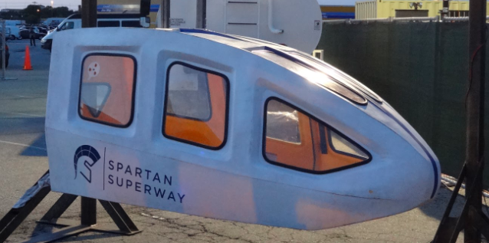
Figure 5. SPARTAN Superway Full-Scale Cabin retrieved from https://www.inist.org/Projects/SpartanSuperway

Analysis was completed on the guideway in 2016 to determine the designs that need improvement and areas within the structure that may cause problems. The team featured over 40 students from different majors. The overall project structure will be discussed in the next subsection of the report.

2.6 Project Structure
The Small Scale Team was organized into three main subteams: guideway, bogie, and controls. Each subteam represents an important aspect of the project, all of which play a large role in the team’s overall success. Asmaa Darwish, Lissette Romero, and Julio de Pereda Banda are on the controls team. Their primary responsibilities were to develop a control system for the pods, the app and the Arduino sketch. Justin Ghieuw and Shane Fatehi designed and built the track for the guideway. Whenever deemed necessary members from either the controls or guideway team came together to work on the bogie to ensure that progress was also made in this area. A visual representation of this division of team members is shown in Figure 6.
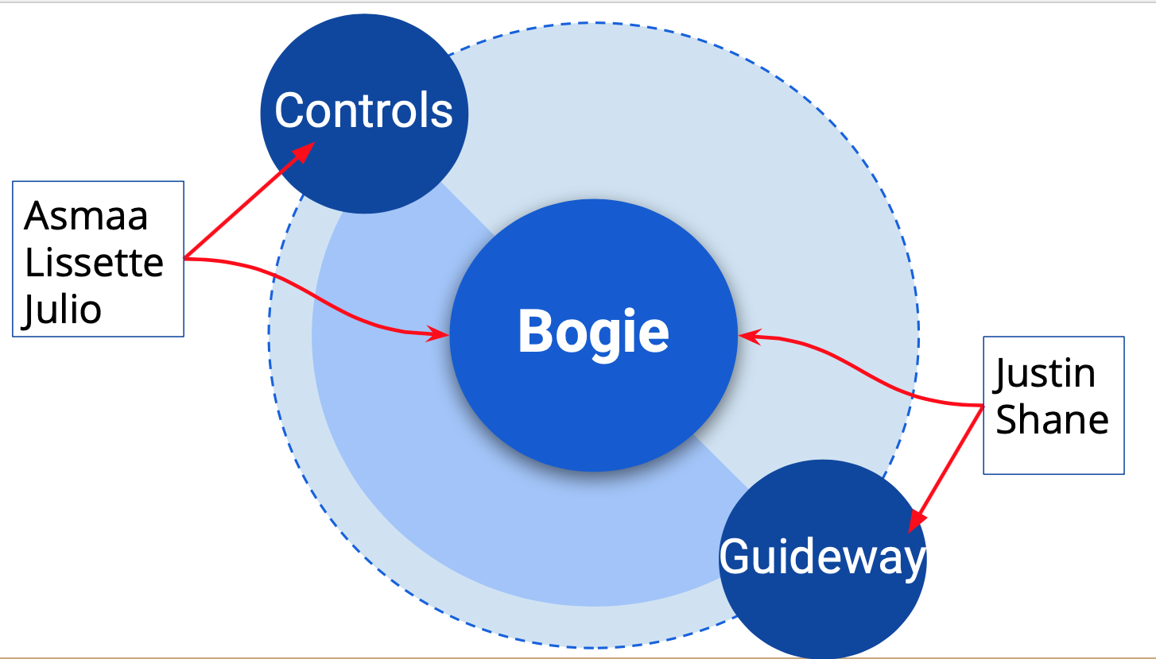
Figure 6. Division of Small Scale Team sub teams.
Now that a brief overview has been given regarding the SPARTAN Superway and the Small Scale Team, the remainder of the report will focus on the projects objectives, requirements and specifications, state of the art literature review, final design, analysis, and finally the results.

3. Project Objectives
The main objective of the Small Scale team was to improve upon previous guideway, bogie, and controls designs to achieve a cohesive and fully functional system. The guideway team focused on designing and building a y-junction and track that is easy to assemble and allows the bogie to travel smoothly. Another objective for the guideway was to improve the interchangeability and manufacturing of the parts for the track. For the bogie, the main objective was to design a switching mechanism that would eliminate failure at the y-junction. The next objective for the bogie team was to develop a pod and bogie which is easy to assemble and modify if needed. In other words, the pod and the bogie should be able to be disassembled to allow for easier access to electronics.
For the controls team, the main objective was to have two pods on the track at the same time, each following its own path without colliding with one another. Another objective is to have an electronic system equipped with a reliable stepper motor that outstand long periods of operations and a reliable station recognition system with a fast response time to identify different stations around the track. Furthermore, the controls objective was to develop an iOS app which allows the user to control the bogies from their mobile device. This app will control every aspect of the bogie, but will also keep the user in mind to create an enjoyable and aesthetically pleasing user interface. This concept of creating a great user experience is crucial for getting people excited about the project. The more excitement and awareness regarding the project, the higher the chance of success. In the next section, specific requirements and specifications will be discussed.

4. Requirements and Specifications
Each Small-Scale subteam has different requirements and specifications that will allow the project to work cohesively as a complete model.

4.1 Guideway Specification
Table 1. Guideway Design Specifications
Parameter | Value | Unit | Comments
Track (MDF Board) | 96 x 48 | in. | Overall length and width of the track
Base (Plywood) | 96 x 48 | in. | Overall length and width of the base
Thickness | 0.25 | in. | Thickness for bottom and top tracks
Straights | 16 | in | Length of top/bottom straights
Outer Curve Top Track  Inner/Outer Radius | 7  3 | in. | Inner and outer radius of the top track for the outer curves, respectfully
Outer Curve Bottom Track  Inner/Outer Radius | 6.5  3 | in. | Inner and outer radius of the bottom track for the outer curves, respectfully
Inner Curve Top Track  Radius | 3.5 | in. | Radius of the top track for the inner curves, respectfully
Inner Curve Bottom Track  Radius | 4 | in. | Radius of the top track for the inner curves, respectfully
Top Y-Switch | 2 | /track | Y-junction rails needed for y-switch of bogie
Corner Supports | 90.86 | sq. in. | Overall area of triangle supports
Threaded Rods (Steel) | 3 | ft. | Length of threaded rods
 | $\frac{1}{2}$-13 | in. | Diameter of threaded rods

4.2 Bogie Specifications
Table 2. Bogie Design Specifications

Parameter | Value | Unit | Comments
Speed | .2 | m/s | The speed without stopping or slowing
Max Weight of Pod | 1.5 | lbs | Including mechanical and electrical hardware
Max Weight of Bogie | 1.5 | lbs | Including mechanical and electrical hardware
Max Weight of System | 3 | lbs | Including mechanical and electrical hardware
Pod Dimensions | 3.5 x 9 x 6 | in
Bogie Dimensions | 9 x 2 x 2 | in
Y switch | 2 | /bogie | 2 fully functional y switches per bogie

4.3 Controls Specifications
Table 3. Controls Design Specifications
Parameter | Value | Unit | Comments
Sensor Response Time |  |  | Maximum
iOS app | N/A | N/A | Fully Functional (Communicates w/ BLE)
Ultrasonic sensor | 1 | /pod
Pixy2 Cam | 1 | /pod | Image recognition Camera
HM 10 (BLE) | 1 | /pod | Bluetooth Module
Nema Stepper Motor | 1 | /pod | Motor has to be able to run at 0.2m/s speed

5. State of the Art Literature Review

5.1 ATN around the world
Several Automated Transit Networks exist in the world and each of these networks offer a unique feature that differentiates them from other networks. Automated Transit Networks offer a common feature where the steering and propulsion are part of the bogie and that the guideway has no moving parts (Furman, 2016). The guideway not having any moving parts is a step towards reducing the long term maintenance costs. The five ATN’s in the world are Morgantown PRT, Parkshuttle Rivium, Masdar City PRT, Terminal 5 shuttle at London Heathrow Airport, and nature park shuttle in South Korea. None of the Automated Transit Networks that are implemented today operate on a suspended guideway.

5.1.1 Wuppertal Suspension Railway
The Wuppertal Suspension Railway is not an ATN system; however, it is an example of one of the very few guideways around the world that are elevated. It is located in Wuppertal, Germany and has been operational since 1901. It comprises one loop which covers a distance of 13 km and transports approximately 85,000 people. Since its first day of operation, there have been a total of 1.5 thousand million people who have used this form of transportation (Wuppertal Tourism and City Information , n.d.). The City of Wuppertal reports that people from all over the world visit the suspension railway on a yearly basis as it has become a popular point of interest. An image of this suspended railway can be seen in Figures 7 and 8.
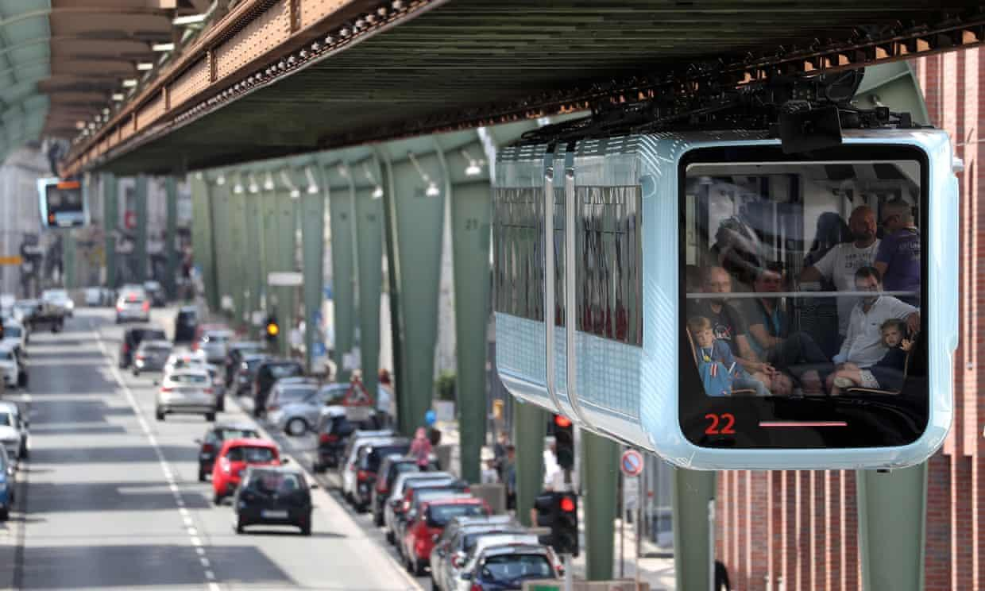 | 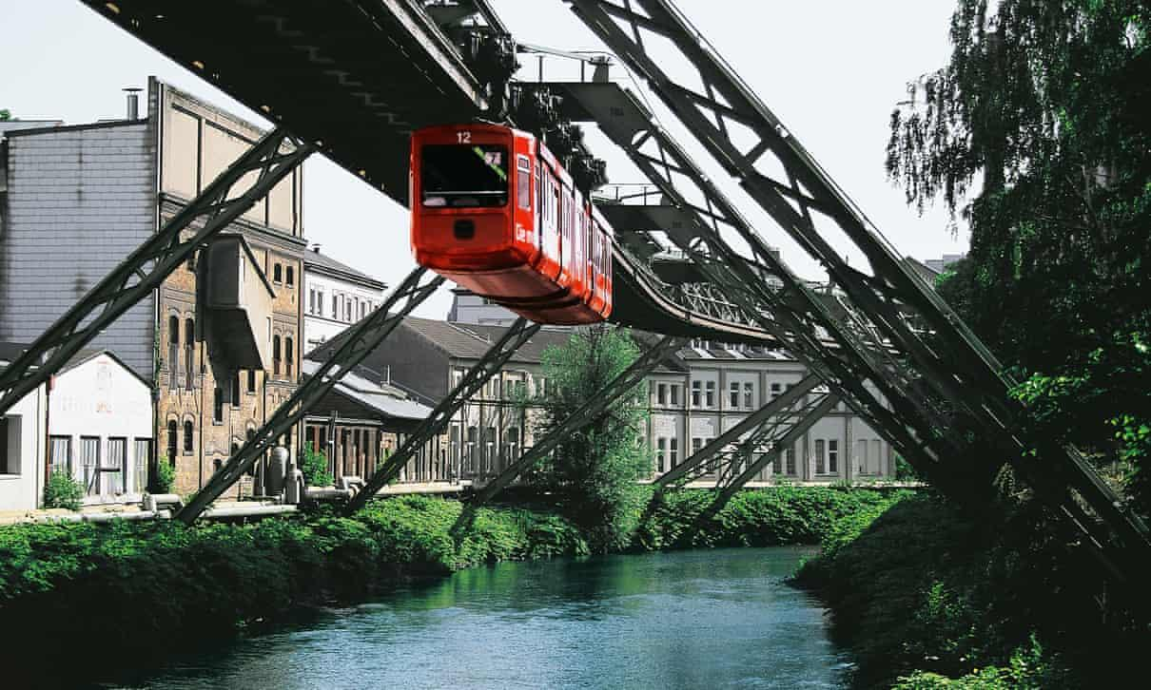
Figure 7. Wuppertal Suspended Railway above traffic (Connolly, 2019) .  https://www.theguardian.com/world/2019/aug/01/worlds-oldest-electric-suspension-train-reopens-in-germany | Figure 8. The Wuppertal Suspension Railway above the city river (Connolly, 2019). https://www.theguardian.com/world/2019/aug/01/worlds-oldest-electric-suspension-train-reopens-in-germany
This suspended railway is electrically powered and it can achieve a top speed of 37 miles per hour, with the whole journey from beginning to end taking a total of 35 minutes. Throughout the route across the city, there are a total of 20 stops at specific points of interest where people can either get on or off the railway (Wuppertal Tourism and City Information , n.d.). The people who use the Wuppertal Suspension Railway state that it is a convenient form of transportation as the railway weaves through the city avoiding all of the traffic (Wuppertal Tourism and City Information , n.d.). This elimination of traffic is a trend with these suspended railways as they provide substantial benefits by reducing ground real estate, which allow these guideways to be implemented anywhere, even above rivers as seen in Figure 8.

5.1.2 Morgantown Personal Rapid Transit System
The Morgantown Personal Rapid Transit system is another example of an ATN that resides in West Virginia and features a driverless system that transports students between campuses. The Morgantown Transit system is responsible for transporting 15,000 riders per day (Boeing, n.d.). Personal Rapid Transport (PRT) offers a smaller people mover, which can hold up to 4 or 6 passengers. The benefit of PRT is that it offers a more personal ride without making unnecessary stops, all the passengers will go to one location quickly. The Morgantown system pods have a similar steering system design as cars shown in Figure 9 (Morgantown, n.d.).
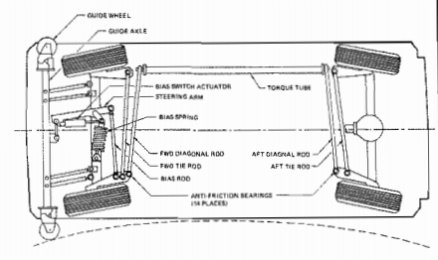
Figure 9. Morgantown vehicle steering system (Morgantown, n.d.). http://www.advancedtransit.org/wp-content/uploads/2011/09/M-PRT_1-1_SYSTEM_OPERATIONS_DESCRIPTION_MANUAL.pdf

5.2.3 Ultra Rapid Transit at London Heathrow Airport
Each one of the twenty-one driverless vehicles at London Heathrow Airport can carry up to four passengers and can travel up to 25 miles per hour while transporting passengers from terminal 5 to the car park in less than 5 minutes on its 2.1-meter wide guideway (Nordstrom, 2009). On the guideway, each pod travels in a single direction on rails as shown in Figure 9. The network is controlled and monitored by personnel that overlook the system inside a control center (Furman, Ellis, Mueller, & Swenson, 2014). Each vehicle is equipped with sensors to prevent collisions and a control system that allows each pod to take people to their destination without interruptions. It achieves this by taking the vehicles offline to avoid disruptions when the PRT is carrying passengers.
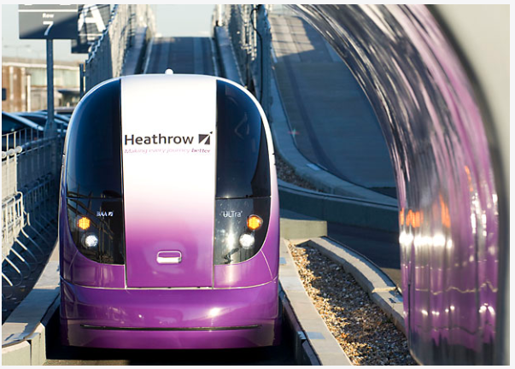
Figure 10. Urban Light Transit PRT in London Heathrow Airport retrieved from https://www.ultraglobalprt.com/how-it-works/ultra-vehicle/

5.1.4 Cabinentaxi PRT in Hagen, Germany
The only other ATN PRT system to have a similar suspended guideway as SPARTAN Superway was developed by a joint-venture between two German companies (Furman, Ellis, Mueller, & Swenson, 2014). This guideway system offers a point-to-point PRT service to increase the time it takes to deliver passengers to each station. This guideway is unique because it uses two types of podcars. The first podcar is suspended on the guideway as shown in Figure 11. The other podcar can ride on top of the guideway rails like a car and is not suspended.
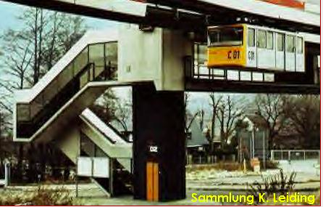
Figure 11. Cabinentaxi in Germany retrieved from https://alchetron.com/cdn/cabinentaxi-37ebcb10-4f8f-456d-98ba-0f94b0f51e6-resize-750.jpeg

This system went through all sorts of endurance testing to ensure it can withstand the real-world conditions for 11 months (Furman, Ellis, Mueller, & Swenson, 2014). The Cabinentaxi project development and funding ended in the 1980s.

5.1.5 JPods
Bill James is the founder of JPods, which is a PRT system as shown in Figure 12 that is functional. James mini scale model inspired two major design decisions for the 1/12th scale guideway and bogie team. The mini scale model offers a fully automated bogie outfitted with wheel encoders to track location and a camera to detect signs. The first design was using MDF material for the guideway, which is low-cost to manufacture. The second design that was inspired was the swivel bogie platform, which allowed the bogie to easily traverse through the corners.
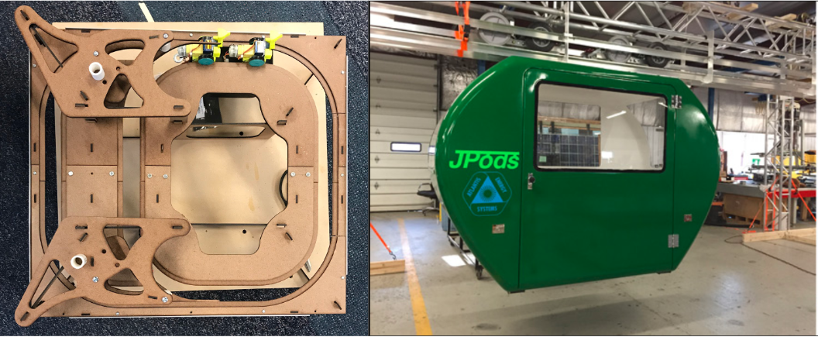
Figure 12. Bill James mini model on the left and JPods full scale on the right retrieved from https://www.jpods.com/construction/SideView141112_02.jpg

5.2 Past Superway Teams
Prior Spartan Superway senior project teams for the 1/12th scale have created designs for the guideway, pod, and controls. The guideway design has mainly been focused around using aluminum bar stock for the track pieces and designing a bending tool that can precisely bend the aluminum for the corners as shown in Figure 13.
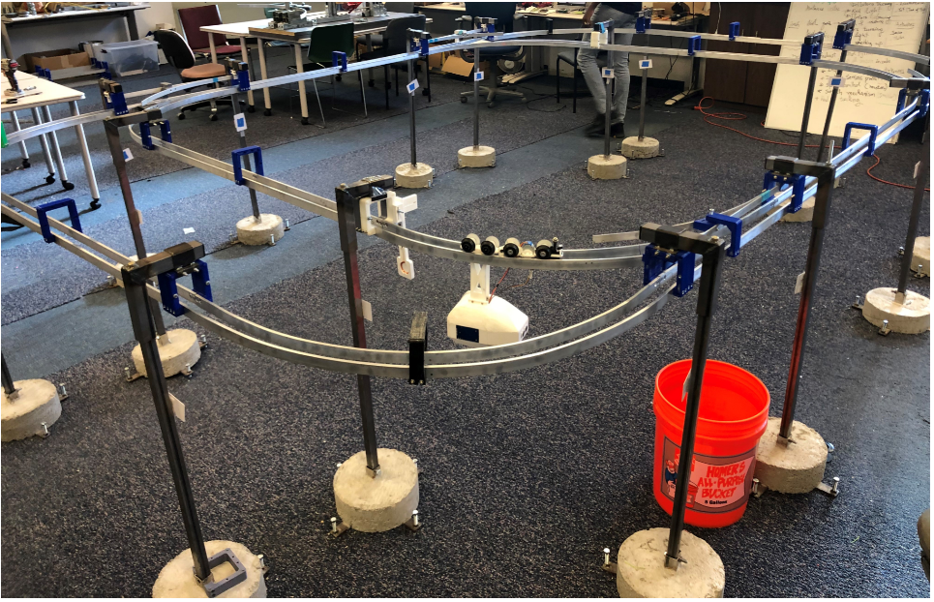
Figure 13. The previous year’s aluminum track
The pod has seen several iterations of redesigns throughout the past six years from a single pod to a dual master-slave pod in most recent years. The most notable developments have been improving the 1/12th scale controls. With the help of graduate software engineering students, the 1/12th scale was fitted with a mobile application user interface that allowed different users to create accounts, schedule rides, and save all pertinent information into a database (Alvarez, et. al., 2016). The interface of the app that was developed in 2016 is shown below in Figure 12. The team developed a complex system that uses an asynchronous programming language (NodeJS) to spawn threads and communicate with the Firebase database to store each user's ticket.
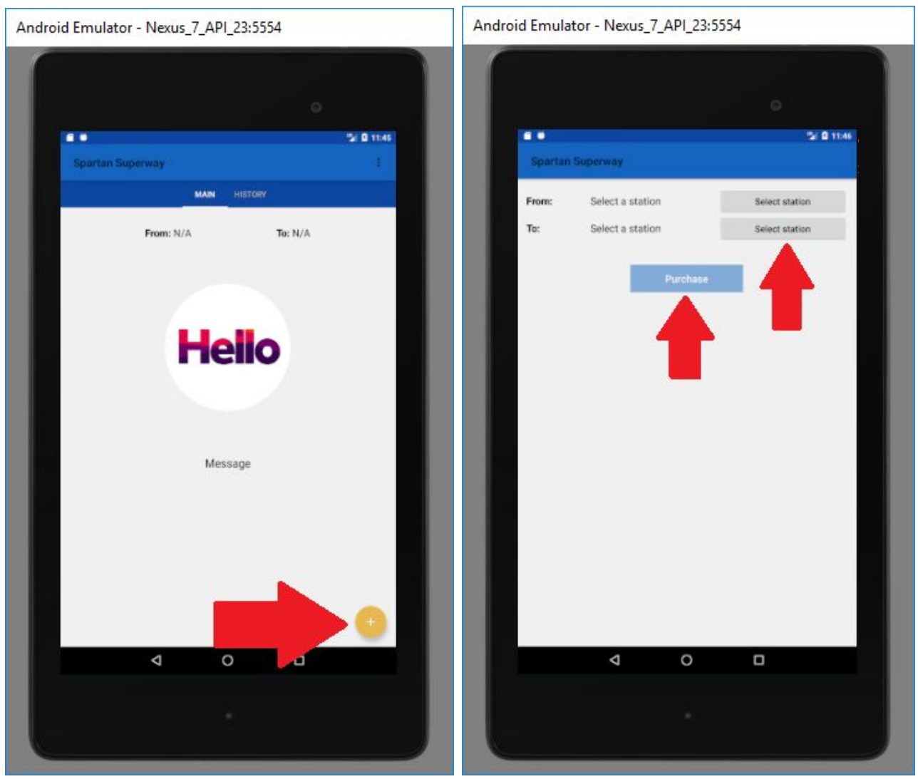
Figure 14. Small-Scale Mobile Application in 2016
In 2017, Superway made progress by upgrading the 1/12th scale track and podcar, improved propulsion and control system for the half-scale model, and small models of rails designs were made (Aquino, et. al., 2017). The small-scale team conducted research on implementing a position sensing system for each podcar that would be able to provide real-time location tracking. Due to the wheels of the bogie slipping and producing inaccurate position data, this method was not implemented. In 2018, the small-scale re-designed the bogie and implemented a master-slave bogie design, which prevents the bogie from getting stuck at round turns or at y-junctions (Halabi & Jocson, 2018). The 2018 team suggested making the bogie more robust by designing a dual-switch mechanism. The small scale SPARTAN Superway teams in the past have designed a guideway that featured 1/12th scale bogies to traverse along the guideway and effectively switch over rails on the y-junctions.
Over the past six years, the guideway has been made out of aluminum bar stock and the two rails separated by a fixed distance using 3D printed PLA clamps as shown in Figure 15 . Previous teams were unsuccessful to get a working guideway due to several issues with the design. First, the aluminum bar stock needs to be bent to a specific radius for the corners of the guideway. The tool used to bend the aluminum was not precise, thus all the bent pieces of the guideway were different from each other. This caused the guideway pieces to not be interchangeable furthermore increasing the time it takes to take-apart and build the guideway. The 2018-2019 team spent the first half of the semester designing and manufacturing a tool that can precisely bend each aluminum bar stock for the corners of the guideway.
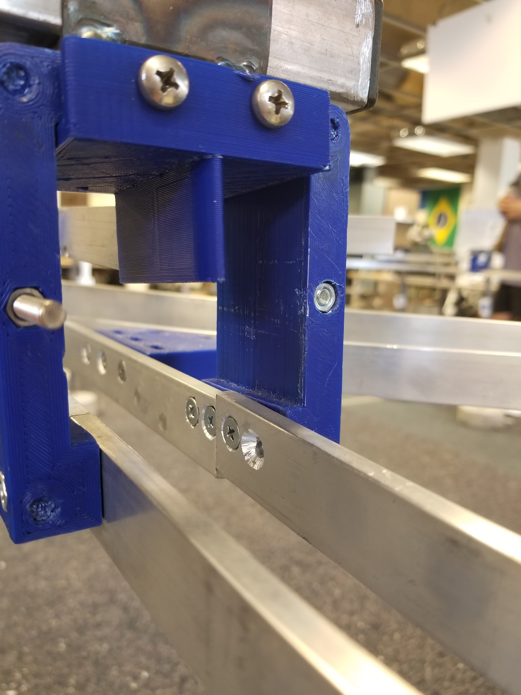
Figure 15. Connection between two tracks
The previous years bogie team developed a master and slave bogie assembly to ensure the system does not fall through the guideway when it switches as shown in Figure16. Previous teams stated that this implementation works better than a single bogie assembly.
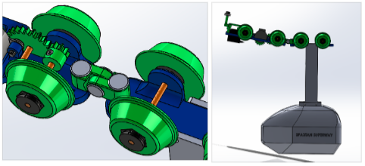
Figure 16. Bogie master-slave.
In addition, the bogie is equipped with inductive charging and tapered wheels. Using an inductive charger resulted in limitations into the types of DC motors that can be used for propulsion. Tapered wheels were used to allow the bogie to easily traverse through the round corners. Non-tapered wheels resulted in the bogie getting stuck. The 2018-2019 controls team developed an application to be used with a Raspberry Pi tablet as shown in Figure 17. The Raspberry Pi tablet was found to be inconvenient to use and determined that a phone application would be a preferable solution.
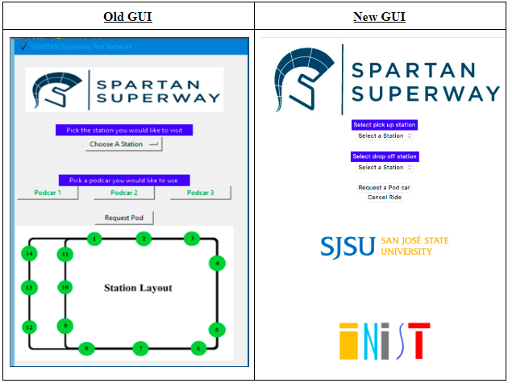
Figure 17. Raspberry Pi GUI from 2018-2019 team.

5.3 Bluetooth Low Energy Research
As mentioned briefly, the goal is to have the ability to control the pods from the iOS app via the BLE module on the Arduino. To do this, a lot of research had to be done to see how this connection between an iOS app and an Arduino was possible. A clear guide was difficult to find; however, there are a lot of different iOS apps which are already able to get this connection. The code for these apps is available from Github and can be analyzed to see how the connection was done. There are also several YouTube videos that attempt to explain this process. Apple also has some brief presentations with information about connecting to a BLE via an Xcode created app. However, there is no clear set of instructions, it takes a lot of piecing together to understand how this connection can be accomplished. In order to get an idea as to how to go about connecting the iOS app to the Arduino, some background research on how BLE technology works and how it can be utilized in Xcode will be explained.
BLE stands for Bluetooth Low Energy, it differs from normal bluetooth because as the name implies, BLE uses significantly less energy than standard bluetooth. This is the case because BLE devices will be in a dormant phase, unless they are searched for with their Universally Unique Identifiers (UUID). This dormant phase allows for the BLE’s battery life to last a lot longer, anywhere from months to a couple of years. In order to understand how to search for the BLE devices via the specific UUID, the concept of central and peripheral devices must be understood.
A central is a device that is seeking information from the peripheral device. Meanwhile, a peripheral is a device that has information or data that the central device can utilize. Apple explains this relationship between centrals and peripherals as a client and server relationship. In which the central is a client who is seeking information from a server. This relationship can be seen in Figure 18:
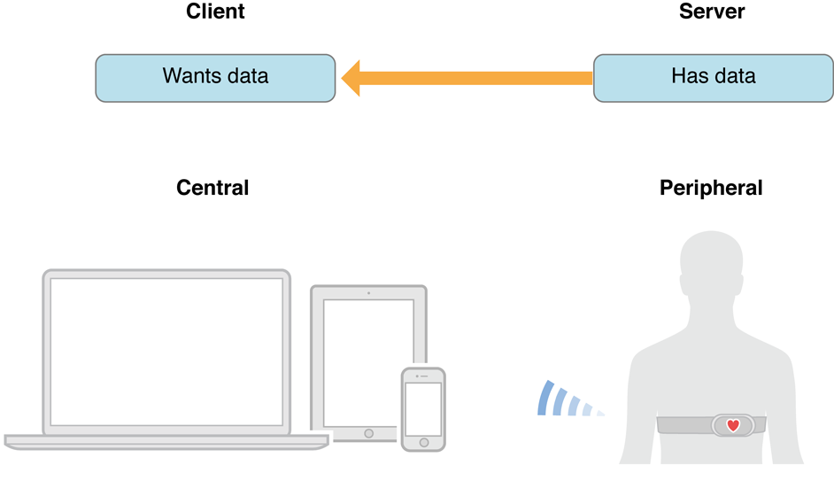
Figure 18. Central and peripheral visual representation. (Core Bluetooth objects on the central side, 2013)
The central device searches for the peripherals who are advertising themselves. Once a central device connects to a peripheral, then the peripheral can send information which is required by the central device. This is a very brief introduction to the concept of centrals and peripherals, but it is necessary as the iPhone via the iOS app will be acting as a central device, scanning for the peripheral device which would be the Arduino via the BLE.
After the intensive research regarding how BLE works and the manner in which it can be implemented into Xcode, the best source of information which was found was this article which listed the “12 Steps of BLE” (Hoyt, 2017). In order to test this, a separate test app was created with a single view (it will be explained in further depth in the analysis section of the report), which aimed to attempt to follow the steps presented in the article to see if a connection would be achieved. The twelve steps the article presented can be summarized into: searching for BLE, connecting to BLE, reading or sending information to and from the BLE. Another guide was discovered that presented the steps in an easier to follow manner, combining the two guides is ultimately what allowed the BLE and iOS app connection to be successful (this guide can be accessed in Appendix J. The next section of the report will discuss the final design for the three subteams.

6. Final Design
The final small scale design consists of a reliable guideway that is easy to manufacture and assemble, a pod and bogie that is simple yet effective, and finally, a controls system that is smart and user friendly. Each facet of the final small scale design will be discussed further in the following sections.

6.1 Guideway Design
The final design of the guideway will consist of two y-switch rails, two loops, track pieces elevated three feet, and additional supports at the corners for stability as shown in Figure 19. The goal of this year's design was to improve upon the weaknesses of the prior teams. The biggest issue previous guideway teams faced was interchangeability between each piece. If the guideway needed to be disassembled, assembling it back up would take too much time since each piece is different.
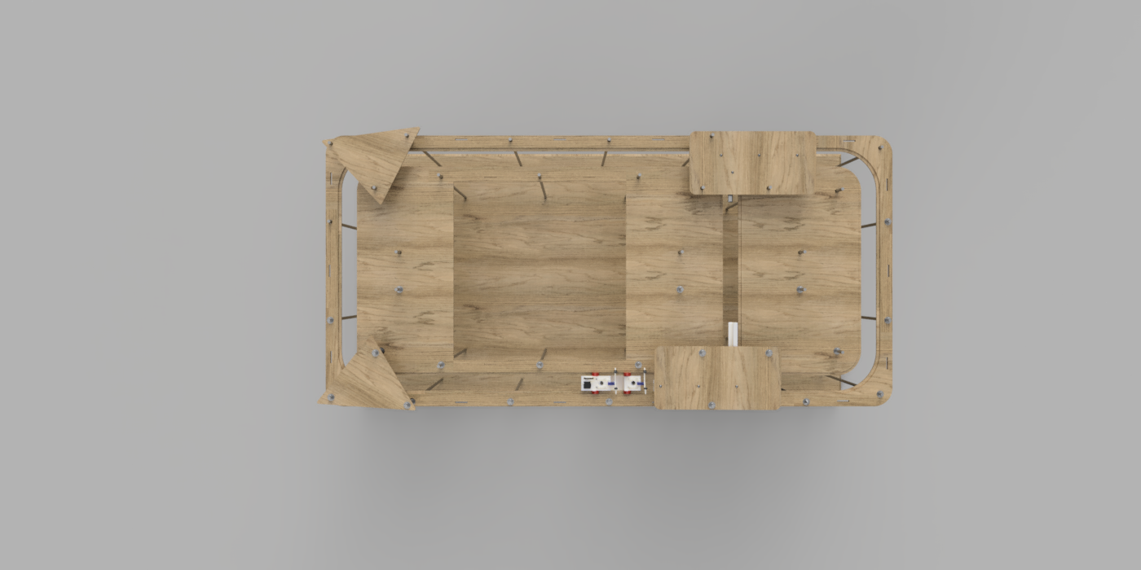
Figure 19. Final guideway with bogie entering right y-switch.

This year's guideway team decided to take a different route than previous teams by changing the material of the guideway from aluminum bar stock to one-quarter inch medium-density fiberboard (MDF). The guideway was elevated 33 inches above the ground using steel ½-13 threaded rods and each guideway piece was manufactured using a laser cutter. As shown in Figure 20, the guideway’s width and length are 48 and 96 inches, respectively.
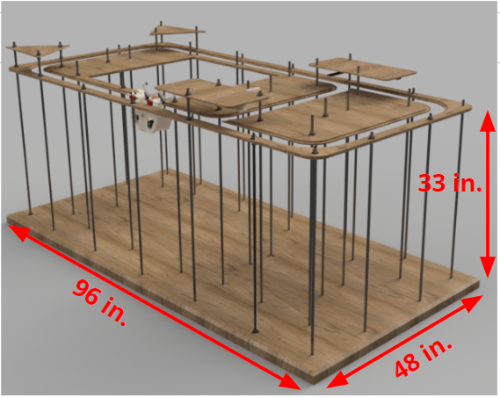
Figure 20. Guideway dimensions
The laser cutter was used in the Makerspace, a facility within the College of Engineering at San Jose State University that offers students equipment free of charge to use throughout the year. The laser cutter has a bed size of 17x32 inches, which was sufficient for the number of pieces needed for the guideway. The MDF board’s standard size bought at Home Depot was 23.75 x 47.75 inch, which was cut to the appropriate dimensions for the laser cutter using wood saws at the Makerspace.
The design intention of the track pieces is to group them in pairs labeled top and bottom. The bottom piece has a width of 2.5 inches while the top piece has 2 inches, which leaves 0.5 inches of space on the guideway for each bogie wheel. There is a 3.5 inch spacing between the track rails where the bogie wheels traverse on. The top piece is glued onto the bottom using wood glue and must be aligned using the rectangular slot on each track piece. One way of utilizing the rectangular slot for alignment is by 3D printing or laser cutting 0.25 x 2 x 4 inch long rectangular blocks. Another method for aligning each track piece prior to gluing is to use 10-32 pan head screws. The team decided to take this route because the hardware was already at the design center. Once the glue for the top and bottom pair dries, they can be assembled like a layer cake design as shown in Figure 21.
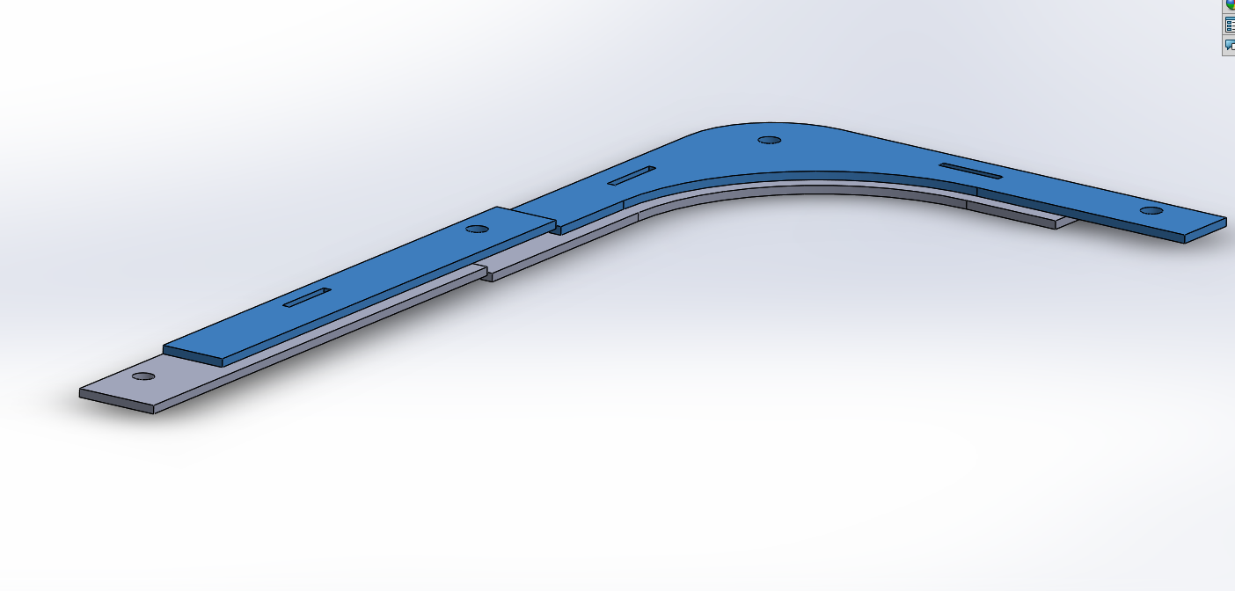
Figure 21. Layer cake design of guideway pieces.
The bogie will encounter two switch assemblies as it traverses the guideway. The right y-switch as shown in Figure 22 is the first y-switch the bogie encounters if it is traversing through the inner loop. The servo motor will stay in the 90-degree position until the camera reads a barcode indicating to make the switch. The bogie can traverse either the inner or outer loop depending on the chosen location entered by the user.
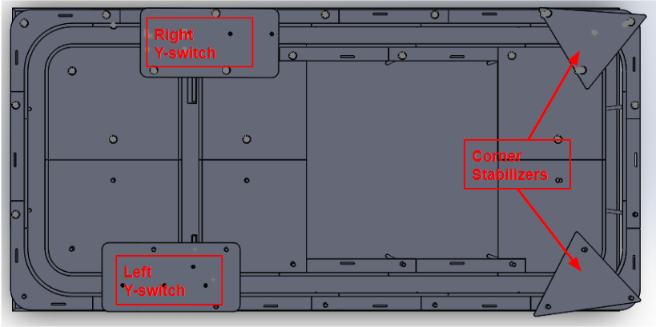
Figure 22. Top view of guideway assembly.
If the bogie traverses the inner loop, the servo motor will rotate to 69 degrees and stay in this position until the bogie has finished traversing the inner loop and reaches a second barcode. The right y-switch assembly is shown in Figure 22. The material for the top part is medium-density fiberboard (MDF) with a thickness of 0.25 inches, which will be manufactured using the laser cutter in the Makerspace. Three holes will be used to mount this top piece onto the guideway threaded rods. The top part will be attached to the bottom part using stainless steel ¼-20x0.75” pan head screws for a total quantity of 4.
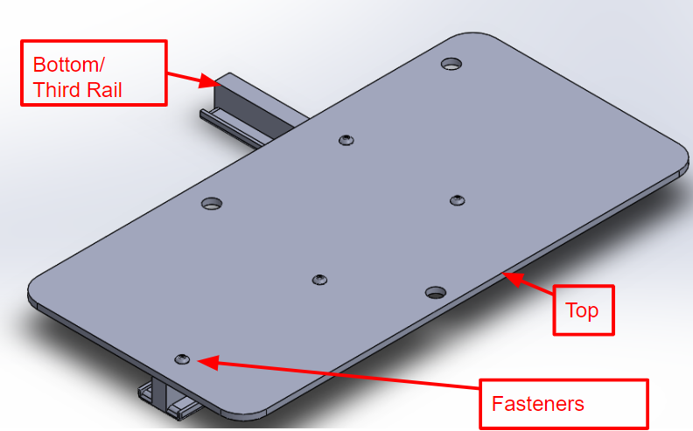
Figure 23. Right Y-switch assembly
The bottom part as shown in Figure 24 below has a length of 19 inches and a width of 11 inches. The corner has a radius of 4.25 inches, which is proportional to the corner of the guideway. The border of both the corners and straights are raised to provide the bogie y-switch bearings with a rail to guide it. This part will need to be manufactured using the larger 3D printer at the Makerspace. The Creality3D CR-10 S5 offers a bed size of 19.69x19.69x19.69 inches and PLA material should be used.

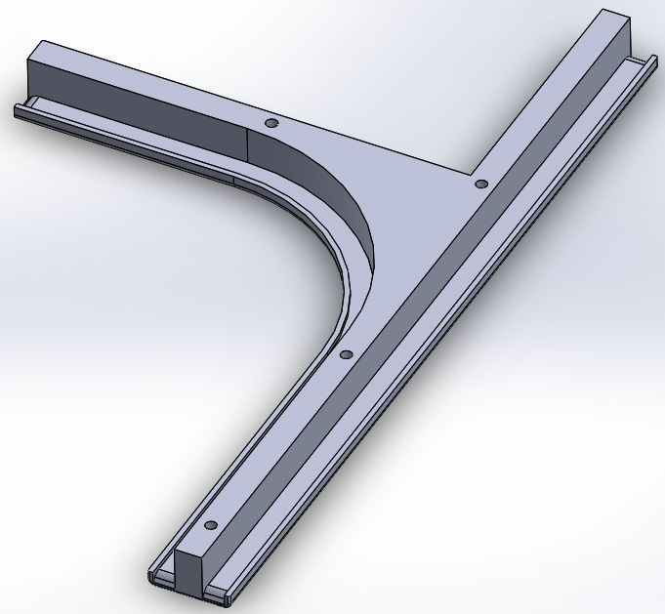
Figure 24. Bottom part manufactured using the 3D printer from Makerspace.
Figure 25 below displays the exploded view to see how the parts are assembled. The initial design intention for the top piece of the y-switch was intended to be easily manufactured, able to quickly assemble and disassemble as needed to improve upon and blend well with the guideway aesthetically. This two-part design y-switch using PLA and MDF is robust and aesthetically more pleasing that addresses the issues highlighted by past small scale guideway teams.
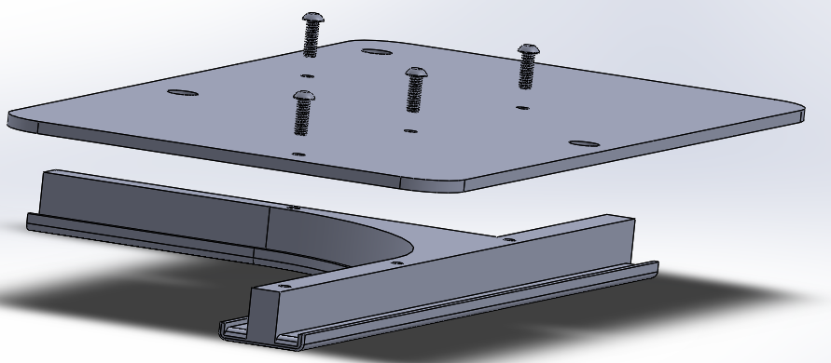
Figure 25. Exploded view of right Y-switch assembly.

If the bogie traverses the outer loop, the servo will need to rotate from 90 degrees to 115 degrees. The left y-switch assembly as shown in Figure 26 uses the same material and hardware as the right y-switch assembly.
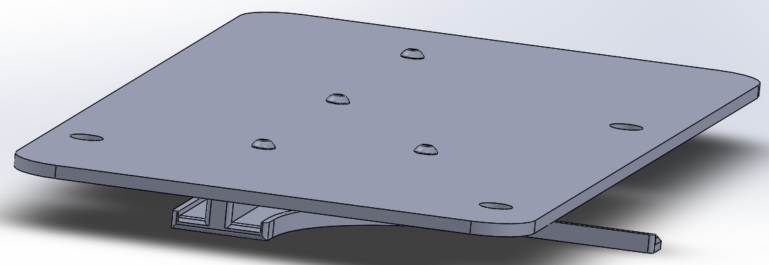
Figure 26. Left y-switch assembly.
The bottom piece of the left y-switch assembly needed to be split into two parts for manufacturing. The total length of both parts is 16 inches making each part small enough to be 3D-print using the printer at the design center. The inner loop railing has a radius of 3.87 inches.
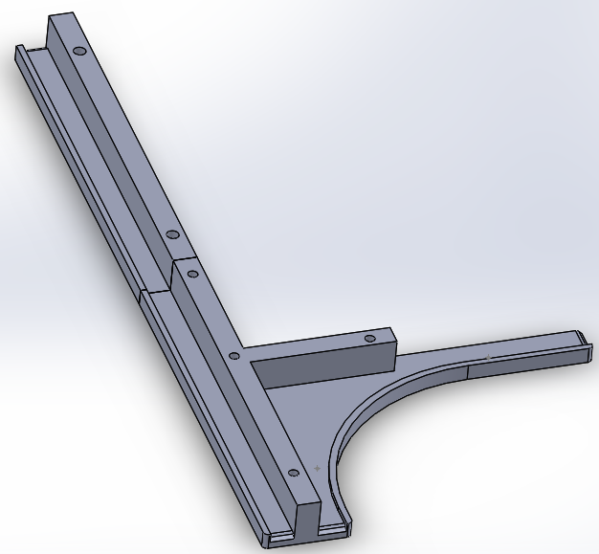
Figure 27. Two-piece y switch bottom piece.
The final design for the y-switch third rail will feature a ramp to allow the bearing on the bogie y-switch to seamlessly slide on. This ramp design was suggested by Dr. Furman as a way for the bearing to smoothly transition onto the surface of the third rail.
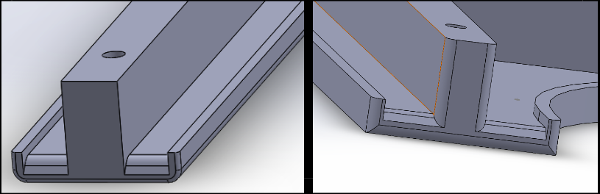
Figure 28. Y-switch third rail featuring a ramp for smooth transitions.

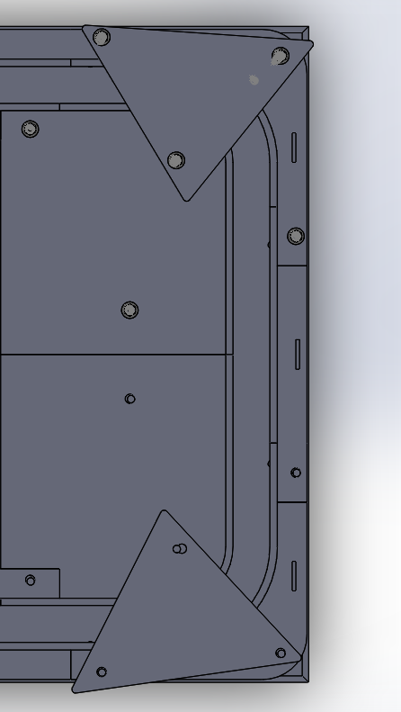
Figure 29. Corner stabilizers located on the opposite end of the y-switch assemblies.

To ensure the guideway will stay rigid and stable as multiple podcars traverse it, two additional supports were added to the corners of the guideway on the opposite side of the y-switch as shown in Figure 29 above. The main purpose of these triangular supports is to ensure the distance between the two rails stays fixed in the case where someone might lean on the guideway. The hardware used to fix the position of the corner supports is shown in Figure 30. The supports are fixed and sandwiched snug by a flat washer and hex nut at a height of 37 inches from the baseboard.
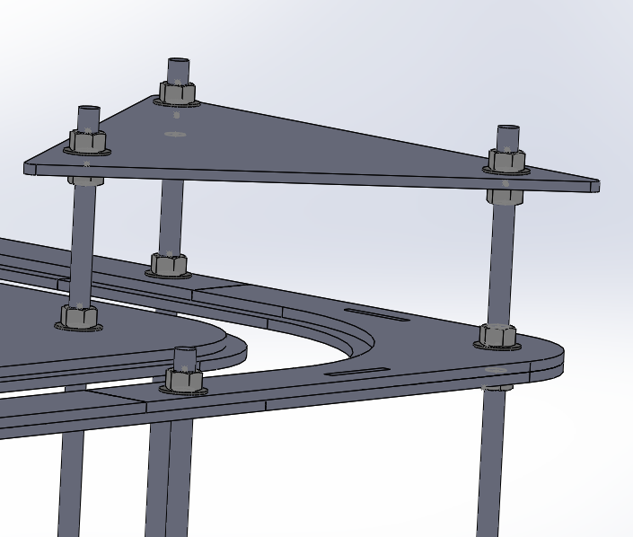
Figure 30. Side view of corner support hardware.
All of the guideway pieces will be securely fastened using ½-13 hex nuts and ½ flat washers as shown in Figure 31. The size of ½-13 thread for the rods was decided after in-person bend testing at Home Depot. Threads smaller than half-inch proved to be too flexible and would not be able to keep the guideway rigid as multiple pods traverse it. The hex nuts can be tightened using two adjustable wrenches. The benefit of using threaded rods is that the height of the guideway can always be fine-tuned and adjusted. The method the guideway team used for setting the height of each piece was by using a tape measure to measure from the top surface of the baseboard to the bottom surface of each track piece to be 32 inches.
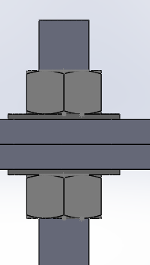
Figure 31. Steel hex nuts and washers to clamp down each guideway piece.

6.2 Bogie Design
The bogie team designed a bogie and pod that improved upon previous iterations. The final design in Figure 32, effectively solves the three main issues that were faced by the prior teams. These issues include difficult assembly and disassembly, challenging electrical maintenance, and an unreliable y-switching mechanism. Detailed drawing of this final design can be found in Appendix G.
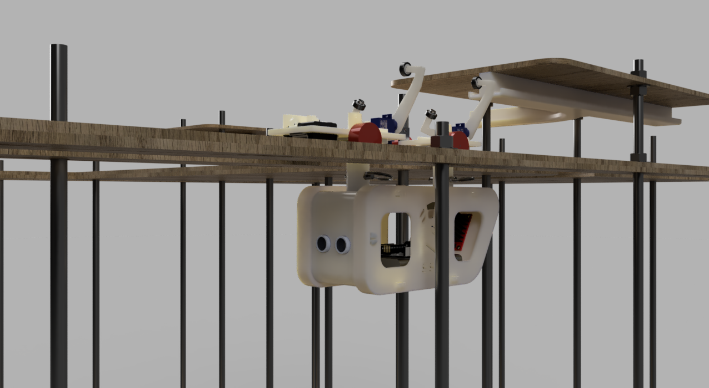
Figure 32. Final rendered pod and bogie.
To allow for adjustments to be made to the bogie, pod, and wiring of the electrical components, it was important to design a system that could easily be disassembled and reassembled. This was done by breaking the design up into multiple pieces that can be 3D printed and snapped together with snap-fits. The snap-fits are designed to take advantage of the properties of the 3D printing material PLA. A 3D printing infill percentage of 25 was chosen to allow for enough bending of the material to fit in the rectangular holes without too much stress that could potentially cause the part to break. More details on the snap-fit design and the clearance that were chosen between the snaps and the holes can be found in the pod drawing shown in Appendix F.
Figure 33 illustrates how the pod itself was broken into five separate pieces. This design allows for quick and easy access to the electrical components that reside within the pod. Additionally, breaking the pod up into several pieces adds flexibility to the design. In other words, if one part were to fail that one piece could quickly be redesigned and printed without having to reprint everything. Thus, saving both material and time.
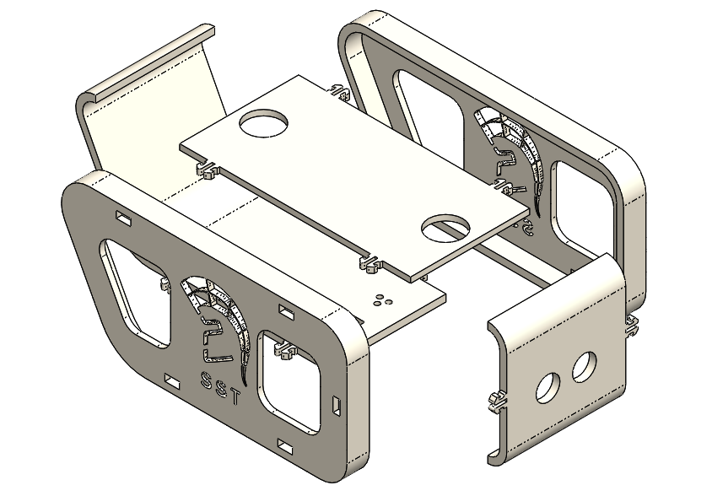
Figure 33. Exploded view of pod design.
In order to safely remove the pod and bogie system from the guideway, without disassembling a part of the guideway, the pod and bogie had to be able to connect and reconnect with ease. To do this, a quick-release pin was added to the connections between the pod and bogie. This connection was also designed to aid the bogie in making turns and to help keep the wires organized. Instead of having one rigid connection, two connections that can rotate independently were implemented so the bogie could make smoother turns around the corners and along the y-junction. Each connection is hollowed out so the wires can pass from the bogie to the pod without any risk of tangling. Doing this also improves the aesthetic of the design. An exploded view of the final swivel connection design can be seen below in Figure 34.
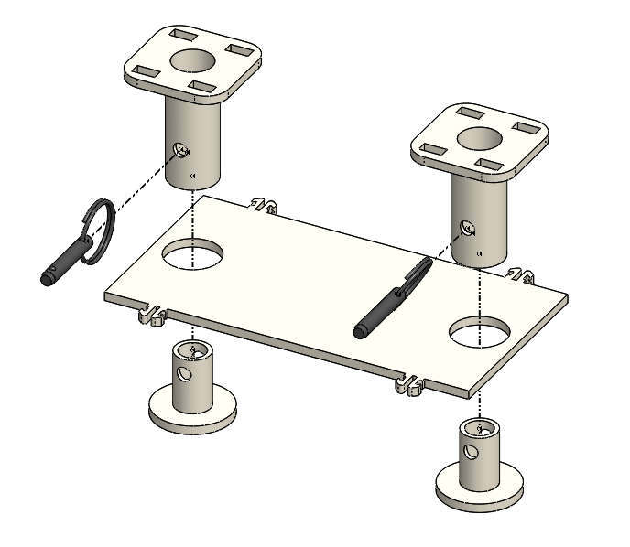
Figure 34. Exploded swivel connection design.
For the swivel connections to work, the bogie platform was divided into two pieces. Doing this preserved the desired degrees of freedom needed to maintain the swiveling motion. Each bogie platform is fixed to their respective connection piece with a snap-fit. Figure 35 illustrates how the platforms are secured to the connections. The snap-fit design utilized to connect the bogie platforms is the same design used to secure the individual pod parts together.
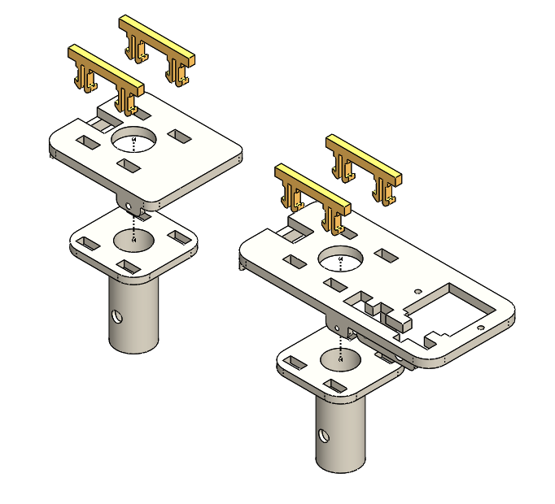
Figure 35. Bogie snap-fit connection design.
Each platform of the bogie is equipped with a set of wheels and a servo. The wheels on the front platform (the longer platform) are driven by a set of three gears that are connected to a stepper motor. The gears were designed around parameters such as the size of the bogie and standard gear sizes. The final gear design consists of 3 gears that have a diametral pitch of 32 and a gear ratio of roughly 1:3. Each gear is fastened to its respective shaft with a set screw. The configuration of the gears on the bogie can be seen in Figure 36.
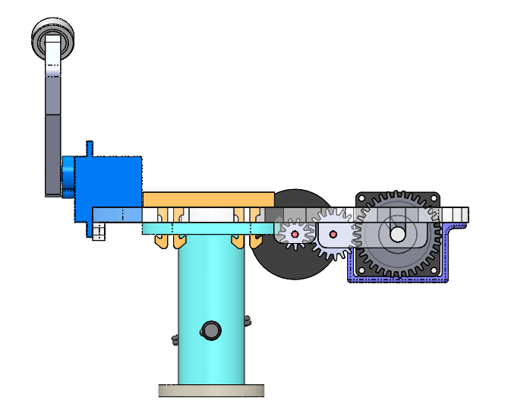
Figure 36. Gears on the front bogie platform.
Attached to each servo is a switch that has been designed to ensure that the bogie does not fail at the y-junction. There is a gap that exists at the y-junction and if the bogie does not support itself properly there is a high risk of failure at the y-junction. The gap can be seen in Figure 37.
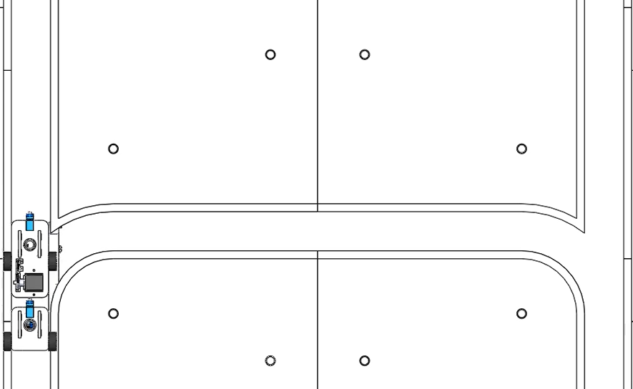
Figure 37. Gap in the track
Previously, teams used a tab like a switch that flipped from one side to the other which provided little support to the bogie. To solve this problem the bogie team designed a more realistic switching mechanism that supports the weight of the pod while traversing across the y-junction. The switching mechanism can be seen below in Figures 38 and 39.
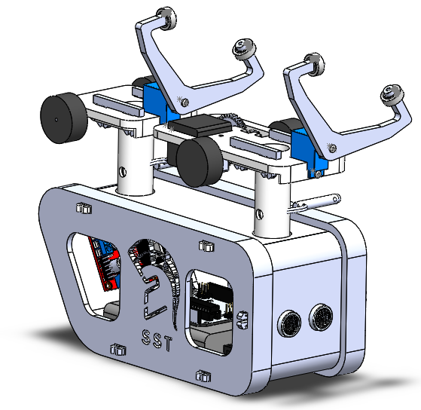
Figure 38. Final bogie and pod design.
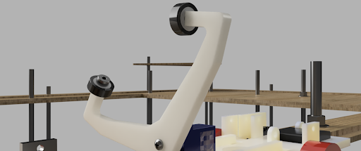
Figure 39. Close up of the rendered y-switch

The y-switch is manufactured in PLA using the 3D printer in the Superway Design Center. The y-switch is attached to the servo motor on the bogie and fastened using an M2.5x5mm pan head Phillips stainless steel screw purchased from McMaster-Carr for $3.84 per pack of 100. Each bogie will consist of two y-switches to securely hold up the weight of the pod and bogie. Each y-switch will require two bearings and two shoulder screws to fasten the bearings as shown in Figure 40. The bearings are stainless steel shielded with a 5mm shaft diameter clearance hole and can be purchased from McMaster-Carr for $8.51 each. However, this is the same bearing prior teams have used, so there are enough bearings for several pods located in the Small-Scale section in the Superway Design Center. The shoulder screw is a 6-32 thread stainless steel with a 0.25” shoulder-length that can be purchased from McMaster-Carr for $2.56 each. The shape of the design for the y-switch was chosen to be optimal because of several key features. First of all, when the y-switch engages onto the inner loop, the other side bearing on the y-switch should not make contact with the guideway and needs to be low as shown in Figure 40.
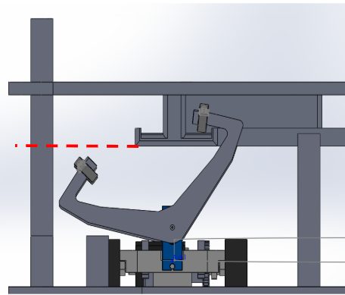
Figure 40. Left arm on bogie y-switch has enough clearance as bogie traverses the corner.
Second, the bearing on the y-switch is at a slight angle when it makes contact with the third rail. This was intentional to allow the bearing to turn smoothly as it continues throughout the third rail. Since the team was unable to print and test this design due to the COVID restrictions, trial and error could not be completed to see whether the angled bearing improves the ability to smoothly turn. The idea behind having this was that the few degrees of positive camber will behave similarly to how the conical wheel design improved the turning radius for last year's small scale team. The design of the bogie y-switch can be easily adjusted to have the bearing sit flat if the in-person testing of the y-switch does not work.

6.3 Controls Design
The final design of the controls team is divided into the iOS app and the electronic system, together they work cohesively to provide a functioning and user-friendly controls system.

6.3.1 iOS App
The iOS app was further developed via Apple's software called Xcode, from the work completed in the Fall 2019 semester (more on how to set up the app in Xcode can be found in Appendix I. At that point, a connection between the BLE and the app had yet to be established and the app had three main tabs, two of which were just to find information about the Small Scale Team (tabs are essentially the main screens that the user can navigate through). A top-level view of what makes up the most up to date iOS app can be seen below in Figure 41:
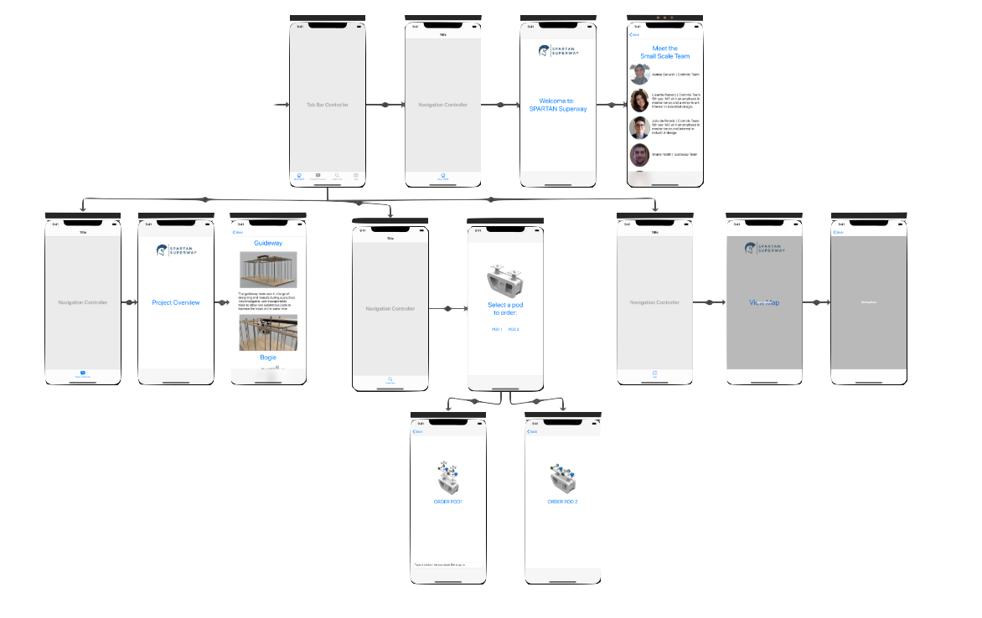
Figure 41. Storyboard view of iOS app.
These are all of the Storyboard components that make up the app. Further information about this can be found on last semester's report and the documentation of the app at the end of Appendix J. The updated final design consists of four main tabs that can be seen below in Figure 42:
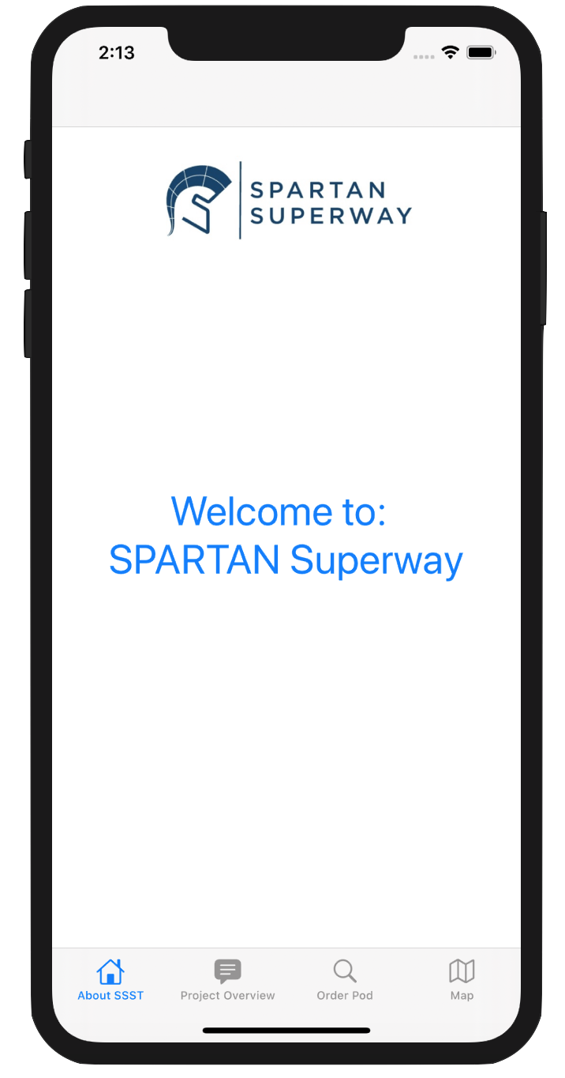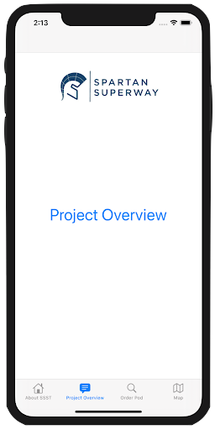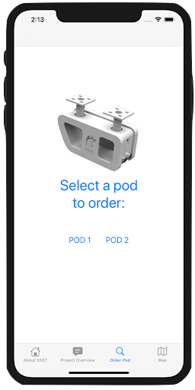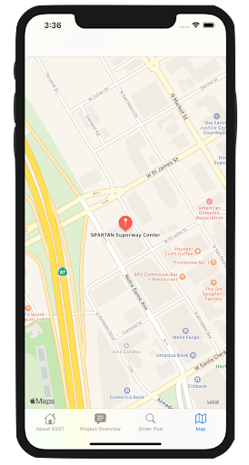
Figure 42. Main tabs of the iOS app.
After the app finishes loading, the first tab that the user is greeted with is “About SSST”, which can be seen in the leftmost image of Figure 42. Once on that tab, the user is free to interact with the “Welcome to: SPARTAN Superway” button or they navigate to any of the three other tabs. If the user decides to click on the button on the “About SSST” tab, they will be led to this new subtab (subscreen), shown in Figure 43:

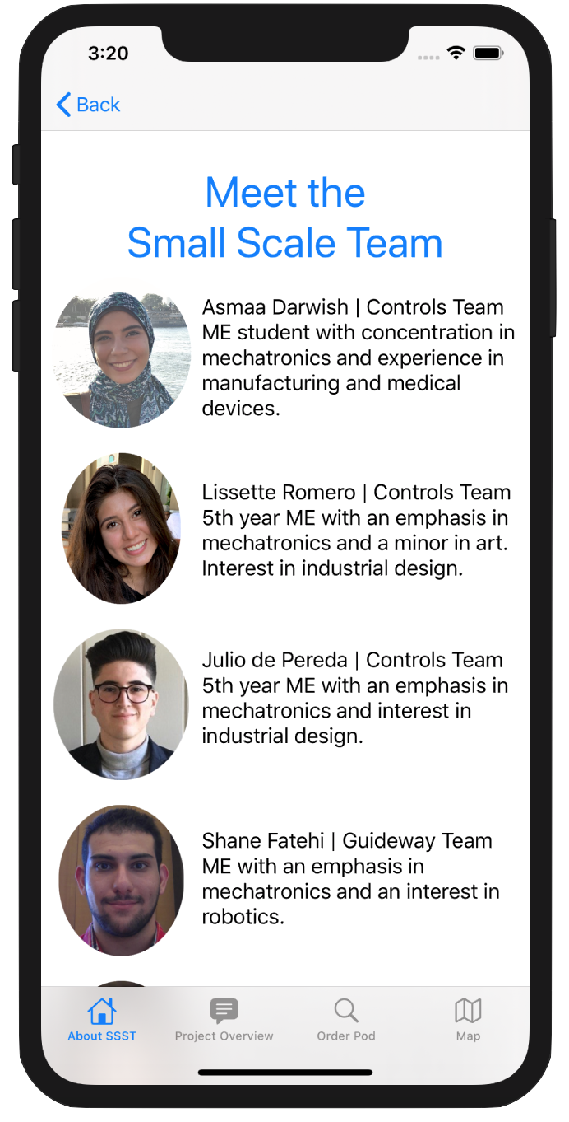
Figure 43. Team info sub tab.
In this view, the user can scroll through and find out information about each of the team members. From this tab, the user can either go back to the original home tab, or they can click on any of the remaining three tabs. If the user clicks on the “Project overview” tab, they will be led to the following screen and if they click on the “Project Overview” button, they will be led to a subtab with an overview of the Small Scale project, both of these can be seen in Figure 44, respectively:
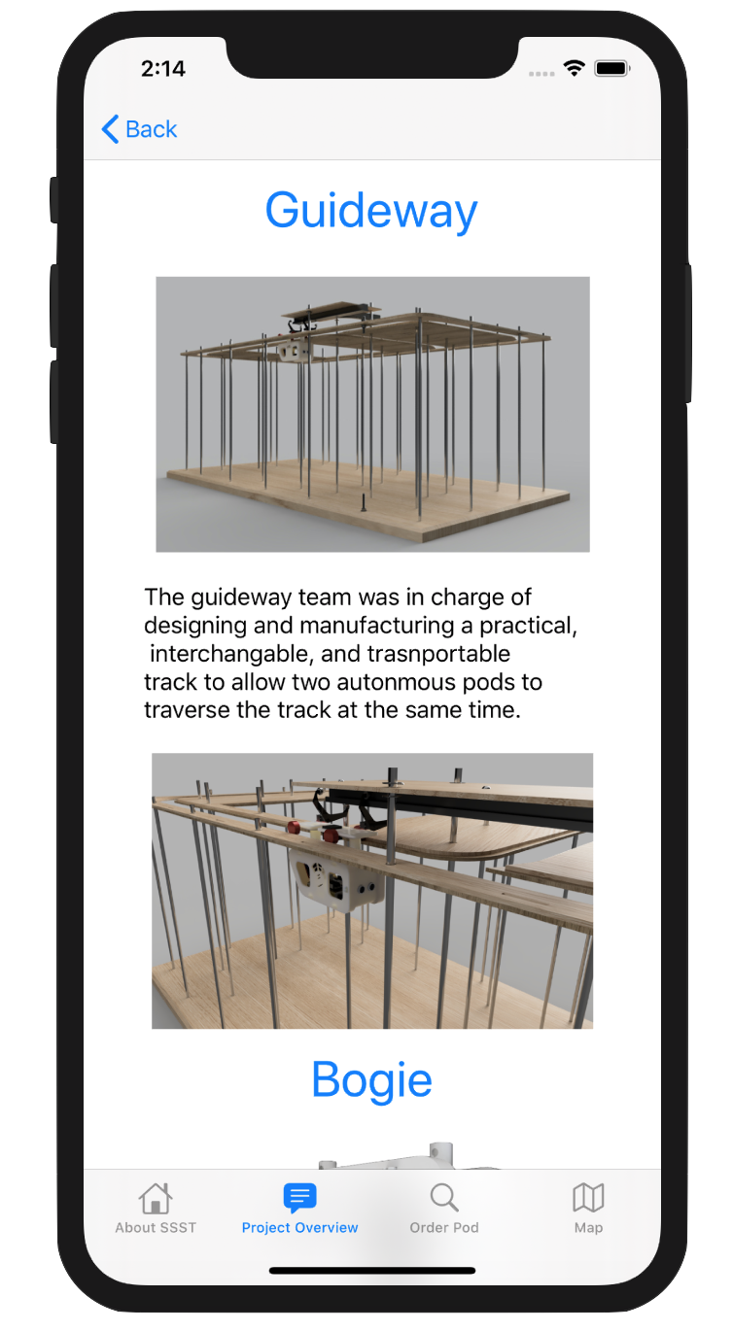
Figure 44. Project overview main tab and subtabs, left to
right respectively
As mentioned above, once on this tab, the user can click on the Project Overview button and they will be able to get a quick summary about each SST subteam. Again, the user can either go back to the “Project Overview” main tab, or they can navigate to any of the other three tabs. If the user decides to click on the third tab, they will be led to the tab in which they can select the pod to connect to. This can be seen in Figure 45 below:
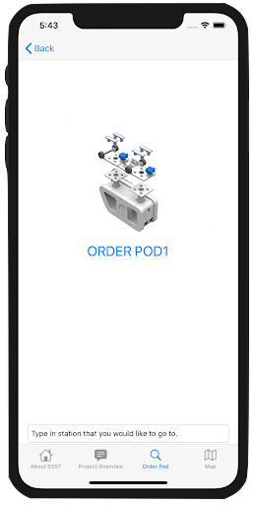
Figure 45. Pod ordering tab and subtab.
Depending on whether the user clicks on “Pod 1” or “Pod 2” buttons, they will be led to a subtab as shown on the right image in Figure 45 in which they can type the station number into the keyboard, and that would cause the pod to navigate to the desired station on the guideway. As will be explained in the analysis section of this report, this feature is not fully operational yet on this iOS app, but in future updates it definitely will.
From these “Pod 1” or “Pod 2” subtabs, the user can either go back to the main “Order Pod” tab, or they can navigate to any of the other three tabs. If the user decides to click on the fourth “Map” tab, they will be led to the following tab shown in Figure 46:
Figure 46. iOS app map tab.
In this tab, the user is able to fully interact with a map, and the location of the SPARTAN Superway Center is loaded up automatically as the starting location. In near updates, the user will be able to get directions from their current location to the Superway Center. They will also be able to click on the red icon to find out more information about the Superway Center.
The main goal with this app, apart from being able to connect to the pods via Bluetooth, was to create an informative and user friendly experience. When the SPARTAN Superway is fully operational, this rudimentary iOS application can be fully developed into something similar to the apps that Uber and Lyft have. The SPARTAN Superway app would function in a similar manner to the Small Scale App, in the sense that there would be different tabs in which the user would be able to find out information regarding the project. In addition,the user would be able to see the Superway stations nearest to them, order, and pay for their ride. The point is that this small scale app can be used as a foundation to build up a full developed version of the app. This would be appealing to a wider range of people.
In parallel to developing the app described above, another testing app was developed to test the connection with the Bluetooth Low Energy module. This app consists of one main tab, with a slider that sends 8 bit unsigned integer values to the BLE. The main user interface of this testing app can be seen below in Figure 47:
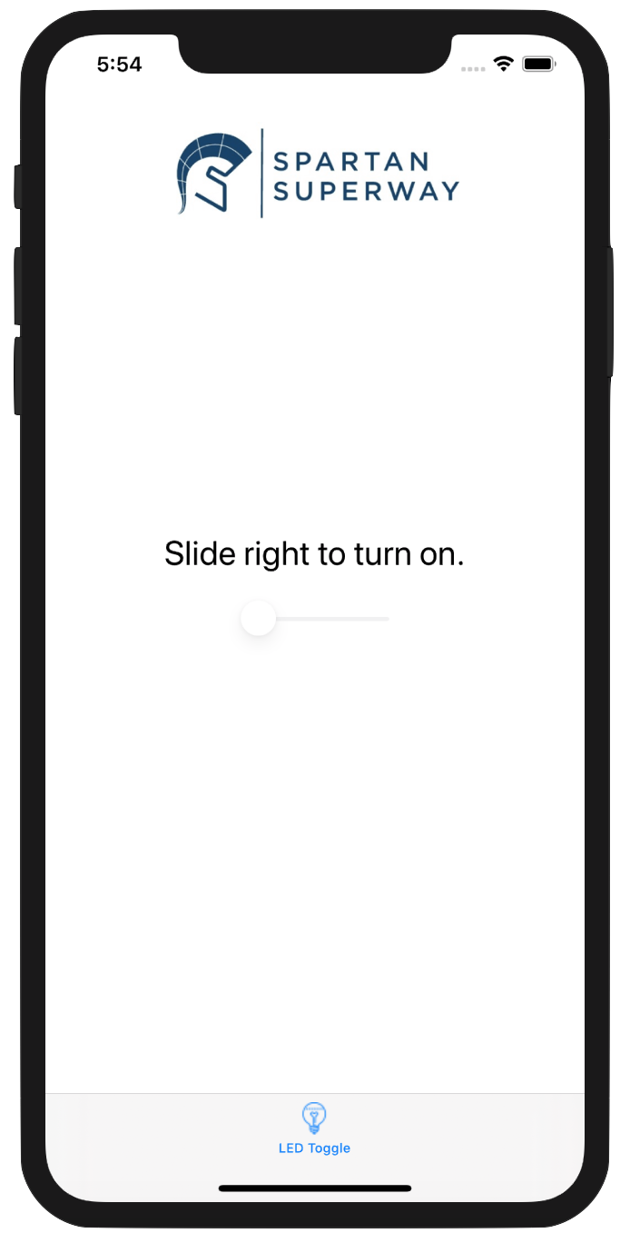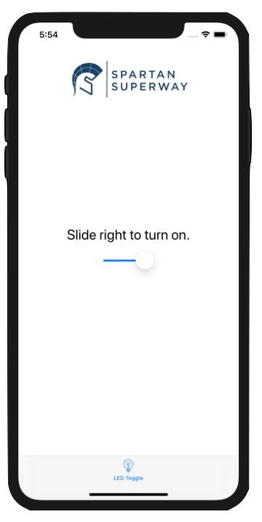
Figure 47: Main interface of BLE connection testing app.
The main reason behind developing this app in parallel to the main app was to have a less complex testing experience and a quicker debugging session. The values that change depending on the position of the slider can be customized in Xcode to have a starting value, along with a min and a max value. These values are the 8 bit unsigned integer values that are sent to the BLE and depending on the Arduino code, the values will correspond to different stations that the pods can travel to. This will all be further discussed in the analysis and results section of this report. In the next subsection, the final design of the electronic system will be discussed.

6.3.2 Electronic System
The Small-Scale team’s electronics system consists of the following components: Arduino Uno microcontroller, BLE module, Pixy2 camera, ultrasonic sensor, two servos, a stepper motor, and a motor driver board. Figure 48, shows the wiring connection between all these components to the Arduino and a small size breadboard. The wiring diagram was created using Fritzing to give a visualization of all connections that will be inserted into the pod. Table 4 shows a clear list of each Arduino pin and its corresponding connection.
Table 4: Arduino Pin Connections.
Arduino Pin | Component
Pin 2 | Servo 1
Pin 3 | Servo 2
Pin 4 | Driver board IN1
Pin 5 | Driver board IN2
Pin 6 | Driver board IN3
Pin 7 | Driver board IN4
Pin 8 | Ultrasonic Echo
Pin 9 | Ultrasonic Trig
Pin 10 | BLE TXD
Pin 11 | BLE RXD

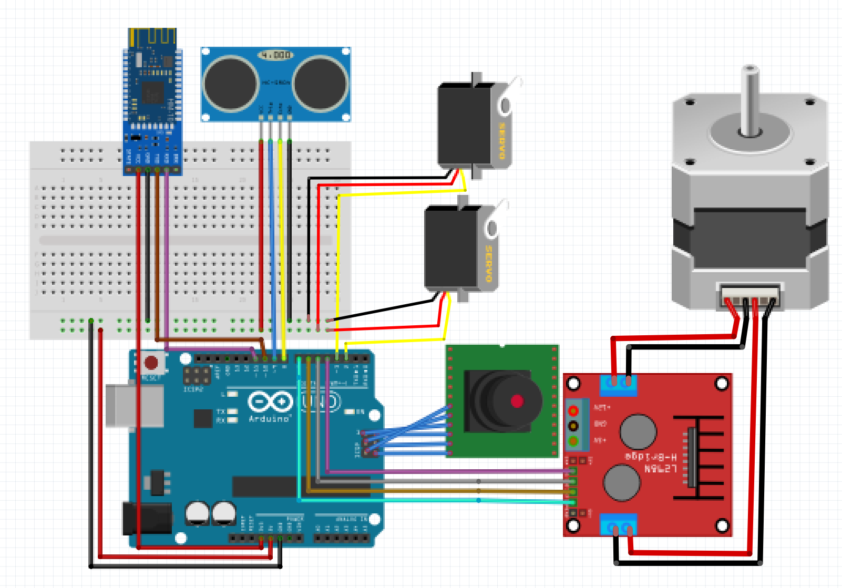
Figure 48: Fritzing wiring diagram of all components.
The team chose the Nema 11 bipolar stepper motor with the specification shown in Appendix R. This motor was chosen mainly because of its small size and light weight that fits the design of the bogie. This motor is commonly used in 3D printers, which predicts its reliability to run constantly without burning out, which is a problem previous teams had. HM-10 with the specification shown in Appendix S was chosen as the BLE module to be used this year. HM10 is a module that has a BLE chip that functions as a serial pass. It has a TX and RX pin that receives data through Bluetooth. This was chosen because of the many available resources that will help create a reliable system without reinventing the wheel. To improve the RFID recognition system that the previous team had to identify the stations, the team looked for an image recognition camera that is compatible with Arduino and has a fast processing time that can be used as a part of the moving bogie. The team found Pixy2 that has an object recognition system as well as a line tracking system to be most compatible. The Pixy2 is able to process 60 frames per second, which means, every 1/16 of a second or 16.7 millisecond, Pixy2 updates all detected objects positions (Pixycam, 2019). More specifications about the Pixy2 can be found in Appendix T.
To be able to achieve a working electronic system with all the components mentioned above, the controls team took small steps to achieve a complete understanding of each component before integrating all of them in one master Arduino sketch. The team started with the design of an anti-collision system. A code was created using a stepper motor and an ultrasonic sensor. The sketch shown in Appendix K, uses four different if statements that compares the values input from the ultrasonic sensor to four different safety distances. The first if statement for a distance of more than 25 cm, which runs the motor at full speed. The second if statement is for a distance between 25 cm and 15 cm, which lowers the speed of the motor to half. The third if statement is for the distance between 15cm and 3cm and it lowers the speed to ¼ the original speed. Lastly, a distance less than 3 cm is an emergency stop, causing the motor to stop completely.
The second step of the electronic system design was to understand how to control the BLE module. The Arduino sketch shown in Appendix L, was created to control an LED by receiving an input from the user. The sketch compares the value received from the BLE using two if statements. The first to compare the value of 1 from the user which converts to 49 in ASCII to turn the LED on, or to a value of 0 which converts to 48 in ASCII. After understanding how the BLE works and finding a way we can easily send data to it, the LED was replaced with the stepper motor. Appendix M is a combination of the ultrasonic anti-collision system and the BLE. If the user inputs a value of one, the motor will run, and if the value is zero the motor will stop. For a better integration between the two sketches, the function “CheckDistance()” was created, which combines all of the four if statement that changes the speed of the motor with respect to the distance read from the ultrasonic into one function that once called, the code will run the anti-collision system. This allows for a cleaner, and better way to understand code and will help in the master Arduino sketch.
The next step for the team was to understand how the Pixy2 camera operates. A lot of research was done on this image recognition camera to identify the best method for the team to utilize the camera in identifying the different station location. Pixy2 has two main programs that it can run, an object recognition program and a line tracking program. The first attempt was done to utilize the object recognition system, by teaching Pixy2 the number of stations as objects. This attempt failed as the object recognition system was identifying the object by their colors. Even if each station number had a unique font color, the camera was identifying random objects in its range as stations, just because they matched the colors associated with the stations. The team then decided to utilize the line tracking program. This program is used by the camera to identify any line. In addition, it has a feature to identify 15 different barcodes. This feature is suitable with the controls team objective as each station will have a unique barcode that can be identified by the camera as it passes by it. More research on the line tracking program used by Pixy2 was conducted on their website. The Pixy2 sketch example called “line_hello_world” shown in Appendix N from the Pixy2 Arduino library was found very helpful to understand how to make the Pixy2 camera switch to the line tracking program, read the barcodes, and print them.
To test the Pixy2 with the stepper motor, the team took a step farther and integrated the stepper motor with the “line_hello_world” example to create the sketch in Appendix O “barecode_test”. This sketch uses a while loop to compare the barcode value read from the Pixy2 to an arbitrary value of 7. If the Pixy2 reads that value then the motor will stop. If not it will go through an if statement that compares the value of barcodes to the condition ≠7 and, if this statement is true, the motor will run. This sketch sets the foundation for the Arduino sketch design that will be explained later.
The team was now ready to combine all codes together to create the first iteration of the master Arduino sketch with only one missing component, which is the turning servo. The first step the team needed to take before integrating all components together was to create a second function that runs the Pixy2 and reads barcodes. This function will help clean up the code as it will be called multiple times within different while loops. The second step was to find a solution to compare the values sent from the app and the barcode values. The common function Serial.read() was initially used to read the BLE value. This function reads the incoming serial data, which in this case are ASCII values. If a user sent a value of 1, Arduino will read it as 49 which is the conversion from ASCII to decimals. For the Pixy2 to compare the ASCII to the barcodes values, it will require a more complicated code to convert each station value to its corresponding ASCII value. A research was conducted through the Arduino website to learn more about the communication serial functions that can be used to solve this problem. The function Serial.parseInt() was found to return the first valid integer number from the serial terminal. This means that the values received by the BLE will be the same as the values assigned to the different barcodes. Using this function to read the BLE value simplified the integration between the BLE and the Pixy2. Appendix P is the first attempt to integrate all of the electronic components. Figure X shows the steps the Arduino loop takes to run. The void loop does not start until a signal is sent to the BLE by the user through the terminal app. The CheckPixy function then compares that value with the barcode values it reads. If the correct value is not found, the CheckDistance function will activate the stepper motor and the anti-collision system. If the values match, then the station is found and the motor will stop.
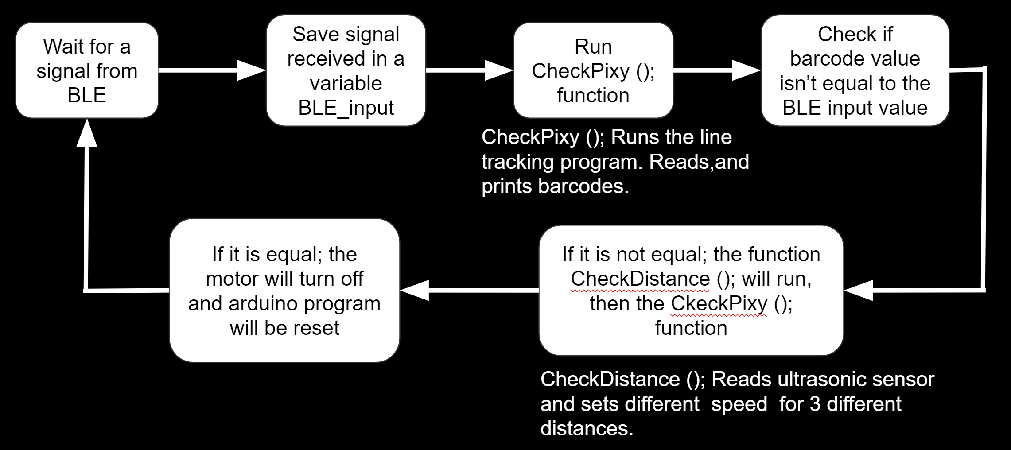
Figure 49. Flow chart of first revision of final Arduino Sketch.
To finalize the Arduino sketch, the team researched for a solution to fix a bug in the sketch. In the first iteration of the final sketch, the code had to be reset manually by reuploading the code to the Arduino after the bogie reaches its desired station. The sketch receives one value from the user and does not accept a new user input value unless the code is reset. The team searched for alternative ways to reset the Arduino by only software. The function void(* resetFunc) (void) = 0; was found in an Arduino form that allows the code to reset once resetFunc() is called once the correct station is found.
The second step to finalize the code was by adding the servos that will activate the switching mechanism. For the bogie to go into an inner loop station, the servos need to move from 90 degrees to 69 degrees to allow the switch to hang on the upper switching track. In the case of the bogie traveling through the outer loop, the servos will have to switch from 90 degrees to 115 degrees. To identify the outer loop station from the inner loop station, the station number 10 was chosen to be the inner loop station. As shown in Figure 50, different barcode values are located throughout the track to identify the different stations. Because the switching mechanism requires the switch to be activated before entering the y-junction, barcodes with value of zero are placed before the junctions to identify the location where the servos have to switch.
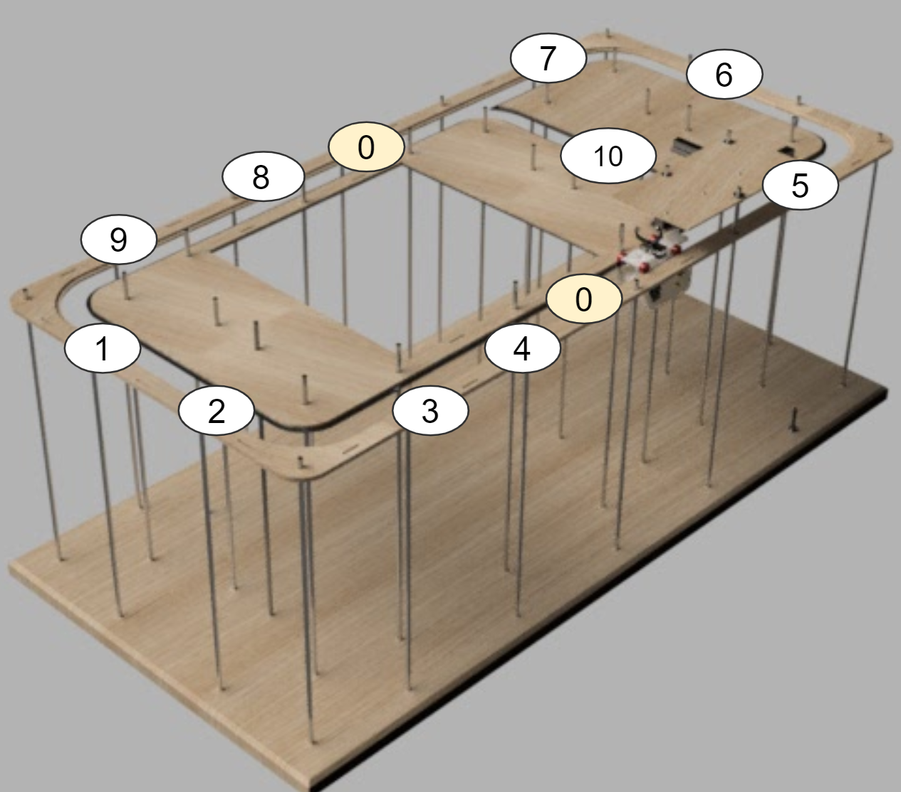
Figure 50. Stations positions around the track.
An if statement was added to create two different paths of while loops that separates the inner loop from the outer loop. If the user input is 10, which is the only inner loop station, the bogie will go through a while loop that reads the barcodes and compares it to the user’s input value. If the correct barcode is found, the motor will stop. If it was not found, the code will keep running until the turning signal that is identified to be the barcode with the value of 0 is found. If it is found, the servo will switch to the value that makes it turn into the inner loop. If the user’s input value is anything but 10, then they choose an outer loop station. The code then will run in the second path, which is designed the same way except for the servo switching value. In this case the servos will turn to keep the bogie traveling through the outer loop until the correct station is found. Figure 51 shows a flow chart of the complete final Arduino sketch.
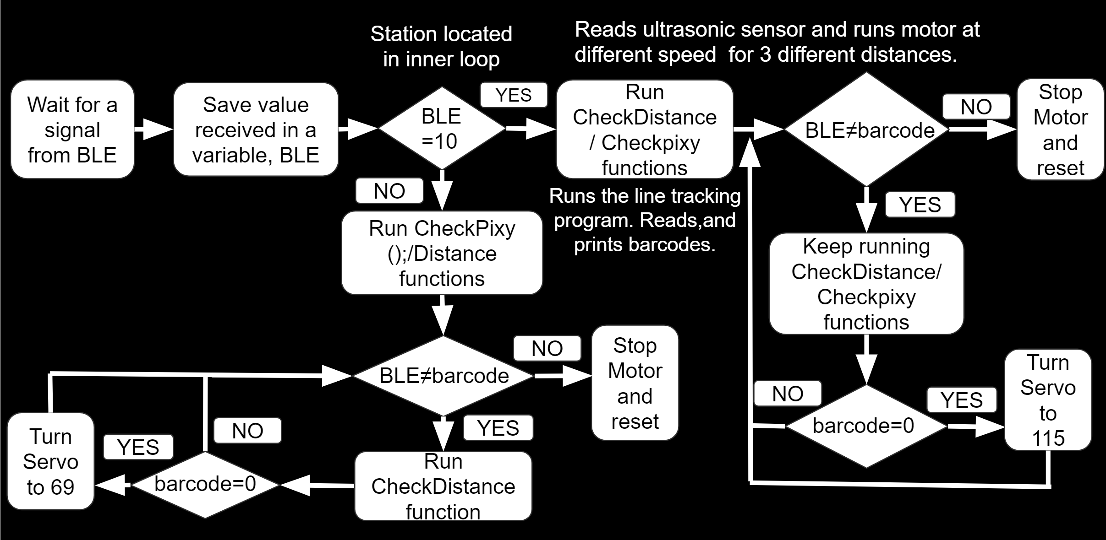
Figure 51. Final flow chart of the final Arduino sketch.
The complete Arduino sketch can be found in Appendix Q. To run this code, four Arduino have to be downloaded and added to the Arduino IDE. Those libraries are: “Stepper.h”, “SoftwareSerial.h”, “Pixy2.h”, and “Servo.h”

7. Analysis
Due to the most recent outbreak of COVID-19 and it’s ensuing nationwide lockdown, many facilities such as the SPARTAN Superway and Makerspace were unavailable for students to manufacture and fabricate their projects. Therefore, much of the analysis provided has been done using software such as ANSYS, Solidworks Simulation, and Solidworks Motion Animations.

7.1 Guideway
Solidworks Simulation and ANSYS were used mainly for the Finite Element Analysis (FEA) to simulate the load on the guideway and its corresponding parts to test its functionality. Solidworks Motion Animation was used to simulate how the bogies would travel across the track. Two bogies were added to the guideway assembly then mated using path mate in Solidworks. Two paths were created to represent the outer loop and inner loop paths as shown in Figure 52. A motion study was then created to add a motor to each bogie that makes it move at a speed of 0.2 m/s. Each bogie followed its own path to create the simulation in Figure 52.
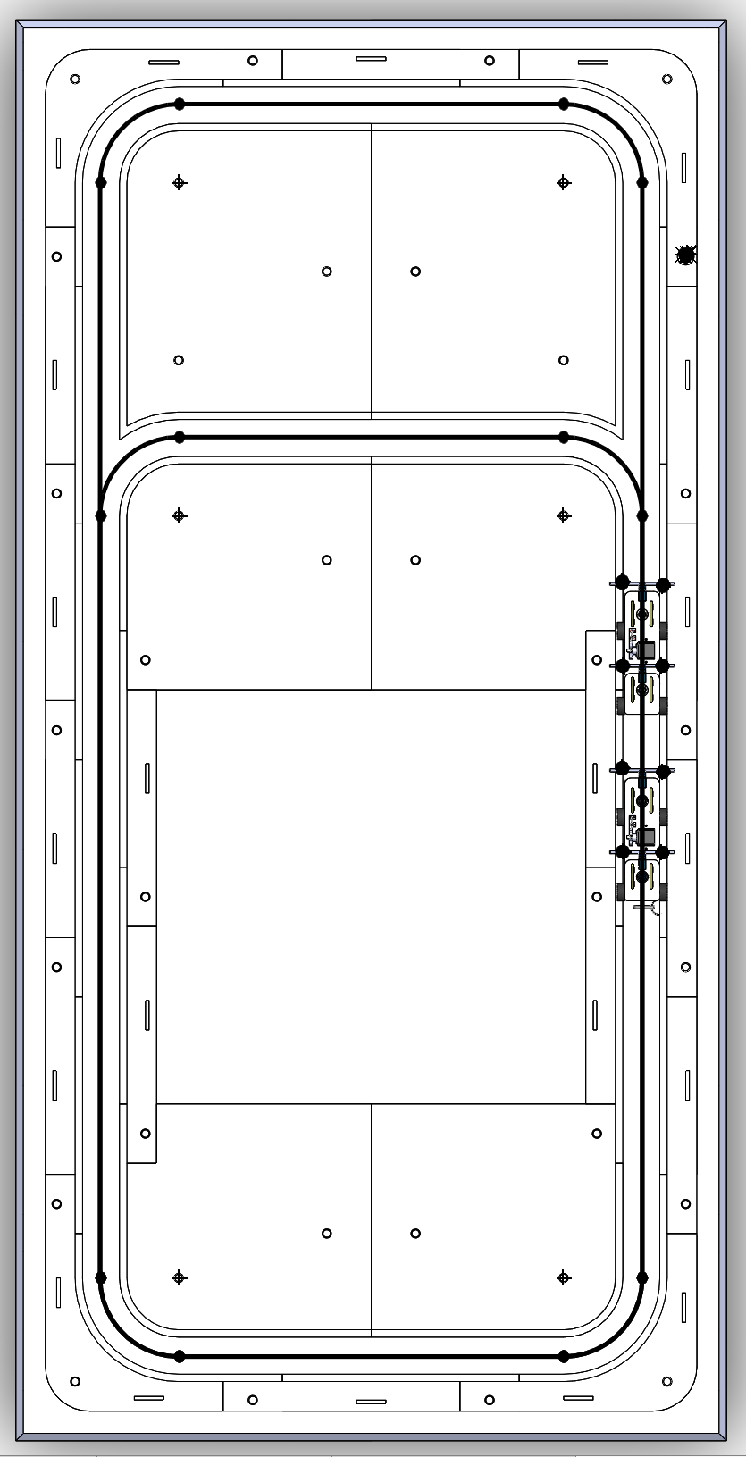
Figure 52. Inner and Outer loop Paths
The final simulation of two bogies on the guideway is shown in Figure 53. This simulation shows that two bogies can travel across all parts of the track without any interference.
Figure 53. Final Guideway with two Bogies Animation
Figure 54 shows the final animation of the Y-junction and Y-switch in motion that provides a visualization of how it will support the bogie as it goes through the outer loop of the junction, without falling through the gaps.
Figure 54. Y-Switch Animation
Finite element analysis (FEA) was used for the curved and straight parts of the track using ANSYS to determine total deformation. First, a static structural analysis system was chosen to simulate the effects that the weight of the pod and bogie would have on the track. The engineering data was modified so that the assigned material of the parts would be medium density fiberboard. The mechanical and material properties were assigned from Makeitfrom.com, with the elastic modulus of 0.58 mega pound-force per square inch and a Posson’s ratio of 0.25. Next, the straight and curved parts were simplified to reduce and apply relative boundary conditions. This was achieved by combining both the top and bottom portions of the parts to act as one solid model, as seen in Figures 55 and 56.
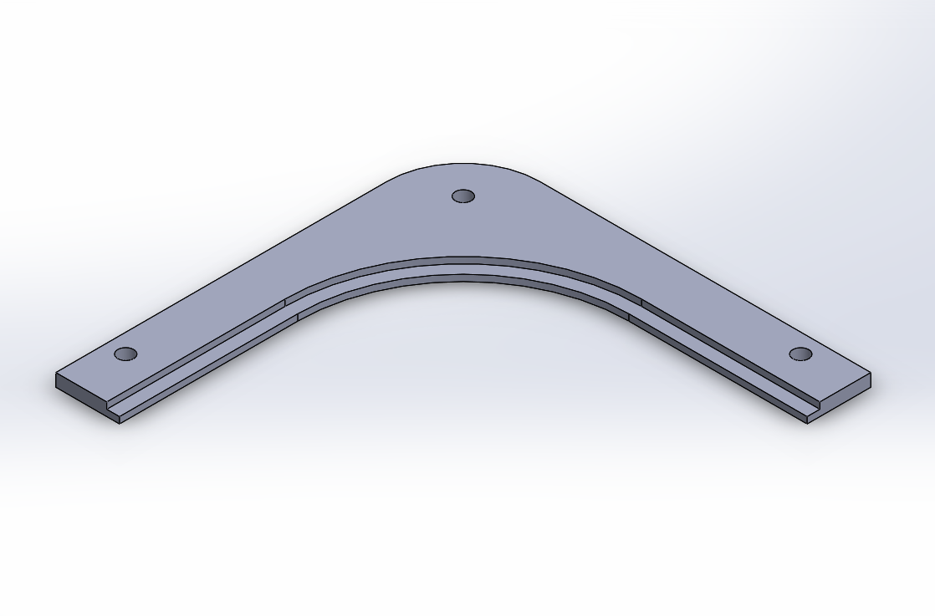
Figure 55. Simplified model of the curved parts.
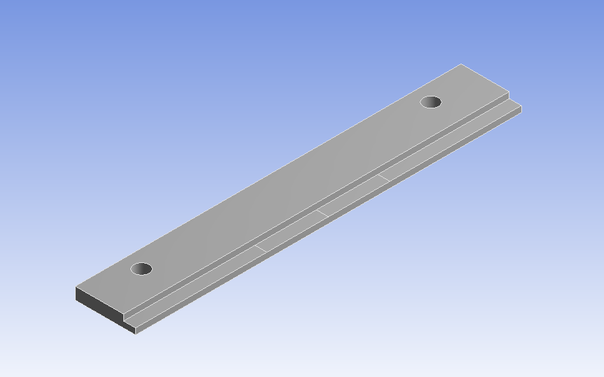
Figure 56. Simplified model of the straight parts.
Holes were also added to the model to add the effect that the rods, nuts, and washers would have on the parts. The geometry was then imported from Solidworks using a STEP file. Once imported, the model was set-up with the proper material assignment using the same MDF Board engineering data from before. A mesh was then created with an element size of 0.25 inches and default details for meshing.
For the analysis settings, the straight and curved parts were analyzed differently. The straight part analysis had two forces, both 0.75 lbf in the downwards directions, that were applied along the edges of the straight track as seen in Figure 57. The distance between these two forces acted as the edges of contact that the wheels would make with the track, which was evenly spaced 5.1 inches apart from the middle of the track.
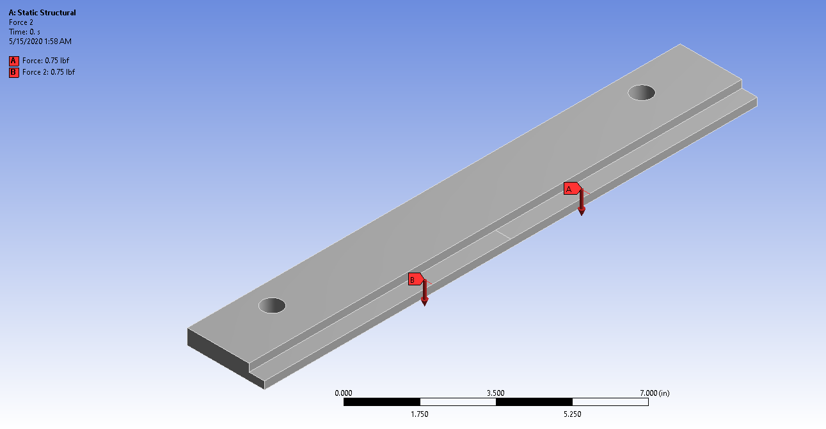
Figure 57. Two forces, each 0.75 lbf, are placed on the edge of the track.
Elastic supports were then added onto the faces of the edges in the XY plane and displacement was also added onto the inner faces of the holes, as seen in Figure 58.
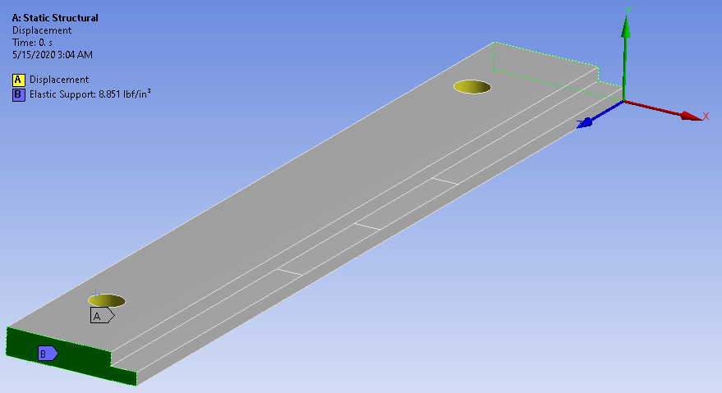
Figure 58. Constraints such as displacements and elastic supports were added to the straight.
The foundation stiffness of the elastic support was set to be 8.851-pound force per cubic inch, which is equivalent to a weak spring with a spring constant value of 1 newton per cubic meter. The displacement was constrained in the X and Y-axis to simulate the fixed directions that the supports had on the track, and free in the Z to allow motion. Total deformation was found to be 0.001188 inches max, as seen in Figure 59.
Figure 59. Visual of total deformation for straight parts with a max deformation of 0.0012 inches.
The curved part analysis had a ramped force of 1.5 lbf downwards along the face of the track, elastic supports, and displacement constraints, as seen below in Figure 60.
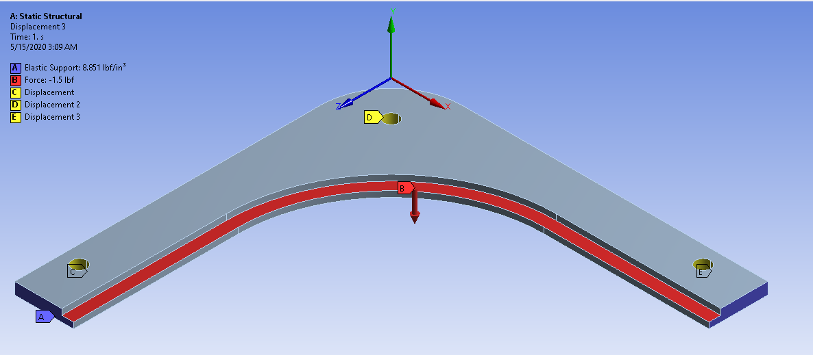
Figure 60. Like the straight, displacements and elastic supports were added to the curve.

Elastic supports were then added to the faces of the edges of the track with the same foundation stiffness of 8.851 pound-force per cubic inch. The displacement that was added to the three holes differed slightly. For the hole on the left, the displacement had constraints in the X and Y direction, but free in the Z. For the hole on the right, the displacement had constraints in the Y and Z direction, but free in the X. For the middle hole, all three directions were constrained. Total deformation was found to be 0.00032 inches max, as seen in Figure 61.
Figure 61. Visual of total deformation for curved parts (max deformation of 0.00038 in)
Force analysis was completed on the third rail of the right y-switch by using a distributed force of 1.5 pounds downward along the inner and outer rails. The rail was fixed at the four mounting holes in the X, Y, and Z direction. The results of the FEA are shown in Figure 62 and the deflection at each side of the third rail is negligible. For traversing through the inner loop, the deflection of the left side rail is a maximum of 0.004 inch. For traversing through the outer loop, the maximum deflection of the right side rail is 0.0002 inch. Furthermore, the right switch assembly can safely hold the weight of the bogie.
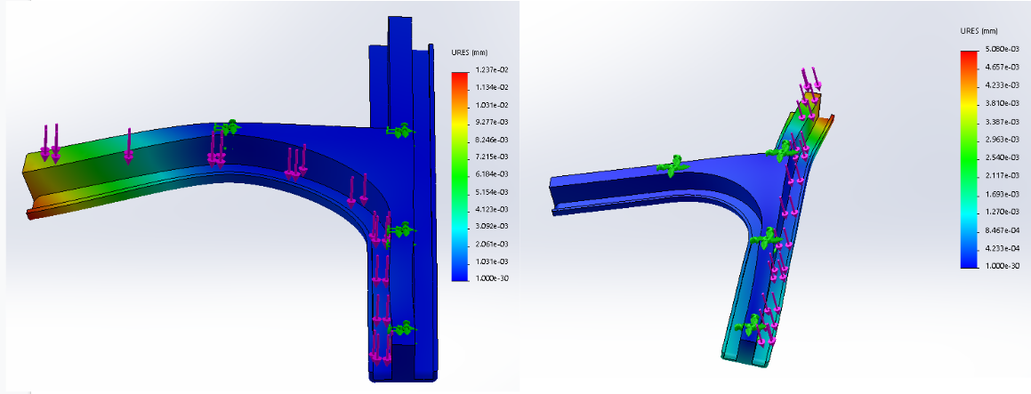
Figure 62. Right y-switch bottom part force analysis showed deflection no more than 0.004 inch.
The left y-switch bottom part has a force of 1 lbf downward distributed along the inner and outer sides of the third rail. The four quarter-inch mounting holes are fixed in the X, Y, and Z direction. The left side of the third rail experiences a maximum deflection of 0.00004 inch and 0.002 inch for the right side as shown in Figure 63. Since the deflection for both sides of the third rail did not exceed a few thousandths of an inch, the deflection is negligible.
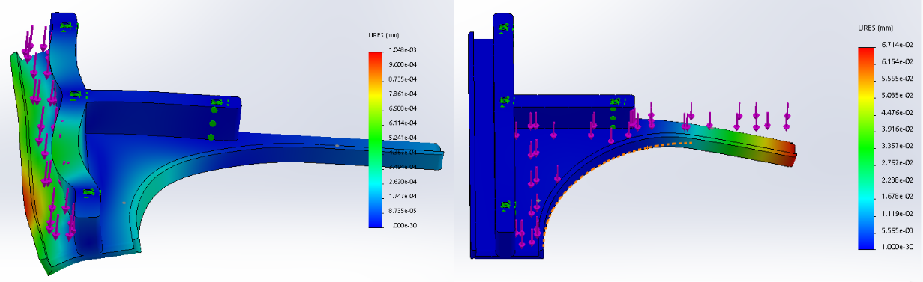
Figure 63. Left y-switch bottom part force analysis deflection no more than 0.003 inch.

7.2 Bogie
The bogie team had to test several things to ensure a successful final design. The first thing that the team tested was different iterations of the snap-fit design. The team chose to use a snap-fit that used an arrow-shaped design which allows the user to connect and disconnect the pieces with ease. Figure 64 shows the pieces that were printed for this test. In the first iteration that was printed, there was too much interference due to the shrinking of 3D printed materials. This yielded in a really tight fit which was not ideal. To fix these adjustments were made to the dimensions of the design to allow for more clearance. After a few trials the ideal dimensions were obtained and the snap fits were then added to the pod and bogie design.
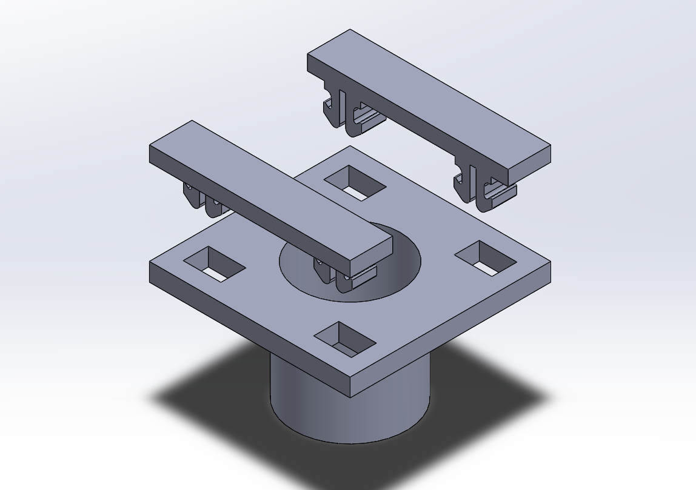
Figure 64. Snap fit tester design.
For the small scale model, the pod serves as a housing for the electrical components that are used. Because of this the team has to ensure that there is enough room in the pod for the components to fit. To verify that the dimensions of the pod were suitable, an assembly was made with all the components inside the pod. Figure 65 displays the assembled pod with all the components inside. To get a better idea as to how the components fit, the pod was rendered in a clear material.

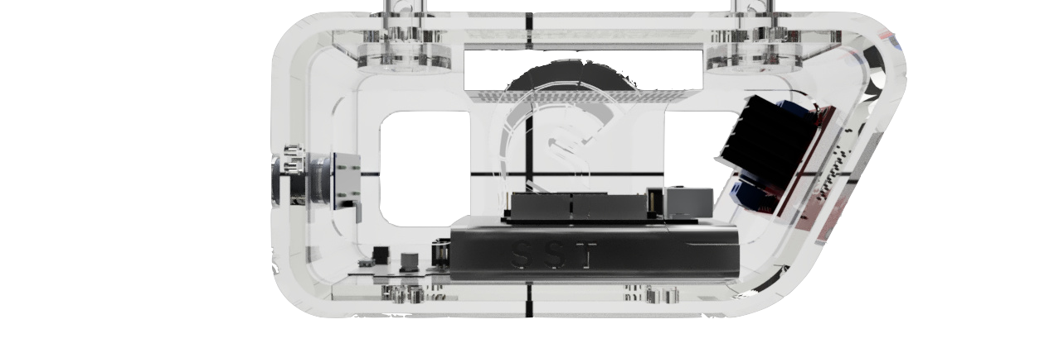
Figure 65. Clear render of pod to ensure space for electrical components.
Through the development of the electronic system, new changes with the Pixy2 camera had to happen, which also resulted in a change of where it will be located. The controls team made the decision that to have a better response from the camera, it is better to have it facing down rather than facing forward. This allows the station indicator barcodes to have a clear background, which reduces the noise in the Pixy2 range. A design change had to happen to switch the camera from the front face to the bottom face. Small alteration had to be made to allow the bottom face to fit the Arduino and the Pixy2 camera.
A simulation of the swiveling design that is shown in Figure 66 was conducted using Solidworks Motions Animation. The animation shows the swiveling mechanism and how it allows for smoother turns around corners of the track.
Figure 66. Animation of the Bogies’s swiveling design.
The gears are another critical part of the bogie design. This year the team decided to order metal gears instead of 3D printing them. This was done to ensure that the gears were accurate and had a longer lifetime. Although the gears could not be physically tested a motion analysis was done on the gears to verify that the design was successful. The motion analysis was done on the assembly in Figure 67. Knowing that the diameter of the wheel (30 mm) the rpm needed for the bogie to travel .2 m/s was calculated by dividing .2 m by the circumference of the wheel and multiplying that by 60. This resulted in an rpm of 127. For the wheel to reach this rpm the motor has to rotate at roughly 42 rpm, which is a reasonable speed for the motor. The full calculation can be found in Appendices A and B.

Figure 67. Gear design motion analysis.
The final component of the bogie that had to be tested was the switching mechanism. If the switch were to fail at the y-junction then the pod would fall through. Because of this it was crucial that the switch was designed to be strong enough to support the weight of the bogie. An FEA analysis was performed on the y-switch to provide confidence in the final design. The results can be seen below in Figure 68.
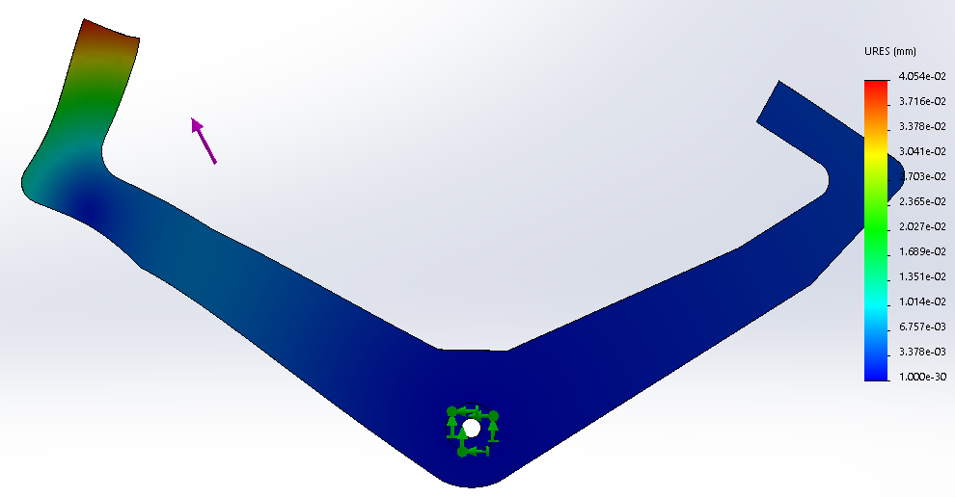
Figure 68. FEA analysis of the switching mechanism.

7.3 Controls

7.3.1 iOS App
As mentioned in the final design section of the report, two separate apps had to be developed to establish the BLE connection. Since the main app was more focused on the user interface, there is not much analysis to be done besides the final design presented earlier. However, for the testing app, several iterations of tests had to be performed in order to get the app to connect to the BLE properly. The idea was to combine both the testing app and the main app into one functional app once both were working as desired individually. This ensured that if any bugs were encountered, they could be pinpointed much quicker. However, the goal was to have a custom developed app that accomplished the same level of connection and that data could be sent to the BLE. Hence, why the second app was developed. The information regarding how Bluetooth Low Energy (BLE) works was discussed in the State-of-the-Art Literature section of this report.In this analysis section, the means by which the BLE connection was successfully established will be explained.
There were several issues last semester establishing the connection. In order to connect to a BLE device, the app has to be either searching for all available devices, or the specific UUID of that BLE device can be input into the code which in turn searches the device in a more direct manner. This is what was done in order to facilitate the searching process; however, the connection was still having issues. The app would get stuck in the searching phase without discovering anything, this can be seen in the following Figure 69:
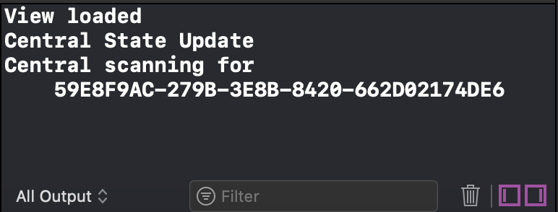
Figure 69. Output screen with wrong UUID when the app was stuck in the scanning phase.
It was later discovered that the wrong UUID was input into the code, it was the UUID provided on the data sheet; however, it was not the right one for being able to establish a connection, thus, the app was searching for a UUID that was not discoverable. BLEs have several different UUIDs attached to them as it was discovered by using an application called LightBlue. This application searches for all of the discoverable Bluetooth devices and allows the user to connect to them and find out all of the specific devices basic Bluetooth information, such as signal strength, whether the device is connectable or not and the different identifying numbers. This information can be seen below in Figure 70:
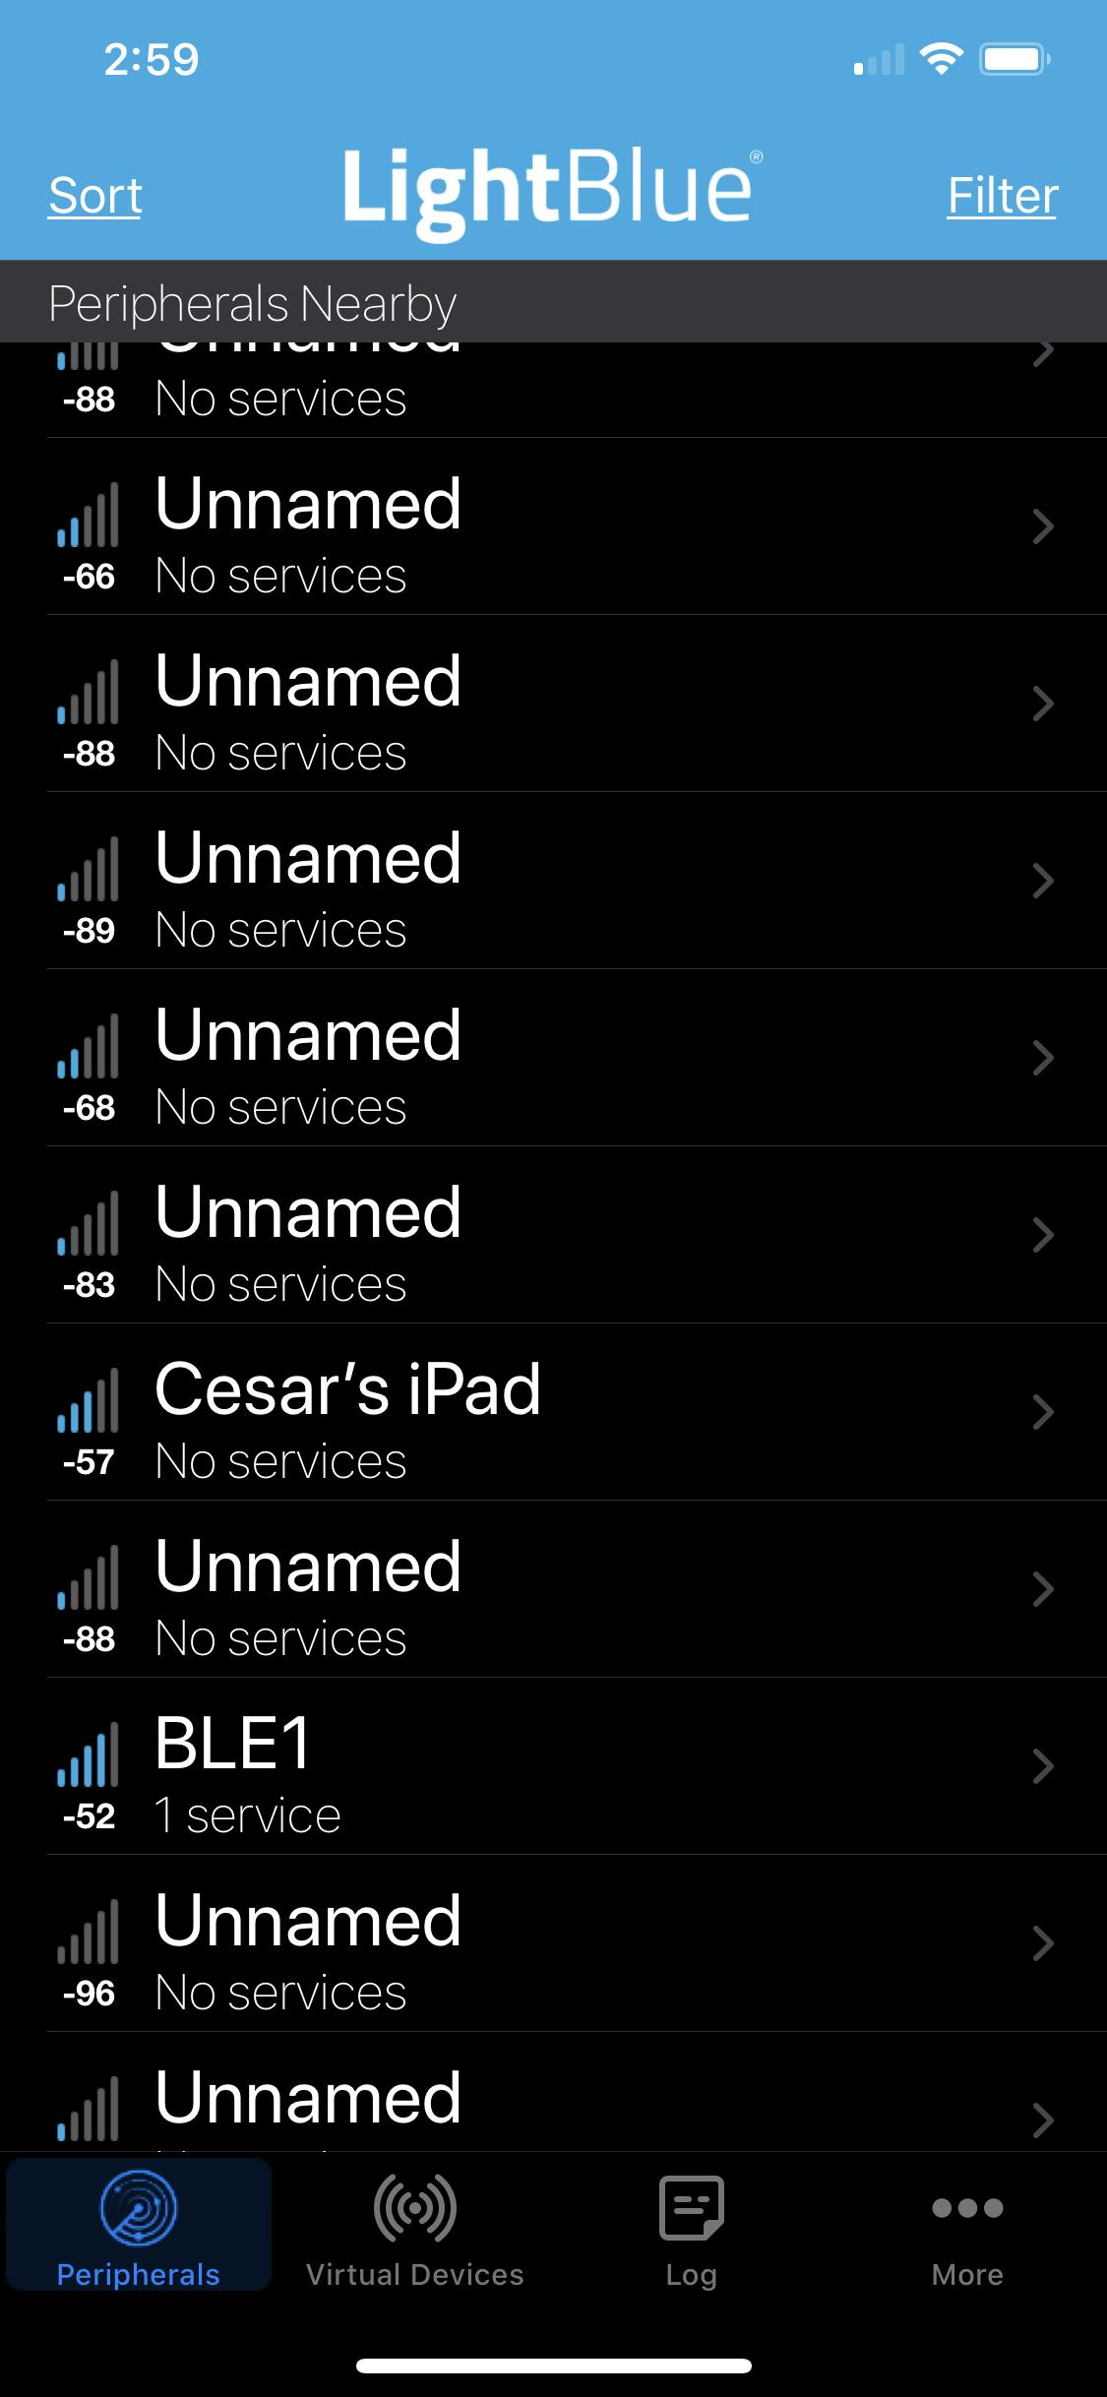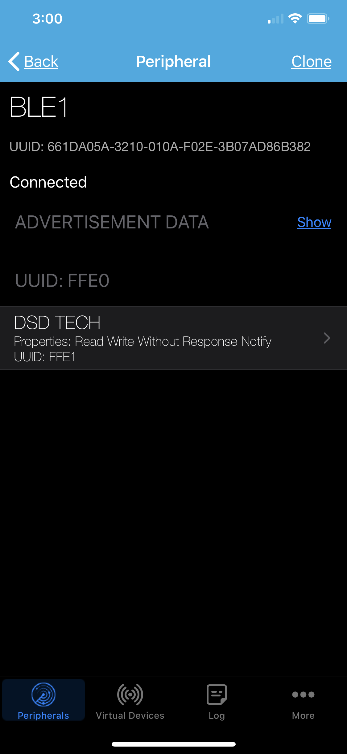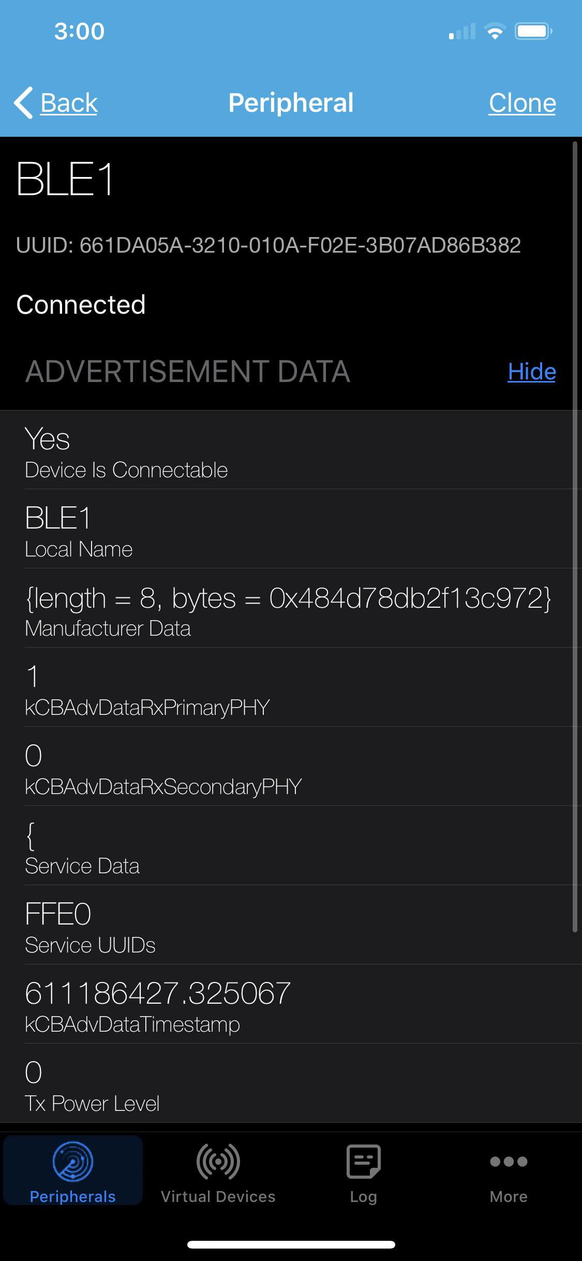
Figure 70. LightBlue application displaying BLE information.
The BLE device was renamed BLE1 soon after purchasing it in the Fall semester, once clicked, the app displays the very long UUID at the top of the second image, along with two other shorter UUIDs “FFE0” and “FFE1”. During the first stages of testing, the controls team was using the long UUID. However, once this app was discovered, the other two UUIDs were tested and a successful connection was established.
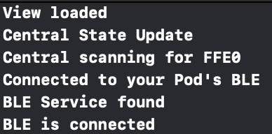
Figure 71: Output screen of iOS app.
The code is set-up so that the output log screen actually displays relevant information about each step of the connection process to ensure that a connection is successfully established and to pinpoint possible stages at which the code may get stuck. The full code that allows for this connection to be established can be seen in Appendix J. Successfully establishing the connection between the app and the BLE was a vital accomplishment. The next step was to test whether or not data could be sent and received by the BLE device. To do this, the slider discussed in the final design section was implemented into the app which can be seen in the following Figure 72:
Figure 72: Main interface of BLE connection testing app.
As mentioned earlier, the slider can be set-up so that depending on its position, different values are sent to the BLE. In Xcode, the user is given the option to choose a starting value, along with min and max values. This can be seen highlighted in red in Figure 73:
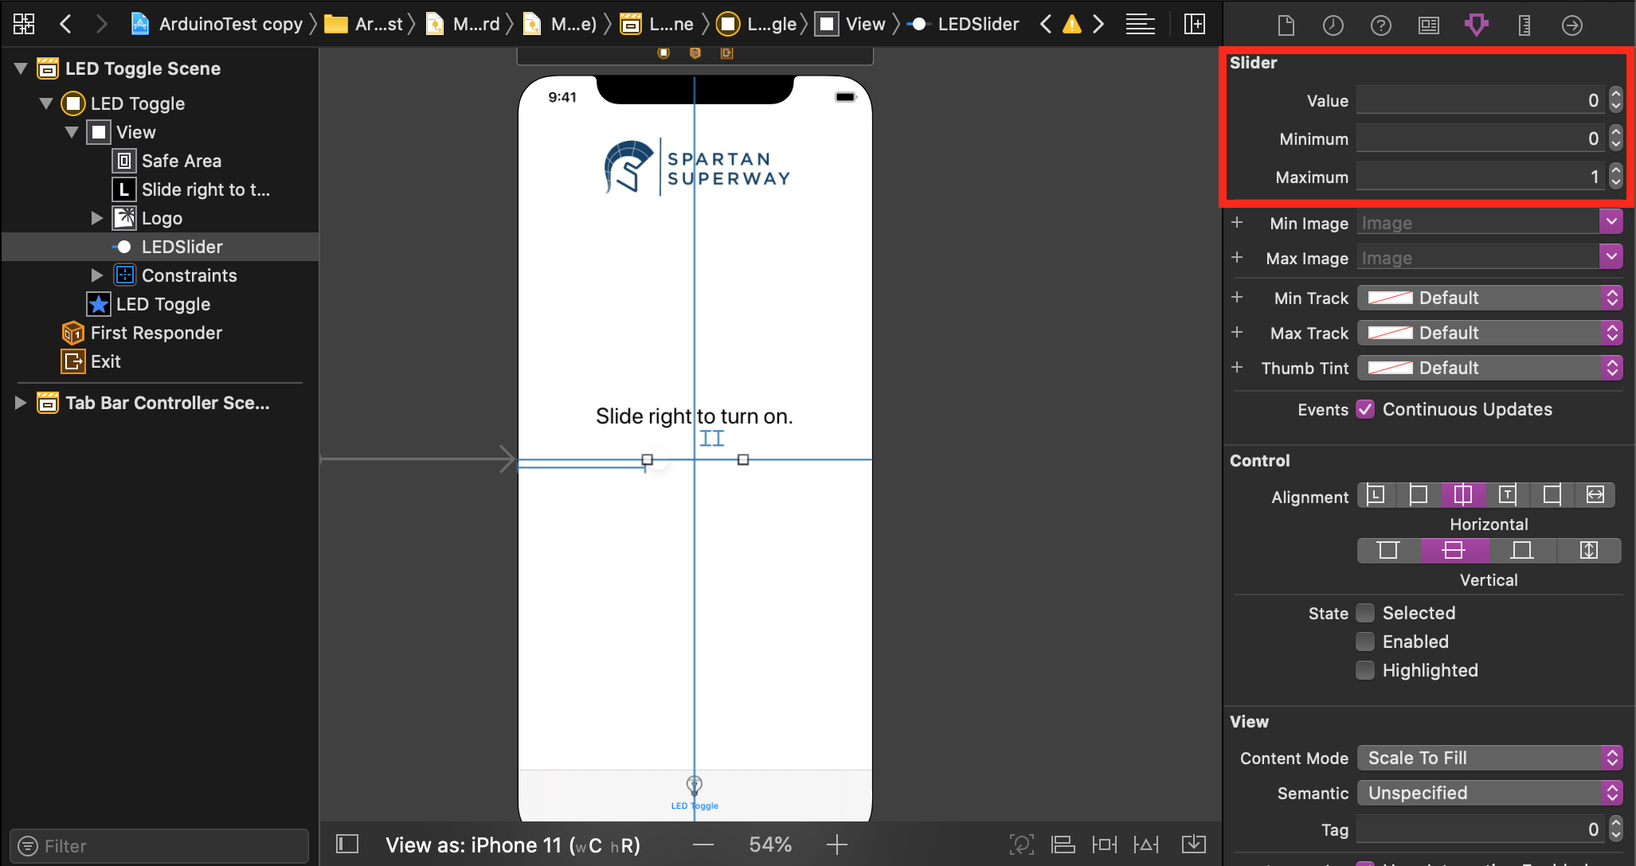
Figure 73. Customizing slider values in Xcode.
In order for these values to have any meaning and actually be sent to the BLE, a function had to be written in the code that allows for the position of the slider to correspond and send 8 bit unsigned integer values to the BLE. Doing so, the Arduino code that was used to test the connection between the “HM-10 Bluetooth Serial” app and the BLE was modified so that if the BLE received a value of 1, which corresponded to the slider being at the rightmost position, then an LED would turn on, signifying that the BLE was indeed receiving and transferring the values to the Arduino. If the slider is at the original leftmost position, which corresponds to a value of 0, then the LED would remain or turn off. This can be seen in Figure 74:
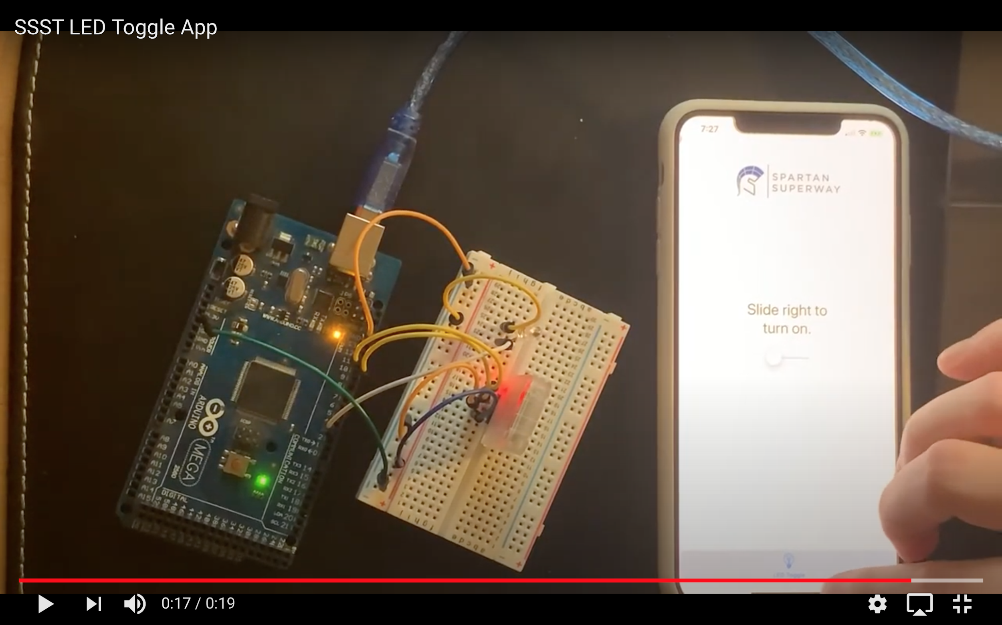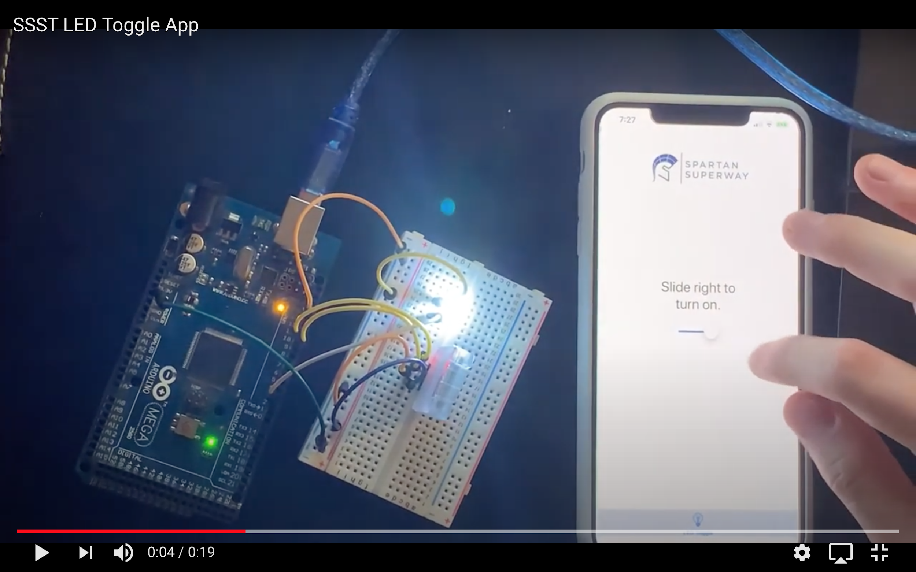
Figure 74. LED being turned on and off with a custom slider app.
Although this was just a small test to prove the connection and transfer of data to the BLE was successful, the next checkpoint was to test the app with the master Arduino code. Due to the shelter in place order and the controls team members being in different locations of California, one team member had all of the main electronic components to fully test everything together, and another team member just had the components shown above in Figure 74. Due to this, testing the components was a bit more challenging; however, this presented an opportunity to confirm that the app could indeed connect to two separate BLE devices. The app was able to be tested with all of the electronic components and will be analyzed further in the next subsection.

7.3.2 Electronic System
As the iOS app had been developing, the electronic system components had to be tested in conjunction to create a working Arduino sketch. To achieve this, a connection app that can send data to the BLE through a serial terminal had to be found. The “HM-10 Bluetooth Serial” app was found in the app store which allowed for the test of the BLE with Arduino by connecting to the phone’s bluetooth. Unfortunately this app is no longer available in the app store, but many other apps can be found that perform the same way. Some of these apps are “Bluetooth for Arduino” and “BLExAR”. The “HM-10 Bluetooth Serial” app was used to represent the iOS app that will behave similarly once it is fully developed. This app uses a serial terminal that sends ASCII values to the BLE. The user will enter a station value from 1 to 10 through this app to identify the station the pods need to travel to. This value will be sent to the BLE and be compared to the barcode values.
Unfortunately, the COVID-19 pandemic interabted a lot of the testing the Small-Scale team was planning on. To adapt to these unfortunate circumstances, tests were done to all components without integrating them in the bogie or the track. Luckly, all of the electronic components were kept with one of the controls team members before the lockdown. This made testing and troubleshooting the final Arduino sketch from home posible, until a working system was achieved. As explained in the final design section each component was tested individually before integrating all of them in one master Arduino sketch. This allowed for easier troubleshooting of components throughout the development of the electronic system. To test the reliability of our stepper motor, it was kept running for 30 seconds, the time needed to complete an outer loop distance, to demonstrate the longest period the bogie will travel to complete one loop. To test the response time of the Pixy2 camera, the team attempted in timing the response speed the code takes from showing the Pixy2 the barcode and the motor stopping. Results of these tests will be discussed in the results section.
After having a complete Arduino sketch that works with all the electronic components, the next step was to replace the “HM-10 Bluetooth Serial” app with the slider app explained in the iOS Analysis section. By moving the slider, an integer value is sent to the BLE, which activates the motor and the sketch starts running as expected. The only obstacle the team faced during this test was that the only value the slider was able to send to the BLE was the value of zero. As explained in the final design section, the barcode with value zero represents the turning signal for the servos and not a station number. Showing Pixy2 the zero barcode resulted in stopping the motor, but also the switching of the servos. This test proved that the slider app can be used with the rest of the electronic system; however, it also indicates that further improvement of the app along with the Arduino sketch has to be done to find the optimal solution to be able to send correct values to the BLE. The next section will discuss the results for each of the Small-Scale subteams.

8. Results

8.1 Guideway
Fabricating the guideway was a core goal that the Small Scale Team had for this Spring 2020 semester. Before lockdown, the outer part of the track was constructed from parts that were either bought or manufactured. Laser cutting the MDF board to create the straights, curves, and loops for the track were successful. Although it took multiple trials to understand how to properly set up the laser printer at the Makerspace, the final end product looked clean and precise. Figure 75 shows a half fabricated, outer track that was assembled the week before the lockdown occured.
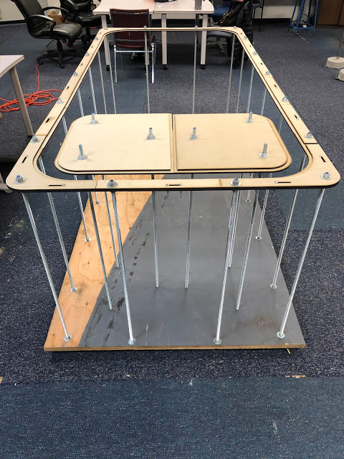
Figure 75. Assembly of the outer track and inner loop.

Solidworks proved to be practical for simulating the bogie and pod’s motion around the track. There was no interference between the rails and the wheels of the bogie, as well as between the y-switch and y-junction. Although virtual, the simulation gives an expectation as to what kind of motion should be expected when the bogie and pod traverse the track in future models.

When testing the rigidness of the outer track, the sides were pushed in the horizontal direction to check for wobbling. From what the guideway team recorded, the track remained stiff and rigid. And although the assembly of the outer track was incomplete, the pieces were quick and easy to assemble. If there had been more time, the estimated duration for assembling the entire track once all the pieces were fabricated or bought would most likely take two to three hours.
Following the simulations done on ANSYS and Solidworks, it was determined that the deformation of the track pieces are negligible. The straights, curves, and y-switch rail had a max total deformation of 0.0012, 0.0003, and 0.0026 inches, respectively. However, it is worth noting that these simulations may not be as accurate as they should have been for multiple reasons. First and foremost, the guideway team had beginner experience with ANSYS and Solidworks simulation software. By watching and learning the basics behind FEA through videos on the Internet, the guideway team used their newfound knowledge to the best of their capabilities. Second, the models used in ANSYS were over simplified. The track pieces, such as the straights and curves, are two-layered. This cake layer design was not implemented into the models that were created on ANSYS. Pieces like the curves and y-switch rail were not able to have direct point of contact for the forces, and instead had to be analyzed using ramped forces along the faces of the track. Overall, finite element analysis on the tracks could be proven physically by testing the bogie and pod on a completed track in the future. A simple rigidness test, such as pressing against the top part of the track in a horizontal direction, could determine whether different or more supports should be added to the guideway.

8.2 Bogie
Although many components of the final design could not be physically tested, the tests that were performed on the bogie provide confidence in the success of the design. Prior to the shelter in place order the pod was completely printed. This allowed the team to have a clearer idea as to how the final design would perform. The snapfits that were implemented into the pod were easy to use and allowed for quick disassembly and reassembly, thus meeting one of the main project objectives. The printed pod is shown below in Figure 76.
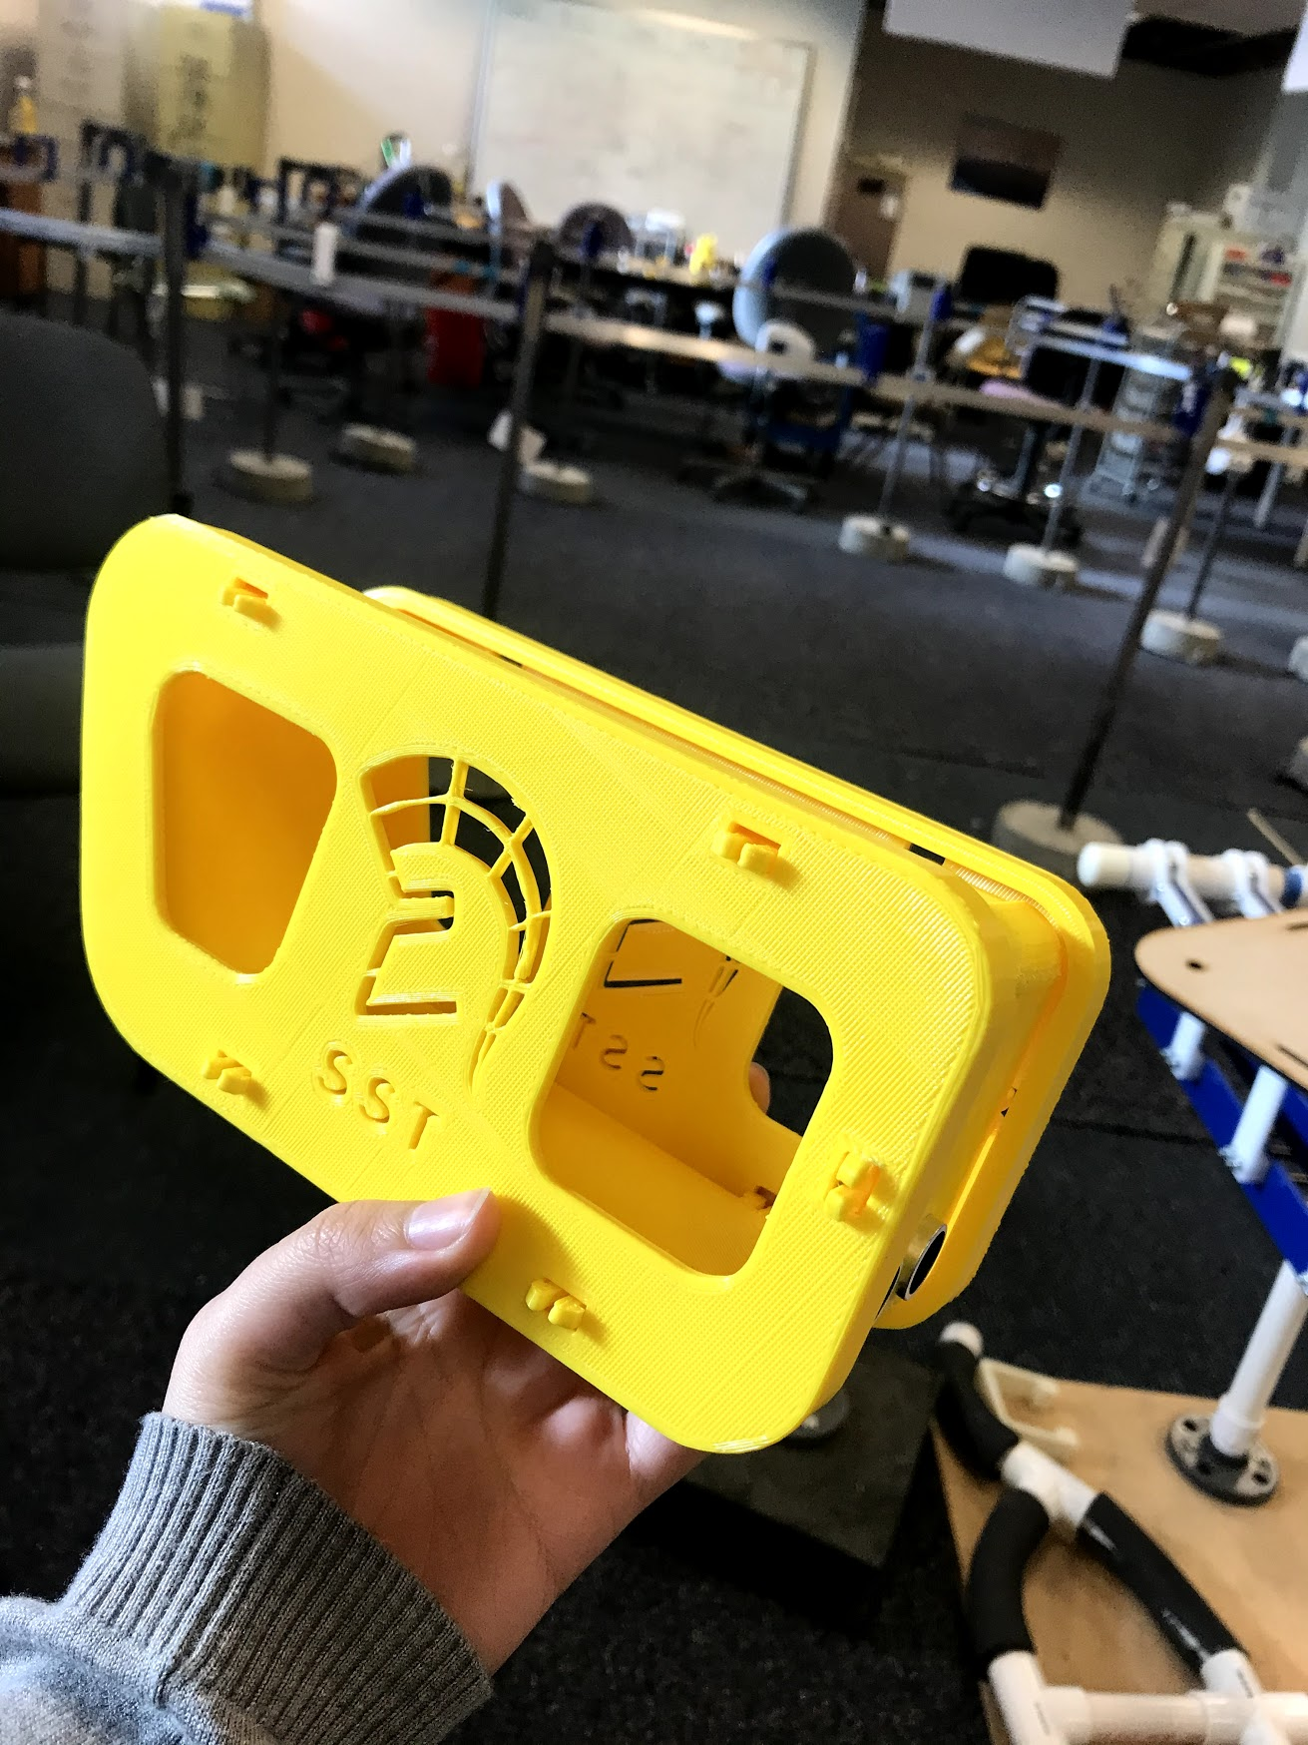
Figure 76. Successful assembly.
Upon printing the pod it was also determined that the team was able to successfully meet many of the bogie design specifications. The final dimensions and weight of the pod did not exceed the specifications that were set at the beginning of the year. With all the electrical components at hand the team also knew that the bogie was not going to exceed the maximum weight of 3 lb. The motion analysis that was performed on the gears of the bogie gave a clear understanding as to how the gears would move when the bogie was in motion. This analysis ensured the team that the gears were placed correctly with respect to each other.
The motion analysis that was done with the pod and track together also verified that the swivel design allowed for the pod to easily make turns. The second motion analysis of the y-switch also ensured that the design worked with the third rail. Ideally, the team would have wanted to physically test all the components of the pod and bogie; however, the team was forced to adapt. With the analyses that were performed on the pod and bogie it is safe to say that the final design met all the specifications that were set while also meeting the objectives of the project. Thus, the bogie design was a success.

8.3 Controls

8.3.1 iOS App
In terms of the overall goals that were achieved by the controls team, the project was successful. An aesthetically pleasing app was developed which allows the user to find out more information about the Small Scale Team, along with the main info about each subteam. The user is also able to view the location of the Superway Center relative to themselves, and in future updates, they will be able to click on the location of the Superway Center and be led to the project website. The team is excited about the work completed on this app because when the Superway is fully operational in a future time, this app closely resembles the experience that a user would have when ordering their pod, seeing its location on the map relative to them, seeing ETA times, paying for their trip, and finding more about the special form of transportation that Superway really is.
Although a separate app had to be developed to establish the BLE connection, and the team had to alter the plan of using a keyboard like the “HM-10 Bluetooth Serial” app from the Apple App Store, once that connection was established to two different BLEs, that met the other important goal of the app. Although at the current moment the slider may not be the most user intuitive experience for what the rest of the electronic system does, it proves that with some tweaks to both the app and the master Arduino code, the user can effectively control what station to go to based on the slider position. The issue that was faced with the original plan to have a keyboard was that setting up the keyboard in Xcode to successfully transfer data based on the users input, was far more complex than what was imagined. Research done on getting the keyboard to work was challenging because there were not any guides or YouTube videos that could be followed. The only option was to look at the code for the “HM-10 Bluetooth Serial” app that was on Github, however, this also proved to be quite challenging as the keyboard was interwoven into several parts of the files in Xcode. There could have been 10 different sliders (or buttons, or switches,) each one corresponding to the 16 barcodes discussed in the final design section, however, this would have been overwhelming for the user. Nevertheless, the slider testing app met the objectives of connecting to two different BLE devices, while the main Small Scale app is user friendly and pleasant to use. The next subsection will be discussing the findings of the electronic system.

8.3.2 Electronic System
A lot of successful results were achieved this year in the electronic system design. The Small-Scale controls team was able to create a working Arduino sketch that meets all the objectives and specifications that was set at the beginning of the academic year. The design allows for two pods to travel though the track without colliding by designing an anti-collision that utilizes an ultrasonic sensor. The design also includes a reliable and fast station recognition system by using the Pixy2 camera that does not limit the speed of the pods traveling throughout the track as it can process 60 new frames per second. Testing response time verified that the time it takes for the Pixy2 to read the barcode and the motor to stop was a fraction of a second. The Pixy2 is also used to identify the location of the y-junction that allows the y-switch to move to its desired location before it enters the y-junction, which completes one of the team’s objectives of having a switching mechanism that protects the bogie from falling through the gaps of the track. The team was also able to find a reliable stepper motor that allows the bogie to travel through the length of the track without overheating or using a lot of power that makes the batteries run out quickly. The sketch also adapts to future user friendliness of a working iOS app by only needing one input from the user that identifies the desired station number to arrive at and the code takes care of the rest. The Small-Scale controls team was able to achieve a straightforward and easy to understand electronic system design that will be easily modified to adapt any future changes in the track, or app design.

9. Conclusion and Recommendation for Future Work

9.1 Guideway
The guideway team met all the objectives set forth in the proposal by designing a functional interchangeable guideway with a y-switch. Choosing MDF board gave the guideway team the ability to create a track that was light weight, something past year teams have not been able to accomplish. The layer cake design proved to be practical by allowing interchangeability and was easily manufacturable with the laser cutter used at the Makerspace. The redesign of the y-switch rail allowed for the bogie and pod to safely traverse the y-junction without a risk of falling through. Although physical testing of the bogie and pod onto the track did not occur this semester, the team was able to gain a new skill in simulations and finite element analysis using programs such as Solidworks and ANSYS. The guideway team also learned a great deal in how to choose the right material for a project given it’s design intent. Communication within the team was solid, and each team member was able to communicate with one another efficiently, even if they were not in the same sub-team.
Future guideway teams can continue progress on the current half built guideway located at the Superway Design Center. Before the COVID-19 stay at home restrictions were implemented, most of the guideway pieces were laser-cut and all of the hardware to assemble these pieces were purchased. The outer loop of the guideway is already securely fastened to the baseboard. The holes on the backside of the baseboard have been counterbored using bits from the center tool room. The tools needed to build the guideway include an adjustable wrenches, portable drill (cordless preferred), Phillips head screwdriver, counterbore drill bit, ¾ drill bit, and a tape measure. The laser-cut guideway pieces are located on the tables in the small scale section of the room. After the guideway inner loop is secured to the baseboard, the y-switch assemblies will need to be manufactured. There is enough 24x48 inch MDF board leftover at the center as well that can be used for laser cutting the top parts of the y-switch assemblies. The left y-switch assembly can be 3D printed first using the printers at the design center. The extended threaded rods will still need to be purchased and one way of doing that is by going to Home Depot and buying the 72-inch ½-13 steel threaded rods. These rods will need to be cut using the electric hacksaw with the correct blade located at the design center. These extended rods are used for the y-switch since it is located 39 inches from the baseboard and the next size below 72-inch length is 36 inches. The second option is to purchase the rods from McMaster-Carr at the exact length and pay the premium for shipping, which takes care of the labor of using the hacksaw. The fasteners for the y-switch assemblies can be purchased at Home Depot. Further redesign of the y-switch and track interchangeability should be considered, so that more pods can be placed onto the guideway and a proper motion analysis study can be conducted.

9.2 Bogie
Although the final design of the bogie met all the objectives, there are still some things that future teams can improve upon for the bogie and pod design. The largest contingency that the team faced was the time it took to 3D print all the parts using the 3D printer at the Superway center which limits the number of parts that can be printed at once due to its small bed surface. Because of this the team should focus on trying to start the printing process early in the year. To lessen the printing time future teams could also look into reducing the material used for each part. This could be done by testing out different infills and optimizing the infill so that rigidity is not sacrificed. Another in which material could be reduced is by utilizing the generative design feature in Fusion 360 or ANSYS optimization feature. This feature takes the original design and generates many alternatives that result in the same strength and rigidity. These alternative designs could then be utilized to reduce the printing time.

9.3 Controls

9.3.1 iOS App
There were a plethora of things that were learned throughout the development process of the iOS apps. First and foremost, developing an app requires patience and computing storage availability (for the computer to run smoothly, at least 60 gigabytes free prior to the start of the developing process). Although not a requirement, multiple team members (at least two) on Apple Mac computers makes the developing and testing process more efficient. The majority of the academic year, it was just one person developing and testing the app, other team members helped research, but having only one dedicated Mac computer made the testing phase a bit more complicated. Another major thing that the controls team learned was understanding how Bluetooth Low energy devices work, how they connect to other devices and what data can and can’t be sent to and from them, is far more complicated than what was expected.
One major thing that should have been done earlier, not necessarily different, is developing and testing the keyboard interface to be able to type in the station number that the pod should go to. As discussed, there were some complications with the keyboard, so the team had to adjust to a slider interface that ultimately works the same, just in a less user friendly manner. With more time, the team believes that the keyboard interface would have been working as desired. Nonetheless, the overall aesthetic and user friendliness of both the main app and the BLE slider testing app turned out nicely. The team is also proud of being able to create a custom app and establish a successful connection to two BLE devices, essentially allowing for remote control of the Arduinos on the pods. In the coming weeks, the controls team will work on combining the slider test app and the main Small Scale app into one. The app will further be revised and will be submitted to the App Store as official version 1 of the SPARTAN Superway Small Scale App.
Future teams should read through all of the guides and forums relating to Xcode, Bluetooth Low Energy devices that this year's Small Scale team has gathered (there are also a lot of good YouTube videos). Doing this as early as possible ensures that the team has a good understanding regarding what they are getting themselves into, prior to continuing the development process. This year's team did most of the legwork for the app and will continue to make updates throughout the summer. The next Small Scale Controls team would just have to work on continuing to make the app more equipped and user friendly, as well as getting the keyboard to work, or finding another creative idea to interface data sent from the app to the BLE corresponding to the different stations on the guideway. It would be useful for future teams to have a computer or software engineer to provide more expertise on the app developing process. Doing these things, the future Small Scale Team should have everything necessary to take the app to an even more developed and advanced level. The next subsection will cover concluding thoughts regarding the electronic system.

9.3.2 Electronic System
The electronic system design successfully met all requirements that results in a reliable control system once integrated with the iOS app. The Arduino sketch is an important part of the overall Small-Scale model. It simplifies the use of the model by having no interference from the user other than choosing the station they would like the pods to travel to. The main take away from this year’s design was that breaking up the code into individual small ones, made it easier for the team to understand the functionality and troubleshooting of all electrical components. It also helped in organizing the design and breaking out tasks to different deadlines that resulted in completing the design in a timing manner.
Although the final electronic system design met all the objectives, additional improvements can be useful for future teams. The current design uses six AA batteries connected to the Arduino to provide it 9V and an additional 4 AA batteries connected to the motor driver board to provide it with 6V. This design takes away from the autonomy design of the Small-Scale design when the batteries die and will have to be replaced. For future teams, it is recommended to look at the 2019/2020 wireless charging design to have charging stations added to the Small-Scale model. The 2019/2020 used induction charging coils to charge a portable lithium battery that can be adapted. Another suggestion is to add an encoder motor that allows the location of the pods on the track to be simulated on the app. This will also provide a calculated time of when the pod will arrive to the user.

9.4 Small-Scale Team as a Whole
Overall, the Small-Scale Team is content with the results as a whole. Although the team was not able to finish assembling and testing all of the components due to the shelter in place order, the simulated analysis, along with the testing of the electrical components gives the team a good feeling that once tested, the Small-Scale Model should function as simulated. There are areas that future teams can improve, but the 2019-2020 team feels that they continued to build a strong foundation for future teams to succeed. Depending on how the shelter in place order pans out, the team might go to the Superway Center to test all the components together in person at some point during the summer.

References
Alvarez, R., et. al., 2016. Spartan Superway: A Solar Powered Automated Public Transportation System. Retrieved from http://tinyurl.com/jbla3hz
Andrews, L. W. (n.d.). How to Stress Less in a Traffic Jam. Retrieved December 7, 2019, from https://www.psychologytoday.com/us/blog/minding-the-body/201509/how-stress-less-in-traffic-jam
Aquino, B., et. al., 2017. Spartan Superway: A Solar Powered Automated Public Transportation System. Retrieved from https://www.inist.org/library/2017-06-02.Aquino%20etal.Spartan%20Superway%202016-2017%20Final%20Report.SJSU%20ME195AB.pdf
Boeing. (n.d.). Personal Rapid Transit System Historical Snapshot. Retrieved from http://www.boeing.com/history/products/personal-rapid-transit-system.page
Bogies | The Railway Technical Website | PRC Rail Consulting Ltd. (n.d.). Retrieved September 29, 2019, from http://www.railway-technical.com/trains/rolling-stock-index-l/bogies.html
Carnegie, J. A., Voorhees, A. M., & Hoffman, P. S. (2007). Viability of Personal Rapid Transit In New Jersey (pp. 1–141). NJ Transit. Retrieved from http://faculty.washington.edu/jbs/itrans/big/PRTfinalreport.pdf
Connolly, K. (2019, August 1). World’s oldest electric suspension train reopens in Germany. Retrieved May 15, 2020, from https://www.theguardian.com/world/2019/aug/01/worlds-oldest-electric-suspension-train-reopens-in-germany
Chen, X., & Liu, Y. (2019). Finite Element Modeling and Simulation with Ansys Workbench. Boca Raton, Fl: CRC Press.
Furman, B. J. (2016). The Spartan Superway: A Solar-Powered Automated Transit Network. Retrieved from http://proceedings.ises.org/paper/solar2016/solar2016-0019-Furman.pdf
Furman, B., Ellis, S., Mueller, P., & Swenson, R. (2014). Automated Transit Networks (ATN): A Review of the State of the Industry and Prospects for the Future. Mineta Transportation Institute, 1–220. Retrieved from https://transweb.sjsu.edu/sites/default/files/1227-automated-transit-networks.pdf
Halabi, I & Jocson, B, 2018. Spartan Superway: Small-Scale Bogie Design. Retrieved from https://drive.google.com/drive/folders/1G644XhphRf8OwJpp2lZjsDeMial7oxoP
Hoiberg, A. (2015, August 14). How to use the HM10: Connect your Arduino to an iPhone with Bluetooth. Retrieved from http://www.hangar42.nl/hm10
Levine, G. (2017, October 26). Two Ways to Reset Arduino in Software. Retrieved from https://www.instructables.com/id/two-ways-to-reset-arduino-in-software/
Morgantown Personal Rapid Transit System. (n.d.). System Operations Description Manual. Retrieved from http://www.advancedtransit.org/wp-content/uploads/ 2011/09/M-PRT_1-1_SYSTEM_OPERATIONS_DESCRIPTION_MANUAL.pdf
Nordstrom, R. (2009). Heathrow Tests Personal Rapid Transit System. Airport Improvement . Retrieved from https://web.archive.org/web/20160304025447/http://prtconsulting.com /docs/Heathrow.pdf
Pixycam. (2019, February 18). wiki:v2:overview [Documentation]. Retrieved from https://docs.pixycam.com/wiki/doku.php?id=wiki:v2:overview
SwiftUI. (n.d.). [Illustration]. Retrieved from https://developer.apple.com/xcode/swiftui/
Core Bluetooth objects on the central side. (2013). [Illustration]. Retrieved from https://developer.apple.com/library/archive/documentation/NetworkingInternetWeb/Conceptual/CoreBluetooth_concepts/CoreBluetoothOverview/CoreBluetoothOverview.html
US Environmental Protection Agency. (2018, May 10). Greenhouse Gas Emissions from a Typical Passenger Vehicle. Retrieved May 15, 2020, from https://www.epa.gov/greenvehicles/greenhouse-gas-emissions-typical-passenger-vehicle
US Environmental Protection Agency. (2020, April 14). Retrieved 2020, from https://www.epa.gov/ghgemissions/inventory-us-greenhouse-gas-emissions-and-sinks
Vital Signs. (n.d.). How Much Time Do Bay Area Drivers Spend Sitting in Traffic . Retrieved May 15, 2020, from http://www.vitalsigns.mtc.ca.gov/time-spent-congestion
Wood-Based Material. (2018, August 2). Retrieved from https://www.makeitfrom.com/material-properties/Medium-Density-Fiberboard-MDF
Wuppertal Tourism and City Information. (n.d.). Suspension monorail. Retrieved from https://www.wuppertal.de/microsite/en/tourism/schwebebahn/schwebebahn.php

Appendices

Appendix A: Guideway Drawings.
Guideway Assembly Procedure: https://docs.google.com/document/d/1NDvAy1TBc-fWK0PKqXeg8-gAh1Hx4CuJt-bml9mWYbs/edit

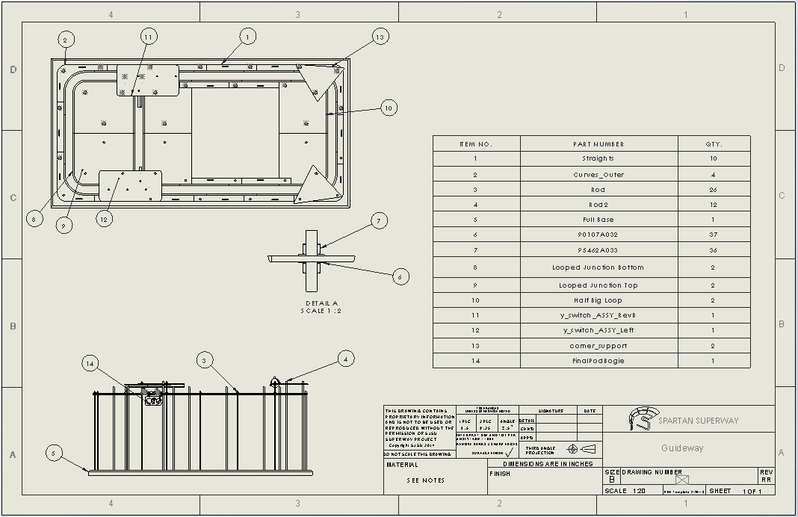

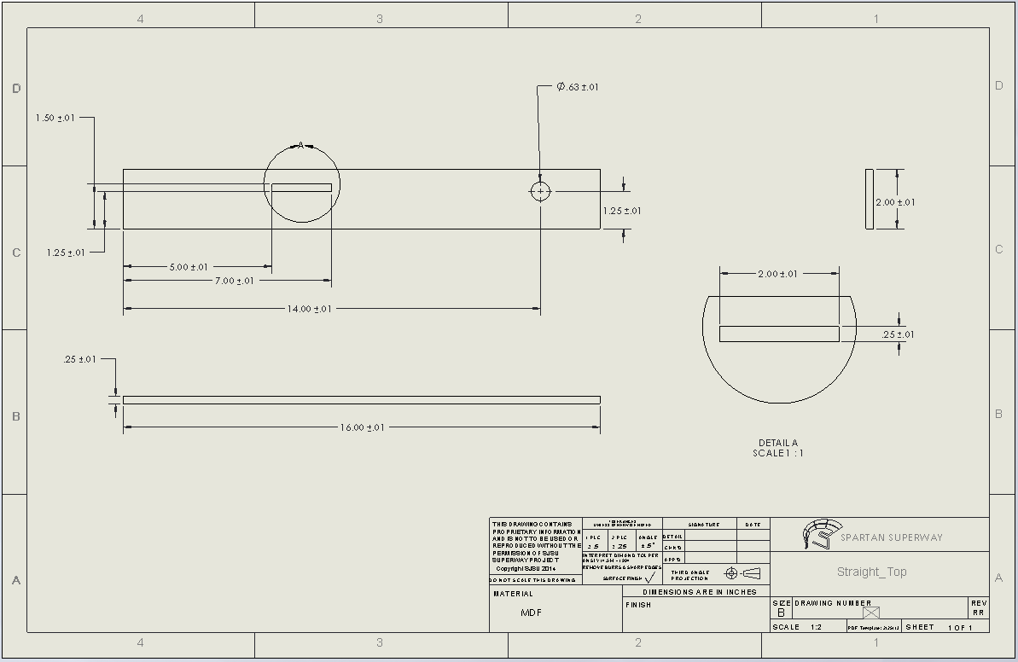
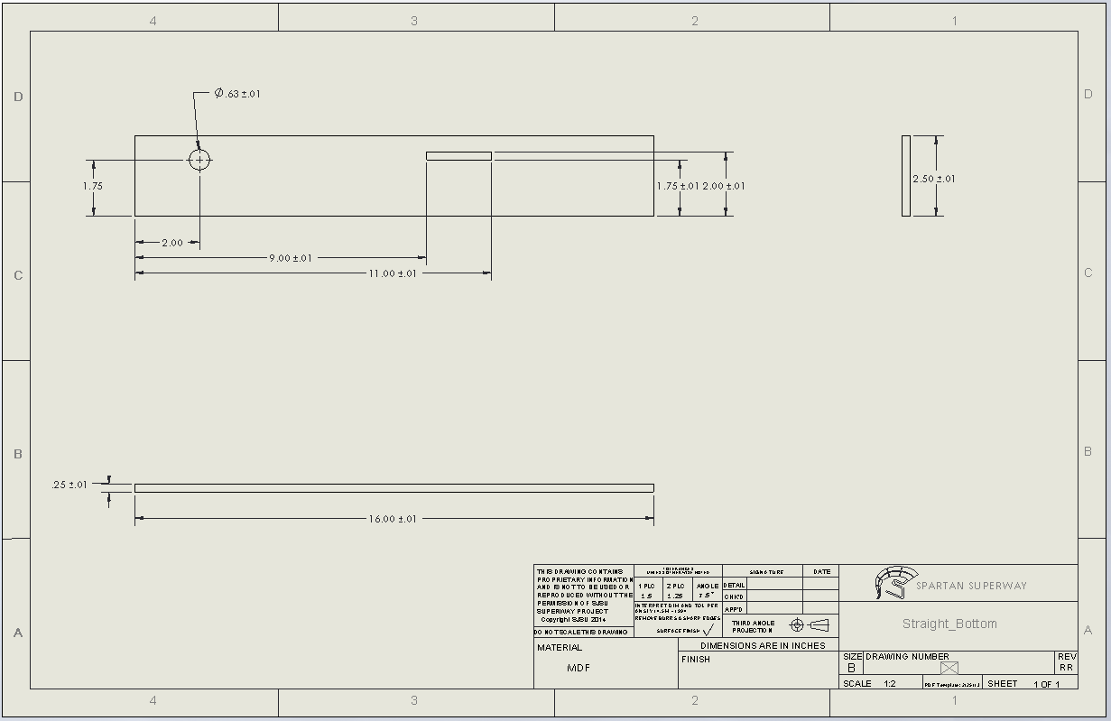
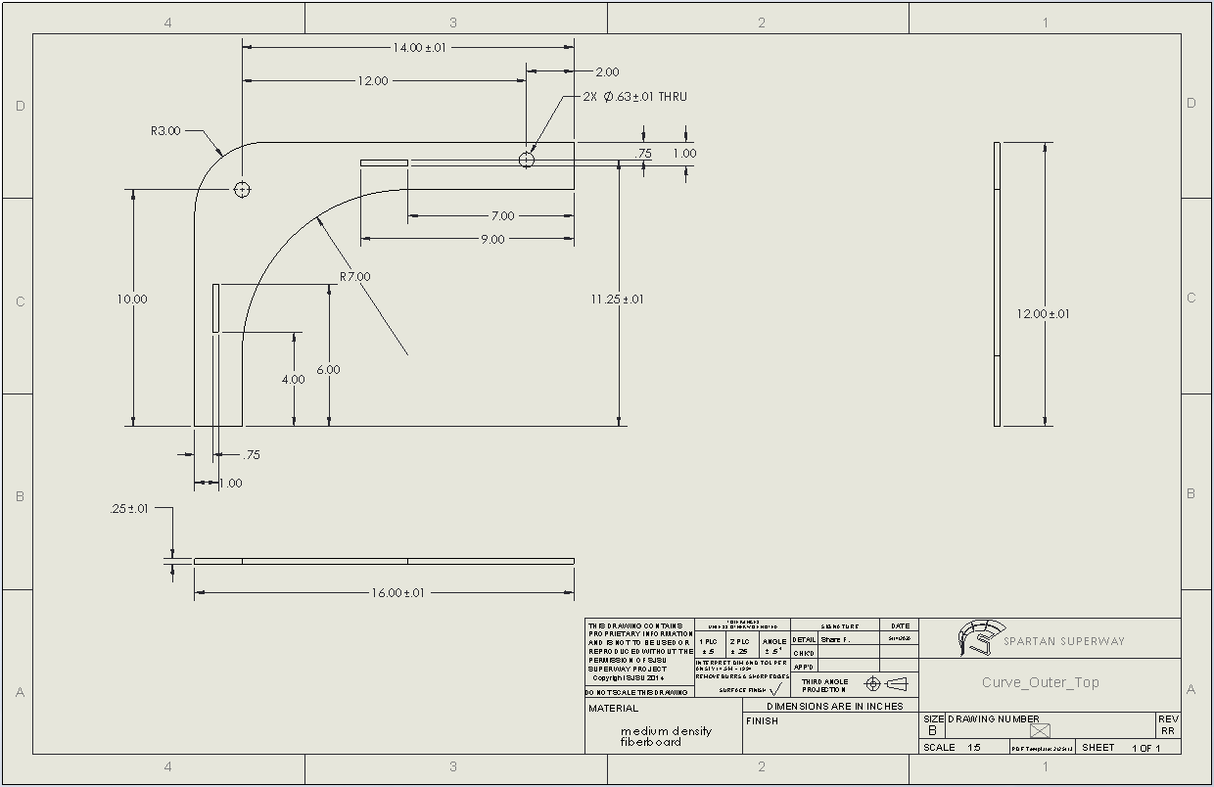
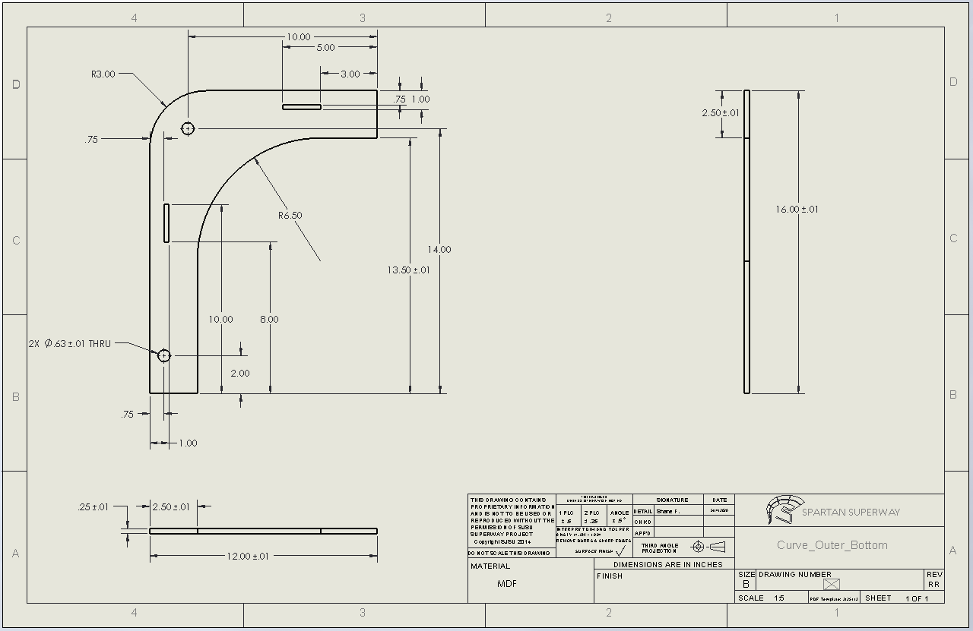
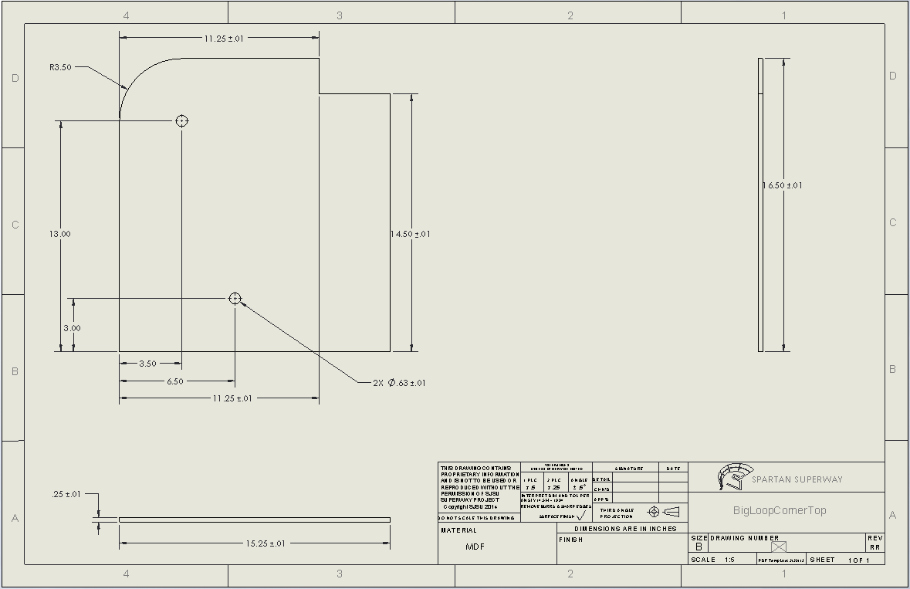
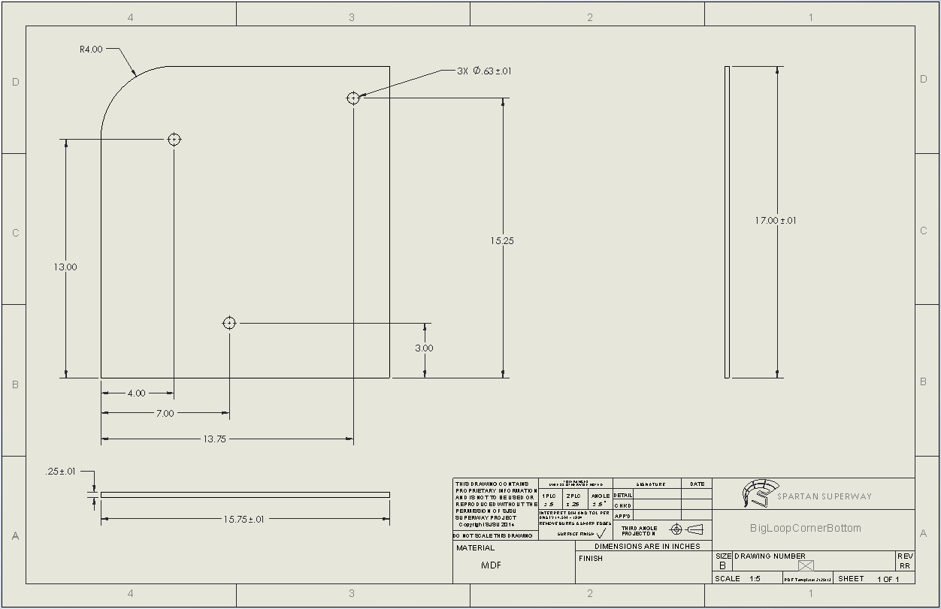
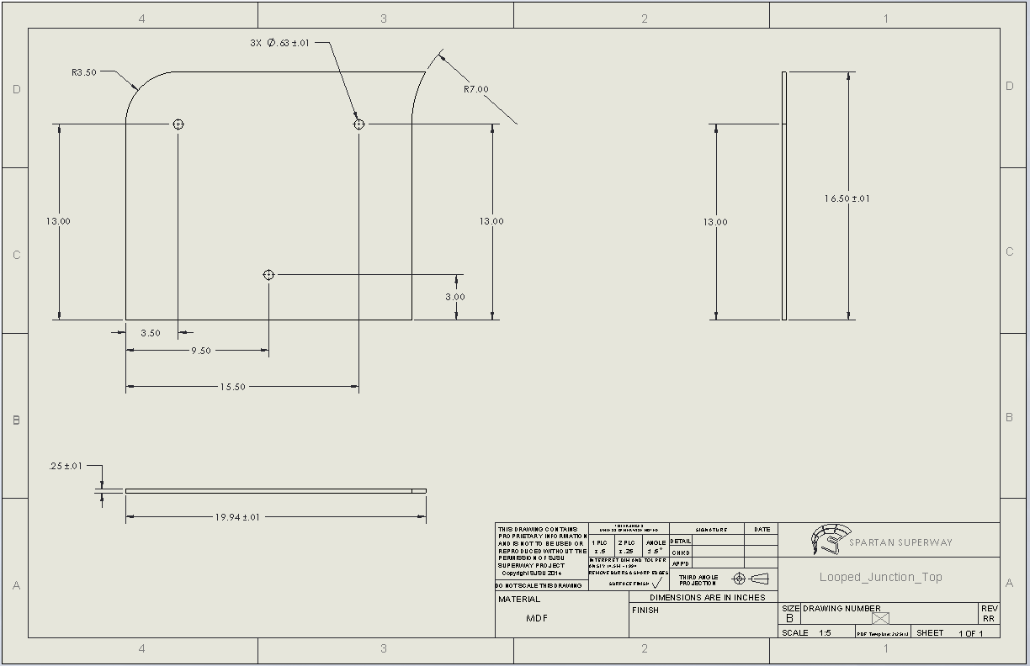
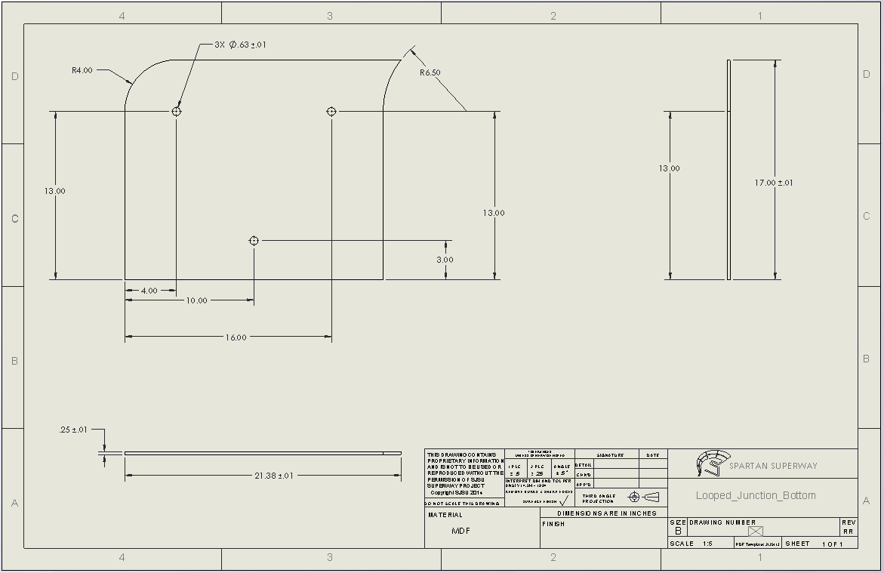

Appendix B: Bogie and Guideway Y-Switch Drawings
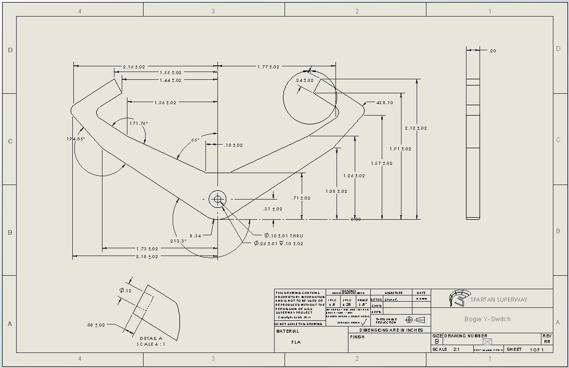
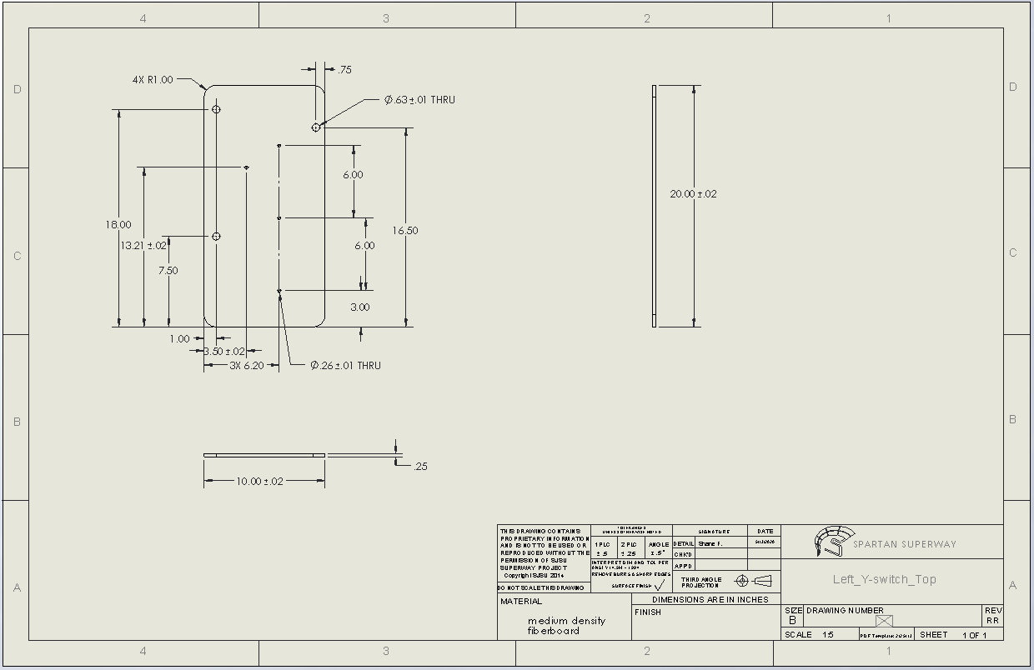
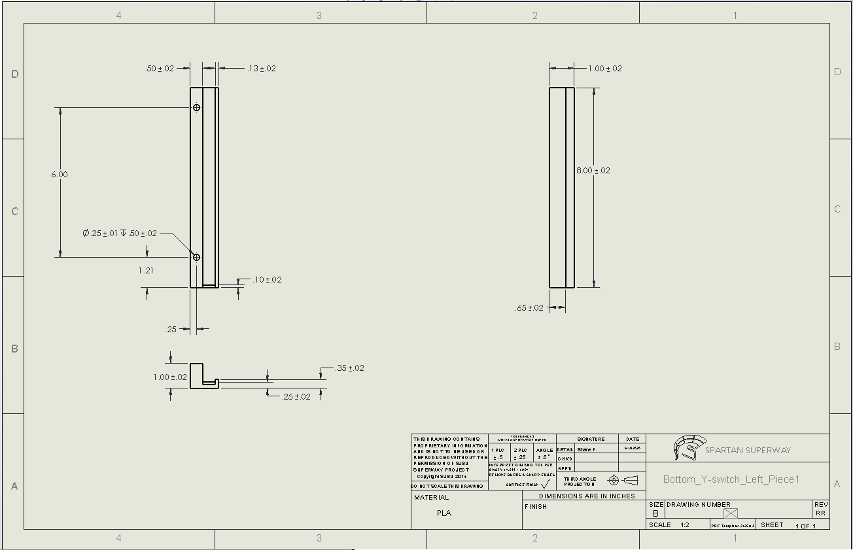
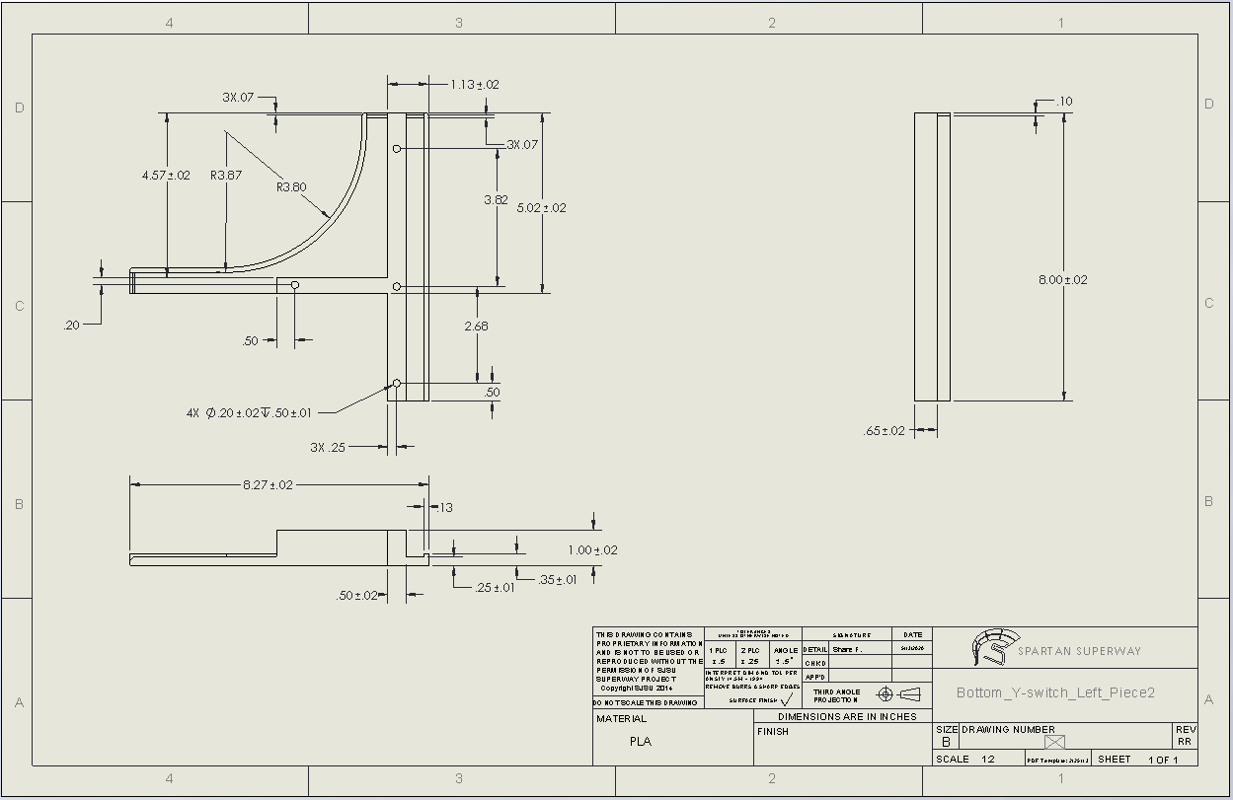
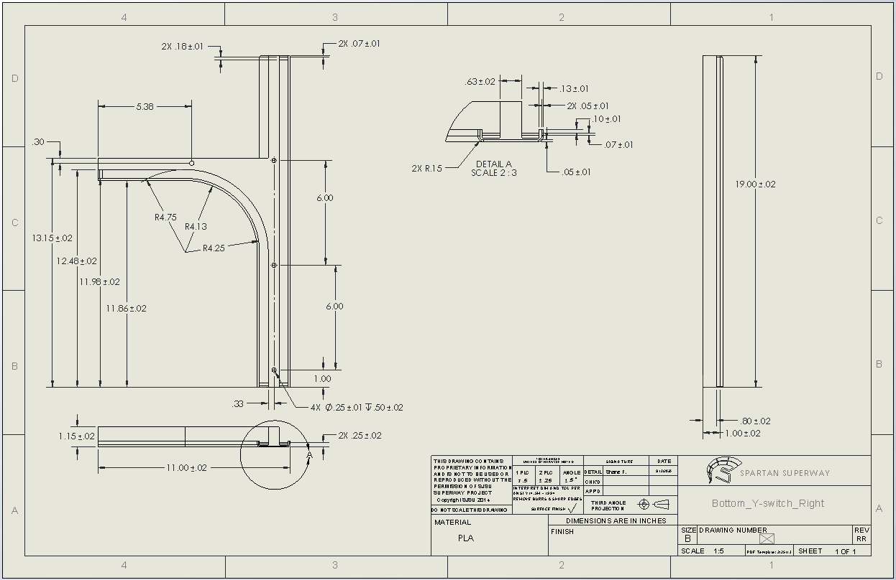

Appendix C: Guideway Corner Support Drawing
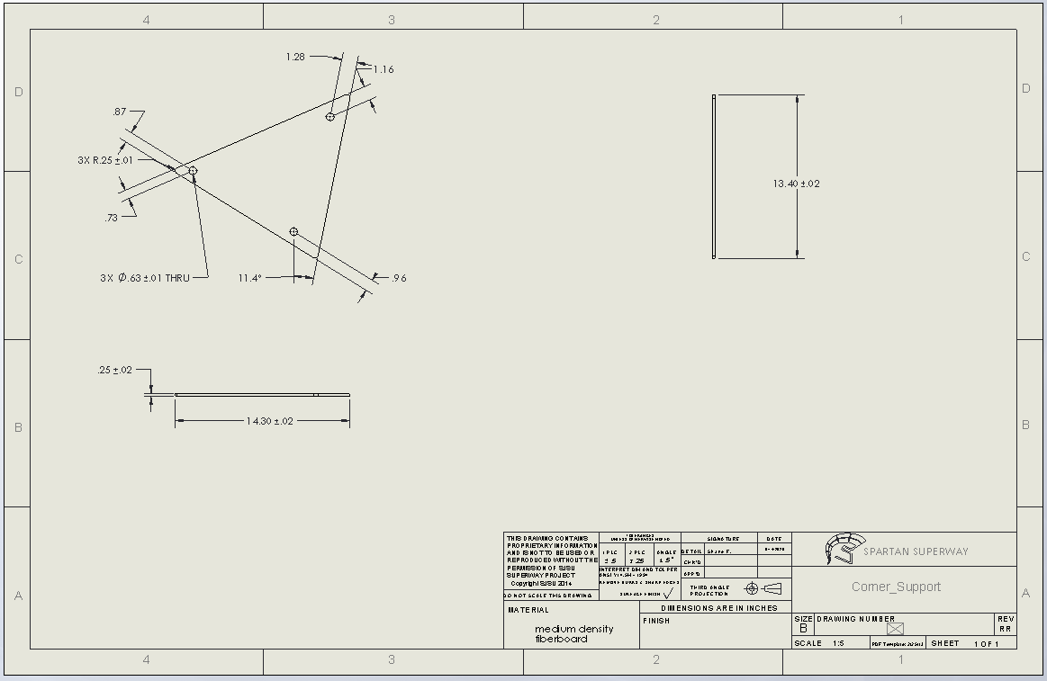

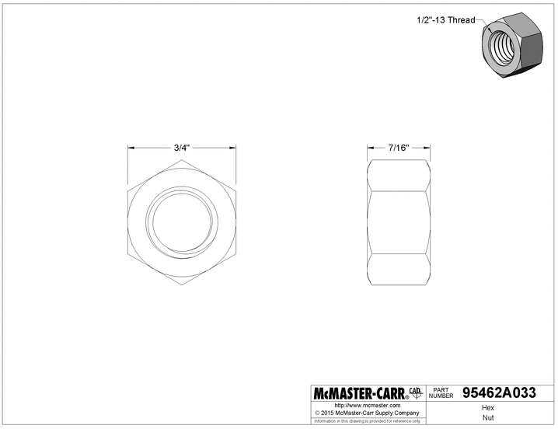
Appendix D: Guideway Hardware Drawings

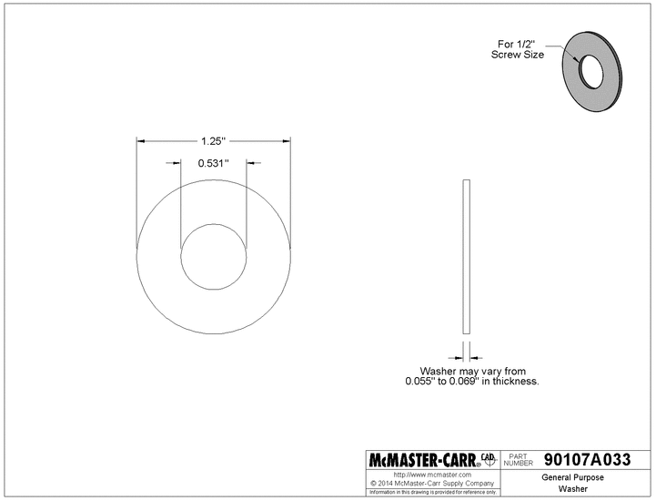


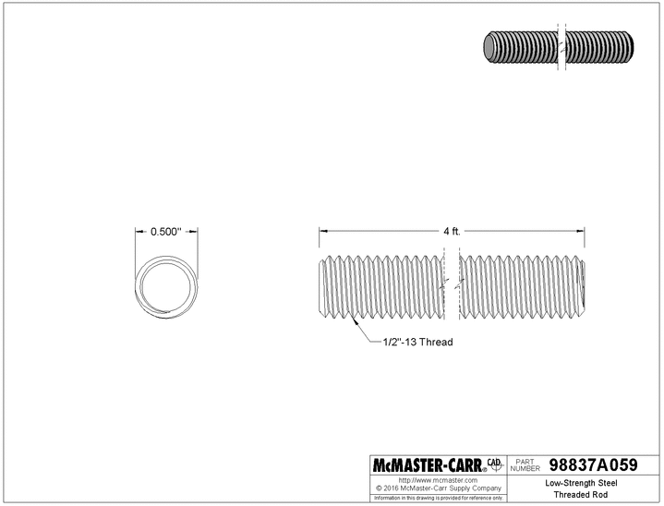

Appendix E: Bogie Y-Switch Hardware Drawings
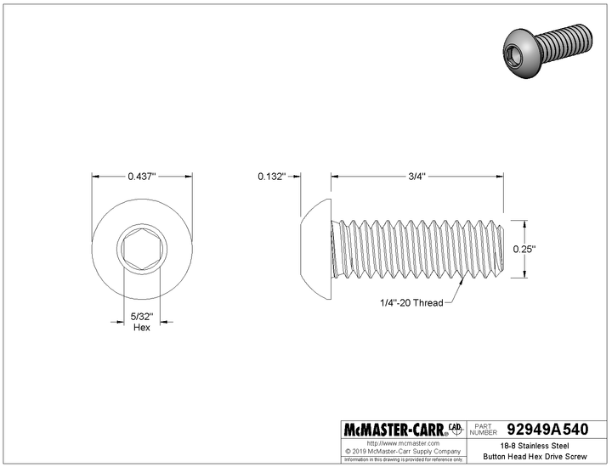
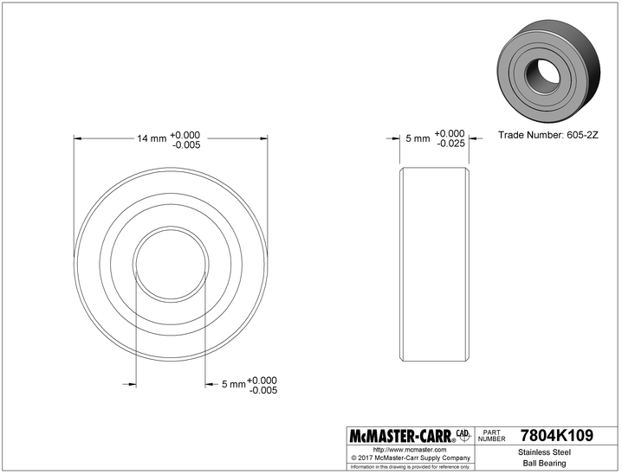
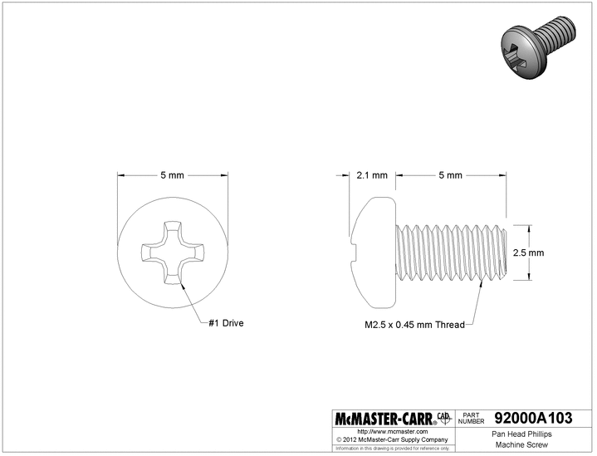
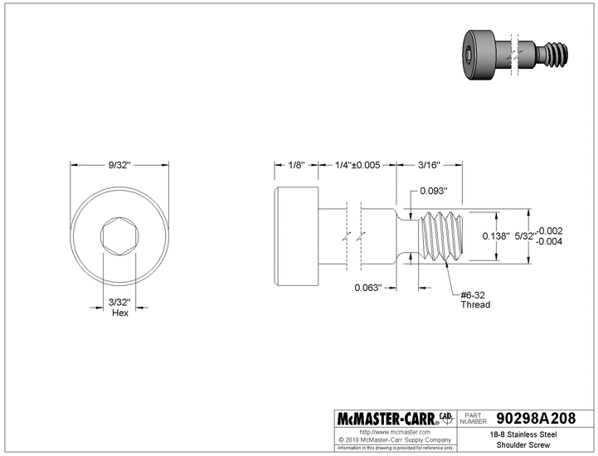

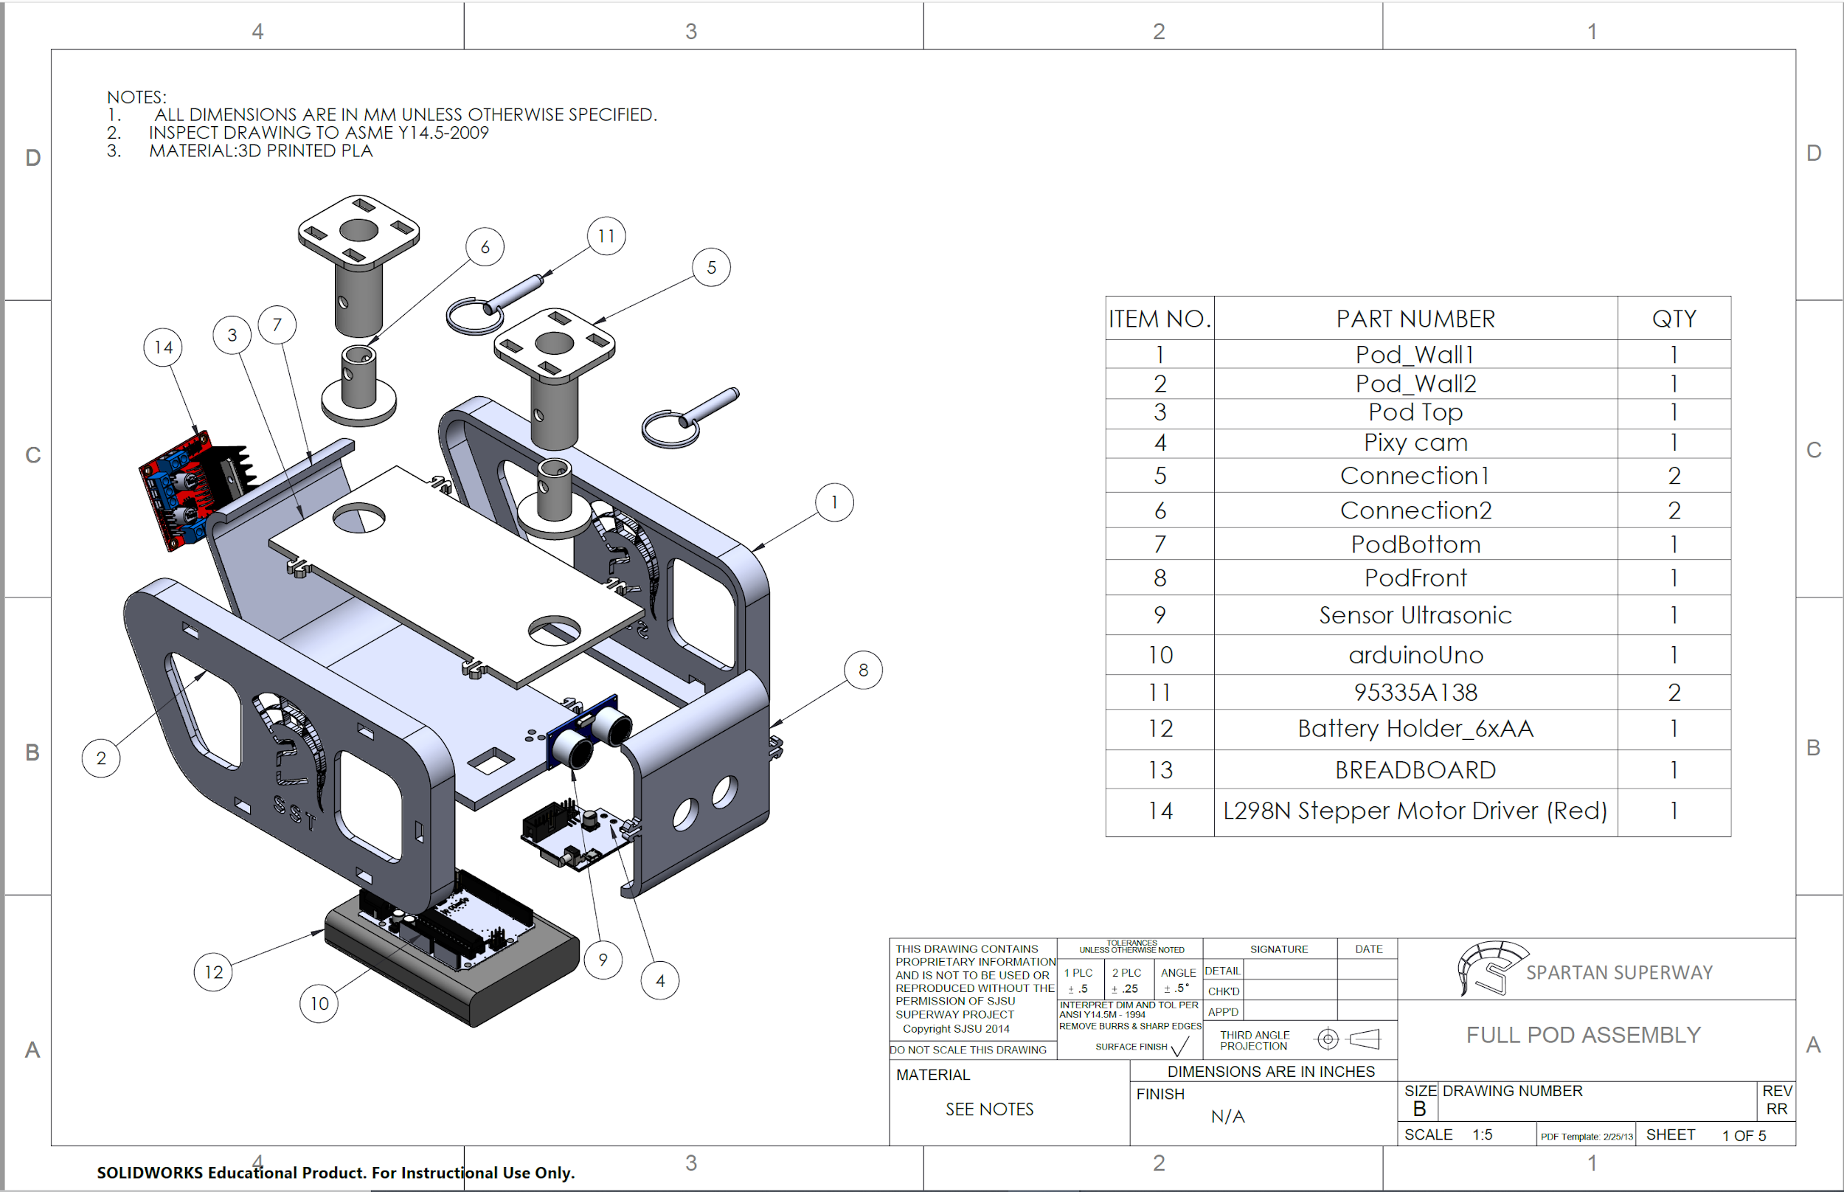
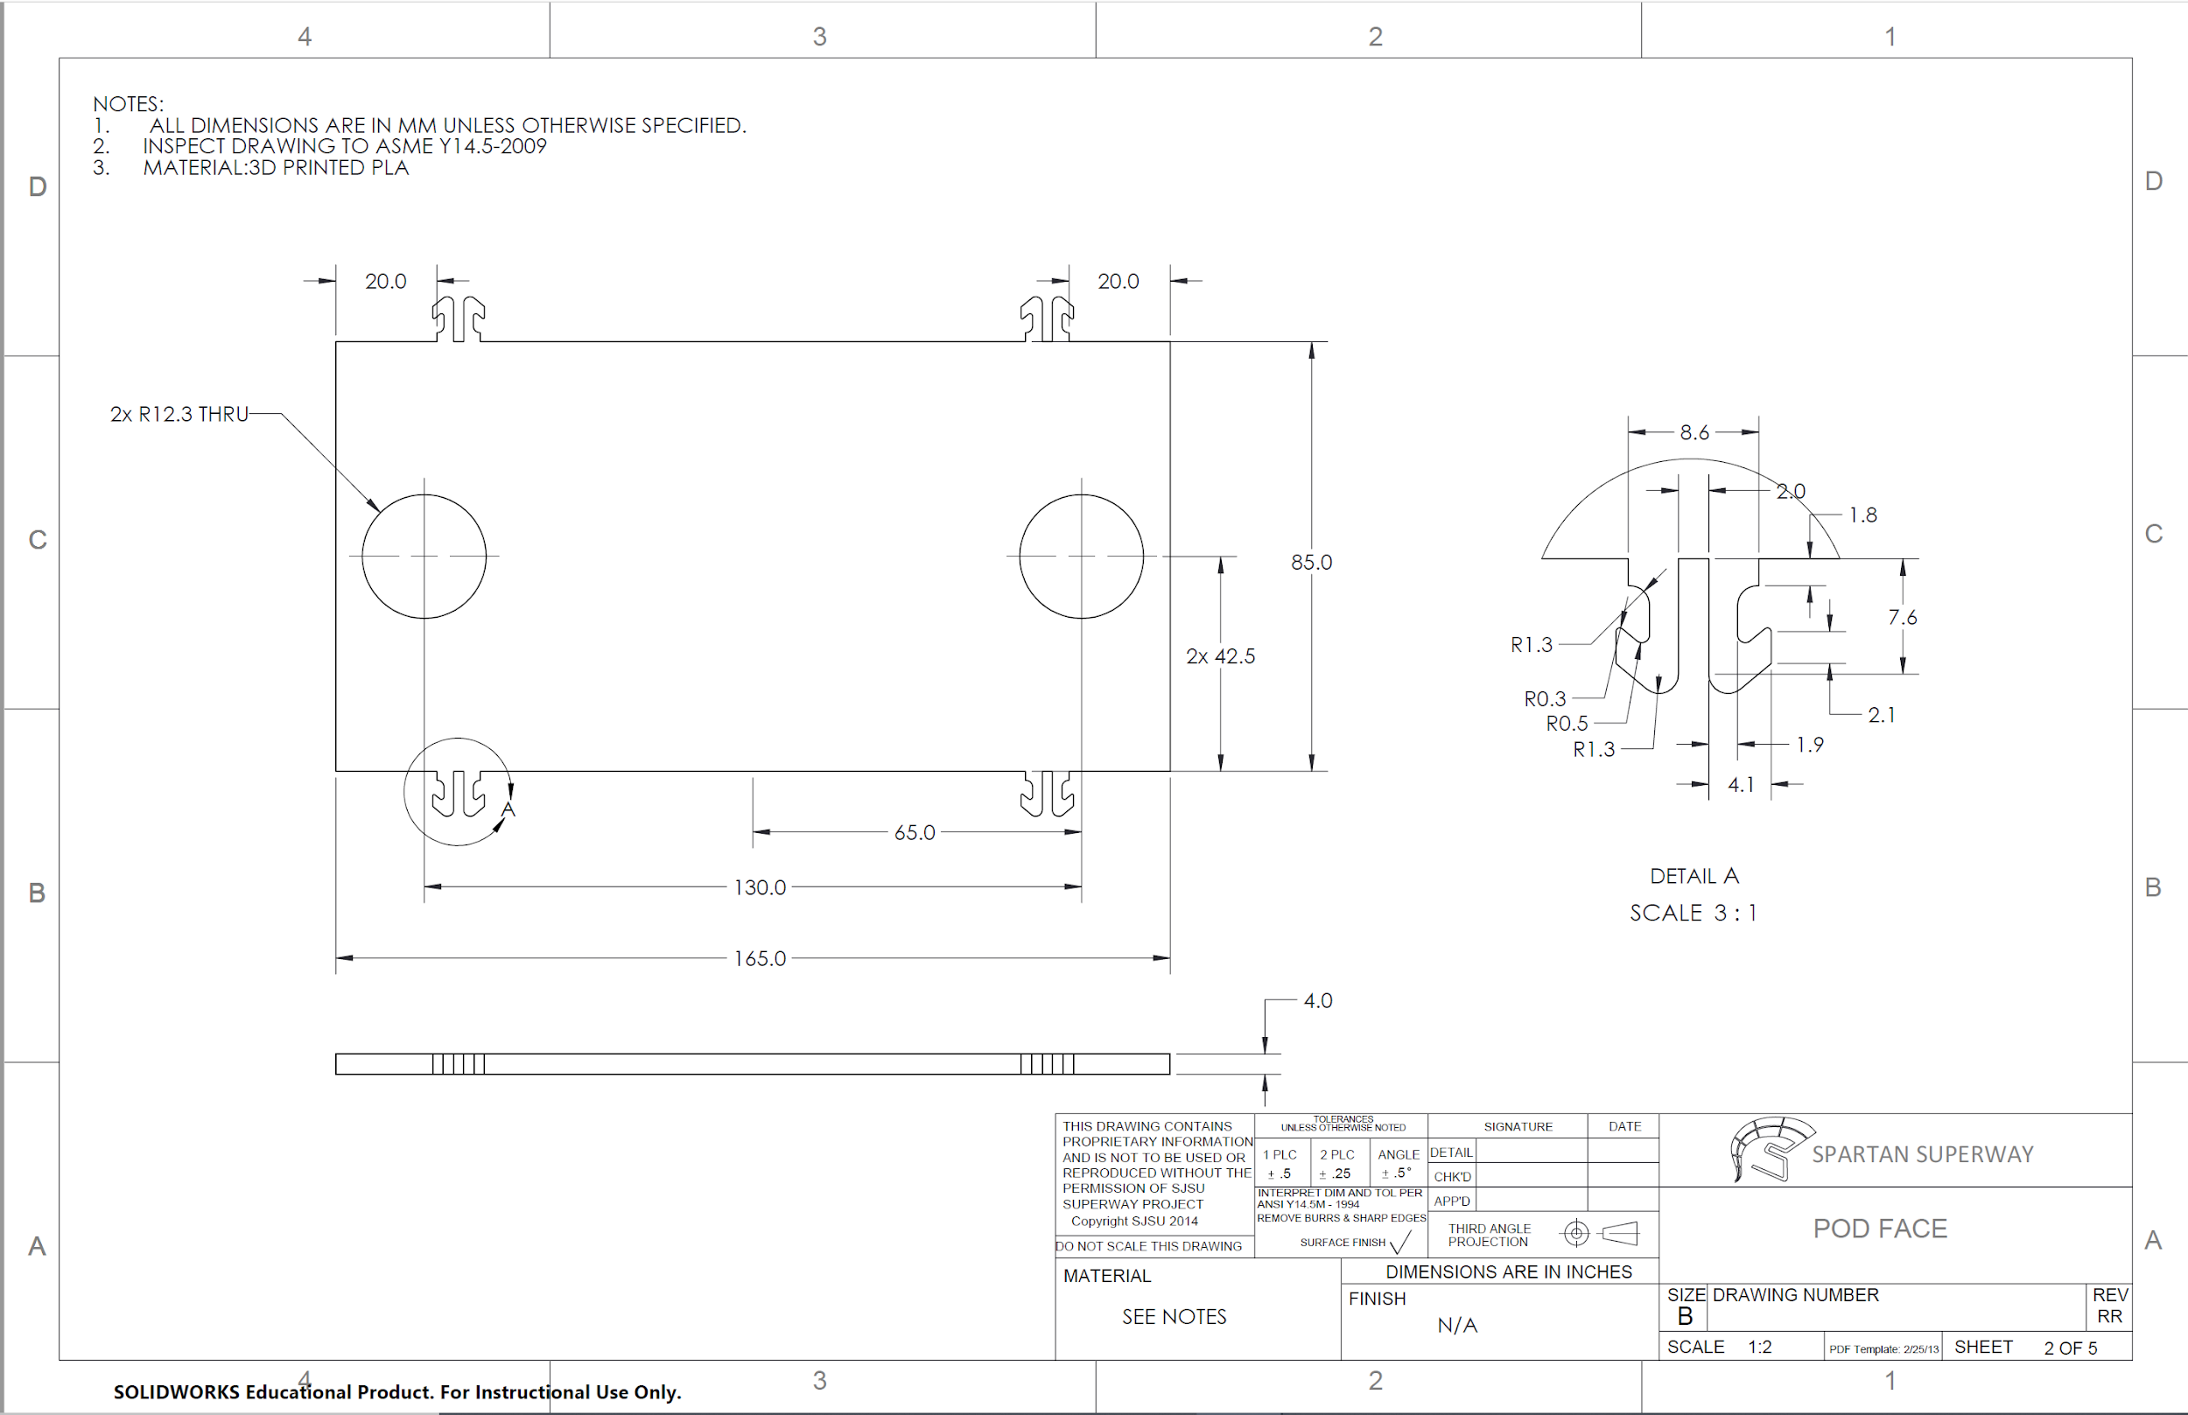
Appendix F: Pod Assembly Drawing
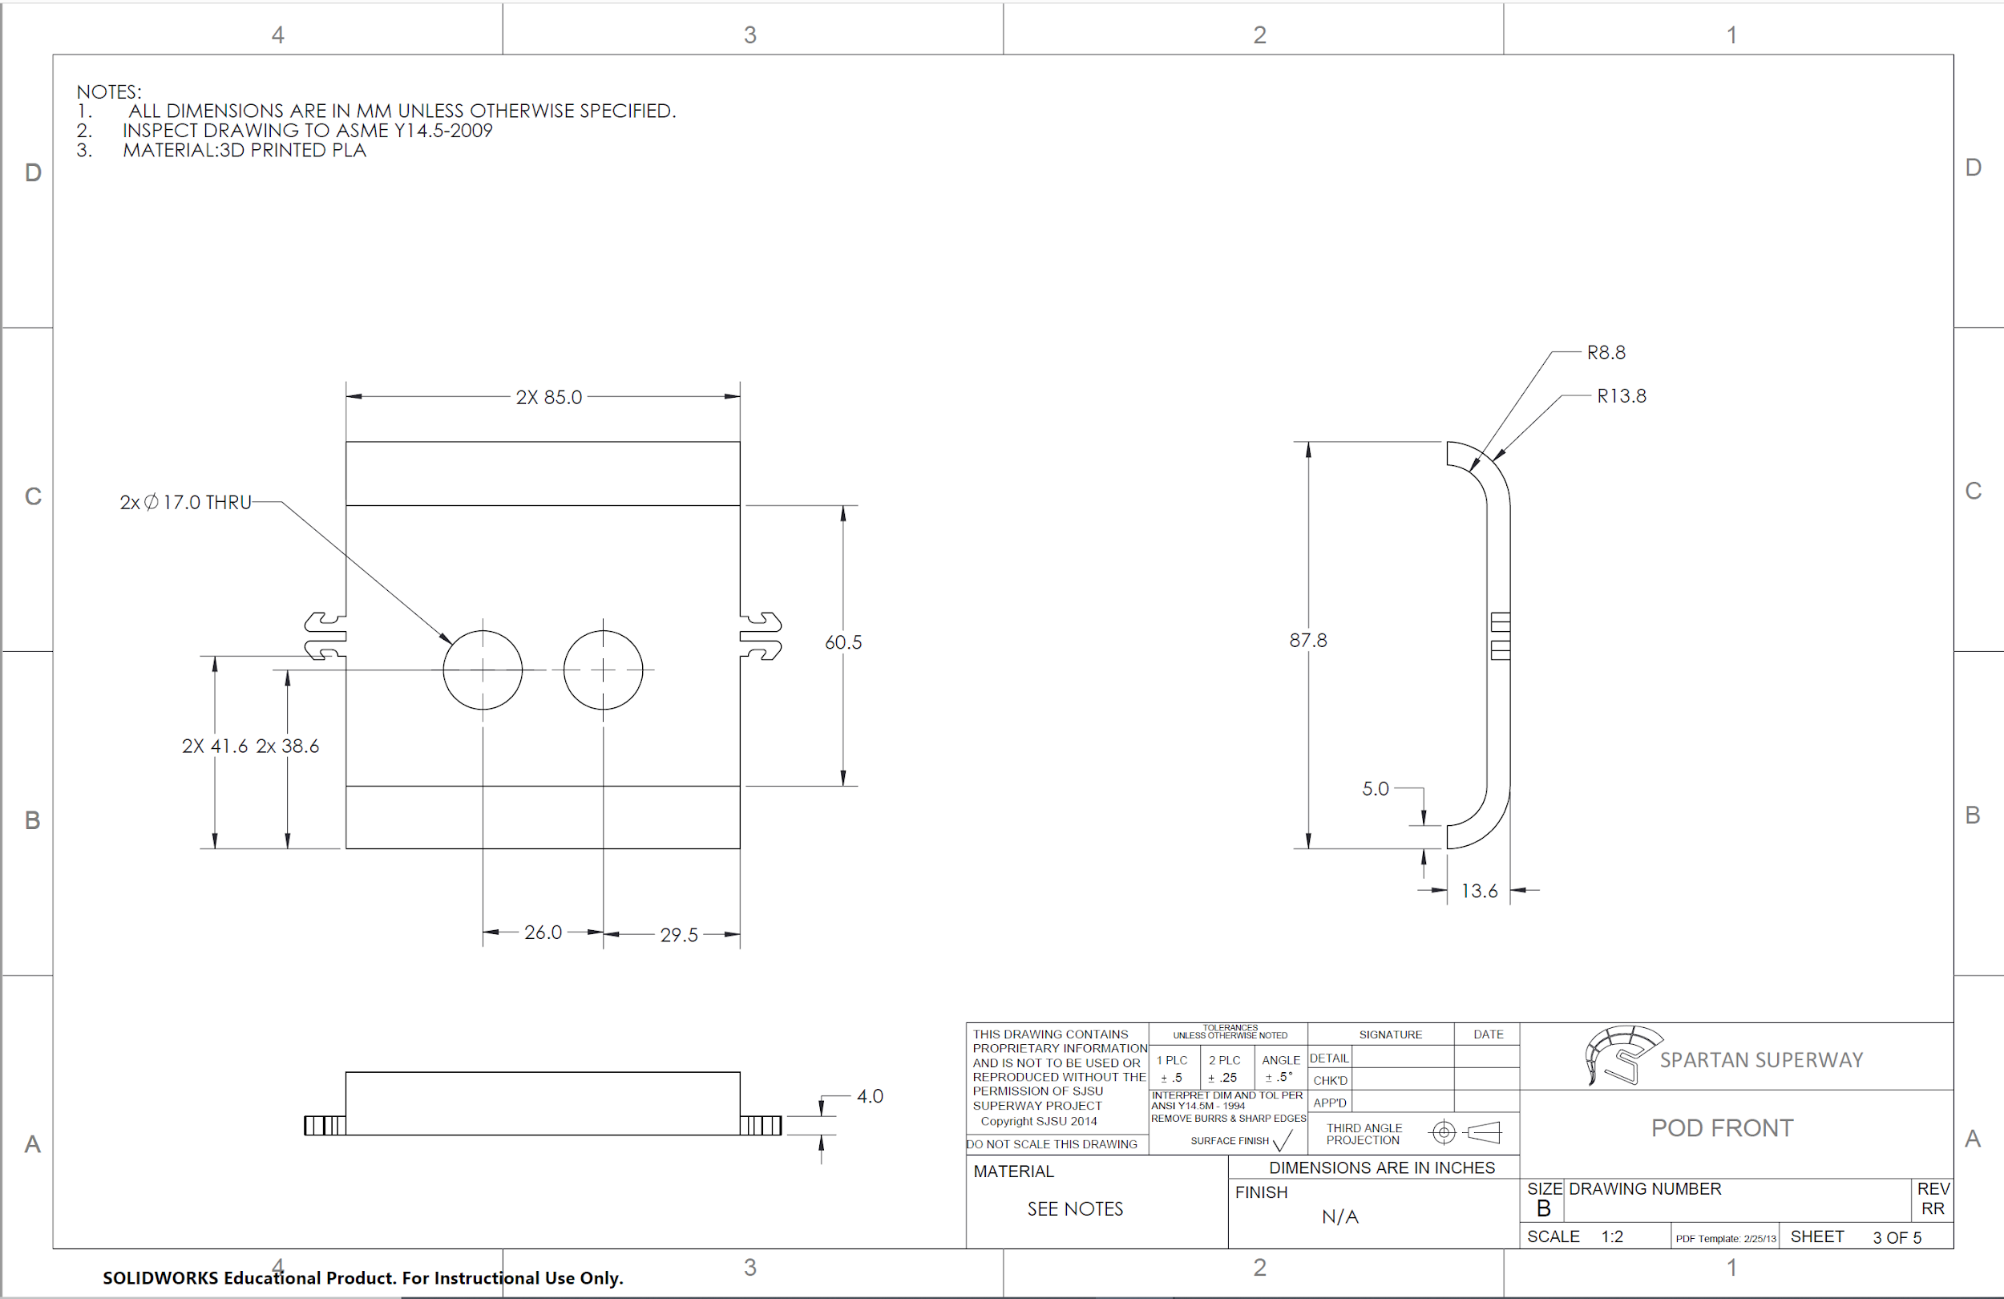
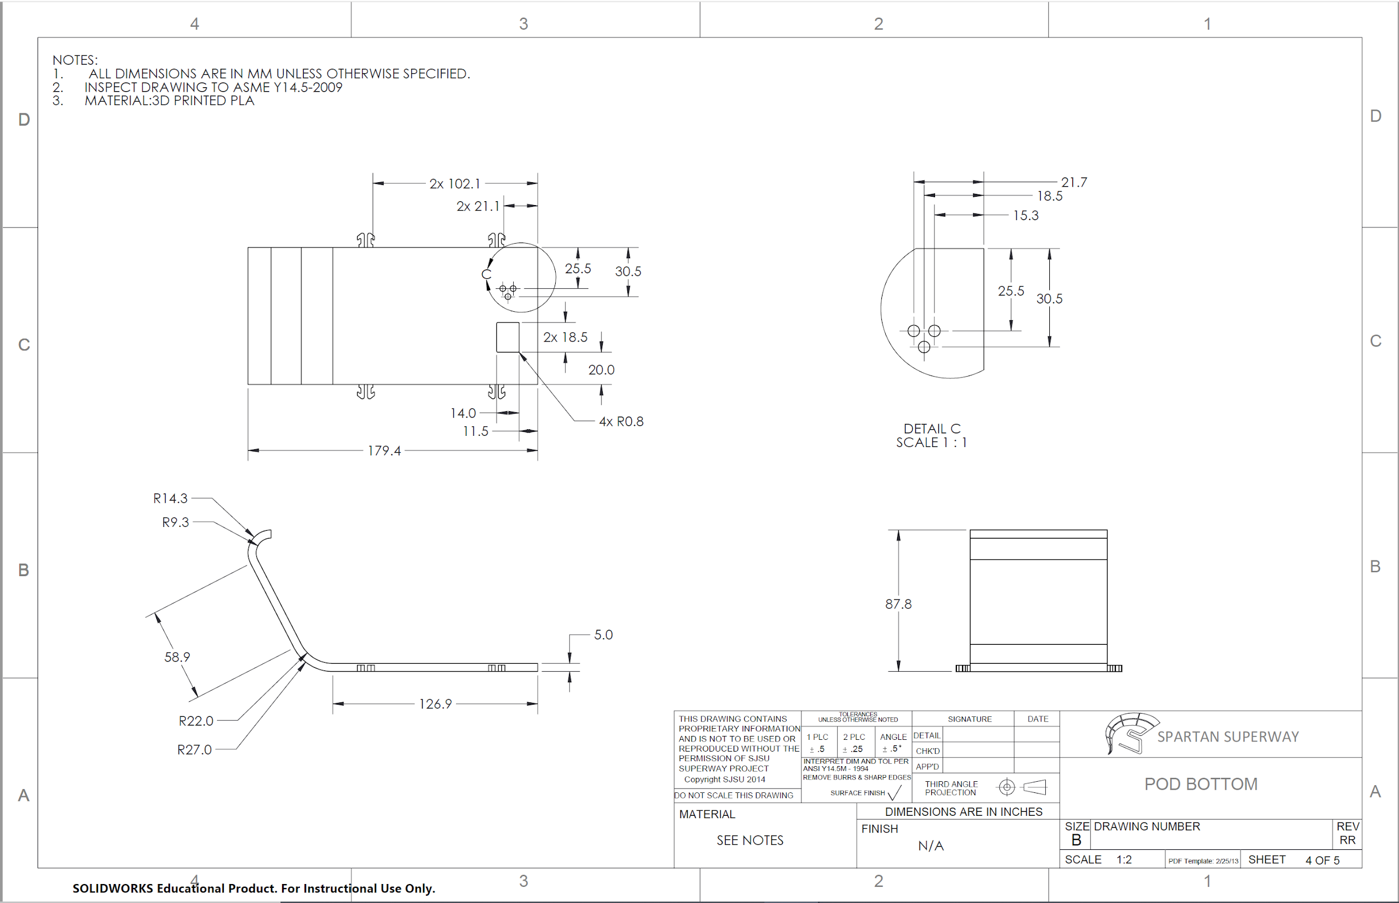
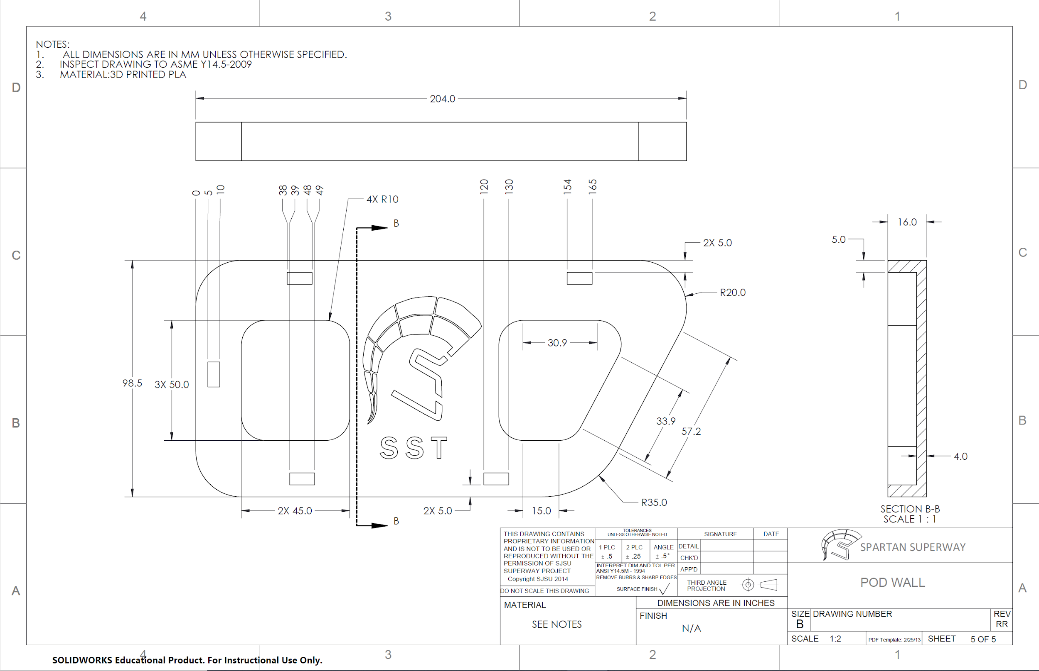

Appendix G: Bogie Assembly Drawing
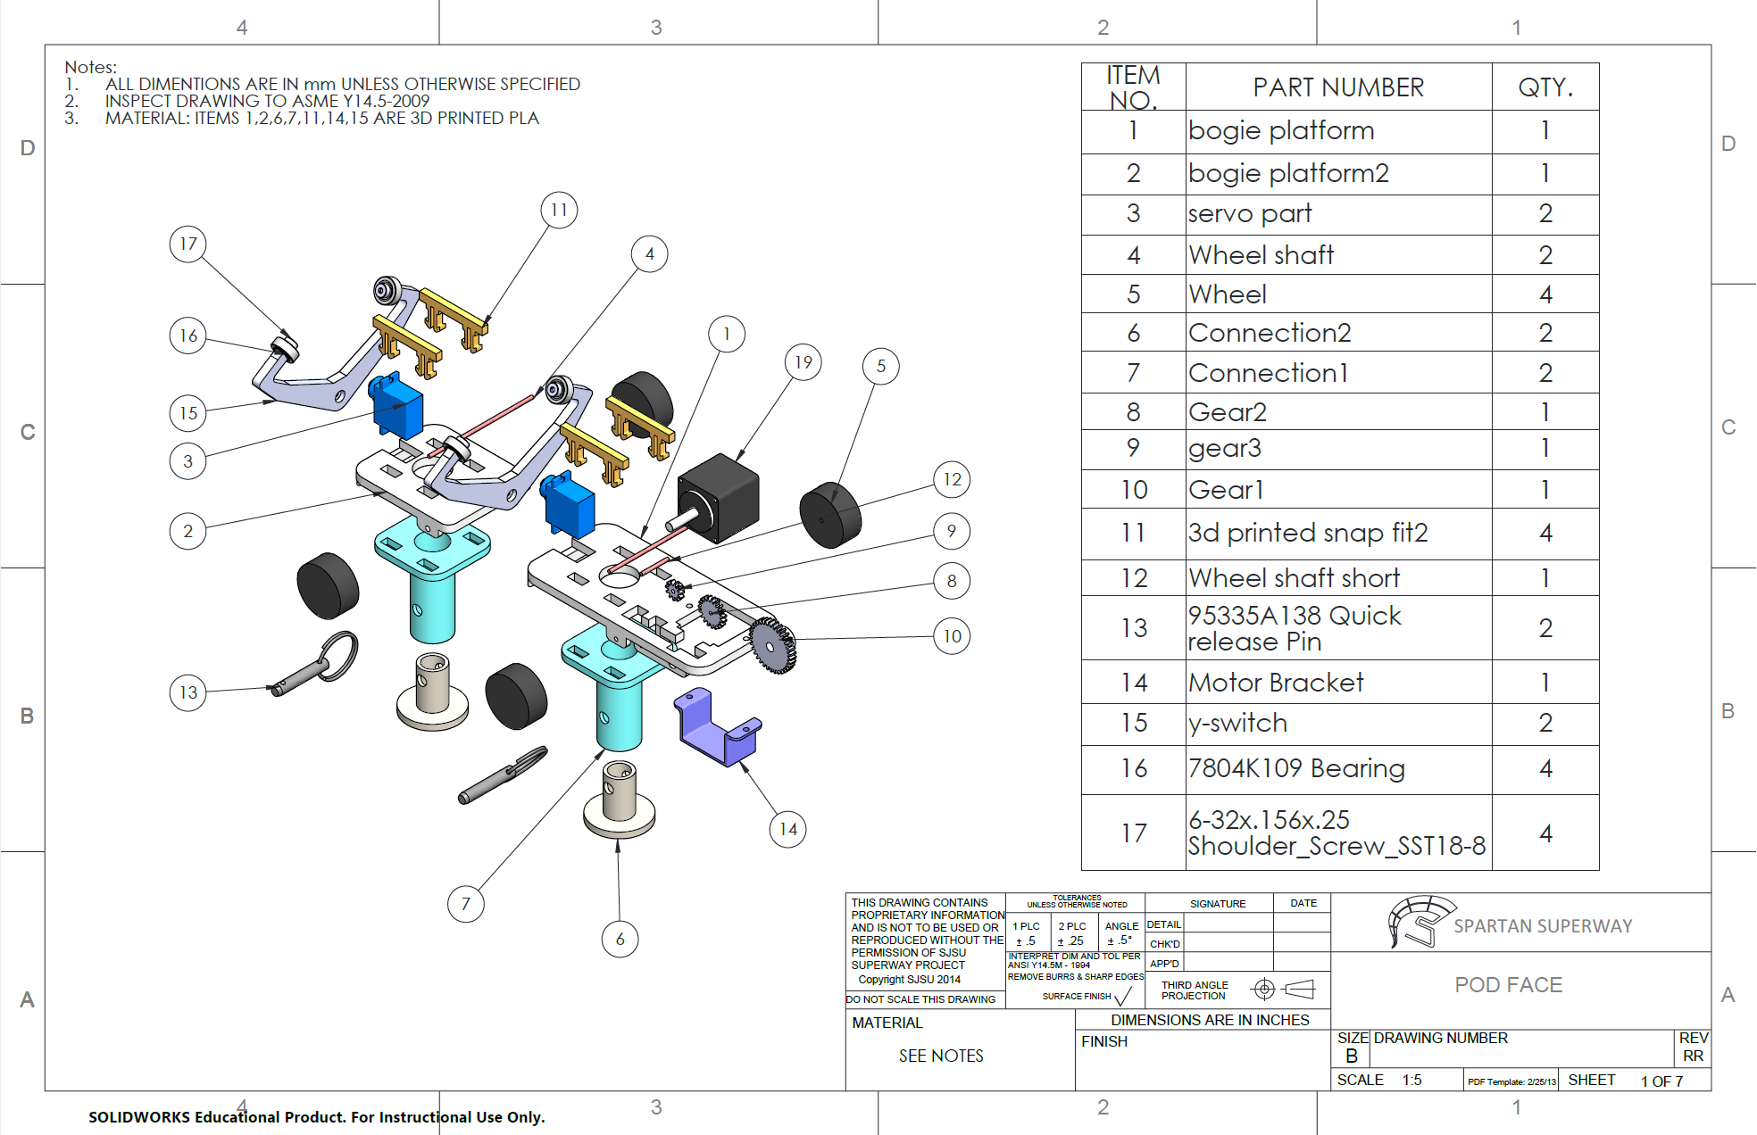
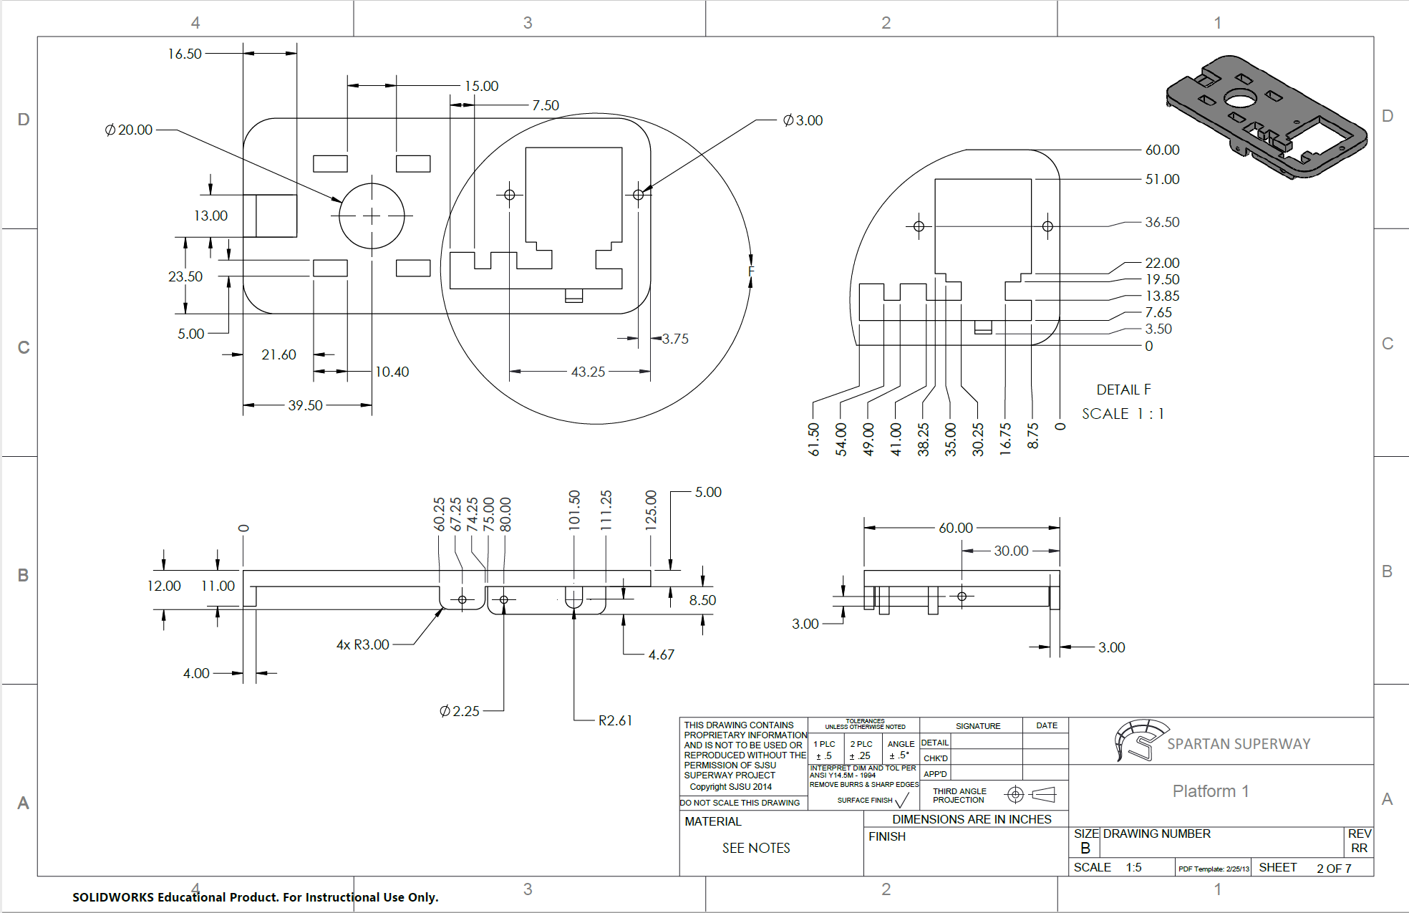
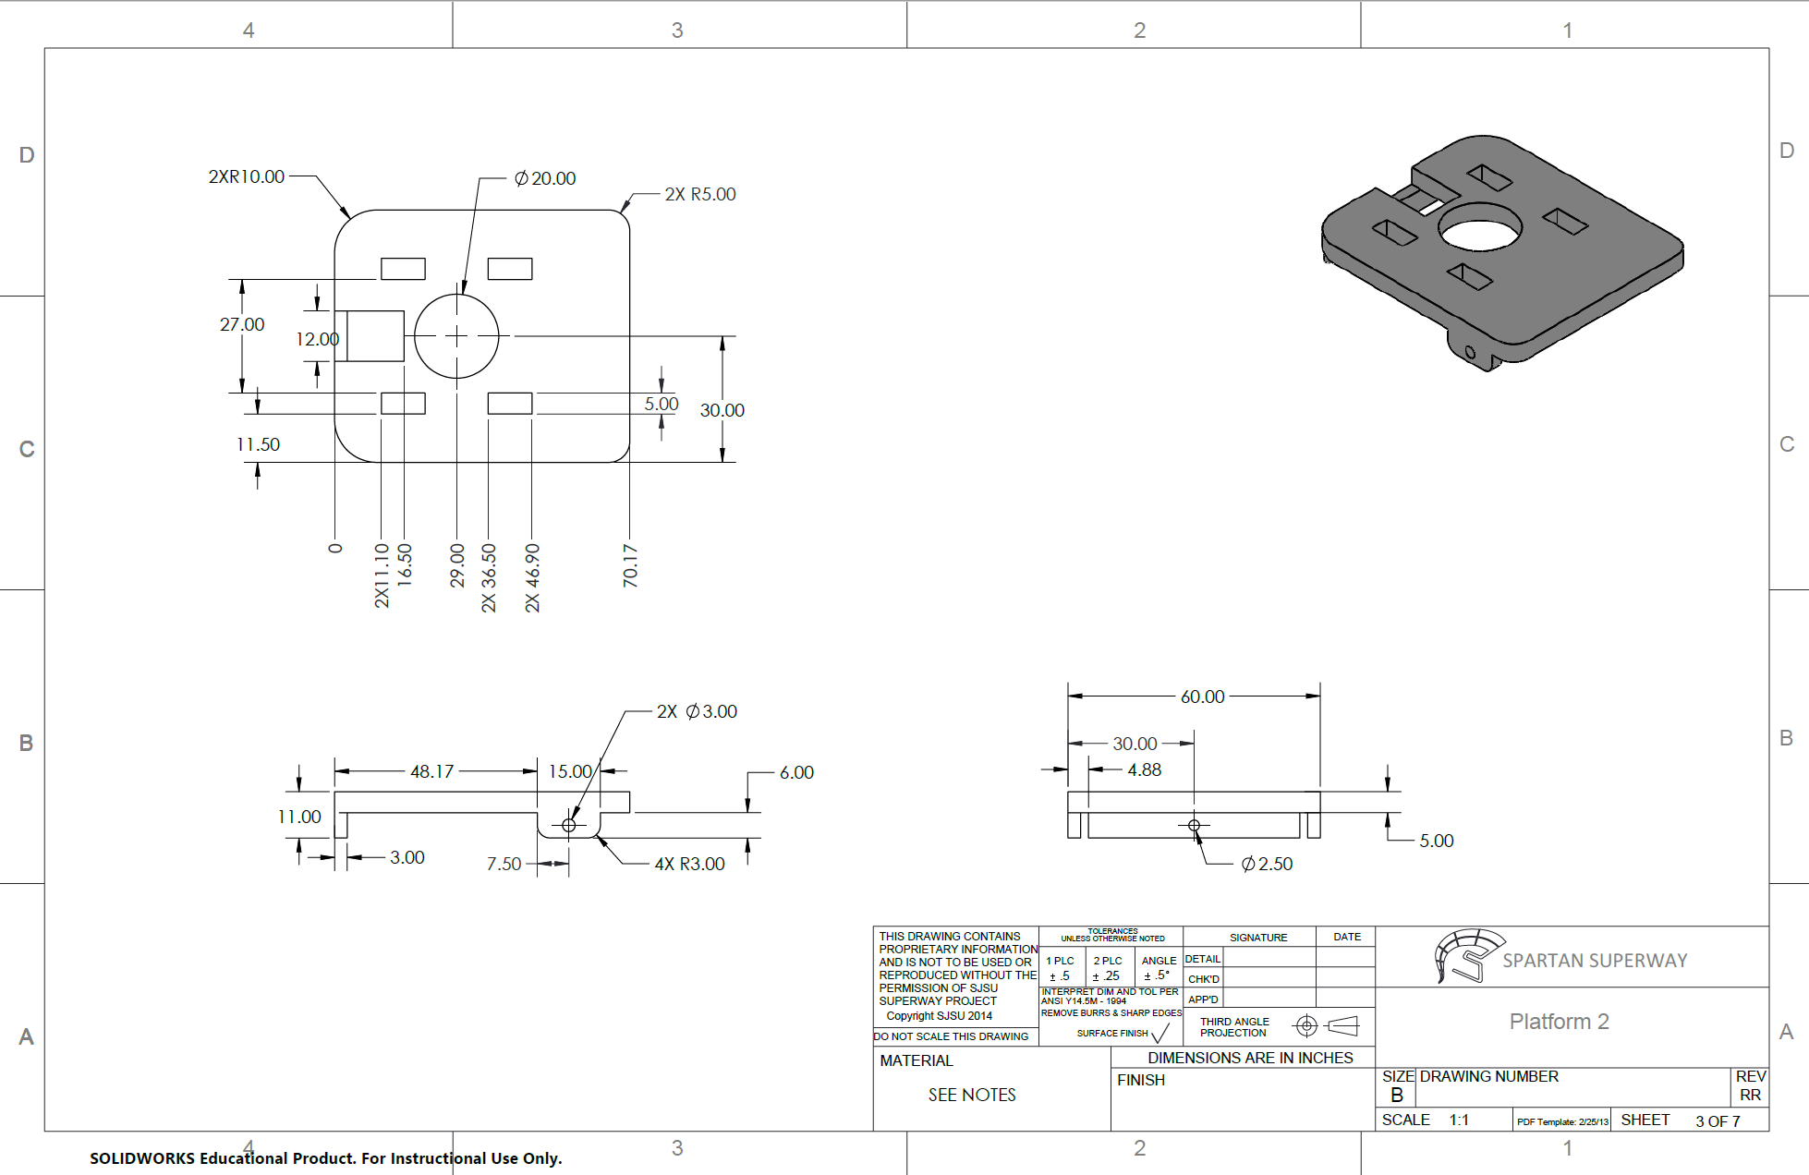
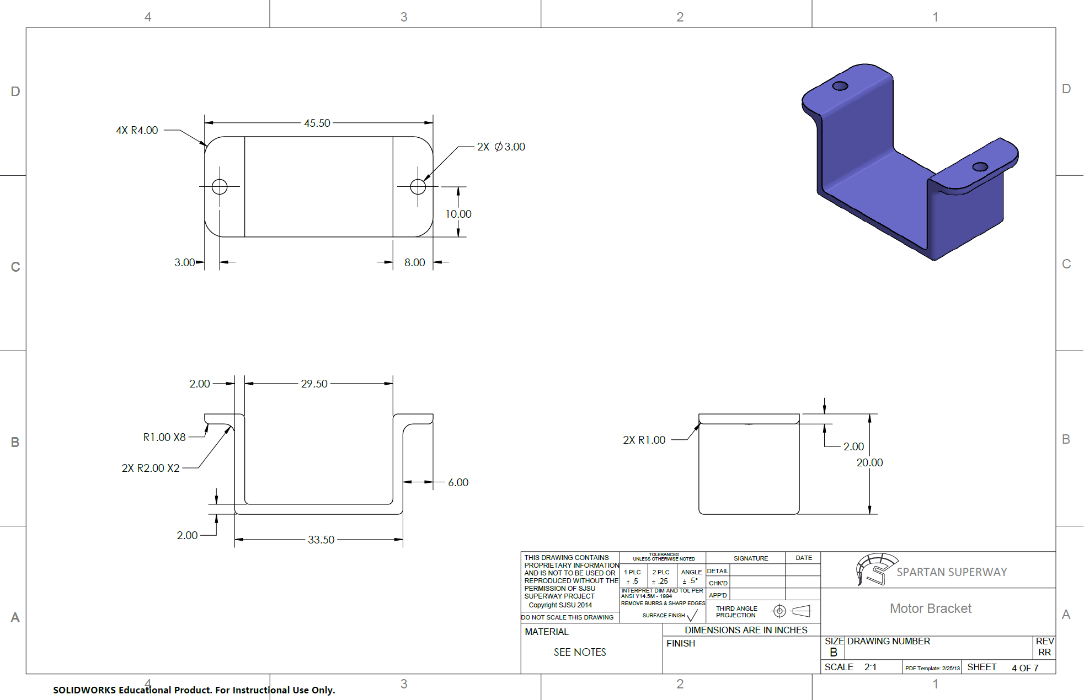
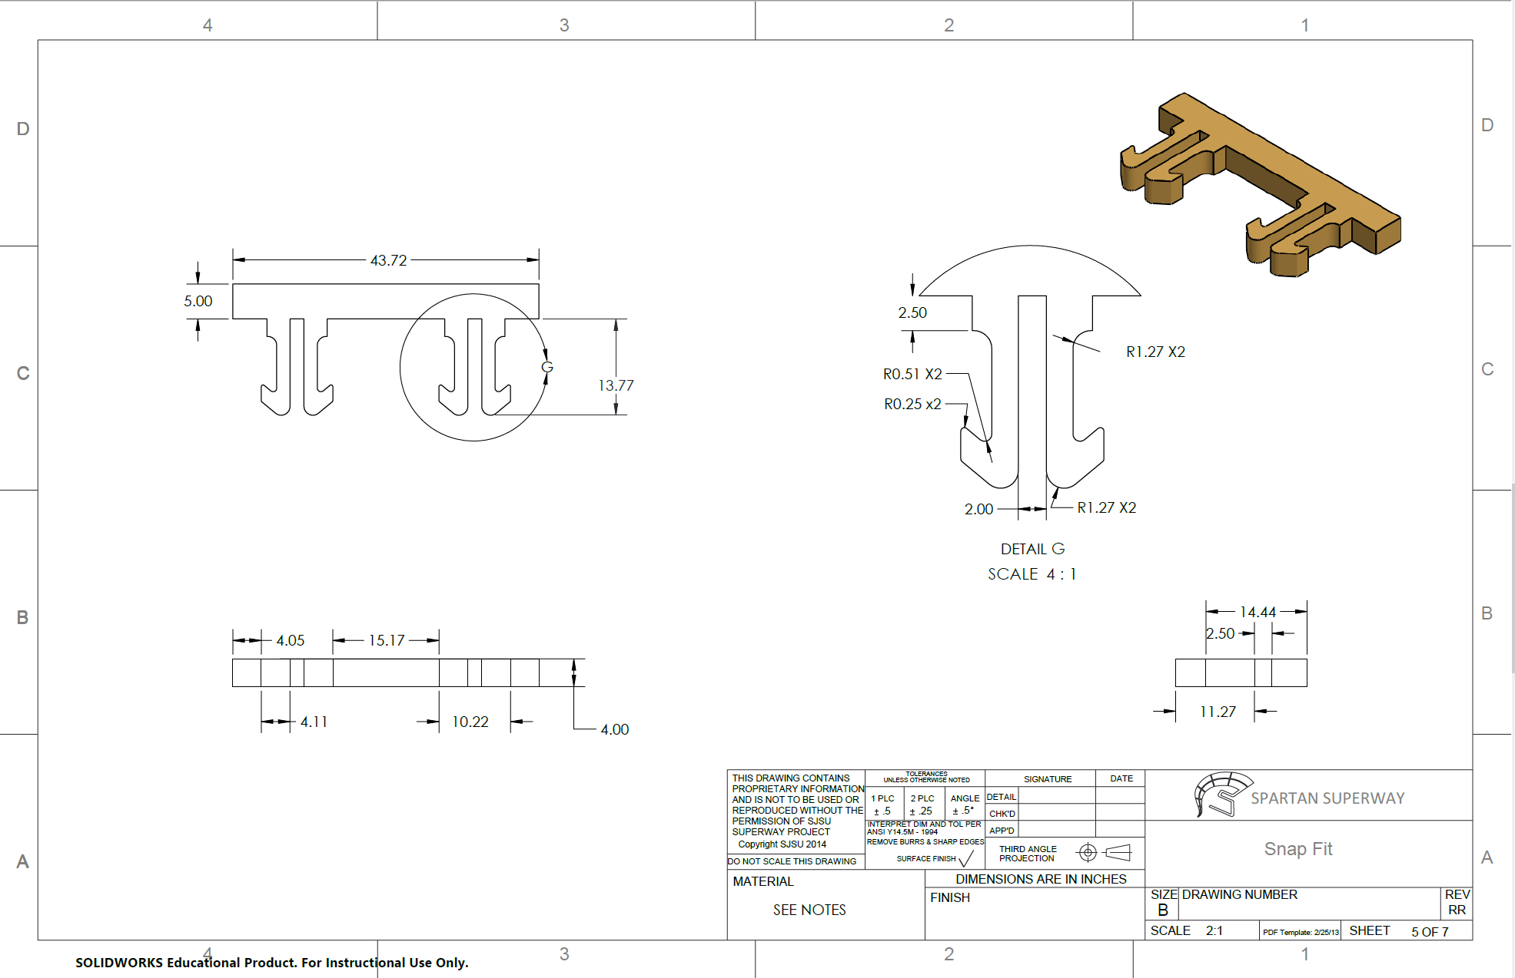
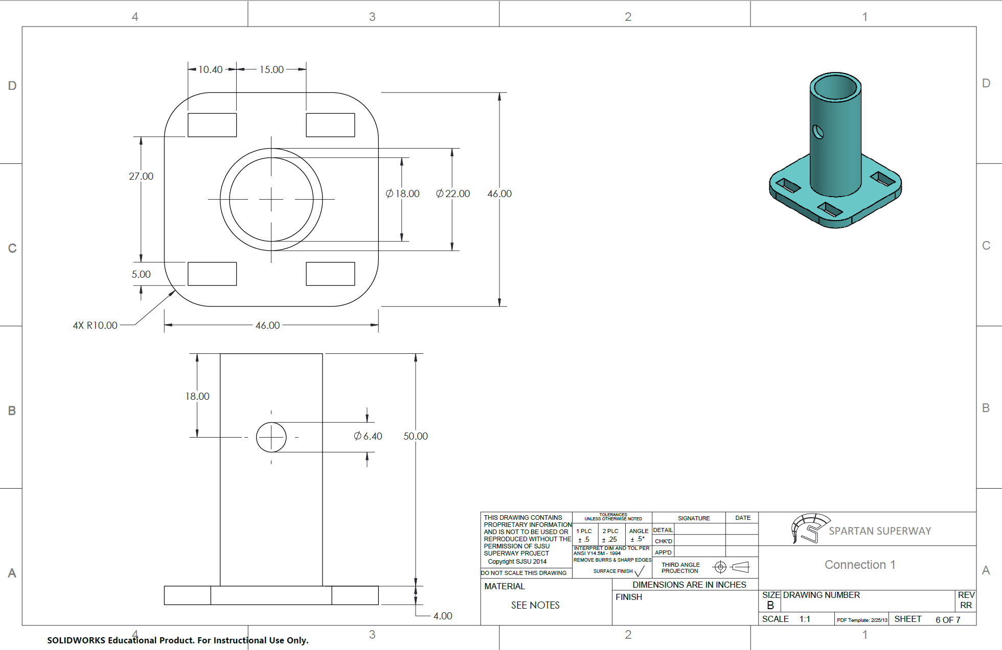
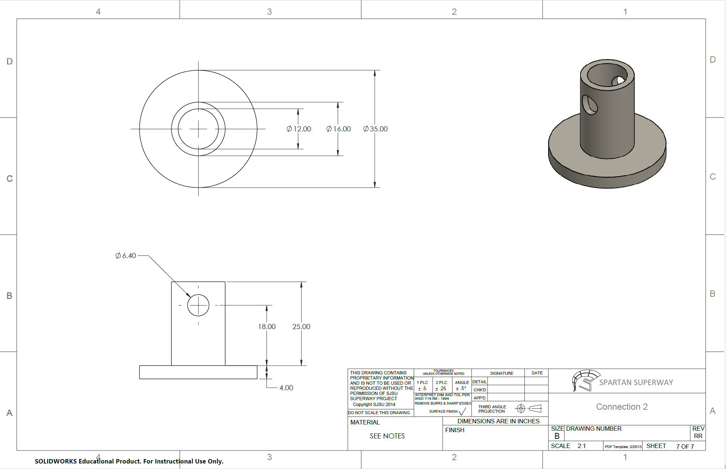

Appendix H: BOM Cost for Pod/Bogie
Description | Supplier | Link | Quantity per Pod | Purchased/ Manufactured | COST
HM-10 Bluetooth | Amazon | Link | 1 | Y | $11
Stepper Motor 28mm Body | Amazon | Link | 1 | Y | $18.50
Motor Driver boards | Amazon | Link | 1 | Y | $10
Arduino Uno | SSC |  | 1 | Y | $0
Battery Holder for 9V |  |  | 1 | N | -
Pixy2 Cam | Amazon | Link | 1 | Y | $65
Ultrasonic | SSC |  | 1 | Y | $0
Pod Wall right |  |  | 1 | Y | $0
Pod Wall left |  |  | 1 | Y | $0
Pod Bottom |  |  | 1 | Y | $0
Pod front |  |  | 1 | Y | $0
Pod Top |  |  | 1 | Y | $0
Bottom Connection |  |  | 2 | Y | $0
Top Connection |  |  | 2 | Y | $0
Quick release pins | AliExpress | link | 2 | Y | $5.45
 |  |  |  |  | $110 | Total

Appendix I: Setting Up Xcode
Designing an app from scratch presents many great challenges and opportunities. As stated earlier in the iOS app prime design section, the software used to develop the different iterations of the SPARTAN Superway app is Xcode. The programming language which Xcode utilizes is called Swift. Apple claims that Swift was designed to be anyone's first language and that it can easily be learned. A lot of the language is based on objective C and C++. Having experience with either of these languages allows the transition to using Swift much easier. However, like any language, there is a learning curve and it takes a lot of practice to become proficient. The versatile thing about Xcode is that it allows for an app to be developed using two different techniques, either SwiftUI which is mostly coding, or Storyboard, which is more of a visual approach. SwiftUI uses essentially every aspect of any other programming language, from integers, string character, functions, cases, and others. This provides an infinitely customizable experience in which every facet of a desired app can be manipulated meticulously. An example of what SwiftUI looks like from the coding, to the actual user interface on a device, can be seen in the following image:
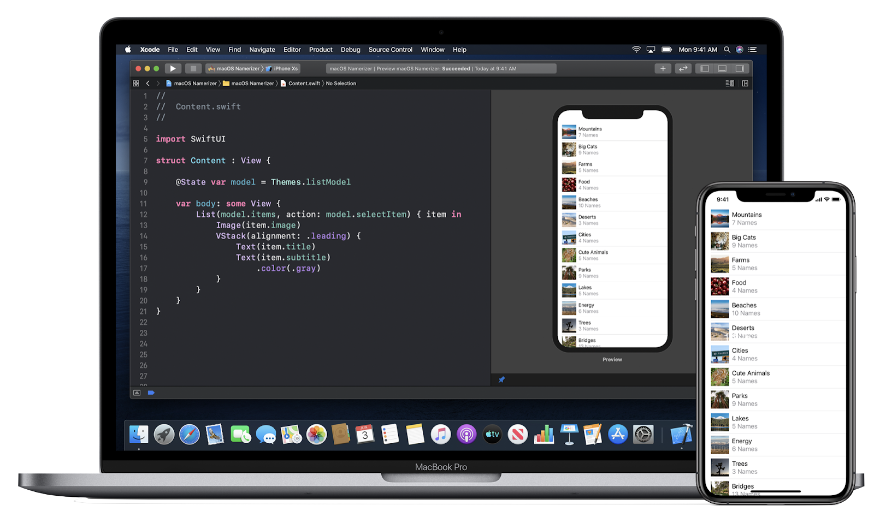
Image. SwiftUI on Xcode and output on desired device. (SwiftUI, n.d.)
The coding in Swift can be seen on the computer screen, along with a simulation of what the end result will look like on an actual device.
The other mentioned approach to building an app in Xcode is to use the Storyboard mode. Using the Storyboard mode, it allows for visual elements and controls to be added to a controller view, which is what the user will ultimately be seeing when using the app. In this mode, a very basic app can be built without writing a single line of code. All that has to be done is add labels, images, buttons, scrolling features, and other cosmetic features to the desired app views. In the development of the SPARTAN Superway iOS app, both approaches were utilized for two separate iterations. When first creating an app in Xcode, a prompt is presented which can be seen below in the image:
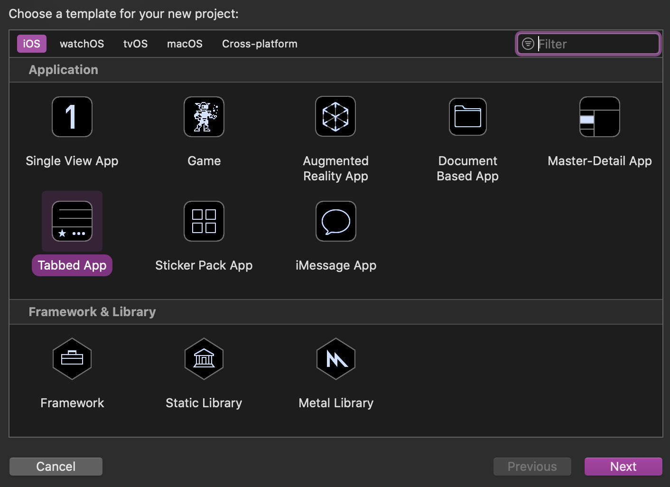
Image. Template options for a new app in Xcode.
In this prompt, several templates are given with regards to the type of app which the user wants to be structured as, this ranges from a single view app, to a game, and to a tabbed app. The latter option was selected for the first iteration of the app. The next prompt that is presented when setting up a new app project is the project settings. This options page can be seen below in the following image:
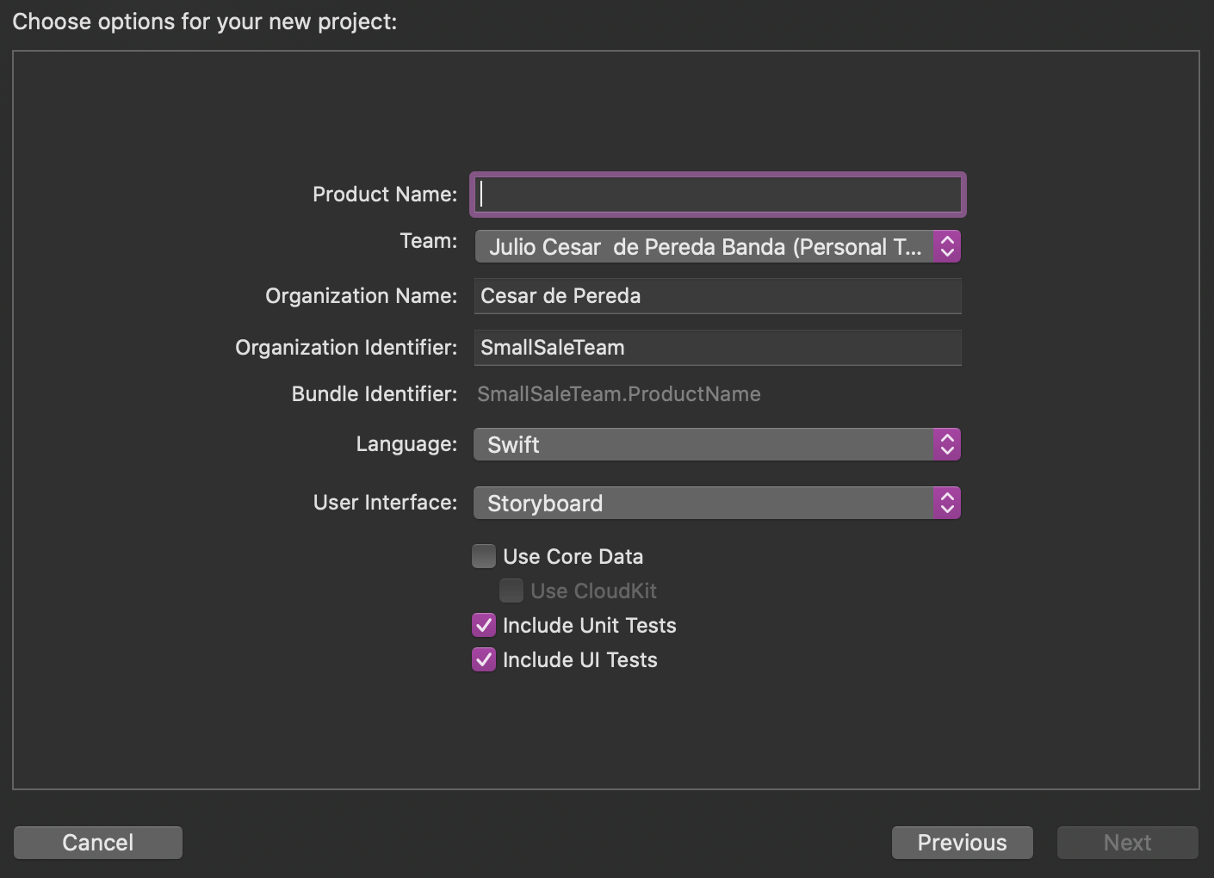
Image. Options page in Xcode
In this page, the name of the app, the team that is working on the app, the language (Swift or Objective C can be chosen), and the desired user interface can be chosen. What is of interest in this options page is choosing whether to use the Storyboard or SwiftUI. This will take the app in two different directions as discussed earlier. The first iteration of the app utilized the SwiftUI approach to build a very simple three tabbed app. Xcode allows for this code to be run and simulated on their simulator software called “Simulator”. Running the code prompts an option as to which Apple device to simulate the app on, this ranges from iPhones to iPads, etc. The other option is to connect a personal device and upload the app to that specific device to test the app.

Appendix J: Small-Scale Slider App Code to connect to BLE
//
// PeripheralConnection.swift
// ArduinoTest
//
// Created by Cesar de Pereda on 2/22/20.
// Copyright © 2020 Cesar de Pereda. All rights reserved.
// This first part is where you input the HM10 BLEs UUID so that the iPhone can search for the specific BLE once the code runs

import UIKit
import CoreBluetooth

class PeripheralConnection: NSObject {
// BLE peripheral UUID
public static let BLEUUID = CBUUID.init(string: "FFE0")
// BLE characteristic (allows to send and receive data) UUID
public static let BLECharactersiticUUID = CBUUID.init(string:"FFE1")
}

// ViewController.swift
// ArduinoTest
//

// Created by Cesar de Pereda on 11/13/19.
// Copyright © 2019 Cesar de Pereda. All rights reserved.
//

import UIKit
import CoreBluetooth

class ViewController: UIViewController, CBPeripheralDelegate, CBCentralManagerDelegate {

//Outlet for sliders (interfaces slider from Storyboard to code)
@IBOutlet weak var LEDSlider: UISlider!

//Charactersitcs
private var LEDChar: CBCharacteristic?

//Properties
private var centralManager: CBCentralManager!
private var peripheral: CBPeripheral!

override func viewDidLoad() {
super.viewDidLoad()
print("View loaded")
centralManager = CBCentralManager(delegate: self, queue: nil) //Establish iPhone as central device
}

//Checks to make sure iPhone is turned on and ready to search for peripherals
func centralManagerDidUpdateState(_ central: CBCentralManager){
print("Central State Update")
if central.state != .poweredOn{
print("Central is not powered ")
}
//Central device begins scanning for peripheral device, i.e. the HM10 BLE module
else {
print("Central scanning for",
PeripheralConnection.BLEUUID); centralManager.scanForPeripherals(withServices: [PeripheralConnection.BLEUUID], options: [CBCentralManagerScanOptionAllowDuplicatesKey: true])

}
}

// If the iPhone finds the BLE, it can stop searching
func centralManager(_ central: CBCentralManager, didDiscover peripheral: CBPeripheral, advertisementData: [String: Any], rssi RSSI: NSNumber){

self.centralManager.stopScan()

self.peripheral = peripheral
self.peripheral.delegate = self

self.centralManager.connect(self.peripheral, options: nil)

}

// Ensures that iPhone is indeed connected to BLE
func centralManager(_ central: CBCentralManager, didConnect peripheral: CBPeripheral){
if peripheral == self.peripheral{
print("Connected to your Pod's BLE")
peripheral.discoverServices([PeripheralConnection.BLEUUID])
}
}

func peripheral (_ peripheral: CBPeripheral, didDiscoverServices error: Error?) {
if let services = peripheral.services{
for service in services {
if service.uuid == PeripheralConnection.BLEUUID{
print("BLE Service found")

// referencing BLE peripheral characteristic UUID peripheral.discoverCharacteristics([PeripheralConnection.BLECharactersiticUUID], for: service)
return
}
}
}
}

func peripheral(_ peripheral: CBPeripheral, didDiscoverCharacteristicsFor service: CBService, error: Error?){
if let characteristic = service.characteristics {
for characteristic in characteristic {
if characteristic.uuid == PeripheralConnection.BLECharactersiticUUID {
print("BLE is connected")
LEDChar = characteristic
LEDSlider.isEnabled = true

}
}

}
}

// function that allows the iPhone to write to the BLE
private func writeLEDValueToChar( withCharacteristic characteristic: CBCharacteristic, withValue value: Data) {

// Check if it has the write property
if characteristic.properties.contains(.writeWithoutResponse) && peripheral != nil {

peripheral.writeValue(value, for: characteristic, type: .withoutResponse)

}

}

// references the Slider UI element and assigns the values to be sent to the BLE as 8 bit unsigned integers based on the position of the slider.
@IBAction func LEDsliderChange(_ sender: Any) {
print("LED:",LEDSlider.value);
let slider:UInt8 = UInt8(LEDSlider.value)
writeLEDValueToChar(withCharacteristic: LEDChar!, withValue: Data([slider]))
}
}

Guide with Xcode/Swift/BLE Info to set up the app(s):
https://docs.google.com/document/d/1hw0iYxlgpXbFHtLLYYX7Kg5WyRPPJvf1sHab4klMQ54/edit

YouTube Videos of Main iOS App and Slider App in Action
Main Small-Scale App In Action
Slider App demonstration with LED

Appendix K: Anti-collision System

#include <Stepper.h>

const int stepsPerRevolution = 200; //RPM
Stepper myStepper(stepsPerRevolution, 4, 5, 6, 7);

const int trigPin = 9;
const int echoPin = 8;

long duration;
int distance;

void setup() {
pinMode(trigPin, OUTPUT); // Sets the trigPin as an Output
pinMode(echoPin, INPUT); // Sets the echoPin as an Input
myStepper.setSpeed(100);
Serial.begin(9600); // Starts the serial communication
}

void loop() {

// Clears the trigPin
digitalWrite(trigPin, LOW);
delayMicroseconds(2);
// Sets the trigPin on HIGH state for 10 micro seconds
digitalWrite(trigPin, HIGH);
delayMicroseconds(10);
digitalWrite(trigPin, LOW);
// Reads the echoPin, returns the sound wave travel time in microseconds
duration = pulseIn(echoPin, HIGH);
// Calculating the distance
distance = duration * 0.034 / 2;

if (distance > 25) //safe distance of 15cm

{
myStepper.setSpeed(160);
myStepper.step(stepsPerRevolution);
Serial.print(distance);
Serial.println(" >25");

}
else if ( distance <= 25 && distance > 15) // slow speed distance between 15cm and 3cm
{
myStepper.setSpeed(35);
myStepper.step(stepsPerRevolution);
Serial.print(distance);
Serial.println(" <25");
}
else if ( distance <= 15 && distance > 3) // slow speed distance between 15cm and 3cm
{
myStepper.setSpeed(15);
myStepper.step(stepsPerRevolution);
Serial.print(distance);
Serial.println(" <15");
}

else //collision distance of 3cm, motor stops
{
myStepper.step(0);
myStepper.step(0);
Serial.print(distance);
Serial.println(" < 3");
delay(100);
}
}

Appendix L: BLE Test with LED
#include <SoftwareSerial.h>
#define LED_PIN 2
int BT_input;
SoftwareSerial mySerial(10, 11); // RX, TX

void setup() {
Serial.begin(9600);
// If the baudrate of the HM-10 module has been updated,
// you may need to change 9600 by another value
// Once you have found the correct baud rate,
// you can update it using AT+BAUDx command
// e.g. AT+BAUD0 for 9600 bauds
mySerial.begin(9600);
pinMode(LED_PIN, OUTPUT);
}

void loop() {

if (mySerial.available()) {
BT_input = mySerial.read();

if (BT_input== 49) //1 in ASCII from char to dec
{
// Non-zero input means "turn on LED".
Serial.println("Got input:");
Serial.println(" on");
digitalWrite(LED_PIN, HIGH);
}
if (BT_input== 48) //0 in ASCII from char to dec
{
// Input value zero means "turn off LED".
Serial.println("Got input:");
Serial.println(" off");
digitalWrite(LED_PIN, LOW);
}
}
}

Appendix M: BLE Test with Anti-collision System
#include <Stepper.h>
#include <SoftwareSerial.h>

int BT_input; // BLE input variable

const int stepsPerRevolution = 200; //stepper motor

Stepper myStepper(stepsPerRevolution, 4, 5, 6, 7); // stepper motor pins
SoftwareSerial mySerial(10, 11); // BLE pins RX, TX

const int trigPin = 9; // ultrasonic
const int echoPin = 8; // ultrasonic

// defines variables for ultrasonic
long duration;
int distance;

void setup() { // Clears the trigPin
pinMode(trigPin, OUTPUT); // Sets the trigPin as an Output
pinMode(echoPin, INPUT); // Sets the echoPin as an Input

myStepper.setSpeed(100); // reset motor speed
Serial.begin(9600);
mySerial.begin(9600); //BLE serial
}

void loop()
{
if (mySerial.available()) // send data only when data is received
{
BT_input = mySerial.read(); // read the incoming byte from BLE

while (BT_input == 49) //1 in ASCII from char to dec
{
Serial.print("Got input:");
Serial.println(BT_input);
CheckDistance(); //read ultrasonic and run motor
Serial.println("motor on");
}
while (BT_input == 48) //0 in ASCII from char to dec
{
Serial.print("Got input:");
Serial.println(BT_input);
myStepper.step(0); //turn motor off
myStepper.setSpeed(0);
Serial.println("motor on");
}
}
}
void CheckDistance() // check distance and slowing down
{
digitalWrite(trigPin, LOW); // Clears the trigPin
delayMicroseconds(2);
// Sets the trigPin on HIGH state for 10 micro seconds
digitalWrite(trigPin, HIGH);
delayMicroseconds(10);
digitalWrite(trigPin, LOW);

duration = pulseIn(echoPin, HIGH);
distance = duration * 0.034 / 2; // Calculating the distance

if (distance > 25) //safe distance of 25cm
{
myStepper.setSpeed(160);
myStepper.step(stepsPerRevolution);
Serial.print(distance);
Serial.println(" >25");
}
else if ( distance <= 25 && distance > 15)
// slow speed distance between 25cm and 15cm
{
myStepper.setSpeed(35);
myStepper.step(stepsPerRevolution);
Serial.print(distance);
Serial.println(" <25");
}
else if ( distance <= 15 && distance > 3)
// slow speed distance between 15cm and 3cm
{
myStepper.setSpeed(15);
myStepper.step(stepsPerRevolution);
Serial.print(distance);
Serial.println(" <15");
}
if (distance <= 3) //collision distance of 3cm, motor stops
{
myStepper.step(0);
myStepper.setSpeed(0);
Serial.print(distance);
Serial.println(" < 3");
}
}

Appendix N: Line_Hello_World
//
// begin license header
//
// This file is part of Pixy CMUcam5 or "Pixy" for short
//
// All Pixy source code is provided under the terms of the
// GNU General Public License v2 (http://www.gnu.org/licenses/gpl-2.0.html).
// Those wishing to use Pixy source code, software and/or
// technologies under different licensing terms should contact us at
// cmucam@cs.cmu.edu. Such licensing terms are available for
// all portions of the Pixy codebase presented here.
//
// end license header
//

#include <Pixy2.h>

Pixy2 pixy;

void setup()
{
Serial.begin(115200);
Serial.print("Starting...\n");

pixy.init();
// change to the line_tracking program. Note, changeProg can use partial strings, so for example,
// you can change to the line_tracking program by calling changeProg("line") instead of the whole
// string changeProg("line_tracking")
Serial.println(pixy.changeProg("line"));
}

void loop()
{
int8_t i;
char buf[128];

pixy.line.getMainFeatures();

if (pixy.line.numVectors)
pixy.line.vectors->print();

if (pixy.line.numIntersections)
pixy.line.intersections->print();

if (pixy.line.barcodes)
pixy.line.barcodes->print();
}

Appendix O: Barcode Test
#include <Stepper.h>
const int stepsPerRevolution = 200; //stepper motor

Stepper myStepper(stepsPerRevolution, 4, 5, 6, 7);
#include <Pixy2.h>

//pixy
Pixy2 pixy;
int code;
void setup()
{
myStepper.setSpeed(100);// reset motor speed
Serial.begin(115200);
Serial.print("Starting...\n");

// we need to initialize the pixy object
pixy.init();
// Change to line tracking program
pixy.changeProg("line");
pixy.setLED(255, 255, 255);
}

void loop()
{
int8_t i;
char buf[128];

pixy.line.getMainFeatures();

// print barcodes
for (i = 0; i < pixy.line.numBarcodes; i++)
{
sprintf(buf, "barcode %d: ", i);
Serial.print(buf);
pixy.line.barcodes[i].print();
}

while (pixy.line.barcodes->m_code == 7)

{
myStepper.step(0);
Serial.println("You have arrived to station 8");
delay(1000);
}
if (pixy.line.barcodes->m_code != 7)
{
Serial.println("On your way to station 8");
myStepper.setSpeed(130);
myStepper.step(stepsPerRevolution);
}

}

Appendix P: Final Sketch Rev 1
//Updated 3/5/2020
//Written by Asmaa Darwish
//2019-2020 SPARTAN Superway Small Scale Team

#include <Stepper.h>
#include <SoftwareSerial.h>
#include <Pixy2.h>

int8_t BLE_input; // BLE input variable

const int stepsPerRevolution = 200; //stepper motor steps

Stepper myStepper(stepsPerRevolution, 4, 5, 6, 7); // stepper motor pins
SoftwareSerial BLESerial(10, 11); // BLE pins RX, TX
Pixy2 pixy;

const int trigPin = 9; // ultrasonic Trig pin
const int echoPin = 8; // ultrasonic Echo Pin

// defines variables for ultrasonic
long duration;
int distance;

void(* resetFunc) (void) = 0; // RESET ARDUINO FUNCTION

void setup() {

pinMode(trigPin, OUTPUT); // Sets the trigPin as an Output
pinMode(echoPin, INPUT); // Sets the echoPin as an Input

myStepper.setSpeed(100);// reset motor speed
Serial.begin(115200); //Pixy serial
BLESerial.begin(9600); //BLE serial

}

void loop() {
while (BLESerial.available()) // wait for input data from BLE
{
BLE_input = BLESerial.parseInt(); // read the incoming byte from BLE in DEC
BLESerial.print("You are in your way to station ");
BLESerial.println(BLE_input); //print BLE value

while (pixy.line.barcodes->m_code != BLE_input) //correct barcode not found
{

Serial.println("motor on");
CheckDistance(); //run motor and check distance
CheckPixy(); // keep reading barcodes from pixy2
}
if ( pixy.line.barcodes->m_code == BLE_input) //correct barcode is found
{
myStepper.step(0); //turn motor off
BLESerial.println("You have arrived to your station");
resetFunc();
}
}
}

void CheckDistance() // Run stepper motor while checking distance and slowing down
{
// Clears the trigPin
digitalWrite(trigPin, LOW);
delayMicroseconds(2);
// Sets the trigPin on HIGH state for 10 micro seconds
digitalWrite(trigPin, HIGH);
delayMicroseconds(10);
digitalWrite(trigPin, LOW);
// Reads the echoPin, returns the sound wave travel time in microseconds
duration = pulseIn(echoPin, HIGH);
distance = duration * 0.034 / 2; // Calculating the distance

if (distance > 25) //safe distance of 15cm

{
myStepper.setSpeed(130);
myStepper.step(stepsPerRevolution);
Serial.print(distance);
Serial.println(" >25");

}
else if ( distance <= 25 && distance > 15) // slow speed distance between 15cm and 3cm
{
myStepper.setSpeed(35);
myStepper.step(stepsPerRevolution);
Serial.print(distance);
Serial.println(" <25");
}
else if ( distance <= 15 && distance > 3) // slow speed distance between 15cm and 3cm
{
myStepper.setSpeed(15);
myStepper.step(stepsPerRevolution);
Serial.print(distance);
Serial.println(" <15");
}

if (distance <= 3) //collision distance of 3cm, motor stops
{
myStepper.step(0);
myStepper.setSpeed(0);
Serial.print(distance);
Serial.println(" < 3");
}
}

void CheckPixy() //Read barcodes from Pixy2
{
pixy.init();
pixy.changeProg("line"); // Change to line tracking program
pixy.setLED(255, 255, 255); //Turn Pixy's white LED on

int8_t i;
char buf[128];

pixy.line.getMainFeatures();

if (pixy.line.barcodes)
pixy.line.barcodes->print(); //Print barcodes values
}

Appendix Q: Master Final Sketch
//Updated 5/6/2020
//Written by Asmaa Darwish
//2019-2020 SPARTAN Superway Small Scale Team

#include <Stepper.h> //Stepper motor library
#include <SoftwareSerial.h> //Serial communication library
#include <Pixy2.h> //Pixy2 Camera library
#include <Servo.h> //Servo motor library

int8_t BLE_input; // BLE input variable

const int stepsPerRevolution = 200; //stepper motor steps

Servo FrontServo;
Servo BackServo;

Stepper myStepper(stepsPerRevolution, 4, 5, 6, 7); // stepper motor pins
SoftwareSerial BLESerial(10, 11); // BLE pins RX, TX

Pixy2 pixy;

const int trigPin = 9; // ultrasonic Trig pin
const int echoPin = 8; // ultrasonic Echo Pin

// Defines variables for ultrasonic
long duration;
int distance;

void(* resetFunc) (void) = 0; // DEFINE RESET ARDUINO FUNCTION

void setup() {

pinMode(trigPin, OUTPUT); // Sets the trigPin as an Output
pinMode(echoPin, INPUT); // Sets the echoPin as an Input

FrontServo.attach(2, 600, 2300); // Servo(pin, min, max)
BackServo.attach(3, 600, 2300); // Servo(pin, min, max)

myStepper.setSpeed(100);// reset motor speed
Serial.begin(115200); //Pixy serial
BLESerial.begin(9600); //BLE serial

}

void loop() {

while (BLESerial.available()) // wait for input data from BLE
{
BLE_input = BLESerial.parseInt(); // read the incoming byte from BLE in DEC
Serial.print("You are in your way to station ");
Serial.println(BLE_input); //print BLE value

if (BLE_input == 9) { //Inner loop station

while (pixy.line.barcodes->m_code != BLE_input) //correct barcode not found
{
Serial.println("motor on");
CheckDistance(); //run motor and check distance
CheckPixy(); // keep reading barcodes from pixy2

if ( pixy.line.barcodes->m_code == 0) //found the turn signal barcode
{
TurnLeft(); //Turns servo to the left
}
}

if ( pixy.line.barcodes->m_code == BLE_input) //correct barcode is found
{
myStepper.step(0); //turn motor off
Serial.println("You have arrived to your station");
delay(1000);
resetFunc(); //resets code
}

}
else { //Outer loop stations

while (pixy.line.barcodes->m_code != BLE_input) //correct barcode not found
{
Serial.println("motor on");
CheckDistance(); //run motor and check distance
CheckPixy(); // keep reading barcodes from pixy2
if ( pixy.line.barcodes->m_code == 0) //found the turn signal barcode
{
TurnRight(); //Turns servo to the right
}
}

if ( pixy.line.barcodes->m_code == BLE_input) //correct barcode is found
{
myStepper.step(0); //turn motor off
Serial.println("You have arrived to your station");
delay(1000);
resetFunc(); //resets code
}
}
}
}

////////////////FUNCTIONS///////////////////

void TurnRight()
{
unsigned long previousMillis = 0;
const long interval = 5000;
unsigned long currentMillis = millis();
if (currentMillis - previousMillis >= interval)
{
previousMillis = currentMillis;
FrontServo.write(115);
BackServo.write(115);
}
}

void TurnLeft()
{
unsigned long previousMillis = 0;
const long interval = 5000;
unsigned long currentMillis = millis();
if (currentMillis - previousMillis >= interval)
{
previousMillis = currentMillis;
FrontServo.write(65);
BackServo.write(65);
}
}
void CheckDistance() // Run stepper motor while checking distance and slowing down
{
// Clears the trigPin
digitalWrite(trigPin, LOW);
delayMicroseconds(2);
// Sets the trigPin on HIGH state for 10 micro seconds
digitalWrite(trigPin, HIGH);
delayMicroseconds(10);
digitalWrite(trigPin, LOW);
// Reads the echoPin, returns the sound wave travel time in microseconds
duration = pulseIn(echoPin, HIGH);
distance = duration * 0.034 / 2; // Calculating the distance

if (distance > 25) //safe distance of 15cm

{
myStepper.setSpeed(130);
myStepper.step(stepsPerRevolution);
Serial.print(distance);
Serial.println(" >25");

}
else if ( distance <= 25 && distance > 15) // slow speed distance between 15cm and 3cm
{
myStepper.setSpeed(35);
myStepper.step(stepsPerRevolution);
Serial.print(distance);
Serial.println(" <25");
}
else if ( distance <= 15 && distance > 3) // slow speed distance between 15cm and 3cm
{
myStepper.setSpeed(15);
myStepper.step(stepsPerRevolution);
Serial.print(distance);
Serial.println(" <15");
}

if (distance <= 3) //collision distance of 3cm, motor stops
{
myStepper.step(0);
myStepper.setSpeed(0);
Serial.print(distance);
Serial.println(" < 3");
}
}

void CheckPixy() //Read barcodes from Pixy2
{
pixy.init();
pixy.changeProg("line"); // Change to line tracking program
pixy.setLED(255, 255, 255); //Turn Pixy's white LED on

pixy.line.getMainFeatures();

if (pixy.line.barcodes)
pixy.line.barcodes->print(); //Print barcodes values
}

Appendix R: Motor DataSheet

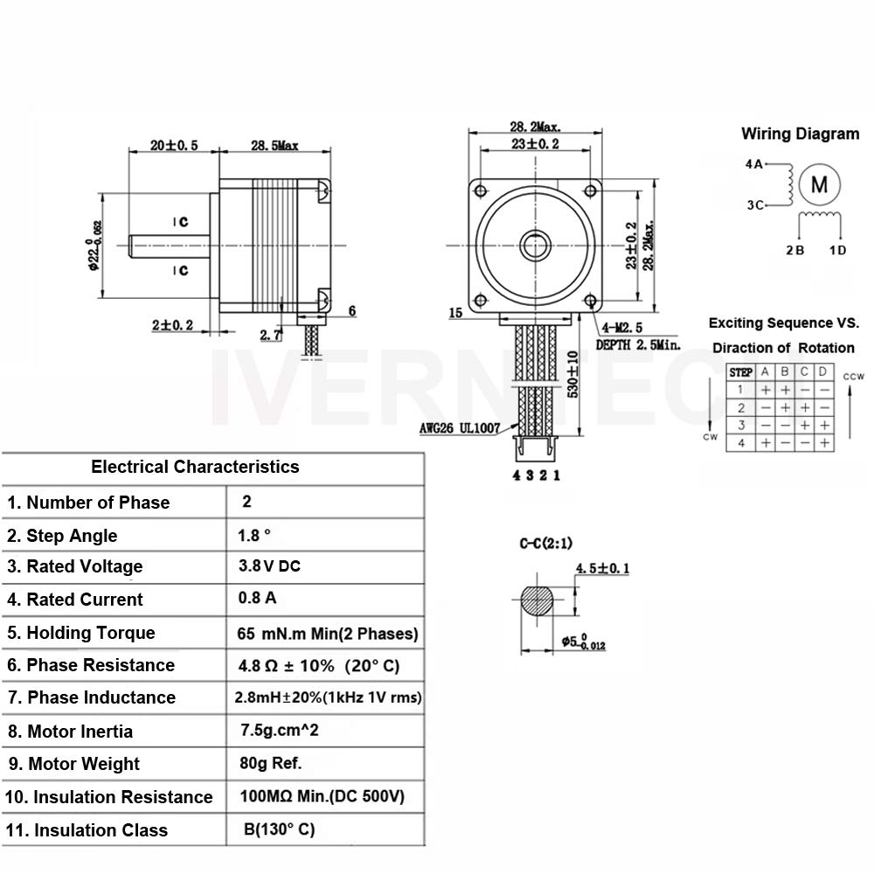

Appendix S: HM10 DataSheet


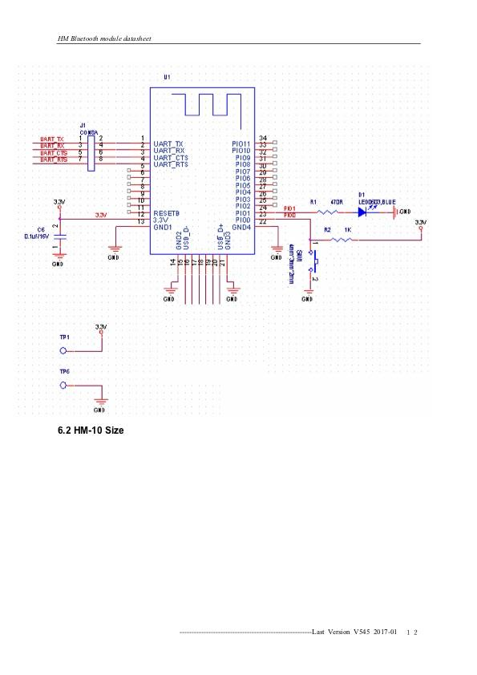
More information can be found http://www.dsdtech-global.com/2017/08/hm-10.html

Appendix T: Pixy2 DataSheet

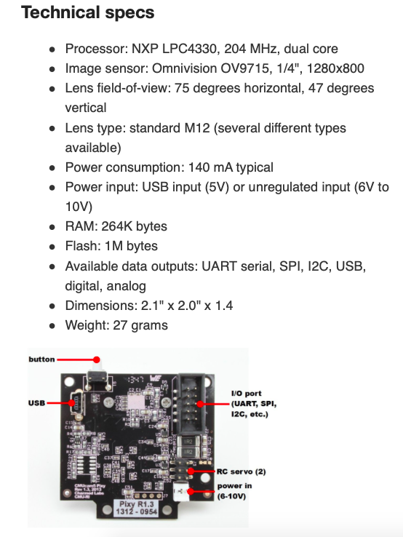
More information can be found https://docs.pixycam.com/wiki/doku.php?id=wiki:v2:start

Appendix U: Ultrasonic Sensor DataSheet



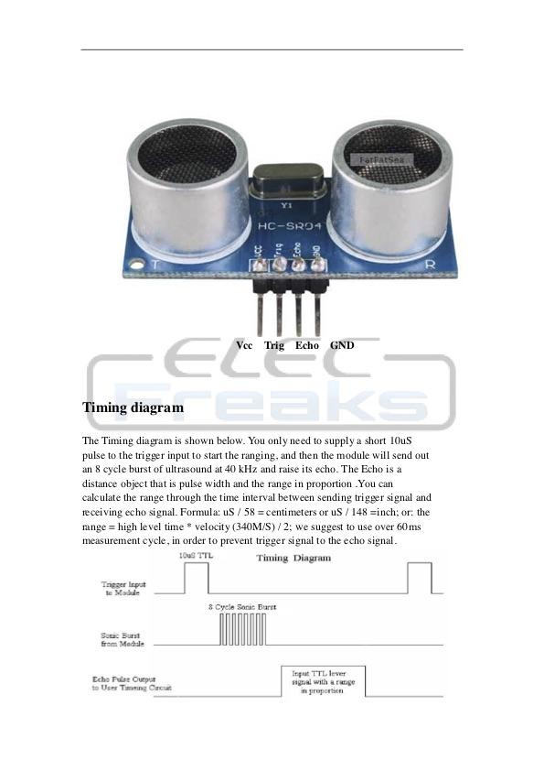

Appendix V: BOM Cost for Guideway
