Charles W. Davidson
College of Engineering
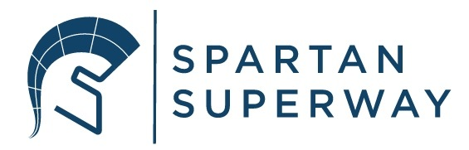
The Spartan Superway
A Solar Powered Automated
Rapid Transit Ascendant Network

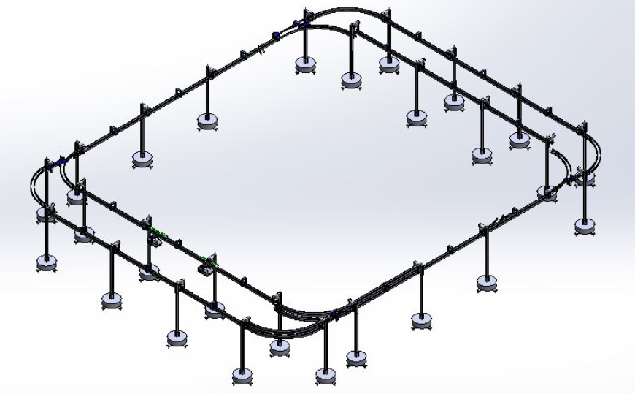

Small Scale Track Design and Manufacturing

ME 195B Senior Design Project Section-4
Dr. Burford Furman

David Cabezas
Brandon Chow
Tyler Shearer
May 19, 2019

Abstract
The Small-Scale Track Design and Manufacturing team is responsible for updating and improving the older iteration of the track. The team carefully evaluated each track component and the assembly as a whole to decide where to focus this year’s efforts. Track subassemblies that were deemed to be fully functioning were kept in the current design and those that caused derailing or other issues have been redesigned. In addition, some sections of the track were expanded to make the track more elaborate and realistic.

This year’s efforts were put towards a few ways of improving the track. The first improvement involved having more consistently bent curved rails for the turns through the creation of a new railbender. In order to provide extra support to these curved sections, a modified hanger bracket was created and attached. Lastly, the track was expanded by adding another pair of switch sections opposite of the preexisting pair.

Overall, all of the year’s goals were met and everything was implemented as planned. The railbender did indeed produce more consistent curves than the railbender that was used in the previous year. The modified hanger brackets were able to provide added supports to the curved sections. Finally, the track was successfully expanded and the additional pair of switch sections were implemented. Some recommendations for the future include the addition of a section of track that demonstrates grade traversal, slight improvements to the trackbender and further expanding the track in whatever creative way they see fit.

Acknowledgments
We would like to acknowledge and thank the following people and groups for their continued help and support throughout the duration of this project:
Dr. Burford Furman:
- Provided valuable design and manufacturing solutions.
- Oversaw progress throughout semester to see if the team’s direction was correct.

Ron Swenson
- Provided valuable design and manufacturing solutions.
- Oversaw progress throughout semester to see if the team’s direction was correct.

Eric Hagstrom:
- Provided recommendations for improving our presentations and blog posts.

Paul:
- Solved many of our SolidWorks design challenges and taught valuable tips.
- Provided support in suggesting how to repurpose old materials to save on manufacturing costs.

Daniel Bolin
- Giving a tour of his manufacturing facility and providing information about the process of injection molding
- Provided suggestions as to how to produce the modified hanger brackets with greater efficiency

Kevin Brasil:
- Provided an in-depth overview of what could and couldn’t be accomplished last year and some precautions for the year
SJSU Associated Students:
- Provided funding for the Spartan Superway Project.

SJSU College of Engineering:
- Provided funding for the Spartan Superway Project.

Table of Contents
Abstract…………………………………………………………………………………………... 1
Acknowledgments…………………………………………………………………………..…… 2
Table of Contents………………………………………………………………………………... 3
Executive Summary………………………………………………………………………….......4
Introduction…………………………………………………………………………………........6
Objectives………………………………………………………………………………………... 8
Structure of the Project…………....…………………………………………………………….9
State of the Art / Literature Review………………………………………………………...…10
Design Requirements and Specifications……………………………………………………... 11
Design Solutions………………………………………………………………………………... 12
Conclusion………………………………………………………………………………………21
References……………………………………………………………………………………….22
Appendix………………………………………………………………………………………...23

List of Figures

Figure 1…………………………………………………………………………………………... 7
Figure 2………….…………………………………………………………………………..…...13
Figure 3………....……………...………………………………………………………………..14
Figure 4…………....………………………………………………………………………….....14
Figure 5…...…………………………………………………………………………………......15
Figure 6....……………………………………………………………………………………….16
Figure 7………………..…………....…………………………………………………………...16
Figure 8……………………………..………………………………………………………...…17
Figure 9…………………………………..……………………………………………………... 18
Figure 10……....………………………………………………………………………………... 19
Figure 11...………………………………………………………………………………………21
Figure 12..……………………………………………………………………………………….22
Figure 13………………………………………………………………………………………...22
Figure 14………………………………………………………………………………………...23
Figure 15…………………………………………………………………………………....…...24
Figure 16…………………………………………………………………………………....…...27

Executive Summary
Introduction and Objectives
The Spartan Superway small-scale track and bogie is primarily used to showcase an engineered solution to the transportation crisis society is facing now. It is a highly portable representative model of the full-scale Spartan Superway. Every year the small-scale track and bogie is shown off at Makers Faire to garner interest in the project and inform the public of a potential solution to the current worldwide transportation problems. In order for the demonstration to be successful, the model must be fully functional, reliable, aesthetically pleasing, attention grabbing, and interesting to watch. The small-scale model may lead to donations to the project or interest from influential figures who can support the project.

Problems
The small-scale track and bogie was inherited from the previous years’ teams and while the design was functional, it can be unreliable at times and there are areas that could be improved. Frequently, the bogie would derail or become stuck going around one of the turns and have to be fixed manually. This is due to two design issues. The first issue was that the two concentric track rails did not have a constant bend radius, so the bogie wheels could slip through the track or bind up. The second issue was that these track areas were not supported. The track was supported only through the straight sections, so there is quite a bit of free movement in the track near the turns.

One of the biggest problems the team faced is that manufacturing new track sections was very difficult due to the previous track bender device. It was a crude device that couldn’t accommodate tight tolerances. Many of the problems with the old track stemmed from the inaccurate bends that this device produced.

Solutions
The small-scale track improved in all of the previously mentioned areas and planned to showcase the improvements at Maker Faire this year which unfortunately didn’t happen. Nevertheless, the new track was demonstrated in-house instead. This year featured the addition of one offline charging station with induction charging docks on both the new and old stations, improved consistency of rail bends and more supported of the curved sections of the track.

The plan of supporting the curved track sections with a new wider bracket design was successful. Previously, they were unsupported because the current bracket width didn’t allow the bogie to traverse the section freely. Additionally, the current track bender has been completely redesigned and replaced to allow for tighter tolerancing. These combined solutions solved many of the reliability issues of the previous track design.

There was the addition of docking stations to demonstrate how the bogies will charge and pick up or drop off passengers. The bogie stops at the new charging station where it automatically charges itself before rejoining the main loop. The team worked closely with the other small-scale teams to accommodate their charging devices and bogie’s abilities.

Introduction
The goal of the Spartan Superway project is to alleviate the growing transportation crisis facing the world. With an ever-increasing population, current transit systems are becoming overcrowded. Several hour commutes to work are not uncommon, especially in the Bay Area. A new rapid transit network can be implemented into these congested, already developed areas to improve the transportation network.

According to an article on the sources of greenhouse gas emissions written by the EPA, the transportation sector accounted for 28% of all carbon emissions in 2016 and was tied with the electrical sector. See Figure 1 below. The Spartan Superway project is a fully solar powered project that would not release additional greenhouse gas emissions after construction. Smog and air pollution has been a decades long problem for California, and the Spartan Superway project can alleviate a great deal of this.
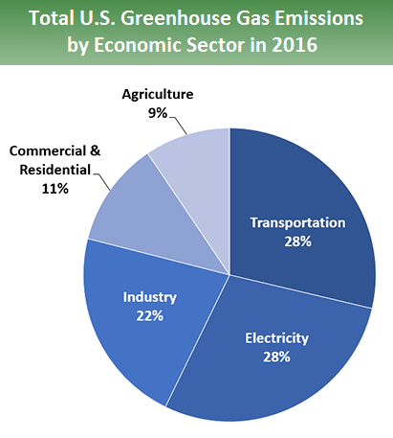
Figure 1. Pie Chart of the Carbon Emission Portion Released by Sector in 2016
https://www.epa.gov/ghgemissions/sources-greenhouse-gas-emissions

One of the great advantages of the Spartan Superway project is that it will reduce the number of vehicles crowding the city streets. Many residents of densely packed urban cities such as San Jose could forgo owning a car and use the Superway as their daily means of transportation. Longer trips or trips where the Superway infrastructure is not available can be served by other services such as ZipCar.

A reduction in car ownership would serve to improve the economy and help those who are struggling to make ends meet by reducing their transportation costs. According to a study done by AAA, the average annual cost of owning an automobile in 2018 that is driven an approximate 15,000 miles a year is about $8,850. Additionally, in an article written by the Peter G. Peterson Foundation about the income and wealth distribution of the US in 2018, the average annual household income in the United States is about $61,000. Considering a two-car household, the costs of owning cars comes out to about 29% of their annual income. A 29% effective increase in income would dramatically improve the lives of the middle and lower class.

Objectives
The 2018-2019 Small-Scale Track team had two main goals and two minor goals that it hoped to address within the year. The first main goal was to redesign the previous track bender. The old track bender that was left behind by the previous years’ team was mostly functional, but the current team agreed that it needed to be improved upon as it produced inconsistent rails. As such, the current team aimed to reconstruct the rail bender such that the radius of curvature of each rail would be more consistent, so the bogie would no longer fall through or get stuck at the curved sections of the track.

The second main goal the team made was to create another offline station with the addition of another pair of switch sections. These offline stations would be a representation of where passengers would board or exit the podcars in addition to where the podcars would charge when low on energy. These offline stations would support the induction charging stations that the small-scale controls team would set up.

The first minor goal of this year’s team was to implement more complex track design to show more advanced movement of the bogie. This included dips, ramps, and potentially a second level of track. However, after talking with one of our presenters, a former BART engineer working with automated transit networks, he explained that more complex movement should not be focused on as a goal, and that it was more important to demonstrate the entire system and a city-like aspect of the track. This is expanded upon in greater detail in the design requirements and specifications section.

Lastly, the second minor goal was to add supports to the curved sections of the track as some of them seemed to sag due to self-weight. This required the slight modification of the current hanger brackets design, so they could be used to support the curved sections of the track without the bogie scraping against them.

Design Requirements and Specification
To produce a successful track model, the following specifications were used:
- Rail Separation: 1.5 inches
- Internal Curve Radii: 25 inches
- 2 New Switch Sections .
- Ability to complete a 15% grade change
- 2 Induction Charging Ports

Many of the design specifications that were decided upon for this year were based off of the 2017-2018 design specifications. As the goal for the year was to expand upon the existing track, any new additions must have adhered to the same specifications as the track was already set to. The 1.5-inch separation between the two rails allows enough room for the bogie to pass through while preventing it from falling in between the rails. The 25-inch radii for the curved section allowed for the bogie to comfortably travel along the arc while also keeping the entire track within a reasonable size.

The added offline station along with the existing one would provide a more realistic representation of the Spartan Superway system. This would demonstrate how the podcar would stop at stations for passengers to board or arrive at their destinations. Lastly, as the previous bogies ran on batteries that required manual replacement, the small-scale controls team aimed to set up an inductive charging station. The small-scale track team’s contribution to this was the designing of a port that would contain the inductive charger and prevent it from falling or being scrapped by the bogie.

Originally, the team planned to add a 15% grade traversal to show more complex and realistic movement within the system. However, after talking with one of our presenters, a former bart engineer working with automated transit networks, he explained that more complex movement was not necessary as a demonstration and that it was far more important to show a “city” aspect. He elaborated that it would be far more influential to people viewing our small scale track to see it connecting separate cities, such as Milpitas and San Jose, so that they could more easily see the benefits. More complicated movements, while interesting, would not serve to get people behind the idea of Spartan Superway. After a lengthy discussion amongst the team members, it was decided to follow his expert advice and put this goal on the backburner. We instead fully designed a 15% percent grade traversal to be used as an entry/exit to another city that next years team can implement.

Structure of the Project
For the two main goals of the project, we have a head leading each goal. For the redesigning and reconstruction of the track bender, Tyler had taken on the lead role. He was tasked with the 2-D drawings and 3-D CAD drawing of the new track bender and oversaw the reconstruction of it. David had taken the lead role for the design of the additional section of the track. As such, he was responsible for the 3-D modelling and design of the modified track as a whole. In addition, David was also responsible for the modification of the hanger brackets that was implemented for the curved section supports. Lastly, Brandon was tasked with the manufacturing and construction of the track. Assisted by both Tyler and David, the rails were cut, bent, drilled and attached to the existing track.

State-of-the-Art/Literature Review
Personal Rapid Transit (PRT) concepts began in 1953 when Donn Fichter, a city transportation planner, began research on PRT and other alternative transportation methods. In 1964, he published Individualized Automatic Transit and the City in which he suggested an automated public transit system as a better way to expand public transportation. One of the key arguments Fichter made was that he believed that people would not leave their cars in favor of public transit unless the system was more flexible and quicker than what was already available by other means such as buses. Fichter believed that the answer to this was a PRT system.

Personal rapid transit systems have been relatively glossed over in favor of personal automobile ownership until recently. Essentially requiring every citizen to own an automobile to support themselves has grown to be an unsustainable practice. As cities grow increasingly dense, implementation of these transit networks has caught the eye of several congested cities. The Morgantown Personal Rapid Transit system is one such example of a successful PRT system. It currently connects the three Morgantown campuses of the West Virginia University and the Morgantown downtown area. It consists of five stations and over 70 podcars. It has proven itself to be a reliable system of automated transit that is inexpensive to operate. The system has a daily ridership of approximately 16,000 people and only requires a 50-cent fare.

The Spartan Superway project led by Dr. Furman at San Jose State University has undertaken the task of designing a new PRT to serve the Bay Area and other communities around the world. The team has been making progress towards this goal for several years and the program is a favorite of mechanical engineering students looking for a senior project that will have a real impact. It is broken up into several sub-teams including small-scale, half-scale, and-full scale teams. Each team is tasked with pushing forward on the design and producing manufactured prototypes at the end of the year. Currently, a full-scale guideway and bogie are present in the manufacturing facility, undergoing improvements.
Design Solution
Remodeled Track Bender
The track bender designed and built by the 2017-2018 team was inconsistent and unreliable. It was decided that it should be improved upon and remodeled to improve its reliability and consistency. The previous setup of the track bender can be seen below in Figure 2.

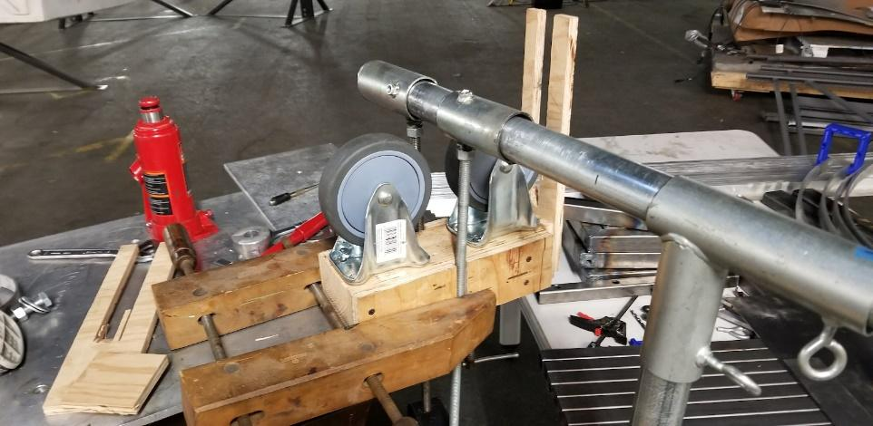
Figure 2. Current Track Bender Setup

As is, the previous track bender only had two points of contact with the railing being bent, at the wheels and by the shaft that was rolling the track. As the wood board in front was placed to keep the rail centered but proved to be rather ineffective, it allowed for lateral movement of the rail. As such, it was decided upon to move from what it currently termed a vertical setup to a horizontal setup. Two hand drawn sketches of the top and side views of the newly designed horizontal setup can be seen below in Figures 3 and 4.
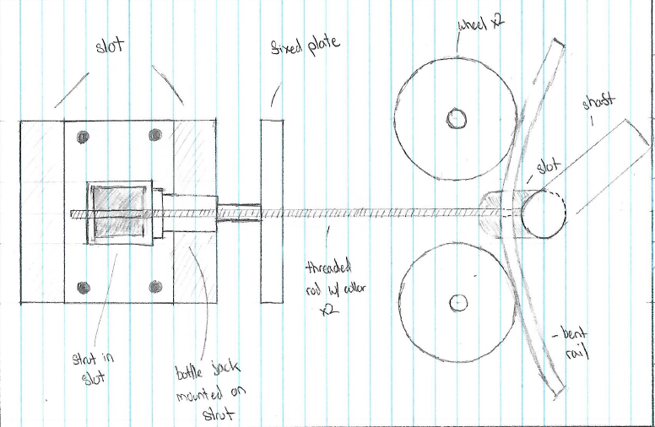
Figure 3. Top View of the Redesigned Track Bender

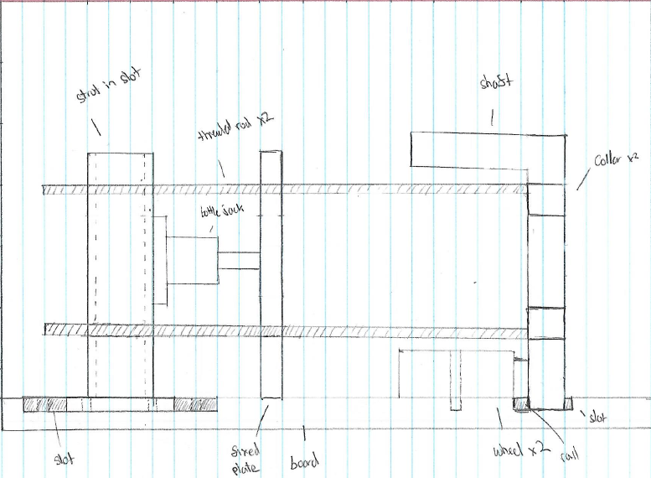
Figure 4. Side View of the Redesigned Track Bender

This new setup utilized the same principles to bend the rails as the previous setup did but the main difference is that the rail would be flat against the baseboard. This resulted in the rail becoming more stabilized and restricted and less free to move than before. This crucial modification allowed for a more consistent bending of rails. As mentioned previously, the track bender still functions the same way. As the bottle jack is situated between two beams, one of which is supported while the other is free to move, when the bottle jack applies an increasing amount of force, the free beam will gradually be pushed back. Since this free-moving beam is connected to the threaded rods and the collars around the shaft, the shaft will also be pulled back, increasing the load applied to the rail being bent. Figures 5 and 6 below demonstrate how the track bender setup changes as the load from the bottle jack is increased.

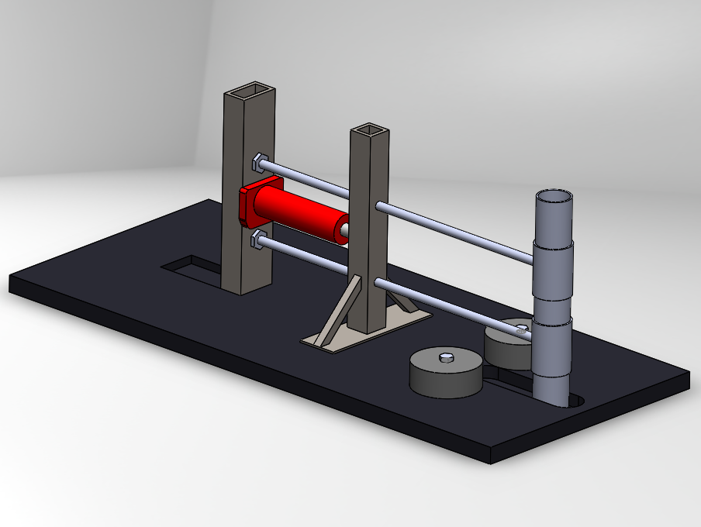

Figure 5. 3-D CAD Model of the Redesigned Track Bender in the Unloaded Position
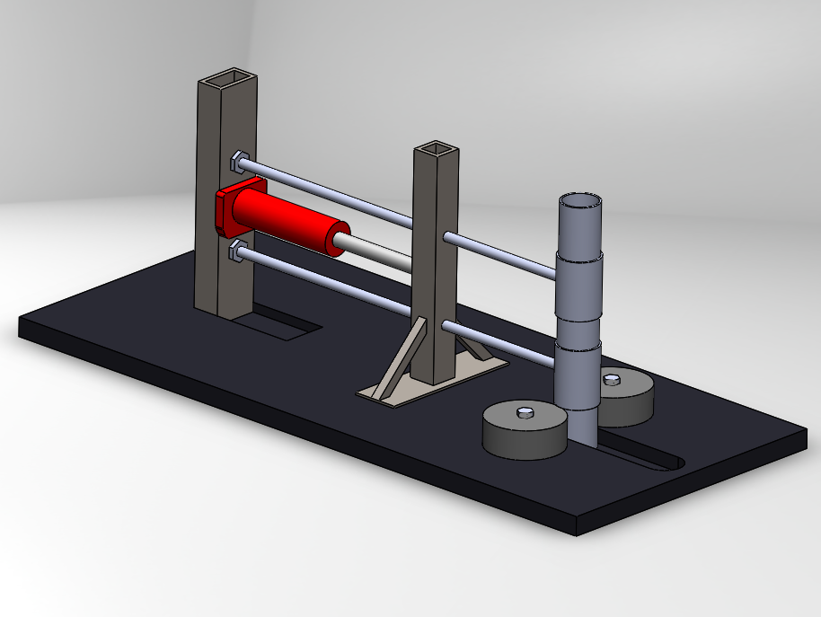
Figure 6. 3-D CAD Model of the Redesigned Track Bender in the Loaded Position

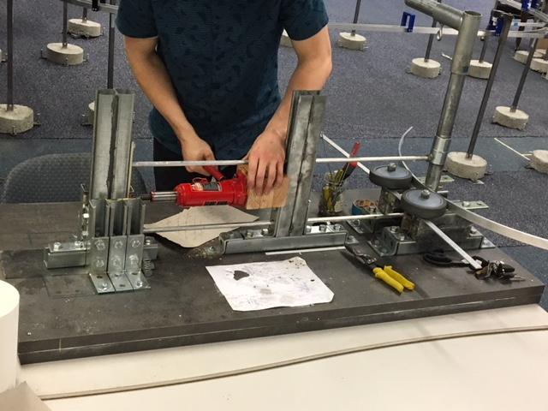
Figure 7. Newly Designed Railbender in Operation

Prime Design: Newly Designed Center Section
As mentioned previously, there was originally a goal to add more complex movement to the already in place track. After discussion with a former BART engineer now focused on automated transit networks, he convinced us to move away from this idea and instead focus on a city-like aspect. Originally, the team decided to fill in the gap within the center with another switch section that led into two separate turns that reconnect to the outer perimeter of the track. This switch section would first be accompanied by a dip in the tracks at a 15% grade. At this newly added level of the track, the team planned on implementing the charging station using inductive charging methods. This wireless induction station was moved to after one of the switch rails, per small scale controls team request. The proposed decline and incline portions of the rails are showcased in Figure 7. below, however they are a little exaggerated so that readers may be able to spot where the track begins to dip.
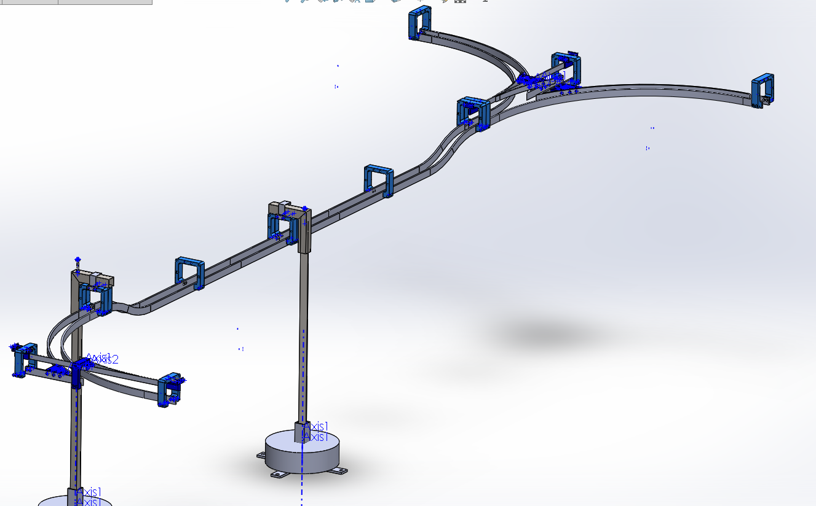
Figure 8. 3D CAD Model of the Newly Designed Section of the Track

After the bogie goes up the incline, it hits the next distinct portion of the new track. Here, a Y-section was going to be added so that the middle portion can reconnect with the outer perimeter of the track. Depending on how the controls team would have moved the bogie, the podcar would then make a left or right turn. At this point, the bogie would begin to merge again with the track, with two switch sections being added towards the end. The Y-section would have been supported by two upper and two lower wedges. These act like cushions that hold up against the track when the bogie makes its turns and also keeps the middle rail in place so that it doesn’t sway when the bogie enters the switch section. The middle rail in the Y-section is extended a little bit further pass the opening to the turns so that it would be supported by another bracket. This was to ensure that the vertical motion the third rail could potentially have is locked in place. A more close up and detailed photo of the team’s Y-section design is shown in Figure 8. below.

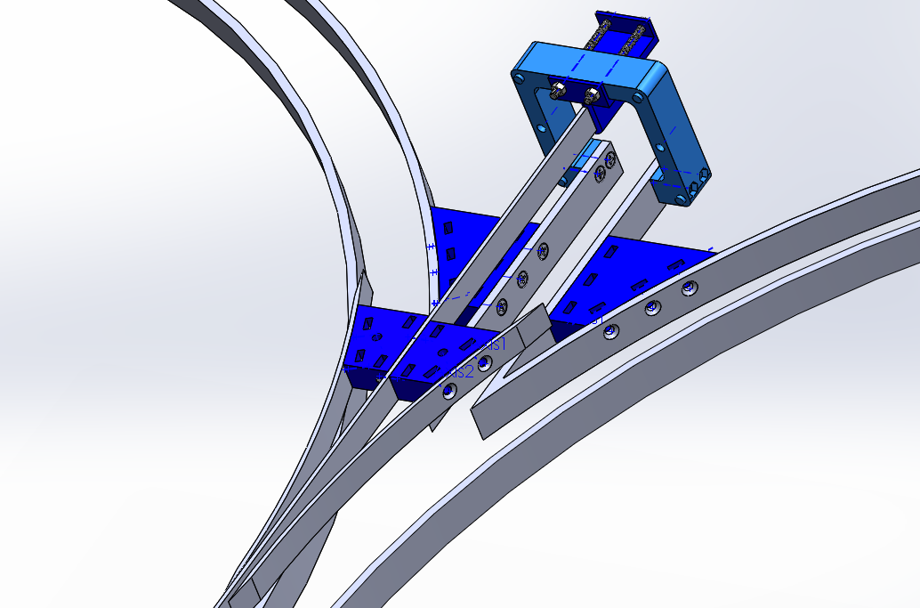
Figure 9. Newly Designed Y-Section

Finalized Design
The final design however did not incorporate the y-section plans. A BART engineer highlighted how the small-scale track should focus more on how the bogey would run between cities instead of just adding complex motion to the bogey and pod. With the new design, an extra loop was incorporated so that the bogey could showcase the two charging stations built between switch sections. As shown below, the newly added portion of the track mirrors the inner loop with two more switch sections and one straight. This section was built using brand new aluminum curves bent using the track bender and 3D printed PLA brackets. The two charging stations were 3D printed using PLA and the inhouse printer. They were incorporated into the hangar brackets exiting the inner loops on both sides, hanging on its side so that the wires and inductive charging pads would reach down to the bogey itself. As shown below, the final design of the new track included two more supports from last year, 5 hanger brackets, and two mirroring switch section.
Figure 10. Finalized design of the track
Fabrication
The team planned on using the machines and tools available in the workshop. For the track bender, some components were able to be repurposed while others needed to be manufactured. The entire design was based on reducing manufacturing costs by repurposing old pieces and making use of already available materials found within the shop, such as the unistrut that the new trackbender is made out of.

The hanger brackets initially were planned on being fabricated through injection molding. However, after meeting with Daniel Bolin of BOJO tools, the mold itself would’ve cost over $10,000 since the part would be too thick for their machines. He explained that sand casting would also be out of the question since the mold is not worth the price for the amount of parts that the team would be needing. Bolin suggested that instead the team should fabricate them by hand. The problem is that there are no plastic plates that are thick enough for what the design entails. Essentially, the team is left with two options: to continue to use 3D printing in PLA or ABS to make the parts, or to use the water jet machine at the shop to make them out of aluminum. The latter way may be the quickest way to get the brackets done, but the intricacies in our design could lead to a lot of potential errors in the manufacturing of our parts, requiring the team to buy more supplies until the brackets are done correctly.
The new trackbender used an extensive amount of repurposed materials to keep costs as low as possible. A large quantity of Unistrut strut channel was available from last years’ project and we were able to reuse it and the mounting brackets to lay out a frame for our track bender. The design went through several iterations and was ultimately successful in producing consistent bend radii.
The new rails were intended to be cut precisely using a mill, and then drilled out and countersunk using a drill press, but both of these machines were out of order due to the move of the Spartan Superway project. Instead they had to be cut using a pipe cutter and then were drilled using a handheld Harbor Freight drill. This made manufacturing much more difficult and time consuming, with more error and less precision. Ultimately the entire track was constructed within our timeframe and under budget through hard work and teamwork

Analysis/Validation/Testing
Supporting Analysis
In order to make sure that the designs would work, there were several stress and displacement analyses done. Hand calculations were done on the rails to check if they were to be displaced when under the load of multiple bogies. For this analysis, it was assumed that one bogie weighed about 4 pounds and so when there is a concentrated load at the center along the 48 inch length of the rail, assuming the team continued to use aluminum 6061, the beam deflection should be about 0.044237 inches and at an angle of 0.002765 radians. This calculation was done knowing the beam would be fixed at both ends.

When a beam is under a load of three bogies at once, a distributed load was used to solve for the maximum deflection. Assuming the rail was fixed at both ends at the distributed load of 0.25 pounds per inch or 12 pounds in total, the maximum displacement of the beam should not be more than 0.082944 inches at an angle of 0.00553 radians. Figure 9. below shows the formulas and diagrams used to solve these values.
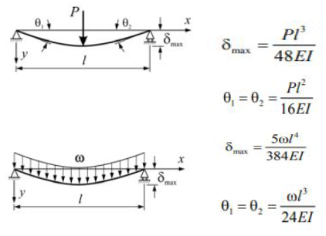
Figure 11. Diagrams and Equations for Displacement Calculations

The next step was to see if these values held up in SolidWorks Simulation. Here the same analysis and assumptions were made and the beam will be under a load of 12 pounds assuming all bogies and podcars were present on the rail. Here the analysis was done on a straight aluminum 6061 rail and it was found that the maximum deflection was approximately 0.01593 inches and 0.01905 inches, respectively. These values were very close to the deflection value found in the distributed load calculation and are small enough to avoid any worry that the beams would fail under the load.
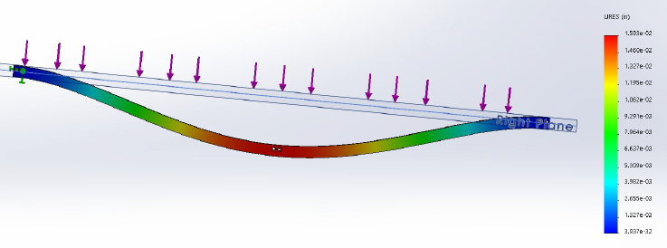
Figure 12. Solidworks Simulation of Deflection of the Rails

For the stress analysis of the brackets and hangers, the team assumed that each one would not be under a load more than 4 pounds. The middle rail bracket stress analysis was done to see if it would be able to keep the rail up without failure whenever the bogie makes a turn in the Y-section. On the same component, another stress analysis was done to ensure it would not fail when the bogie makes a turn within a switch section. Here the load was applied on the side since the bogie would be making a right turn to the middle portion of the track or returning to the outer perimeter. Both values ended with a yield safety factor of 18 and 6.3, respectively. Meaning that under these conditions the bracket would not fail.
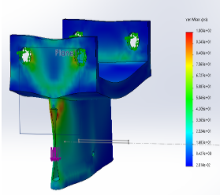
Figure 13. Stress Analysis on Middle Rail Bracket
For the hanger brackets, a similar analysis was done. When a bogey passes through one of these hangers in one of the turns, it would experience a load of about 4 pounds. Using the yield strength of plastic of 1890 psi, the safety factor turned out to be 16. Meaning that the newly designed bracket will not fail under these conditions. For full schematic drawings of the new hanger bracket, see Appendix A.

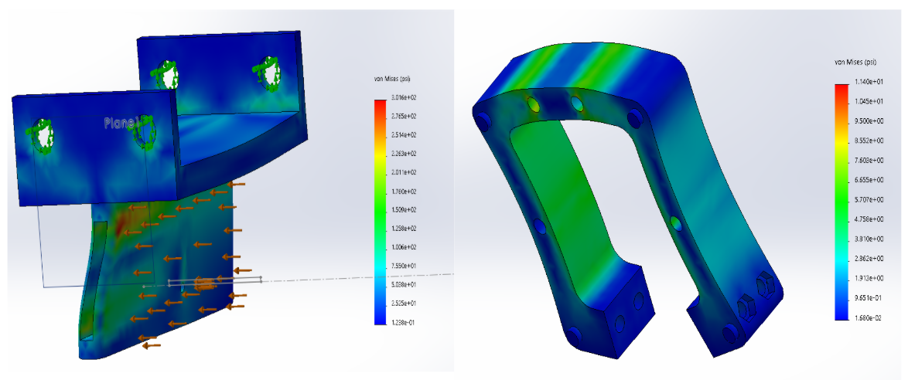Figure 14. Stress Analyses for Both Brackets

One of our main goals was to designing a new track bender for more consistent bend radii. In previous years, the bogie would fall through large gaps in the rails or get caught in tighter sections of the parallel rails. In Figure 15. below, an example of last years’ rails is shown on the right, while a set of our new rails are on the left. As you can see, last years’ rails bow out in the middle, are tight where they would be bracketed together, and have incompatible lengths. The meant that many rail sections held a large amount of tension when they were bracketed together leading to many broken brackets and difficulty assemble the structure. Our new rails have much tighter tolerancing and greater consistency in the bent rails. In testing, these new rails were higher performance, with no bogies falling through the track and less bogies having difficulty traversing bracketed ends.
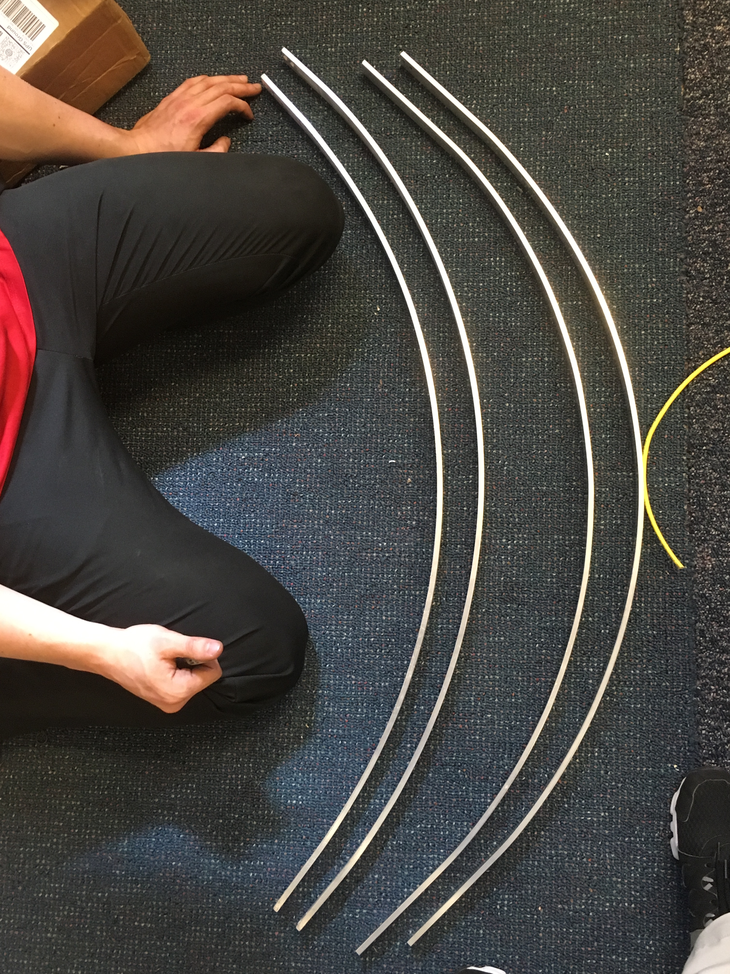
Figure 15. Greater Consistency in the Bent Rails

Money Spent on the Project
In total, we spent $522.93 over the course of the entire year. Our initial budget was $1066.79, so we were able to save a total of $543 (a 49% savings). We were able to achieve a great deal of savings by repurposing old materials from the previous years, such as the Unistrut strut channel that the new track bender is made of. We were also able to repurpose aluminum rods and 2x4 wood sections. We went to (sometimes excessive) lengths to save money on the project, with the knowledge that the overall budget for this year was very tight. Shown below is our bill of materials for this year.

Supplier | Product | Qty: | Amount:
Home Depot | Superstrut 1/2 in. x 15/16 in. Strut Hex Head Bolt - Silver Galvanized (5-Pack) | 6 | $30.84
Home Depot | Superstrut 1/2 in. Strut Channel Spring Nuts (5-Pack) | 6 | $30.18
Home Depot | VPC 1/2 in. x 24 in. PVC Sch. 40 Pipe | 1 | $1.31
Home Depot | Superstrut 4-Hole 90°Angle Strut Bracket - Silver Galvanized (Case of 10) | 1 | $22.50
Home Depot | Assorted Nuts,Bolts,Screws,Washers | 1 | $20.00
McMaster Carr | Flat Rectangular 6063 Aluminum Bars (0.25”x 1”x 4ft) | 26 | $328.90
McMaster Carr | 3003 Aluminum Sheet (12”x 12”x 0.25”) | 2 | $75.20
Harbor Freight Tools | Corded Power Drill | 1 | $14.00

Results and Discussion
The big idea behind this year’s improvements are based off of the city-like concept. As mentioned previously, it was originally intended to add more complicated motion to the track though the addition of the Y-section that was designed. Part way through the year, it was suggested that rather than adding complex motion, it would be more beneficial as a demonstration model, that it showed the Spartan Superway system rather than making it relatively flashy and exciting to watch. As such, after discussing it long and hard as a team, we decided to follow this piece of advice and adjust our project scope and built the two offline stations instead.

Building off of this same concept and the track that is being left beyond, it is hoped that the team inheriting it will build upon it and continue to develop the city-like aspect of the small-scale track. With one conceptual city being in place, the future team can expand it such that it connects to another city in addition to adding more stations of which may include a decline and later an incline that would overall allow the small-scale model of the Spartan Superway to give a more accurate demonstration of what the full-scale version would be like and what viewers can expect to see in the future.

Conclusion and Suggestions for Future Work
Over the course of the last year, our team has learned a tremendous amount about the Spartan Superway project and the small scale efforts. We intend to transfer as much of our gained knowledge to next years’ team as possible so that they get a good running start on the project and don’t fall into the same mistakes that we made.

We highly spending as much time as possible during the design phase and getting full detailed dimensioned drawings for what you want to build. Try and use these drawings to get quotes for manufacturing, such as for laser cutting new curved rails if they are needed. Our team spent a massive amount of time manufacturing in house while most other teams sent their designs out to be made. Our hand bent rails took hundreds of man hours to complete and saved probably thousands of dollars of manufacturing costs, but other teams do not appreciate the effort needed for what seems at face value to be a simple task. We recommend any additional rails or replacement rails to be laser cut from sheet aluminum using the makers space on campus.We recommend using outside manufacturing and sponsors as much as possible.

If you decide to continue using the track bender, there are some modifications that should be made. The wheels that the aluminum rest on while being bent are near the end of their life and need to be replaced. We recommend finding metal casters or large bearings with a center hole to replace them with. Additionally, the bottle jack is held in place only by its own force and when the jack is released it falls down, so a stand should be made for it.

If you intend on working on a new entry exit to replace the latch mechanism, we recommend making another switch section and using a 15% grade that is laser cut from sheet aluminum to introduce a downhill/uphill section of the track while introducing the city concept. This will serve as an interesting addition to the track and demonstrate the goal of Spartan Superway to be an extended automated transit network connecting multiple cities.

The brackets supporting the curved section greatly improve the tolerancing of the parallel bent rails but these brackets are not supported by concrete stands. We suggest manufacturing additional concrete stands to support these sagging areas as needed. These wider brackets allow for looser tolerancing as the bogey passes through them, and we suggest replacing all of the blue brackets with these new wider brackets.

The team spent a massive, massive, amount of time disassembling and reassembling the track because of the fact that the screws are all mounted inside of the two rails. This requires a screwdriver that is bent at 90 degrees to screw and unscrew them, and chews up a huge amount of time. When Kevin Brasil came to visit during our makers faire, he was very surprised at our difficulties and explained that they had purchased several 90 degree ratcheting offset screwdrivers that cut the time to assemble by about 70%. These were not mentioned in their report, and we never knew they existed since they kept them as they were an out of pocket cost. See the figure below for an example of what these tools look like. They are available on Amazon and Harbor Freight for less than 10 dollars.
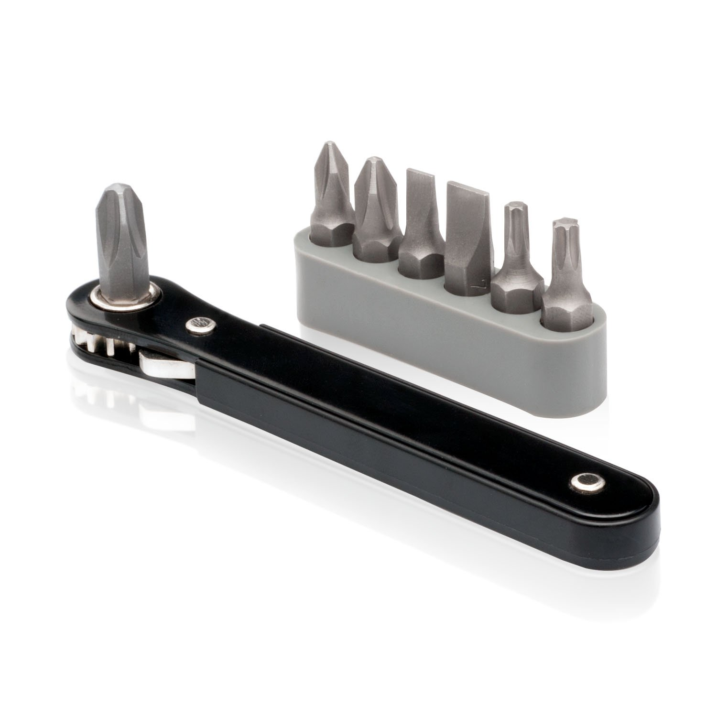
Figure 16. 90 Degree ratcheting offset screwdrivers

One of the biggest goals for next year should be to introduce the city concept by making a duplicate track and connecting them together. This will reinforce the concept of Spartan Superway being an intercity travel system and get people interested in the project.

References
Edmonds, E. (n.d.). Your Driving Costs. Retrieved December 14, 2018, from
https://newsroom.aaa.com/auto/your-driving-costs/

Income and Wealth in the United States: An Overview of the Latest Data. (2018, September 13).
Retrieved December 14, 2018, from https://www.pgpf.org/blog/2018/09/income-and-wealth-in-the-united-states-an-overview-of-data

Sources of Greenhouse Gas Emissions. (2018, April 11). Retrieved December 13, 2018, from
https://www.epa.gov/ghgemissions/sources-greenhouse-gas-emissions

Appendix A
Hanger Bracket Schematic Drawings
