Superway-A Solar Powered Automated Transportation Network:

Twelfth-Scale Bogie Design Team

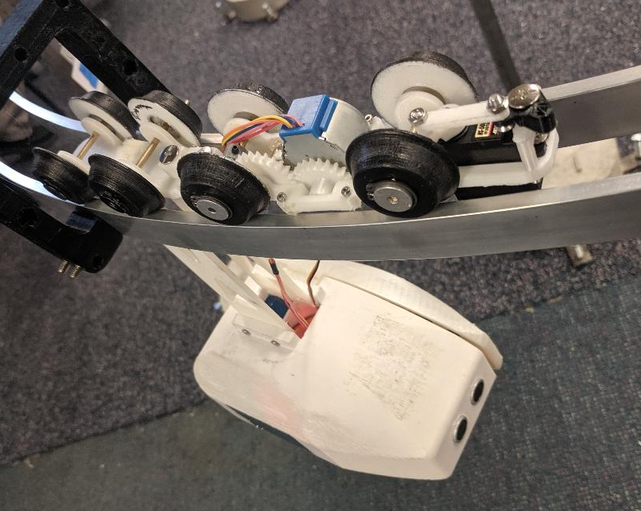

April 19, 2019
San Jose State University
Logan R. Seitz

Abstract
For this semester, design, prototyping, and manufacturing of a revised master-slave bogie system was conducted to integrate a new motor, conical wheels, articulating joint and track switching mechanism. The new motor was significantly larger in size and slower than the previous year’s motor which warranted a new chassis design and 3 gear gearset. For the conical wheels a 1.08 ratio was calculated between the inner and outer distances of the track which was used to determine the amount of taper for the wheels. The wheels were coated in a rubber spray to increase traction. An articulating joint was integrated to provide an improved joining system for the master and slave bogie using binding posts as a way to reduce friction. A linkage system was implemented to the track switching mechanism to allow easy replace parts to take the impact rather than the servo motor.
The master-slave bogie system was designed and modeled using Solidworks 2018. A Prusa i3 MK2 and Alunar 3D printer were used to manufacture most of the components. Ultimakers Cura was used as the slicing software for generating the G-code needed for 3D printing.
At the end of the project a new master-slave bogie system was created and integrated with a small-scale new track. This small-scale bogie faced multiple challenges when facing turn sections and joining sections of the track that prevented the system from traveling the full track without assistance. The root causes were the low speed of the motor and low friction of the master bogie. Poor quality filament also resulted in some components breaking prior to use or when contacted with low forces. From these results new design for a new motor and overall refinement of the master-slave bogie-system is required to provide a functional small-scale model.

Acknowledgements
Special thanks to Professor Burford Furman and Ron Swenson for guiding the Small-Scale Bogie team and working behind the scenes to support the Spartan Superway program. I would also want to thank Daniel Bolin for providing feedback on the bogie chassis design and suggesting alternative methods of manufacturing it. Also, thanks to Eric Hagstorm for providing feedback on presentations and blog posts.

Table of Contents
Abstract 1
Acknowledgements 2
Executive Summary 4
Introduction and Project Description 6
Objectives 8
Design Specifications 8
State-of-the-Art/Literature Review 9
Final Design 11
Analysis 17
Cost 19
Results and Discussion 20
Conclusion and Next Steps 21
References 21
Appendix A 22
Appendix B 28

Executive Summary
For the Spring semester the Small-Scale bogie team strived to build the small-scale bogie system to function on the improved small-scale track utilizing design concepts chosen in the previous semester. There were three major issues dictated the design changes to enhance the functionality and durability of the bogie system which are outlined in Figure 1. The first issue addressed was that the that the previous year’s motors burned out after excessive use. Second was the occurrence of wear on the wheels and thirdly there was excessive binding at the joining section of the master and slave bogie. The motor chosen in the previous year were brushed motors and were prone to wear out after continuous use. Wear on the wheels was a result of using a single axle preventing the wheels to spin at different speeds during turns causing the wheels to slip. For the master bogie a single axle was used causing the system to rock creating the joint of the two systems to bind. Furthermore, it was desired to increase the capability of the bogie by allowing it to travel at an incline in which the old joint did not allow. These issues were addressed and set as the primary focus for this project.
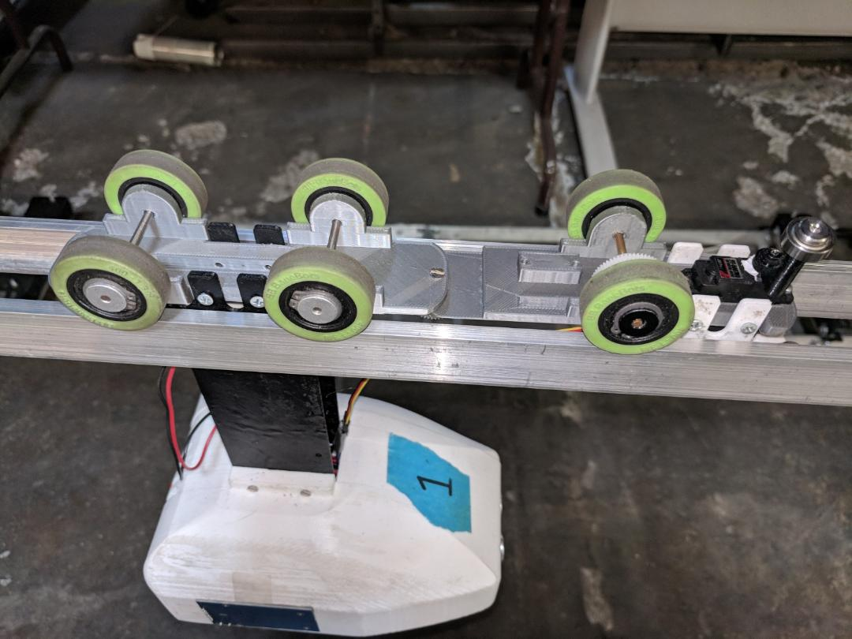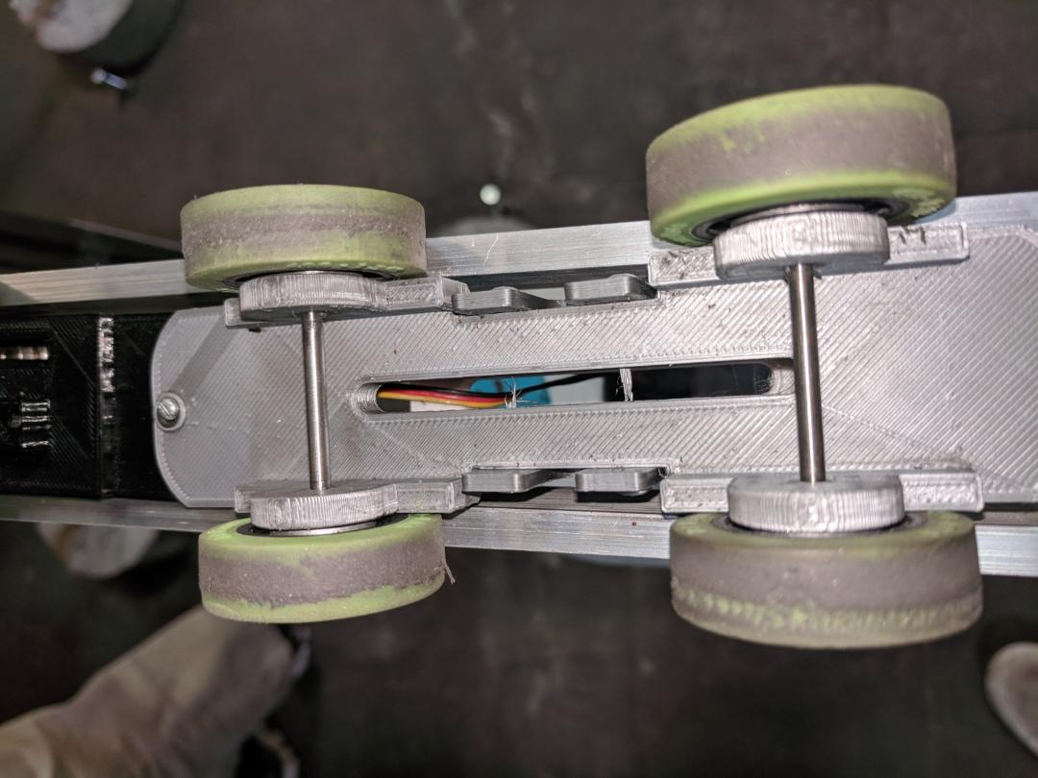
Figure 1. Areas of wear on last previous bogie design.

To combat these issues, design considerations for the overall durability of the bogie were influenced the latest design. A stepper motor was selected by the Small-Scale Controls team to power the bogie system which required a new chassis design for the master bogie. The master chassis design needed to be big enough to house all major drive and track witching components as well as small enough to fit on the track and in between the support brackets which can be observed in Figure 2. A 2:1:1 gearset was implemented to allow the motor to be positioned near the center of the chassis to prevent interferences with the wheels and increase the speed at which the bogie could travel. The motor was placed upside down to lower the position of the pinion gear to prevent it from colliding with the guiderail. Conical wheels provided a simple and cost-effective solution to reducing wheel wear as opposed to using a differential. Do to the unique application, the wheels where 3D printed and modified to fit this application. A rubber coating was added to the wheels to increase traction. An articulating allowed two degrees of freedom for turns and going up and down vertical sections of the track which used binding posts to reduce friction for smoother travel. Given the relative high cost of electrical-mechanical components, a linkage system was integrated to prevent damage to the track switching servo. A four-bar linkage was used to distribute the force from the impact of the guide rail for track switching away from the servo motor.
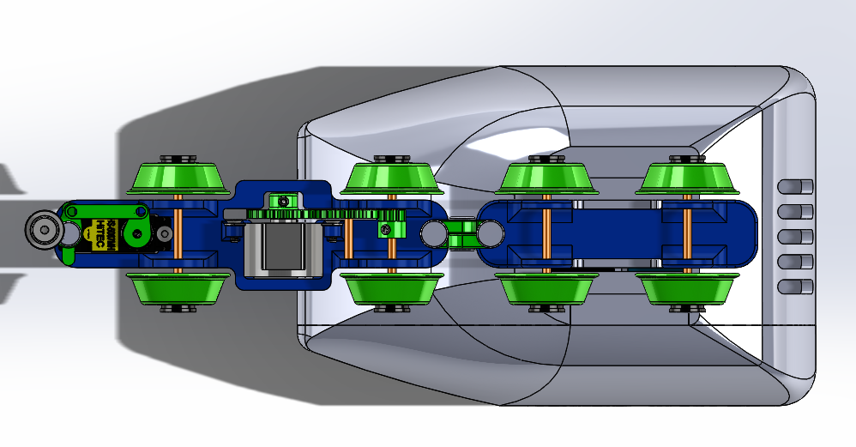
Figure 2. Master bogie on track clearing brackets.
Many iterations of components were created and changed do to issues found during prototyping and testing. The final build fit all desired components and mechanisms required to reduce wear of the bogie, however, it was unable to travel along the track without assistance. The low speed of the motor caused the bogie to get caught on gaps in track. Additionally, the bogie was unable to switch tracks because it would fall through the gap. It is recommended that motor be replaced with one that can travel faster so the bogie can overcome small gaps in the track. A method to support the slave bogie during turns should be introduced to allow track switching. The primary use of 3D printing parts was time consuming and required that the printer be readily available. Alternative manufacturing processes may be implemented like using molds for the conical wheels.

Introduction and Project Description
Automated personal rapid transportation (APRT) provides an alternative solution towards reducing the negative effects of current modes transport. As such, the Spartan Superway aims to provide a sustainable method of transportation that will benefit both the environment and society by reducing harmful emissions and congestion in urban cities.
With a growing population in urban cities current modes of transportation are either unsustainable or contribute to overpopulating the streets. Gas powered vehicles produce CO2 emission inducing climate change and pollute the air threatening the health of the local populace. In recent new, California has spent $18 billion recovering from fires brought upon by drought because of climate change (Smith, 2018). Fortunately, gas powered vehicles are being phased out of car dealers bringing in electric vehicles, however, electric vehicles still take up space on the streets aiding in traffic jams and remain a potential threat to pedestrians. As such, California ranks as the fifth state with the worst commute in the US (Sweeney, 2017) with cities, like San Jose, experiencing increased pedestrian casualties annually (Kunkle, 2018). The solution for these problems surrounding transportation go beyond moving to electric vehicles.
Primary focus on innovating road-bound vehicles, while beneficial in many ways, still carry downsides to society. Electric vehicles, for example, aid in providing transport with zero emissions out of the gate but come at a high cost that most cannot afford. Additionally, there remains the concern of coal facilities that provide the electricity to charge electric vehicles. Inefficient means of transportation also take part in social displeasure with road-bound vehicles populating the streets wasting peoples time and public transportation, which has potential to remove vehicles off the road, are unpopular.
To address the current issues of transportation, personal rapid transportation (PRT) and automated transit networks (ATNs) have been developed and investigated as possible solutions. These methods of transportation provide the functionality like Uber with the appealing on-demand and origin-to-destination service with no intermediate stops. ATNs include the benefit of automated vehicles to eliminate human error and allow efficient network mapping. These systems are made to be used on guideways allowing easier integration and potential to be configured as ascended networks allowing the ground space to be occupied by pedestrians.
Structure of the project
As a team of one the tasks pertaining to the development and improvement of the bogie system was handled singularly. Guidance and feedback on the progression of the project were fulfilled through Professor Furman, Ron Swenson, and Eric Hagstrom. The fall semester focused on conducting research on ATNs and bogie systems to understand how they are used and what exists today to create the foundation of this project. Research on solutions to the problems at hand was then done to then generated design concepts at the end of the semester. SolidWorks was used to develop 3D models for analysis. Basic analysis was conducted prior to modeling to validate concepts. At the beginning of the Spring semester manufacturing of prototype bogies was fulfilled by 3D printing for efficiency. Modifications were made after testing prototypes. The necessary hardware and other components were acquired through Amazon or were used from previous years build. The primary focus was to produce a functional master-slave bogie system that would transport a four-pound podcar along the improved track.

Objectives
For this project, the primary tasks were to improve upon an existing two system bogie design to better functionality and durability on a small-scale track. Observing the existing design there was noticeable wear on the wheels and excessive binding at the joint. It was also noted that none of the motors were functional or were unreliable for additional use for this project. It was then decided focus on improving the solidity of the bogie. To improve the durability of the design three areas took precedence including the following: wear on the wheels, wear on drive and track switching components, and wear at the joint of the bogie. Additionally, the team was tasked with designing the bogie with vertical drive capability in correspondence with the track team’s desire to implement a gradeability section to the track. The small-scale versions of this project will act as a proof-of-concept for large scale progression. In other words, present the potential this method of transportation is capable of at a low cost that will continue to function beyond the spring semester of 2019.

Design Specifications
The small-scale bogie team aimed to improve the durability of the master-slave bogie design and provide a functional small-scale bogie. Figure 3 shows last year’s design.
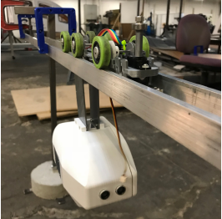
Figure 3. Previous years bogie design.
From observing issues relevant in the prior year’s model, a new design was needed to support a new motor, reduce wear of tires and at the joint of the master and slave bogie. As an additional contribution towards improving the durability and alternative design for track switching was desired. Due to a change in motor the master bogie chassis required significant redesign. With a desire to implement a gradeability section in future tracks, the bogie also needed an articulating joint to prevent binding at the joint. Excessive wheel wear warranted a method of preventing wheel slipping on turns was also addressed. Thus, the following design specifications were formed:
- Max build volume: 12in x 1.75in x 1.25in. (305mm x 44mm x 32mm)
- Capable of transporting supporting a 4lb podcar
- Capable of traveling along a 15% grade track
- Budget of less than $100

State-of-the-Art/Literature Review
ATN and PRT Overview
ATN technology has recently been discussed as an extension of PRT systems as of 2010 and pose an alternative solution to the modern transportations issues society faces today. One of the most notable PRT systems is the Morgantown Personal Rapid Transit system in Morgantown, West Virginia, which has been in use sense 1975. This system provides the students of West Virginia University with on-demand service and two additional modes of operation including schedule mode, and circulation mode. The other two modes of operation aim to provide transportation during high demand hours of the day. Furthermore, a single podcar can transport 21 people and is accessible for passengers with disabilities. The system introduced the world’s first such as, transit switching via in-vehicle switching and automated transit system utilizing central control communication (Raney & Young, 2004). By providing a successful and appealing mode of transportation this system was recently refurbished with funding of $100 million (Palca, 2016).
A more recent PRT system is in Suncheon bay, South Korea, which was developed by Vectus and began operation in 2014. The vehicle can travel at a speed of 30 mph and transport up to six people. One of the key differentiators for this system is its efficient operation by providing service only when there are passengers (Tebay 2013).
San Jose State University’s Contribution
San Jose State University, in 2012 began contributing to the paradigm shift in transportation by developing the Spartan Superway a Solar Powered Automated Rapid Transit Ascended Network (SPARTAN). Unlike existing ATN systems, the Superway project utilizes solar panels as the power source and functions on an elevated track. Over the years students have produced prototypes at one-twelfth, one-half, and full-scale to which are intended to be implemented in dense urban cities. The Superway aims to providing a sustainable mode of transportation that will greatly reduce the number of vehicles on the road by occupying vertical air space. Overall, society will acquire the benefits such as reduced air pollution, more efficient commuting, and reduced pedestrian casualties bettering the local populace’s quality of life.
The Need for Small-Scale
To ultimately achieve a functional ATN network that the Spartan Superway continuously work towards, intermediate steps are necessary. One of these steps is to generate small-scale prototypes to present the desired function of the track-based system and test design concepts for larger scale teams to integrate in later models. The small-scale bogie team focuses on improving existing designs to better resemble the working system while also allowing a cost-effective way to generate design concepts. Continuous revisions on the bogie design must be undertaken to integrate new components and improve durability and functionality to meet those objectives and present the ATN system.

Final Design
Motor Integration
Supporting a new motor took precedence for the design of the master bogie. After reviewing a few brushless motors including a gimbal motor and motor used for drones the Small-Scale Controls team chose to move forward with a stepper motor as the other solutions lacked availability and were unable to travel at a reasonable speed respectively. The stepper motor was significantly larger and slower than the previous years brushed motor which influenced some design decisions.
The first was to have a 2:1 gear ratio to increase the speed. Lego gears were chosen for the gears as 3D models were readily available for modification and were able to be produced using a 3D printer with sufficient quality. A 48-tooth gear with a 24-tooth gear were chosen initially to be implemented with the motor however the large pinion gear was interfering with the guide rail. When switching to smaller gears there was interference between the motor and wheel. As a solution an idler gear was implemented. The idler gear allowed the motor to be positioned towards the center of the chassis away from the wheel as shown in Figure 4. Two 24 tooth gears and one 8 tooth gear were chosen for the gears. The idler was placed on an axle fixed to holes within the chassis.
Figure 4. View of motor with 2:1:1 gearset.
Additionally, the motor was positioned upside down to lower the pinion gear, so it would not interfere with the guiderail. The motor was lowered to increase the distance from the guiderail. To prevent the driven gear from slipping and moving during operation an extrusion with a hole was added to the pinion and driven gear to allow a set screw to be used to fasten the gear to the axle as shown in Figure 5. The idler was kept in position by the cutout in the chassis.
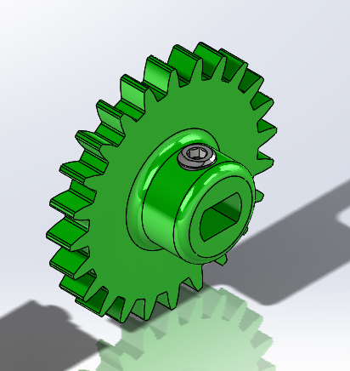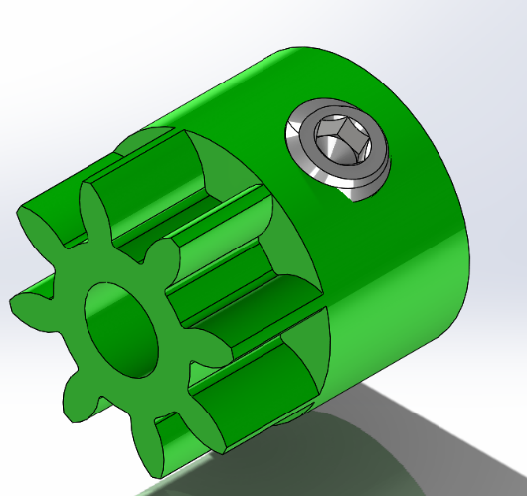
Figure 5. Pinion and driven gear with set screw.
Conical Wheels
Conical wheels were chosen to allow inner and outer wheels to adjust to the difference in distance travelled during turns. Off the shelf wheels were not available that would fit this particular application, so they were designed for 3D printing. Flanges were added to prevent the bogie from derailing. Initially the wheels were designed using 3D printed axles that were used with a prototype design. The chassis design prevented the wheels from slipping along the axle but was fitted for a gimbal motor which was eventually changed to a stepper motor. The chassis also was prone to getting caught on the brackets that supported the track. Those required a new chassis design which warranted a new method of attaching the wheels so that the wheels would not slip off and would keep the bogie positioned properly on the track.
The method for assembling the wheels to the axle was influenced by the previous year’s design. A hex nut with a set screw and snap ring was used to attach the wheel to the axle as shown in Figure 7. The hex nut has a threaded hole for the set screw and the snap ring would press the wheel against the flange of the hex nut. The wheels were 3D printed using supports as surface for the nut flange was needed inside the wheel.
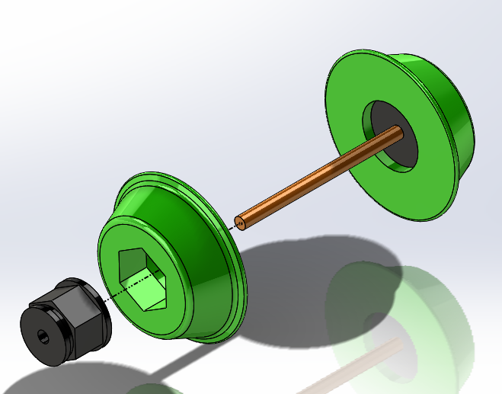
Figure 7. Conical wheel assembly.
When testing the final version of the bogie the wheels did not have sufficient traction on the track to move the bogie. To combat this a rubber coating was sprayed on the wheels. 3 layers of Plasti Dip were applied to the wheels and gave the wheels enough traction to move on the track. Additional weight was added to the bottom of the master bogie to see if it would improve but yielded no results.
A simple articulating joint was designed to allow the master and slave bogie to transition into the turn section of the track smoother and be able to travel on an incline. Initial design concepts were generated from concepts shown in Figure 8. Due to their size and simplicity these components were also 3D printed.
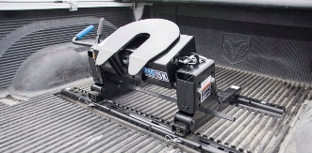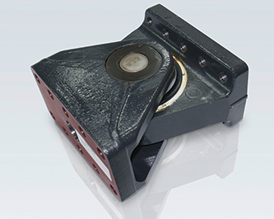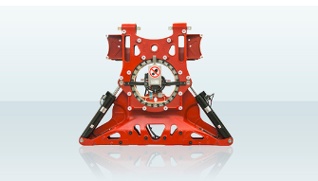
Figure 8. Articulating Joints from research.

Binding posts were desired as they provided smooth surface for the parts to rotate on and had sufficient strength to carry the load of the podcar. The bogies slight tilt (yaw) when entering the turns due to the nature of conical wheels drove designs to include another degree of freedom, however, this would allow the slave bogie to fall off at the gap in the track at the switching sections. The degree of tilt was determined negligible as spaces between the joints would allow some movement to make up for it, so it was not included. The final design can be shown in Figure 9.
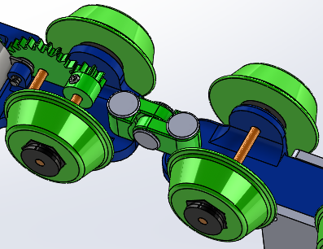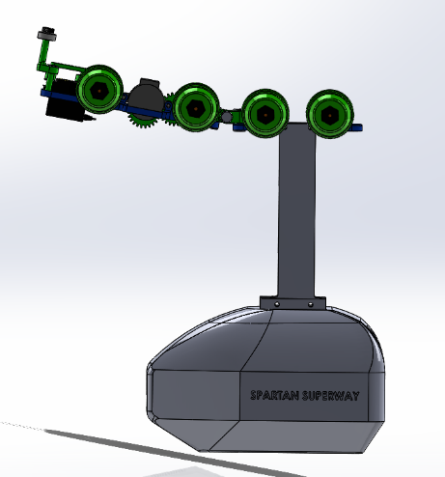
Figure 9. Articulating joint.
The last component added to the master bogie was the four-bar linkage for the track switching mechanism. One design concept is shown in Figure 10. The design intended to improve the strength of the guide arm and reduce the length of the overall master chassis, however, the arm was too wide to travel through the support brackets for the track and were replaced.
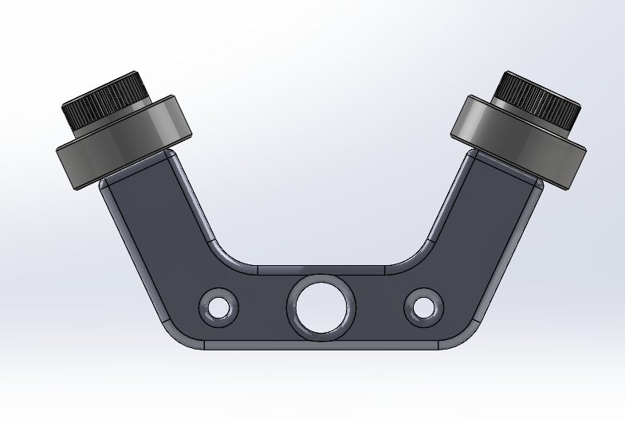
Figure 10. Design concept for track switching arm.
An input link was first designed to mount onto the servo. The input link was then modified to make the switch arm. The switch arm was designed to fit a bearing on the top to allow smooth travel along the guide rail. The track switching mechanism assembly can be shown in Figure 11.
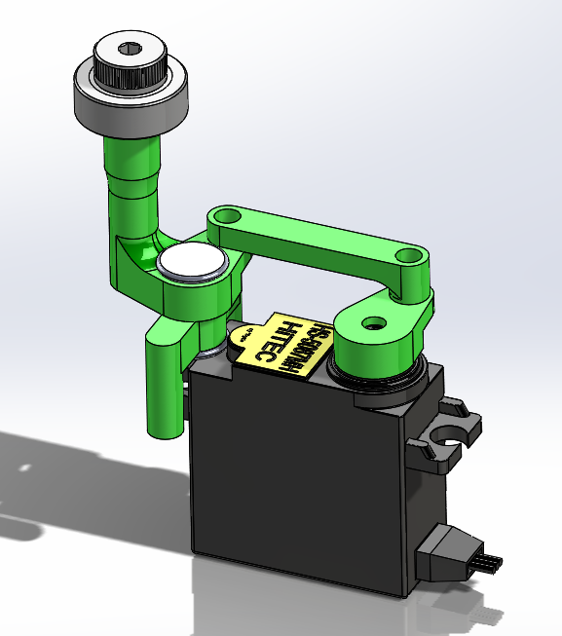
Figure 11. Switch arm assembly.
Last year’s analysis on the arm got a factor of safety of 8 which allowed the diameter of the arm to be reduced. The upper part of the arm was increased to provide enough space for the threaded bolt which fastened the bearing to the top of the arm. A mount for the arm was designed as a separate part as it would interfere with the servo upon assembly which is shown in Figure 12. A binding post was used to fasten the arm to the mount. After positioning the input link and guide arm the coupler was designed. The coupler would be fastened using M2 screws as the preferred binding posts were to large to integrate. With coding in mind, the linkage system was designed to travel 180 degrees as a round number for the arm to switch between positions for determining the direction it needs to travel.
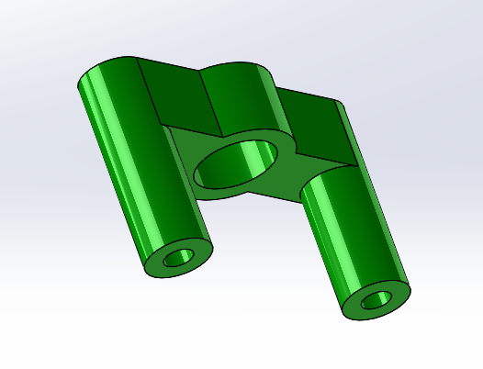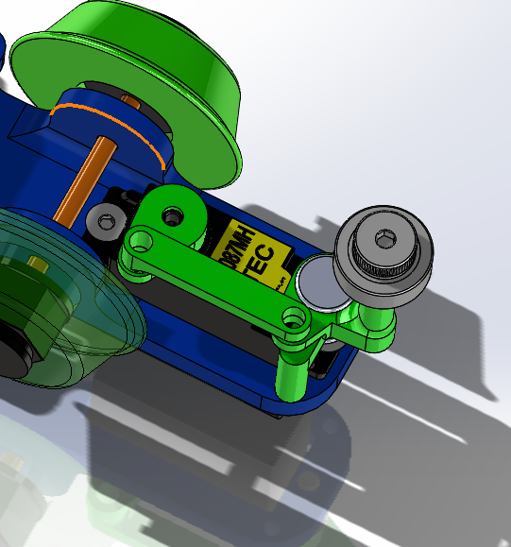
Figure 12. Switch arm mount and visual of assembly on chassis.
For the slave bogie its function did not warrant significant change. As such the slave chassis was designed using the master bogie model with all the features for the drive components removed. A cutout was created to mount the side plates, so they would not interfere with the wheels as shown in Figure 13. A hole was added for the articulating joint and the length was shortened to meet the design requirements.
Figure 13. Slave Bogie

Analysis
When attempting to do FEA analysis on components, the results yielded very high Safety factors that were not accurate or reliable. The unique characteristics of the 3D printed components cannot be captured within FEA software making it difficult to verify designs would fail during worst case scenarios. Additional factors such, as the quality of the filament used for the parts, also make FEA an unreliable tool for this particular case. As such, general rules of thumb were applied instead.
For components or features that would support significant loads such as the motor mounting holes or holes for the wheels a material thickness of 3mm minimum was used throughout the design of the chassis and other qualifiable components. The fill amount setting for critical components like gears was also increased to 30% rather than the standard 20% used on other parts to increase the strength of the part. Low load components like the coupler were allowed a thickness of 2mm minimum as it simply needed to move the weight of the guide arm. The load from the switch arm would be supported by the binding post and the arm itself which kept a 3mm thickness. Large fillets were placed at stress concentration points.
The design for the conical wheels was dependent on the difference in chord lengths of the inner and outer tracks for turns. Conical wheels were first designed and 3D printed to test with the existing track as a preliminary experiment to see if they would work with the small-scale track. Conical wheels allow passive turning for bogies and can be seen used in most trains and track vehicles. With a varying diameter cross section as the bogie inserts a spin at different speeds remembering that velocity is a function of radius and angular velocity. Three iterations of test wheels were created at 3, 25, and 15, degrees of taper. The 3 degrees did not show any signs of passive turning leading to a more drastic angle being used for the next test. Increasing the taper showed significant results with the wheels able to turn with the track, however, there was excessive rocking of the test rig, shown in Figure 14.
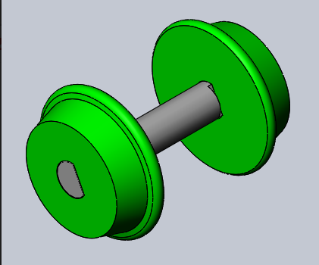
Figure 14. Test rig used for testing conical wheels.
After confirming that this method would work on the track, calculations were done to determine the degree of taper for the wheels. The ratio of the inner and outer track chord lengths was taken and turned out to be 1.08. Sense the diameter of the wheels are directly proportional to the circumference of the wheel and thus the speed of the bogie the ratio of chord lengths can be directly applied to the diameter of wheels. This was done using when designing the wheels in Solidworks. The larger radius dimension was set to be 1.08 times larger than the inner radius both of which were placed 1.50mm away from the center of the wheel as shown in Figure 15. This ideally will cause the bogie to shift 1.5mm to the right during a left turn to which the differences in diameter would make up for the difference in distance traveled. The inner radius was changed until the center radius was around 15mm to meet the Controls team’s desired circumference for traveling long the straight sections.
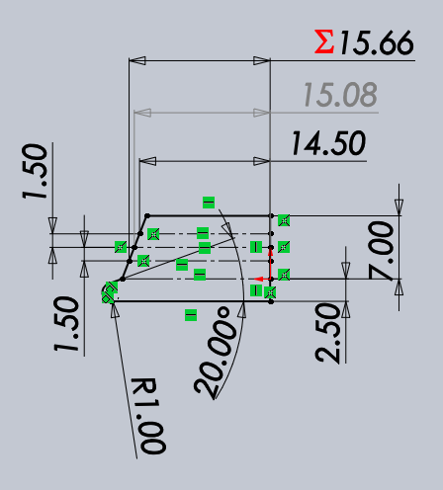
Figure 15. Design for conical wheel.

Cost
The initial budget was set to below $100 for the total bogie design. Utilizing 3D printing as the main method of producing parts, the cost for materials was set to be 30% of the budget which can cover close to two roles of filament. The remaining amount was allocated to any other necessary components and hardware. Reusing materials from previous years builds aided in reducing costs for building the project. A lot of the hardware and components were bought in bulk and were not all utilized for the project leading to an increase of price, however, the supplies can be used for future projects, thus, not a major concern. The overall cost can be shown in Appendix B.

Results and Discussion
At the end of the project deadline the bogie was unable to travel the entire track without assistance. The master-slave bogie system was able to travel along straight sections but when facing a gap between two track pieces it would get stuck and be unable to move. Additionally, the guide arm was unable to provide enough support for the system to travel through the switch section and would just fall through. Poor quality filament was used to make the guide arm causing it to fail at on the final day. From the design specifications the overall design met two of the four listed goals. The bogie was within the specified build volume and cost was kept under $100.
It was decided that a faster motor or higher gear increase would allow the bogie to clear the imperfections within the track. As for the gap at the switch section a support for the slave bogie maybe needed to prevent it from dragging the system down when traveling over the gap at the switch section. The previous year’s master bogie would support the slave bogie at the joint section with the guide arm bearing some of the load which was considered, however, the low speed, lack of a guide arm, and reduced length prevented it from clearing the gap. Increase in speed would give the bogie enough momentum to overcome small inconsistencies within the track. Another guide arm would prevent the full load system to be supported by the master bogie. Significant refinement of the design is needed to produce a functioning model.

Conclusion and Next Steps
In conclusion, this semester failed at providing a functional small-scale master-slave bogie system in time to be showcased at the end of the semester. The master bogie was able to house all desired design changes and was able to stay within the desired build volume all at a low cost. Failure occurred when implementing the bogie to the track as the necessary speed, lack of a guide arm and length of the system were not compatible with the track. Better organization of time that allowed testing of the system weeks before the deadline would have benefited the team and allowed design changes to be made to address the issues.
For next semester, it is suggested that a design review process be implemented for the group to catch mistakes and improve initial designs. This will greatly improve efficiency of the group for time will not be wasted producing parts that fail because of poor design. As for the bogie design a new faster brushless motor would allow the bogie to overcome inconsistencies in the track. Additionally a support for the slave bogie could be implemented to prevent the master bogie from bearing the full load of the system when traveling over the gap at the switch sections of the track. New modes of manufacturing could also be implemented. Instead of having to apply a rubber coating the wheels creating a mold for the wheels and using an alternative material like silicone can be used. Lastly strain reliefs for the motor and servo cables can be added to keep the components safe as well as improve the look of the system.

References
Kunkle, F. (2018, May 09). Pedestrian deaths soar 46 percent, insurance group finds. Retrieved from https://www.mercurynews.com/2018/05/08/pedestrian-deaths-soar-46-percent-insurance-group-finds/

Palca, J. (2016, October 03). A Revolution That Didn't Happen: Personal Rapid Transit. Retrieved from https://www.npr.org/2016/10/03/494569967/a-revolution-that-didnt-happen-personal-rapid-transit

Raney, S., Young, S., & Young, S. E. (2004). Morgantown People Mover – Updated Description TRB 2005 Reviewing Committee: Circulation and Driverless Transit (AP040). Retrieved from http://www.cities21.org/morgantown_TRB_111504.pdf

Smith B., Adam. (2018). 2017 U.S. billion-dollar weather and climate disasters: a historic year in context. Retrieved September 21, 2018 from https://www.climate.gov/news-features/blogs/beyond-data/2017-us-billion-dollar-weather-and-climate-disasters-historic-year

Sweeney, D. (n.d.). California commute times among worst in U.S. Retrieved from https://www.sacbee.com/news/state/california/article158587554.html

Tebay, A. (2015, July 16). PRT System to Open for Suncheon Bay Garden Expo. Retrieved from https://kojects.com/2013/02/13/prt-system-to-open-in-april-for-suncheon-bay-garden-expo/

Appendix A

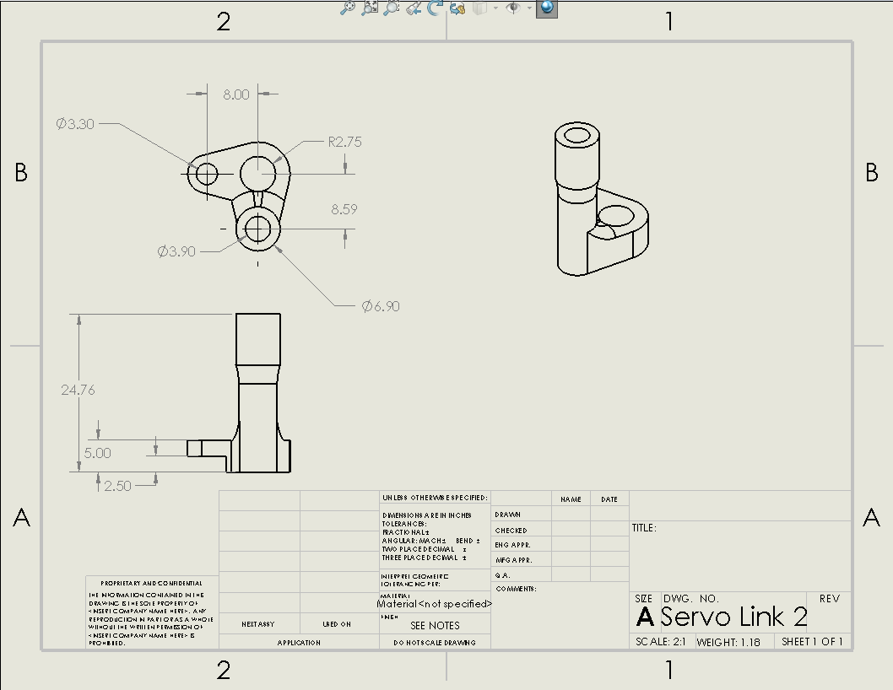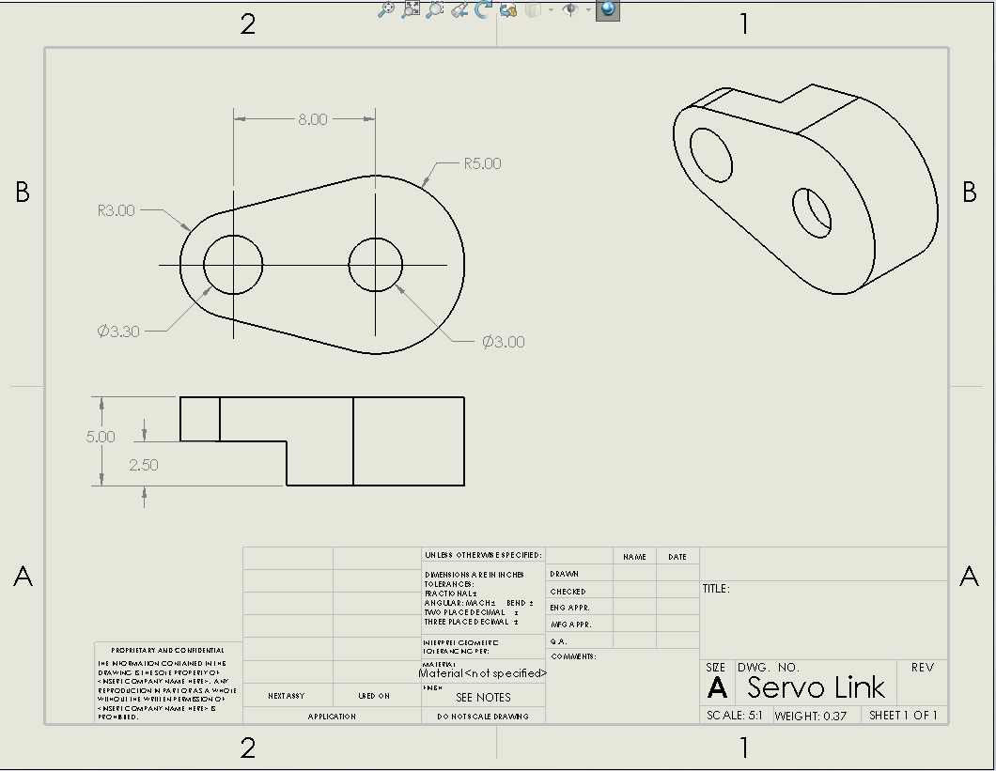
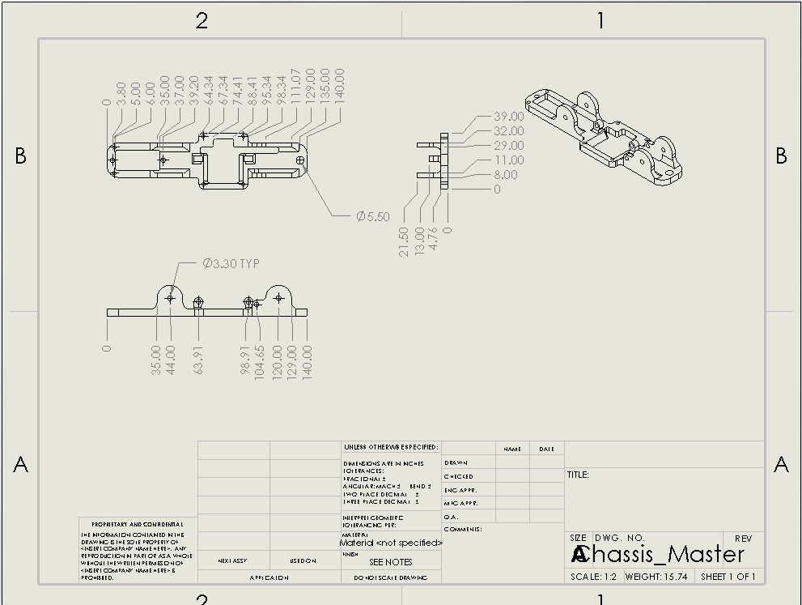
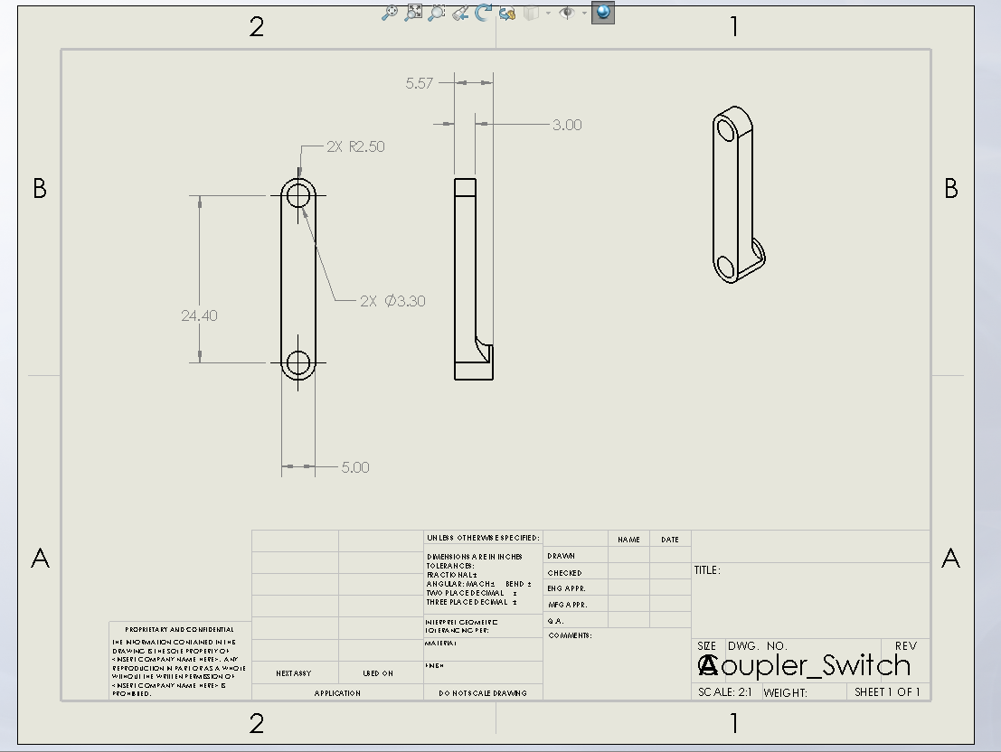
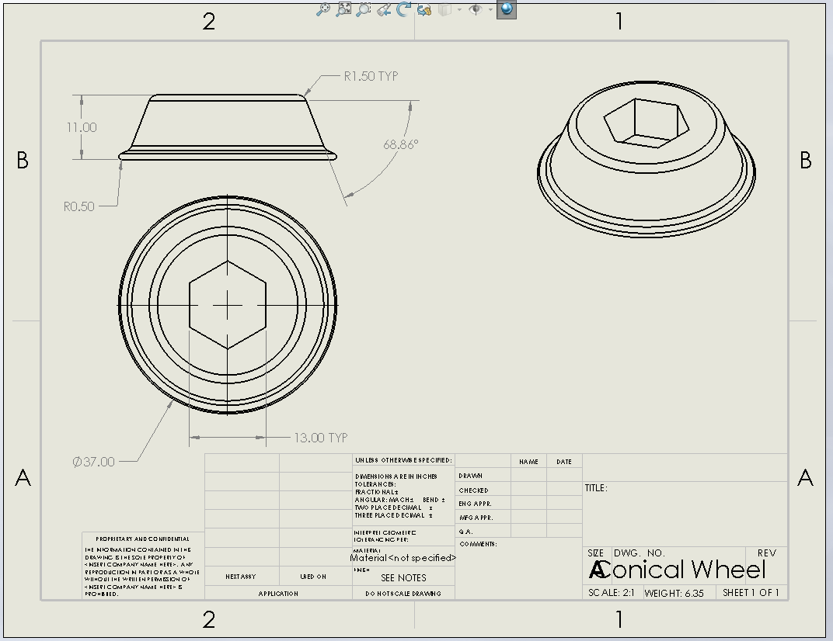
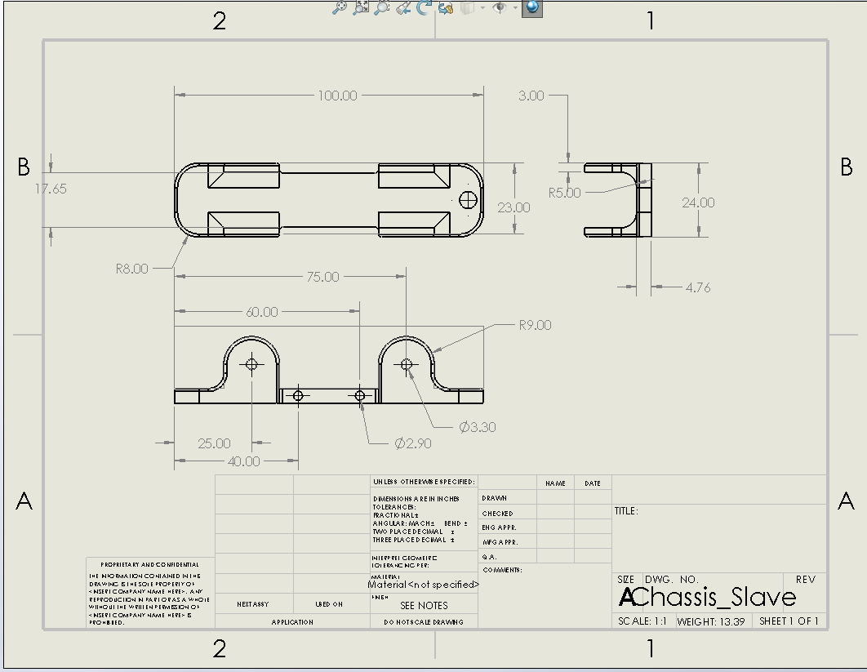

Appendix B
Spartan Superway BOM
Description | Vendor | Qty. | Cost | Amount
Hilitchi 460-Piece Metric M3 M4 M5 Hex Socket Flat Head Countersunk Bolts Screw Nut Assortment Kit - 304 Stainless Steel |  | 1 | 15.99 | 15.99
Hilitchi 60-Set M5 x 5/10 / 15/25 / 35/45 Phillips Chicago Screw Binding Screws Posts Assortment Kit for Scrapbook Photo Albums Binding and Leather Saddles Purses Belt Repair |  | 1 | 10.18 | 10.18
Sutemribor Brass Solid Round Rod Lathe Bar Stock, 3mm in Diameter 100mm in Length (10Pcs) |  | 1 | 7.39 | 7.39
Hilitchi 420pcs M2 M3 Stainless Steel Hex Socket Head Cap Screws Nuts Assortment Kit with Box (304 Stainless Steel) |  | 1 | 11.99 | 11.99
SUNLU PLA Plus 3D Printer Filament - 1KG(335m/1099ft) 1.75mm, Dimensional Accuracy +/- 0.02 mm, 1KG(2.2LBS) Spool 1.75 mm, White (Ivory White) |  | 1 | 18.99 | 18.99
PLATI DIP 11 oz. Black Rubber Coating Spray |  | 1 | 5.98 | 5.98
 |  |  | Total = | 70.52

