About Team Ångström
We are seven engineering students, studying our third year on a five-year program in Energy Systems Engineering and are doing this as the project for our bachelor exam. There are current plans of building a podcar system in our town of Uppsala, Sweden. We will look into the possibilities of designing a system that supplies its own electricity demand. Our focus is to solve this with solar panels in connection with the tracks, but to make sure the system will be reliable for our northern weather conditions other renewable energy sources will also be looked into. For a reliable supply of electricity during all of the systems operational hours, solutions for a storage system will be needed.
The project will be finished in June 2013.
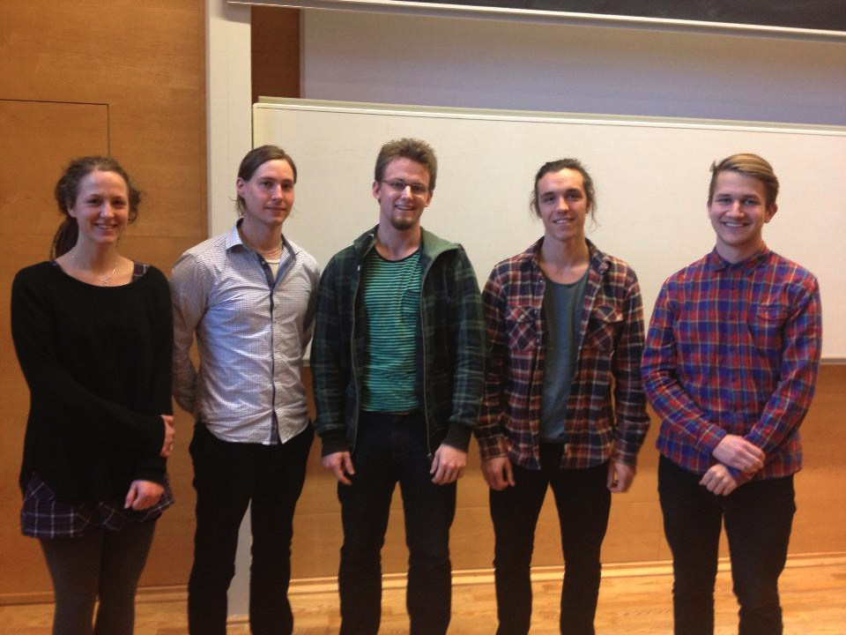
Figure 1: Five of the team members

